Aurora Research and Heliophysics by Wendy Esch

Table of Contents
Lesson Overview and Objectives 2
Materials 4
5E Steps 4
Resources 5
Handouts 6

Lesson Overview:
Level: Middle and High School Time: two 88 minute class periods
Students will research the cause for aurora and learn the phases of an auroral substorm. Students will apply what they learned to new pictures of aurora and answer questions about the auroral pictures they see. Then students will research and make a poster depicting many of the past, current, and future heliophysics missions. Presentations will be made to the class, students will communicate what was gained or will be gained from these missions.

Educator Background Knowledge
Educators should be familiar with the different substorm phases and Heliophysics missions.

Framework for Heliophysics Education
NASA Question: What causes the Sun to vary? Big Idea: Energy from the Sun is created in the core and travels outward through the Sun and into the heliosphere.

NGSS Performance Expectations
- HS-ESS1-1

Common Core Standards for Mathematical Practice
CCSS.MATH.PRACTICE.MP1
CCSS.MATH.PRACTICE.MP3
CCSS.MATH.PRACTICE.MP8

Targeted STEM Skills
- Analyzing and interpreting data
- engaging in argument from evidence
- obtaining, evaluating, and communicating information

Learning Goal
To learn more about aurora, how they form, and the different phases they go through as they propagate. Another goal in this unit is to learn about several heliophysics missions.

Learning Objectives
Students will:
- Complete research on aurora and auroral substorm phases and answer several questions from their research.
- Apply the knowledge gained during their research on aurora to new pictures of aurora they have not seen.
- Describe the substorm phase observed and the location of the observer.
- Give a description of the aurora using terminology found in their research.
- Compare the substorm phase observed to the latitude of the observer.
- Conduct research on 1 heliophysics mission and complete a poster depicting several facts about the mission.
- Communicate what was gained from their research to fellow classmates.

See Handouts following the lesson
- Aurora reading
- Aurora questions
- Aurora substorm phases lab
- Student heliophysics mission poster

Links to Digital Resources for Students
- Aurora Image Gallery
- Aurorasaurus

Key Vocabulary
Aurora, substorm, phases of an auroral substorm

Materials
- Heliospheric mission decal cards to hand out to student groups. See examples in the Handouts session. See all the missions here: Heliophysics Missions Poster
- Access to Canva or other tool

Material Preparation:
- Make and laminate the heliophysics mission cards students are going to research (optional)
- Make copies of the handouts or have them do the work digitally using the links above. (aurora pictures must be in color to correctly assign substorm phases, I made colored copies and then laminated them for classroom use. Or have them use a computer to view them)
- Locate a youtube video of aurora to engage student interest.

Steps
Day 1
- Begin class by asking the students if they have ever seen the Aurora Borealis? Also discuss the southern lights, Aurora Australis. Show the students footage from aurora from youtube.
- Explain to them what a substorm is and that the substorm progresses in a set of phases, have them read the article on aurora substorms and answer the questions (see Handouts). When completed, discuss what they learned about the phases of a substorm.
- Now, students will complete the aurora substorm phases lab and answer the questions (see handouts. When completed take time to go over with the students, especially the questions at the end of the lab. Refer students to the website Aurorasaurus https://www.aurorasaurus.org/
Day 2
- Review what was done on Day 1 –aurora, the substorm phases, and the cause for aurora. Pass the heliophysics mission cards out, one for each student. Using the handout linked above, have the students research the heliophysics mission they were assigned. Students can use an app like Canva, to make a poster highlighting their heliophysics mission.
- When students have completed their poster, they present it to the class. Students should jot down some notes in their science notebook for each mission.
- The substorm phases (still pictures) and basic information on heliophysics missions will be included in the unit test.

5E Steps
Engage
Student engagement is attained by the initial discussion of the sighting of aurora and the youtube video on aurora.

Explore
Students explore and research aurora and learn the terminology for an auroral substorm by looking at still photographs as well as gifs of aurora.

Explain
Group discussion and notes on auroral substorms for a check for understanding.

Elaborate
Students apply knowledge gained during their research on still photographs of the aurora from around the world which they have never seen.

Evaluate
An evaluation of this lesson will be on the unit test.

Handouts
Aurora Substorms reading
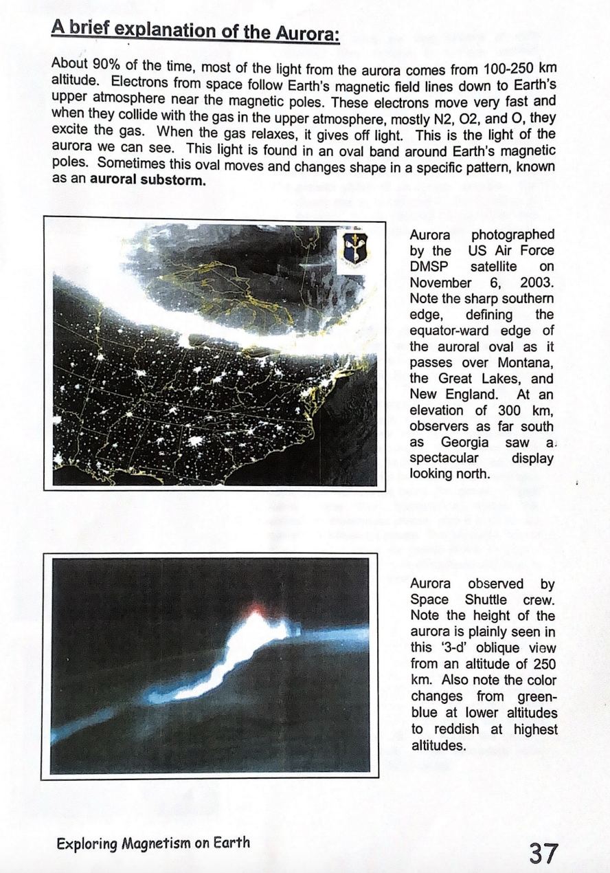
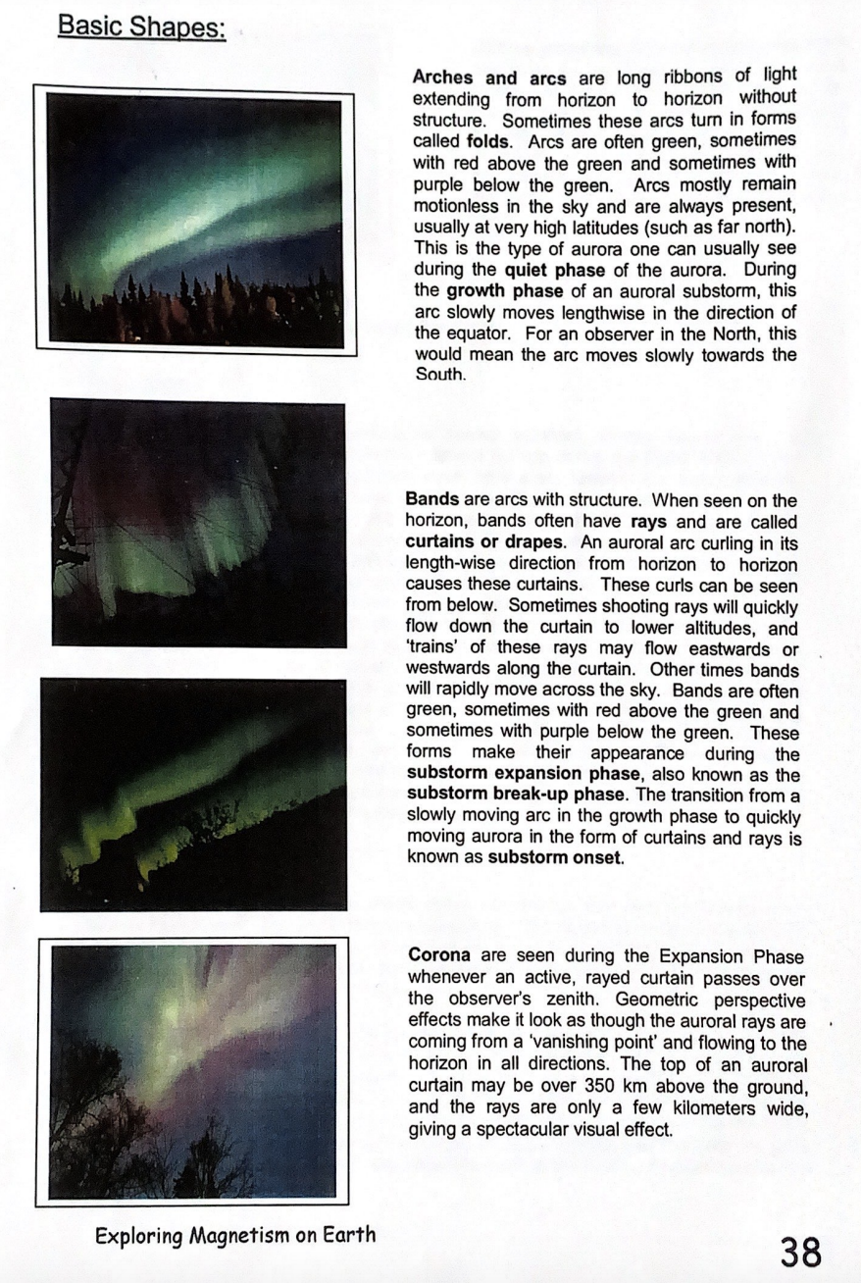
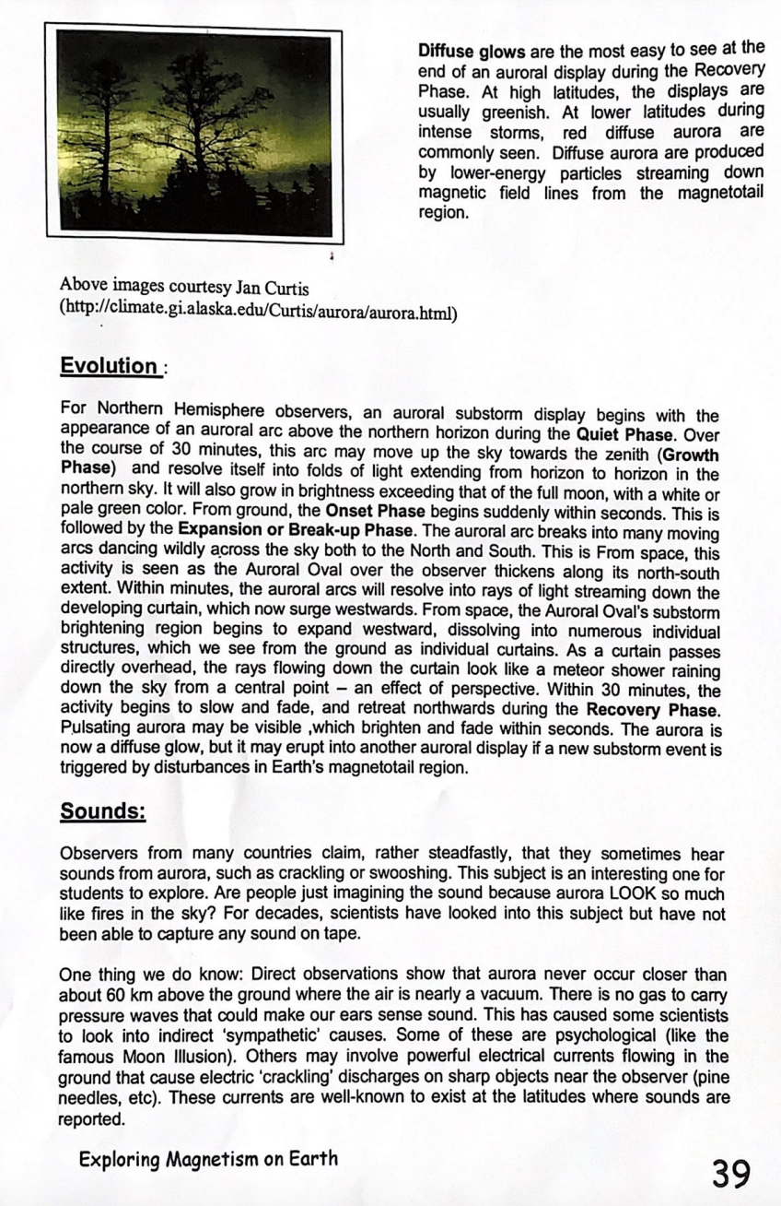Questions about Aurora after reading
- What causes the light that we see when we observe the aurora?
- What is an auroral substorm?
- What are the four phases of an auroral substorm?
- What are arches and arcs? What color are they? Do they move? What phases are they found in?
- What occurs during the growth phase of an auroral substorm?
- What is a curtain or drape? Do they move? What color are they? What phase are they associated with?
- What is a substorm onset?
- What is a corona? What phase are they associated with?
- What are diffuse glows? What color are they?
- Do the aurora give off sound?

Electromagnets and the Earth's Magnetic Field
1. What is an electromagnet?
2. Set up the electromagnet using the materials you are given.
3. How much weight can the electromagnet hold before it breaks?
4. Describe how a compass needle reacts when it is brought near the electromagnet.
5. Explain how the magnetic field of the earth is generated now that you know how an
electromagnet works. Make a simple motor using the materials you have been given.
6. How does the world's simplest motor work?

Magnetism and the Magnetic Field around a bar magnet
Materials: White poster board, Bar magnet, Transparent compass
- What types of materials interact with magnets?
- What happens when you bring a compass near a magnet?
- Draw what you hypothesize the magnetic field will look like around the single bar magnet. Include arrows that point in the direction the compass points north.
- Procedure
- Draw how it looks from your measurements with the compass?
- How does the magnetic field vary far from the magnet? Why do you think this occurs?

Examples of Mission Decal Cards

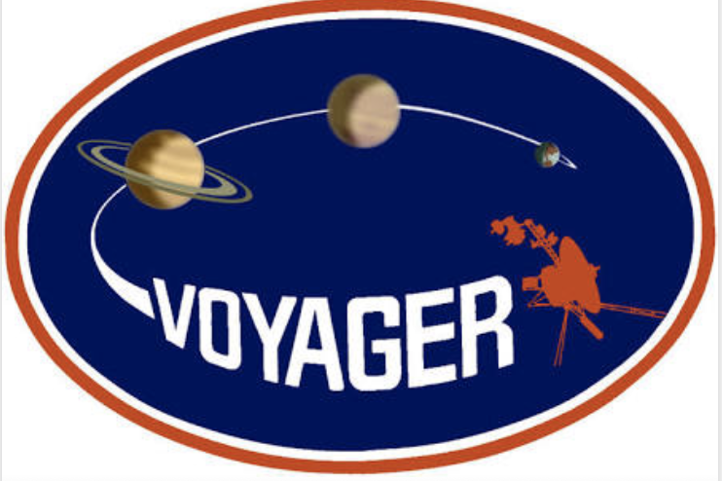
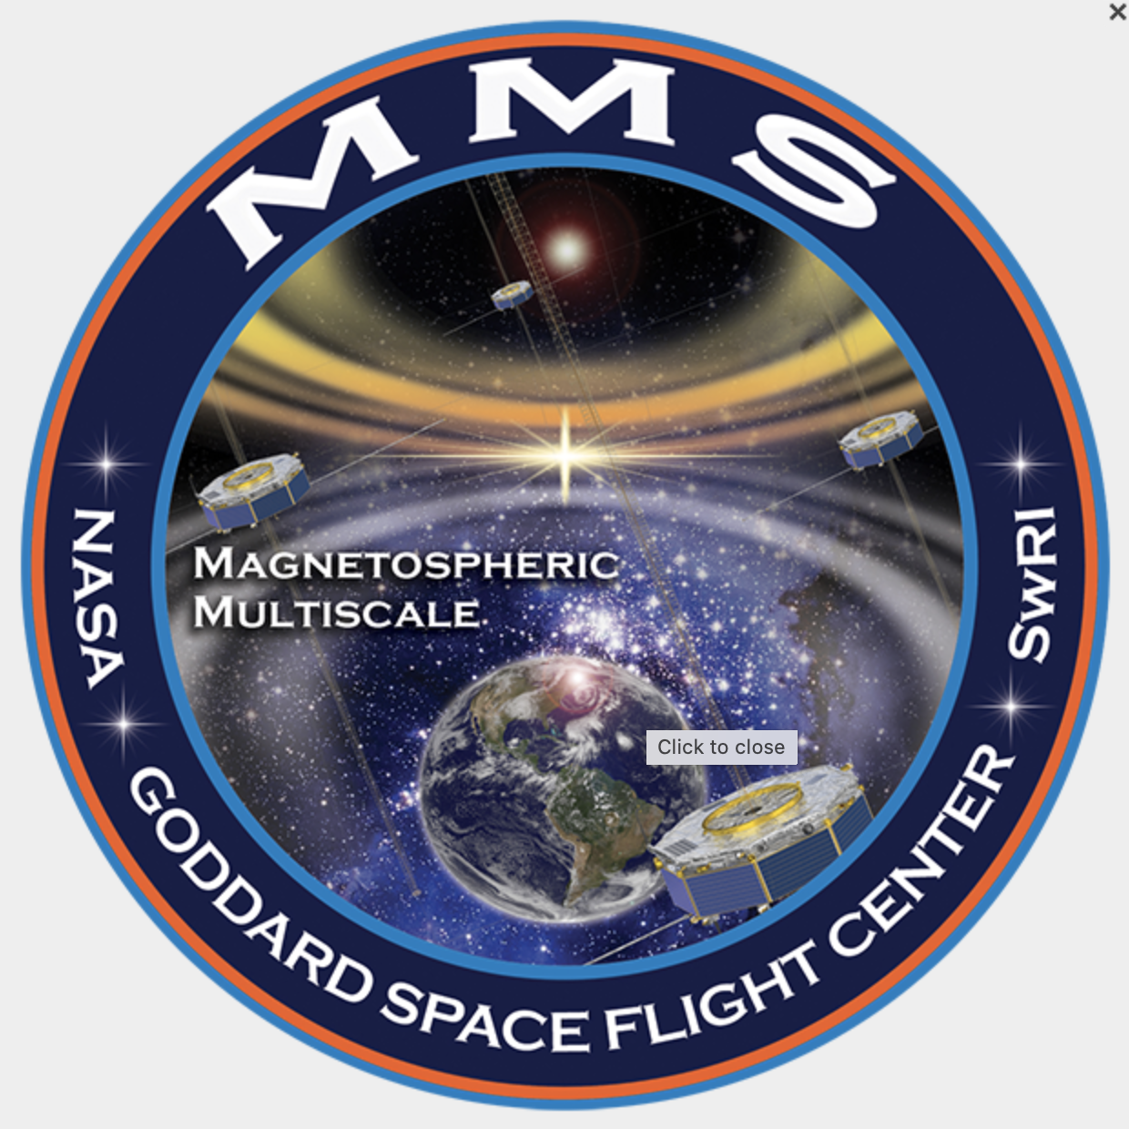
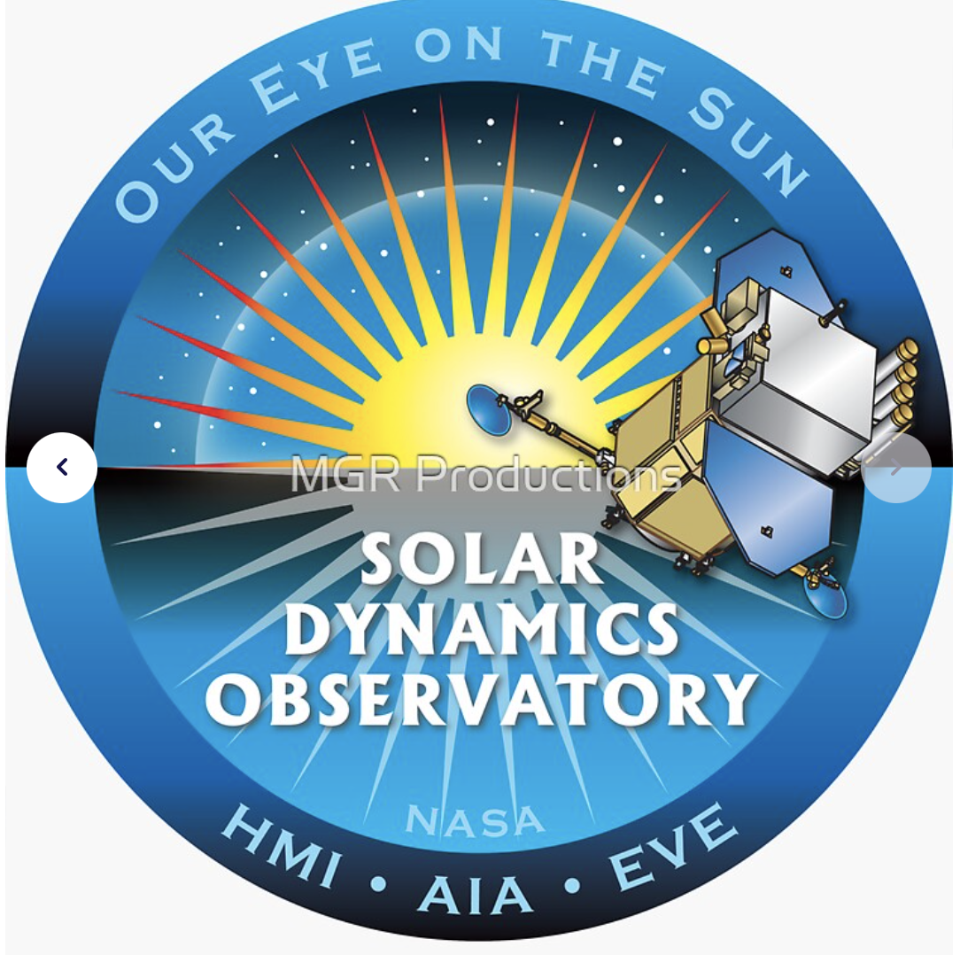
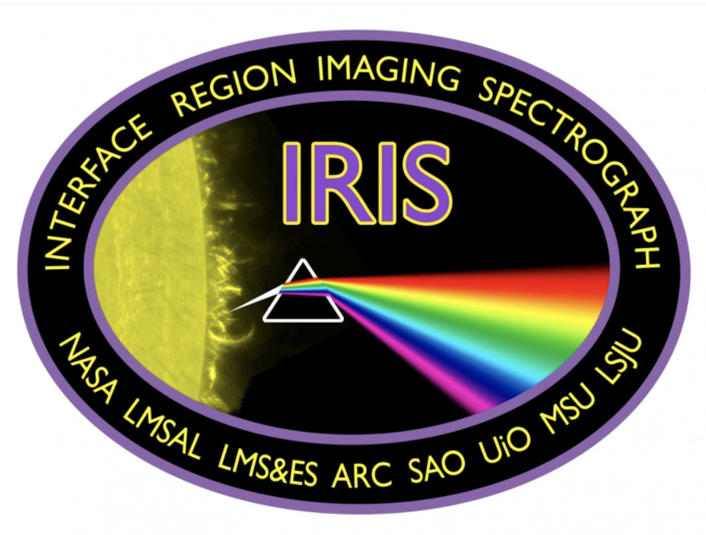
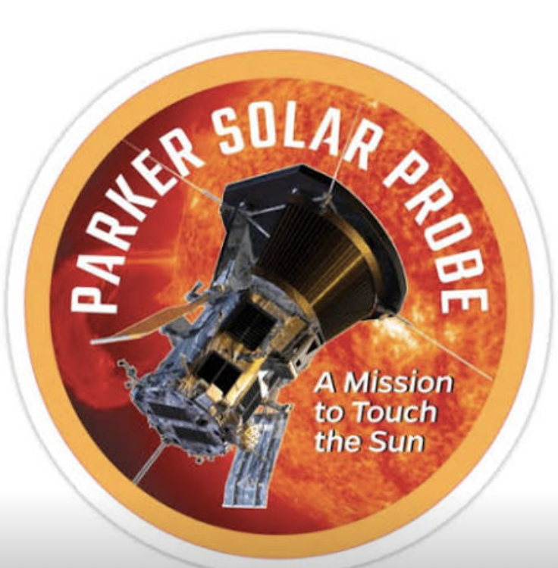

Heliophysics Quiz
Name:
____________ 1. A type of aurora that is observed when an active curtain passes over an observer's zenith.
_____________2. Occurs when the auroral oval changes shape in a specific pattern.
_____________3. Metals that are attracted to a magnet.
_____________4. The Earth's magnetic poles vary in strength and move over time.
_____________5. The most energetic solar storm occurred in September of 1859, it is an event known as the …
_____________6. A rapid release of heat and light located close to the sun's surface is
called a …
_____________7. The strongest class of solar flare is given the letter
_____________8. The sun's magnetic field and the earth's magnetic field come in contact with each other at the
_____________9. The letters CME stand for
_____________10. The sun's magnetic field is called _______when it is out near
the planets.
_____________11. protects us from harmful particles from the sun.
Heliophysics Exam: You may use your notes and other classroom materials on this portion of the exam.
      - Explain the following statement: Our star, the Sun, is a dynamic object having effects on our planet beyond just providing light and heat.
      - Explain how the strength of the Earth's magnetic field has changed over the last 800,000 years.
3.. How does the “normal” solar wind vary from the “stormy" solar wind?
4. List the sequence of events that would and could occur if an Earth directed CME left the sun at 10:30 central standard time. Write a scenario of what could occur if this CME had the strength of the Carrington Event of 1859, occurring today. (You should list eight events that could be triggered by this geomagnetic storm)
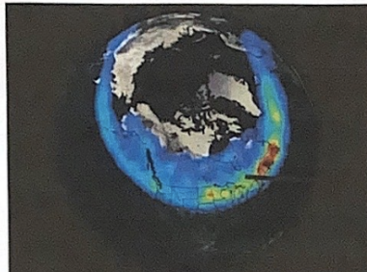
5. What is depicted in the picture to the right? Define.
6. Answer the questions about the pictures below:

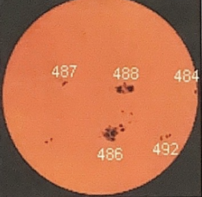
6a. What are the black dots on the sun?
6b. What causes them to form?

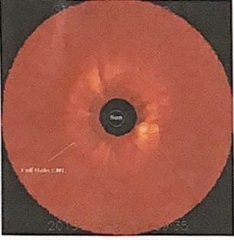
7a. What event is occurring on the sun?
7b. Why is its shape significant?
8. Explain the significance of the data below
IMF Biotal: 23.1 nT Bz: 20.3 nT south

9. Explain the significance of the colors in the picture below
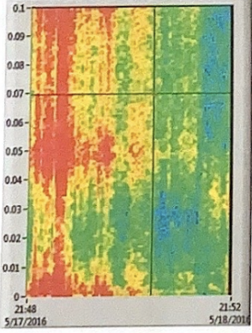

10. Calculate the Kp using the magnetometer signature below. Scale 1mm=4nt
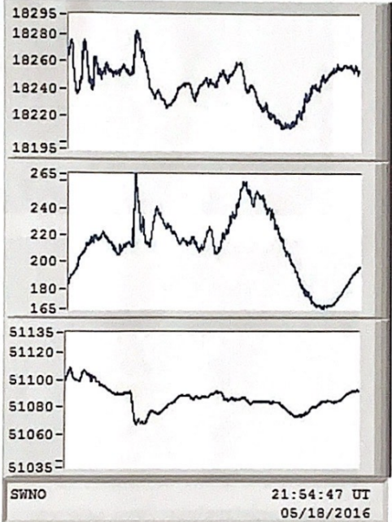

11. Using the data on pp. 2,3,4 make a prediction as to the likelihood of seeing aurora in Shawano Wisconsin. Explain. You should address the 5 bits of data, and then make your prediction

12. State the sub-storm phase and describe the features in the following auroral photographs.
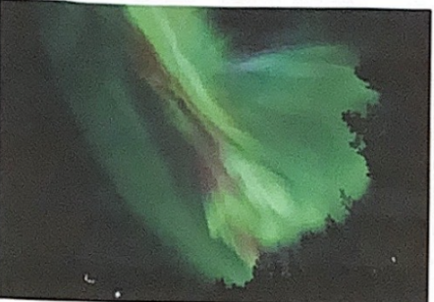 | 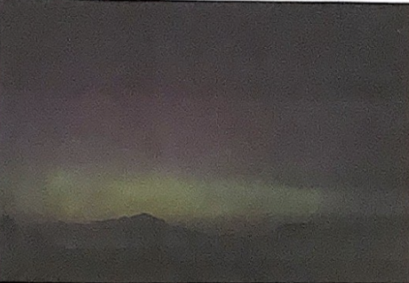
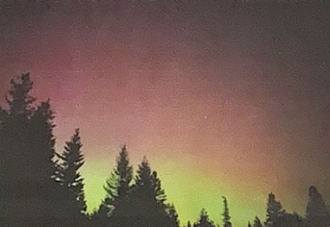 | 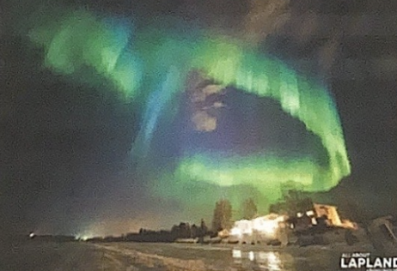

Answer keys
Heliophysics Quiz:
____________ 1. A type of aurora that is observed when an active curtain passes over an observer's zenith. corona
_____________2. Occurs when the auroral oval changes shape in a specific pattern. auroral sub storm
_____________3. Metals that are attracted to a magnet. iron, cobalt, nickel
_____________4. The Earth's magnetic poles vary in strength and move over time. true
_____________5. The most energetic solar storm occurred in September of 1859, it is an event known as the …Carrington event
_____________6. A rapid release of heat and light located close to the sun's surface is
called a …flare
_____________7. The strongest class of solar flare is given the letter, X
_____________8. The sun's magnetic field and the earth's magnetic field come in contact with each other at the magnetopause
_____________9. The letters CME stand for coronal mass ejection
_____________10. The sun's magnetic field is called _______when it is out near
the planets. interplanetary magnetic field
_____________11. protects us from harmful particles from the sun. magnetosphere

Electromagnets and the Earth's Magnetic Field
1. What is an electromagnet? when an electric current flows through a wire, it creates a magnetic field
2. Set up the electromagnet using the materials you are given.
3. How much weight can the electromagnet hold before it breaks? it varies
4. Describe how a compass needle reacts when it is brought near the electromagnet. it goes crazy, pointing to the north pole of the magnet which is produced
5. Explain how the magnetic field of the earth is generated now that you know how an
electromagnet works. Make a simple motor using the materials you have been given. the outer core of the earth is in motion (rotates). Anytime you have electrons in motion (electric current) it sets up a magnetic field.
6. How does the world's simplest motor work? when electricity is passed through a wire coil, you create a magnetic field. This magnetic field pushes the coil away from the magnet. When you give the coil a spin, since one side of the wire is insulated, you break the circuit briefly, so the coil continues to rotate using its momentum. When the circuit is complete again, the magnetic field once again repels the coil, so it keeps spinning.

Magnetism and the Magnetic Field around a bar magnet
Materials: White poster board, Bar magnet, Transparent compass
1. What types of materials interact with magnets? iron, nickel, cobalt
2. What happens when you bring a compass near a magnet?
3. Draw what you hypothesize the magnetic field will look like around the single bar magnet. Include arrows that point in the direction the compass points north.
4. Procedure
5. Draw how it looks from your measurements with the compass?
6. How does the magnetic field vary far from the magnet? Why do you think this occurs? The compass starts to pick up the earth’s magnetic field instead of the magnet’s field
Heliophysics Exam: You may use your notes and other classroom materials on this portion of the exam.
1. Explain the following statement: Our star, the Sun, is a dynamic object having effects on our planet beyond just providing light and heat. Students should mention something like the sun has an 11-year cycle of activity, they may talk about solar max and solar min.
2. Explain how the strength of the Earth's magnetic field has changed over the last 800,000 years. It has increased and decreased over time, but it has never reached zero.
3.. How does the “normal” solar wind vary from the “stormy" solar wind? the stormy solar wind is denser and moving at a faster velocity
4. List the sequence of events that would and could occur if an Earth directed CME left the sun at 10:30 central standard time. Write a scenario of what could occur if this CME had the strength of the Carrington Event of 1859, occurring today. (You should list eight events that could be triggered by this geomagnetic storm)
- The radiation (x rays and gamma rays) would reach the earth in 8 minutes traveling at the speed of light.
- The particles (protons and electrons, plasma) would reach the earth in around 1 to 2 days) which would cause aurora at the northern latitudes.
· Increase in solar wind speed
· Increase in solar wind density
· Distortion of magnetosphere
· Black outs, power surges
· Cell phones out, tv out
· Naviation, GPS out
· X,Y,Z vectors disrupted in the magnetogram
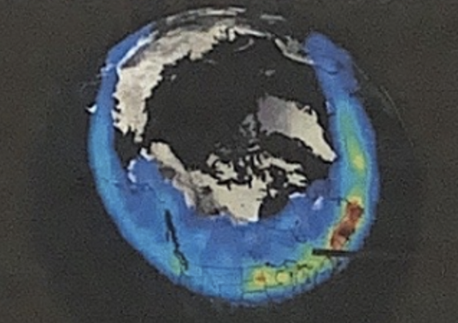
· Kp indices above 5
5. What is depicted in the picture to the right? Define. Auroral oval, an oval of auroral light that surrounds the north and south pole of earth
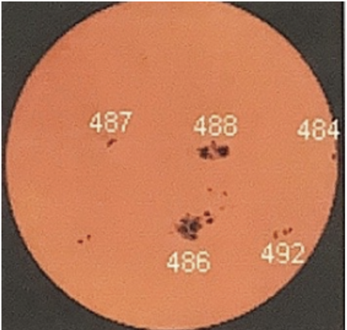
6. Answer the questions about the pictures below:

6a. What are the black dots on the sun? Sunspots

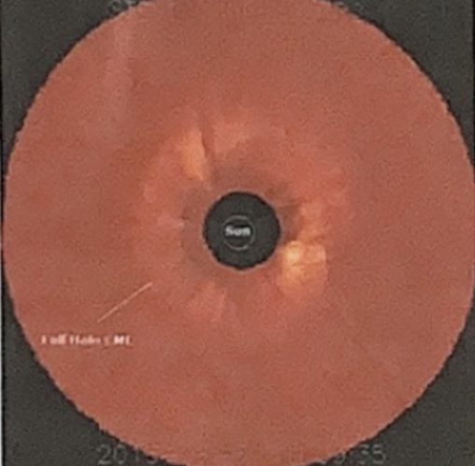
6b. What causes them to form? They are caused by kinks or loops of magnetic field extending through the lower atmosphere of the sun. These areas of concentrated magnetic field repel hot material trying to rise from the sun’s interior, so the section of the sun under the knot cools off and darkens.

7a. What event is occurring on the sun? A halo coronal mass ejection
7b. Why is its shape significant? It is significant because its shape tells me that it is earth directed.

8. Explain the significance of the data - IMF B total: 23.1 nT Bz: 20.3 nT south
The earth’s magnetic field points north at the magnetopause. If the Interplanetary magnetic field points south (Bz south) at the magnetopause, the two can cancel each other out. The earth is not protected from incoming plasma, and this can lead to an influx of plasma to the earth.

9. Explain the significance of the colors in the picture below
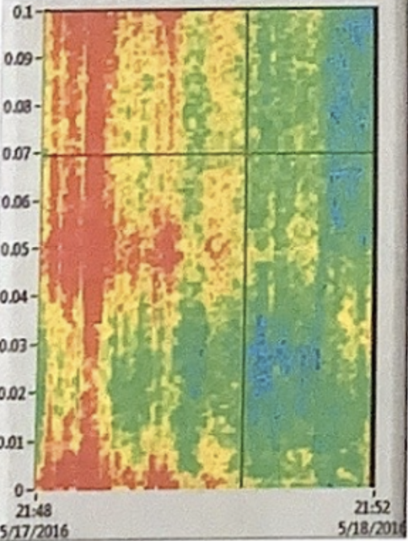

Red, yellow on the spectrograph means a disruption in the earth’s magnetic field.

10. Calculate the Kp using the following magnetometer signature below. Scale 1mm=4nt

Kp of 5

 | K index  0  1  2  3  4  5  6  7  8  9 | nT diff.  0-5  5-10  10-29  20-40  40-70  70-120  120-200  200-330  330-500  >500

11. Using the data on pp. 2,3,4 make a prediction as to the likelihood of seeing aurora in Shawano Wisconsin. Explain. You should address the 5 bits of data, and then make your prediction
· Aurora may occur due to the Kp of 5, the auroral oval located over Wisconsin, the halo CME directed at earth, the Bz south vector, and the many sunspots on the sun.
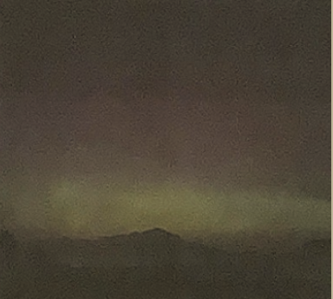
12. State the sub-storm phase and describe the features in the following auroral photographs.

Recovery phase, Diffuse glow
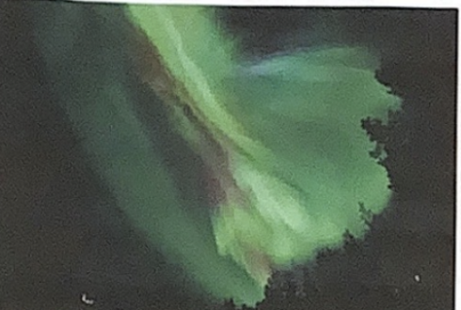
Expansion phase; corona
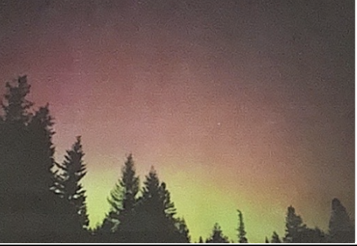
Recovery phase, diffuse glow
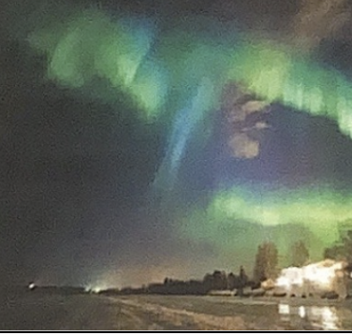
Expansion phase, curtains with rays

