Characteristics of the Sun: Sunspots, Solar Flares, and Plasma
By Raphael Lucas

Table of Contents
Lesson Overview and Objectives 2
Materials 4
5E Steps 5
Resources 8
Handouts 9

Lesson Overview
Level: Middle School Time: Three 50-minute class periods
Students will answer three (3) questions as part of a warm-up activity to help them focus on the ideas they will learn during the lesson. Students will then use NASA eclipse glasses to observe the Sun (providing conditions permit) and then return to the class to draw what they observed. They then will learn about the Structure and Composition of the Sun. Then students will use a large foam ball to make a labeled model to show the internal regions of the Sun, using the NASA diagram “Anatomy of the Sun/NASA” by Jenny Mottar. Students will work in groups of threes to make models of the Sun’s Anatomy.

Educator Background Knowledge
Anatomy of the Sun/NASA - This link goes to a NASA website showing the composition of the internal regions of the Sun.
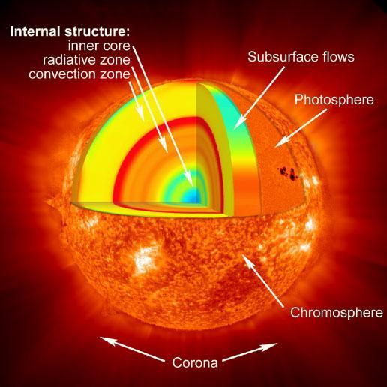
Note: Between the radiative and convective zone is the tachocline region that produces the magnetic fields. In this region, the gases going in contrary directions produce currents, which then produce magnetic fields.The dark red band in the diagram.
‌
Learning Goals
Students will grow their knowledge about the properties of the Sun.

Learning Objectives
- Students will construct a 3D Model that shows the characteristics of the Sun and describe the characteristics.
- Students will describe how plasma creates magnetic fields on the Sun.
- Students will predict how the Sun affects the Solar System.

Framework for Heliophysics Education
NASA Question: What causes the Sun to vary?
Big Ideas: The Sun is made of churning plasma, causing the surface to be made of complex, tangled magnetic fields.
Energy from the Sun is created in the core and travels outward through the Sun and into the heliosphere.

NGSS Performance Expectations
ESS1: Earth’s Place in the Universe: Develop and use a model of the Earth-Sun-Moon system to describe the cyclic patterns of lunar phases, eclipses of the Sun and Moon, and seasons.

Crosscutting Concepts
- Systems and System Models: Models can be used to represent systems and their interactions. (MS-ESS1-2)

Disciplinary Core Ideas
- ESS1B: Earth and the Solar System: The solar system consists of the Sun and a collection of objects, including planets, their moons, and asteroids that are held in orbit around the Sun by its gravitational pull on them (MS-ESS1-2), (MS-ESS1-3). This model of the solar system can explain eclipses of the Sun and the moon. Earth’s spin axis is fixed in direction over the short-term but tilted relative to its orbit around the Sun. The seasons are a result of that tilt and are caused by the differential intensity of Sunlight on different areas of Earth across the year.(MS-ESS1-1) The solar system appears to have formed from a disk of dust and gas, drawn together by gravity. (MS-ESS1-2).

Targeted STEM Skills
- Developing and Using Models: Modeling in 6–8 builds on K–5 experiences and progresses to developing, using, and revising models to describe, test, and predict more abstract phenomena and design systems.

Materials
NASA eclipse glasses; large foam balls; colored markers, box-cutter knives; orange, red, green, yellow and blue paint; labels for the model; materials to make Sun paper: paper, wax paper, shaving cream, cardboard, food.
Handouts
- I notice/I wonder (T Bar) Chart
- Blank Claim, Evidence, and Reason (C-E-R) Handout
- Claim, Evidence, and Reason (C-E-R) Activity Worksheet
- Anatomy of The Sun NASA Image
- Pre-post Assessment for a Heliophysics Unit that includes three lessons by Raphael Lucas: 1) Characteristics of the Sun; 2) EM (Electromagnetic) Spectrum; and 3) Space Weather.

Links to Digital Resources for Student
- The Sun: Size and Structure (2/2): https://www.youtube.com/watch?v=hwjJ23Ex8KY
- The Structure and Composition of the Sun: https://www.youtube.com/watch?v=sExr3RAXTYE
- What Is Plasma | Properties of Matter | Chemistry | FuseSchool: https://www.youtube.com/watch?v=94tReSbyPYc
- Make Sun Paper: https://spaceplace.nasa.gov/sun-paper/en/
- Student Helioviewer: https://student.helioviewer.org
- Anatomy of the Sun/NASA Diagram: https://www.nasa.gov/mission_pages/sunearth/science/solar-anatomy.html

Key Vocabulary
Plasma, ionized particles, corona, coronal streamers, convection zone, core, radiative zone, chromosphere, photosphere

Material Preparation
- Obtain the materials needed for the lesson including copies of the handouts for the students.

5E Steps
Engage
Warm-up Activity: Have students answer the following questions:
- What is the largest object in our solar system?
- How far away is the Sun from the Earth?
- How many Earths do you think it would take to fill the Sun?

Explore
- Before using NASA's eclipse glasses, have students draw a diagram to show what they “think” the Sun looks like.
- Have students use NASA eclipse glasses to observe the Sun and draw a diagram of what they observed.
- Have students briefly describe their before and after Sun diagrams. Ask them: How are they similar, and how are they different?
- Have students use the helioviewer link below to explore the relative size of the Earth and Sun. This can be done by using the slider at the bottom left of the screen and looking in the Earth Scale window above the slider. https://student.helioviewer.org
- Then have students observe each of the following Sun events using the drop down menu.
- Ask students to draw what they see (I notice) on the Sun using the T-Bar chart (see Handouts)and then write one question (I wonder) for each event.
Drop down views:
- Flares and Active Regions
- Eruptions and Coronal Mass Ejections (CMEs)
- Magnetic Fields
- Coronal Holes
- Sunspots

Explain
Students will use the videos below to learn about the properties of the Sun, its composition, and its atmosphere and answer follow up questions. Then students should make a claim of their own about The Structure and Composition of the Sun movie, provide evidence and an explanation (reasoning) to support or refute their claim. Students can use the blank Claim, Evidence and Reason Handout.
Student Video Analysis Activity

The Sun: Size and Structure: https://youtu.be/hwjJ23Ex8KY
- Hot gasses move by convection in the Sun. Name two Earth events that move by convection:
- The size of the Sun’s atmosphere is larger than the Sun itself. (True or False)
- The best time to see the Sun’s Atmosphere is during a __________.
- Write one question you have about the video.

The Structure and Composition of the Sun: https://www.youtube.com/watch?v=sExr3RAXTYE
- How many Earths can fit comfortably in the volume of the Sun?
- How does the composition of the Earth compare with that of the Sun?
- List two reasons why the presenter in the video described the Sun as the “bully” of the Solar System
- Write one question you have about the video.

What Is Plasma | Properties of Matter | Chemistry | FuseSchool: https://www.youtube.com/watch?v=94tReSbyPYc
- How is plasma formed?
- What makes plasma different from other gases?
- List four (4) examples of plasma in our everyday lives.
- Write one question you have about the video.

Extend
- Option 1: Students will use the diagram below and other materials (listed above) to make a 3-dimensional model of the Sun.
- Option 2: Select an activity here: https://spaceplace.nasa.gov/sun-paper/en/

Evaluate
Pre and Post Assessment for three lessons done as a Heliophysics Unit: Characteristics of the Sun; EM (Electromagnetic) Spectrum; and Space Weather by Raphael Lucas. See the end of the Handouts section.

Pair or Group Evaluation:
In addition to the pre and post assessment, students (working individually or with a partner or in a group of not more than three students) will identify/select a Heliophysics concept for which they will: (1) Conduct an investigation, (2) Design a product, or (3) Create a model.
Students' models should show the internal regions of the Sun. Labeled parts should describe their functions and behavior.

Students will complete a C-E-R reflection (see below) on their experience making the model and include descriptions of the regions of the Sun and explain why they think the Sun is important.

Link to detailed Anatomy of the Sun/NASA: This image in more detail is in the Handouts. https://www.nasa.gov/mission_pages/sunearth/science/solar-anatomy.html

Claim, Evidence, and Reason Reflection Activity (See Handouts)
- Claim: 109 Earths placed side by side fits across the Sun’s Diameter
- Evidence: Use the diameter of the Sun (1,390,000 Km) and the Earth (12,742 Km) to decide whether you agree or disagree with the CLAIM above.
- Reason: Use the evidence you obtained to explain your choice.

Resources
- I notice/I wonder (T Bar) Chart
- Student Video Analysis Worksheet
- Blank Claim, Evidence, and Reason (C-E-R) Handout
- Claim, Evidence, and Reason (C-E-R) Reflection Activity Worksheet
- The Sun: Size and Structure (2/2): https://www.youtube.com/watch?v=hwjJ23Ex8KY
- The Structure and Composition of the Sun: https://www.youtube.com/watch?v=sExr3RAXTYE
- What Is Plasma | Properties of Matter | Chemistry | FuseSchool: https://www.youtube.com/watch?v=94tReSbyPYc
- Make Sun Paper: https://spaceplace.nasa.gov/sun-paper/en/
- Student helioviewer: https://student.helioviewer.org
- Anatomy of the Sun/NASA: https://www.nasa.gov/mission_pages/sunearth/science/solar-anatomy.html
- Pre-post Assessment for a Heliophysics Unit that includes three lessons by Raphael Lucas: Characteristics of the Sun; EM (Electromagnetic) Spectrum; and Space Weather.

Handouts
These begin on the next page.

I NOTICE/I WONDER (T-Bar) Worksheet

Name:_____________________________________Date:__________

I noticed… | I wonder…

Name(s):______________________________________________________Date:_________

Student Video Analysis
Watch each video and answer the questions.

The Sun: Size and Structure:
- Hot gasses move by convection in the Sun. Name two Earth events that move by convection:
- The size of the Sun’s atmosphere is larger than the Sun itself. (True or False)
- The best time to see the Sun’s Atmosphere is during a __________________.
- Write one question you have about the video:

The Structure and Composition of the Sun:
- How many Earths can fit comfortably in the volume of the Sun?
- How does the composition of the Earth compare with that of the Sun?
- List one reason why the narrator described the Sun as the “bully” of the Solar System:
- Write one question you have about the video:

What Is Plasma | Properties of Matter | Chemistry | FuseSchool
- How is plasma formed?
- What makes plasma different from other gases?
- List four (4) examples of plasma in our everyday lives:

- Write one question you have about the video:
Student Video Analysis Answer Key

The Sun: Size and Structure:
- Hot gasses move by convection in the Sun. Name two Earth events that move by convection: Thunderstorms, the Water Cycle.
- The size of the Sun’s atmosphere is larger than the Sun itself. (True or False)
True.
- The best time to see the Sun’s Atmosphere is during an eclipse.
- Write one question you have about the video: Accept any reasonable question, not necessarily testable.

The Structure and Composition of the Sun:
- How many Earths can fit comfortably in the volume of the Sun? 1.3 million Earths fit in the volume of the Sun.

- How does the composition of the Earth compare with that of the Sun? The Sun is a ball of plasma or ionized gas, while the Earth is made up of solids, liquids and gases.
- List one reason why the narrator described the Sun as the “bully” of the Solar System: The Sun was described as the "bully" of the solar system because of its enormous size compared to all other objects in the solar system.

- Write one question you have about the video: Answers may vary.

What Is Plasma | Properties of Matter | Chemistry | FuseSchool
- How is plasma formed? Plasma is formed when a gas loses or gains an electron to become free ionized particles.
- What makes plasma different from other gases?
- List four (4) examples of plasma in our everyday lives:
- Write one question you have about the video:
Claim, Evidence, and Reasoning Student Worksheet

Name: _________________________________Date: ____________
Claim:  Sentence starters:  My claim is…  I think….  I noticed…. | Claim:
Evidence:  Sentence starters:  The data shows…  My evidence is…  My proof is… | Evidence:
Reasoning:  Sentence starters:  I know this is true because…  The reason this is…  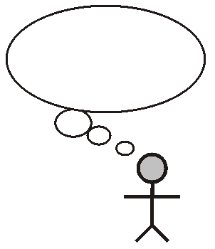  This happened because… | Reasoning:
Claim, Evidence, and Reasoning Student Activity
Name: _________________________________Date: ____________

Claim:  109 Earths placed side by side fit across the Sun’s Diameter. | Claim:
Evidence:  Use the diameter of the Sun (1,390,000 Km) and the Earth (12,742 Km) to decide whether you agree or disagree with the CLAIM above. | Evidence:
Reasoning:  Use the evidence you obtained to explain your choice. | Reasoning:
Claim, Evidence, and Reasoning Student Activity Answer Key
Name: _________________________________Date: ____________

Claim:  109 Earths placed side by side fit across the Sun’s Diameter. | Claim:
Evidence:  Use the diameter of the Sun (1,390,000 Km) and the Earth (12,742 Km) to decide whether you agree or disagree with the CLAIM above. | Evidence:  Here, the goal is for students to figure out the need to divide the two diameters.
Reasoning:  Use the evidence you obtained to explain your choice. | Reasoning:

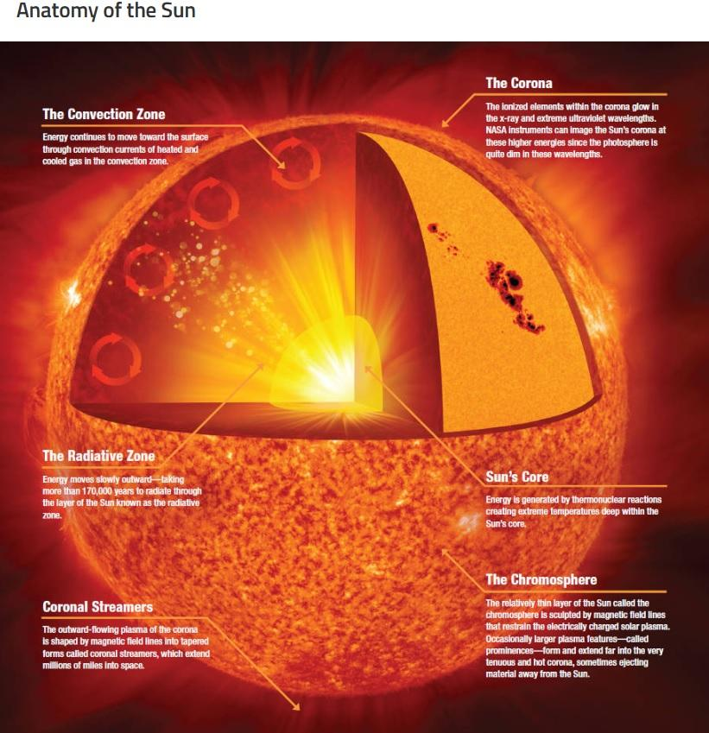
Credit NASA: https://www.nasa.gov/mission_pages/sunearth/science/solar-anatomy.html
Pre and Post Assessment for Heliophysics Unit:
Characteristics of the Sun, EM Spectrum and Space Weather Lessons
Total Points = 75

Name: ___________________________________________________Date: ____________

Answer all questions to the best of your ability:

- What is the largest body in our Solar System?_____________________(2 points)

- How far away is the Sun from the Earth?_____________________Km? (2 points)

- How many Earths do you think it would take to fill the volume of the Sun?
______________________________________________________________ (2 points)

- The size of the Sun’s atmosphere is larger than the Sun itself. (True or False)_________________________________________________________ (2 points)

- Why do you think the Sun is considered the bully of our solar system?

--------------------------------------------------------------------------------------------

—----------------------------------------------------------------------------- ( 2 points)

- How is plasma different from other gasses?

—------------------------------------------------------------------------------------------

—------------------------------------------------------------------------------- (3 points)

- Give four (4) examples of plasma in everyday life: (2 points)

(i) (iii)

(ii) (iv)
- The six (6) interior regions of the Sun are: (3 points)
(i) (ii)

(iii) (iv)

(v) (vi)

- How does light travel from the Sun to reach us on Earth? (2 points)

—-------------------------------------------------------------------------------

- List four (4) properties that are common to all EM waves. (4 points)

—-------------------------------------------------------------------------------

- Give one (1) example of how each of the following EM waves are used in everyday life. (12 points)

- Radio waves:___________________________________________________

- Microwaves:____________________________________________________

- Infrared radiation:_________________________________________________

- Ultraviolet radiation:______________________________________________

- X-rays:__________________________________________________________

- Gamma rays:_____________________________________________________

12. Match the Length of wavelength to the type of EM wave in the table below by drawing a line to connect the two. (6 points)

Type of EM wave | Length of wavelength
1.Infrared wave | - Football field
2. Gamma rays | - Bee
3. Radio waves | - Atom
4. Microwaves | - Bacteria/Virus
5. X-rays | - Cell
6. Visible light | - Nuclei

13. A transmitter on the surface of the Moon emits radio wave signals towards the Earth. The frequency of the wave is 12 MHz. (10 points)

Calculate:

(a) The wavelength of the signal:

(b) The distance between the Earth’s surface to the Moon’s surface if it takes 2.5 seconds for the signal to reach the Earth:

14. What are sunspots? (5 points)

__________________________________________________________________________

__________________________________________________________________________

__________________________________________________________________________

15. What are two (2) effects the “Carrington Event” had on daily life in September, 1859? (4 points)

(i) —----------------------------------------------------------------------------------

(ii) —---------------------------------------------------------------------------------

16. Why is the sky blue and why do sunsets and sunrises make the sky orange?
(4 points)

__________________________________________________________________________

__________________________________________________________________________

__________________________________________________________________________

17. What is the Solar Cycle? In your response explain the following terms: solar minimum, solar maximum, sunspots and aurora. (10 points)

__________________________________________________________________________

__________________________________________________________________________

__________________________________________________________________________

__________________________________________________________________________

__________________________________________________________________________

ANSWER KEY FOR UNIT TEST
- What is the largest body in our Solar System? The Sun. (2 points)

- How far away is the Sun from the Earth? 150,000,000 Kilometers (Km) (2 points)

- How many Earths do you think it would take to fill the volume of the Sun? (2 points) 1.3 million Earths.

- The size of the Sun’s atmosphere is larger than the Sun itself. (True or False) (2 points) TRUE.

- Why do you think the Sun is considered the bully of our solar system?( 2 points) The Sun is considered the bully of our solar system because of its massive size in comparison to all other bodies in our solar system.

- How is plasma different from other gases? (3 points)
Plasma is made up of particles that have either gained or lost an electron and are therefore free charged particles.

- Give four (4) examples of plasma in everyday life: (2 points)

(i) lightening (iii) fluorescent light

(ii) stars (iv) welding arcs

- The six (6) interior regions of the Sun are: (3 points)
(i) Corona (ii) Convection zone
(iii) Radiative zone (iv) Chromosphere
(v) Photosphere (vi) Sun’s core

- How does light travel from the Sun to reach us on Earth? (2 points)
By radiation.
- List four (4) properties that are common to all EM waves. (4 points)
- EM waves are transverse
- EM waves do not need a medium to travel through
- EM waves exhibit wave properties
- EM waves transfer energy from point to point

- Give one (1) example of how each of the following EM waves are used in everyday life. (12 points)

Radio waves: Communication

Microwaves: Communication, Heating food

Infrared radiation: Airport scanners

Ultraviolet radiation: Security features and sterilization

X-rays: Diagnostic tool in fields of medicine and engineering

Gamma rays: To treat cancer

12. Match the Length of wavelength to the type of EM wave in the table below by drawing a line to connect the two. (6 points)

Type of EM wave | Length of wavelength
1.Infrared wave E | A. Football field 3
2. Gamma rays F | B. Bee 4
3. Radio waves A | C. Atom 5
4. Microwaves B | D. Bacteria/Virus 6
5. X-rays C | E. Cell 1
6. Visible light D | F. Nuclei 2

13. A transmitter on the surface of the Moon emits radio wave signals towards the Earth. The frequency of the wave is 12 MHz. (10 points)

Calculate:

(a) The wavelength of the signal:

(b) The distance between the Earth’s surface to the Moon’s surface if it takes 2.5 seconds for the signal to reach the Earth:

Solutions: (a) wavelength = (3x10⁸ m)/(12x10⁶ Hz) = 25m

(b) Distance = speed x time = 7.5 x 10⁸ m

14. What are sunspots? (5 points)
Sunspots are planet-size regions of strong magnetic fields on the surface of the sun. These regions of the Sun appear darker because they are cooler than their surroundings

15. What are two (2) effects the “Carrington Event” had on daily life in September, 1859? (4 points)
- The Aurora was seen around the world
- The Aurora Borealis was seen as far south as the Caribbean
- Telegraph system around the world failed

16. Why is the sky blue and why do sunsets and sunrises make the sky orange?
(4 points) The sky appears blue because only the short wavelengths of light get scattered or reflected during the day by the presence of nitrogen in the atmosphere, while only the long wavelength light is reflected late in the day.

17. What is the Solar Cycle? In your response explain the following terms: solar minimum, solar maximum, sunspots and aurora. (10 points)
- The solar cycle is the cycle that the Sun’s magnetic field goes through approximately every 11 years.
- Every 11 years or so, the Sun’s magnetic field completely flips. This means that the Sun’s north and south poles switch places. Then it takes another 11 years for the Sun’s north and south poles to flip back.
- The solar cycle affects activity on the surface of the Sun, such as sunspots which are caused by the Sun’s magnetic fields. As the magnetic fields change, so does the amount of activity on the Sun’s surface.
- The beginning of a solar cycle is a solar minimum, or when the Sun has the least sunspots. The middle of the solar cycle is the solar maximum, or when the Sun has the most sunspots.
- Giant eruptions on the Sun, such as solar flares can cause lights in the sky, called aurora.

