The Electromagnetic (EM) Spectrum
By Raphael Lucas
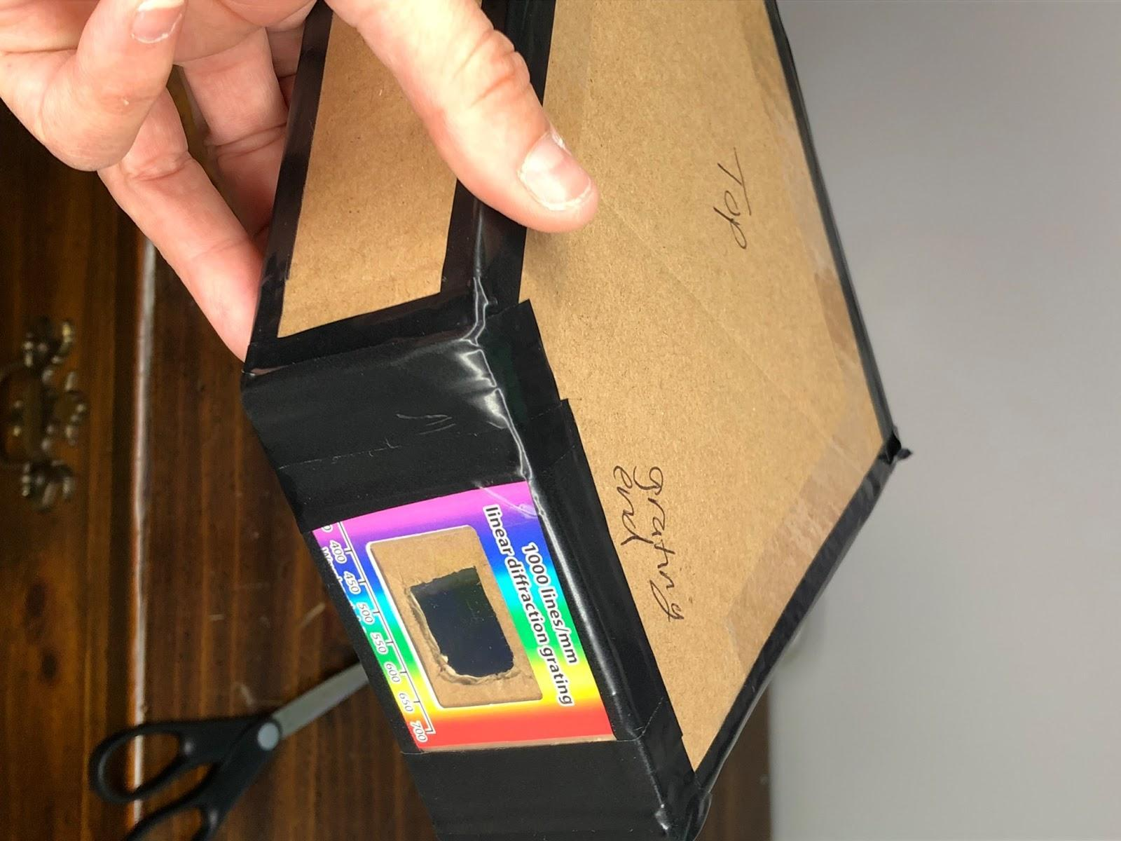
Table of Contents
Lesson Overview and Objectives 2
Materials 5
5E Steps 6
Resources 8
Handouts 8

Level: Middle School Time: 3 50-minute class periods

Lesson Overview
Students watch a short time lapse video of a sunrise and complete a T-chart (I Notice/I Wonder), and the question, “How does light from the Sun and other stars travel through space to reach the Earth?”

Students watch a second video entitled, “What are Electromagnetic (EM) wave properties?” They explain properties of EM waves and learn about the mathematical equation to describe the relationship between wave properties and energy.

Students then construct a spectroscope, which they use to analyze light. They also use the EM wave equation (v = f X lambda). They will observe UV beads that glow in the dark and then make bracelets with those beads.

Educator Background Knowledge
- The spectrum of colors is known as the visible light because it is visible to the human eye. The human eye can only see visible light. Visible light consists of violet, indigo, blue, green, yellow, orange and red.
- The visible spectrum is only a small part of a large family of waves called electromagnetic (EM) spectrum. This family also includes radio waves, microwaves, infrared (IR) radiation, ultraviolet (UV) radiation, X-rays, and gamma. These waves vary in their wavelengths. Radio Waves have the longest wavelength (the length of football fields) and gamma rays, the shortest, (smaller than the size of an atom).
- Regarding the guiding question: “How does light from the Sun and other stars travel through space to reach the Earth?” This was one of the hardest questions for scientists. It took scientists more than a century to answer it because they had an incorrect assumption that space was not a vacuum, but filled with a substance called ether. The ether was assumed to be weightless, transparent, frictionless, undetectable chemically or physically, and literally permeating all matter and space. The theory met with increasing difficulties as the nature of light and the structure of matter became better understood. (Source: Encyclopedia Britannica).
‌
Learning Goals
Students will learn about the extensive use of EM waves in communication. They will become familiar with and learn to use the mathematical equation that relates wave properties and energy. Students will recognize that the visible spectrum is only a small part of a large family of waves called the electromagnetic spectrum.

Learning Objectives
- Students should be able to recall the properties of EM waves.
- Students can differentiate between the different types of EM waves in terms of their wavelengths.
- Students can identify a source and use each type of EM waves.

Framework for Heliophysics Education
NASA Question: How do the Earth, the solar system, and heliosphere respond to changes on the Sun? Big Idea: The Sun is the primary source of light in our solar system.

NGSS Performance Expectations
MS-PS4-1: Waves and Their Applications in Technologies for Information Transfer: Use mathematical representations to describe a simple model for waves that includes how the amplitude of a wave is related to the energy in a wave.

Disciplinary Core Ideas
- PS4.A: Wave Properties: A simple wave has a repeating pattern with a specific wavelength, frequency, and amplitude. (MS-PS4-1).

Crosscutting Concepts
- Energy and Matter: Energy may take different forms (e.g. energy in fields, thermal energy, energy of motion) (MS-PS3- 5). The transfer of energy can be tracked as energy flows through a designed or natural system (MS-PS3-3).

Common Core Standards for Mathematical Practice
- Solving Real World Problems (Expressions and Equations)

Targeted STEM Skills
- Developing and Using Models: Modeling in 6–8 builds on K–5 experiences and progresses to developing, using, and revising models to describe, test, and predict more abstract phenomena and design systems. Develop and use a model to describe phenomena. (MS-ESS1-1), (MS-ESS1-2)
- Analyzing and Interpreting Data: Analyzing data in 6–8 builds on K–5 experiences and progresses to extending quantitative analysis to investigations, distinguishing between correlation and causation, and basic statistical techniques of data and error analysis. Analyze and interpret data to determine similarities and differences in findings. (MS-ESS1-3)
- Using Mathematical and Computational Thinking: Mathematical and computational thinking at the 6–8 level builds on K–5 and progresses to identifying patterns in large data sets and using mathematical concepts to support explanations and arguments. Use mathematical representations to describe and/or support scientific conclusions and design solutions. (MS-PS4-1)

Materials
UV beads, string, scissors, box-cutter, cardboard, toilet paper rolls, diffraction grating (one per student pair), black construction paper, electrical tape, scotch tape, ruler, pencil, colored pencils. (Note: Diffraction grating slides can be found in sets of 10 or 25 for less than $12 on Amazon.)

Handouts
- KWL Chart
- T-Bar Chart (I noticed/I wonder)
- Pizza Box Spectroscope
- Rainbow Science Project – Make a Spectroscope
- Visible Light Science Lesson Reading
- Pre-post Assessment for a Heliophysics Unit that includes three lessons by Raphael Lucas: 1) Characteristics of the Sun; 2) EM (Electromagnetic) Spectrum; and 3) Space Weather. See lesson: Characteristics of the Sun.

Links to Digital Resources for Students
- Free Sunrise Timelapse Video | Royalty Free 4K Stock Video Footage: https://youtu.be/1oGDGaVEJkA
- What Are Electromagnetic Wave Properties? | Physics in Motion: https://youtu.be/ftyxZBxBexI
- Construction Video (Spectroscope): https://drive.google.com/file/d/1s0p2FzicmPxVIisyVsagl4qaqpQOOJf1/view?usp=sharing
- Make a Spectroscope Science Project: https://learning-center.homesciencetools.com/article/how-to-make-a-spectroscope-science-project
- Introduction to the Science of Light:
https://learning-center.homesciencetools.com/article/light-science-lesson/

Key Vocabulary
Wavelength, frequency, prism, diffraction, transverse wave, electromagnetic spectrum, vacuum, radio waves, microwaves, Infrared Radiation (IR), Ultraviolet Radiation (UV), X-ray, Gamma rays, Plasma, Trough, Crest, amplitude.

Material Preparation
Collect toilet roll tubes or ask students to bring these in from home. Provide one diffraction grating per student pair.

5E Steps
Engage
Students will use a T-Chart (I Notice/I Wonder) to gather students understanding of what they see in this video of a sunrise: Free Sunrise Timelapse Video | Royalty Free 4K Stock Video Footage.

Guiding Questions
- Complete a T-Chart (I Notice/I Wonder) about what you saw in the video listing things you observed, and what questions you still have.
- How does light from the Sun and other stars travel through Space to reach us here on Earth?

Explore
Have students watch this video then use what they learn to answer the questions in the next Explain section.
- What Are Electromagnetic Wave Properties? | Physics in Motion: https://youtu.be/ftyxZBxBexI

Explain
Have students answer the questions on the student worksheet in the Handouts.

1. Which of the following statements are true?
- EM waves have the same speed in a vacuum
- EM waves have the same frequency in vacuum.
- EM waves travel slowest in vacuum.
- EM waves cannot travel in vacuum.

2. Answer each question below:
(a) State four properties that are common to all electromagnetic waves.
(b) State three types of EM waves that can be used in communications.
(c) Name the type of EM wave that can be used to see people/objects in the dark.
(d) State the type of EM wave that can be used to treat cancer.

3. A transmitter on the surface of the Moon emits radio signals towards the Earth. The frequency of the wave is 12 MHz. Calculate:
(a) The wavelength of the signal.
(b) The distance between the Earth’s surface to the Moon’s surface if it takes 2.5 seconds for the signal to reach Earth.

Extend
Students construct the spectroscope and use it to analyze from various sources, including the Sun and a light bulb.
- Pizza Box Spectroscope – See Handouts
- Rainbow Science Project – Make a Spectroscope – See Handouts

Students investigate the following question: Why is the sky blue? by reading the Visible Light Science Lesson handout.

Evaluate
- Students successfully complete the construction of a spectroscope and the “Investigation” and answer the “Explain” questions correctly.
- Students complete a KWL Chart/Reflection of What I learned about the EM Spectrum.

Resources
- KWL Chart: For teachers if used as a group activity in Engage, and can be used by students for reflection in Evaluate.
- T-Bar Chart (I noticed/I wonder) - For student use.
- Pizza Box Spectroscope
- Rainbow Science Project – Make a Spectroscope and Visible Light Reading
- Free Sunrise Timelapse Video | Royalty Free 4K Stock Video Footage: https://youtu.be/1oGDGaVEJkA
- What Are Electromagnetic Wave Properties? | Physics in Motion: https://youtu.be/ftyxZBxBexI
- Construction Video (Spectroscope): https://drive.google.com/file/d/1s0p2FzicmPxVIisyVsagl4qaqpQOOJf1/view?usp=sharing (Made by Raphael Lucas)
- Make a Spectroscope Science Project: https://learning-center.homesciencetools.com/article/how-to-make-a-spectroscope-science-project
- Introduction to the Science of Light:
https://learning-center.homesciencetools.com/article/light-science-lesson/
- Pre-post Assessment for a Heliophysics Unit that includes three lessons by Raphael Lucas: Characteristics of the Sun; EM (Electromagnetic) Spectrum; and Space Weather: See the lesson Characteristics of the Sun.

Handouts
These begin on the next page.
K-W-L Chart

TOPIC:__________________________________

What I Know | What I Want to Know | What I Learned
I NOTICE / I WONDER Worksheet (T-Bar Chart)

Name:_____________________________________Date:__________

I noticed… | I wonder…

EM Spectrum (EXPLAIN) Student Worksheet
Raphael Lucas (Science Educator, New Century School)

Name:_________________________________Date: ________ Class:_____________

Use the following link to watch the video “What are Electromagnetic (EM) Wave Properties? Then answer the questions below.
https://youtu.be/ftyxZBxBexI

1. Which of the following statements are true? (2 points)
- EM waves have the same speed in a vacuum.
- EM waves have the same frequency in a vacuum.
- EM waves travel slowest in a vacuum.
- EM waves cannot travel in a vacuum.

2. (a) State four properties that are common to all electromagnetic
waves. (2 points)

- _______________________________________________________

- _______________________________________________________

- _______________________________________________________

- _______________________________________________________

(b) Name three types of EM waves that can be used in communications.
(2 points)

______________________________________________________________________________

______________________________________________________________________________

______________________________________________________________________________
(c) Name the type of EM wave that can be used to see people/objects in the dark. (1 point)

______________________________________________________________________________

(d) Name the type of EM wave that can be used to treat cancer. (1 point)

______________________________________________________________________________

3. A transmitter on the surface of the Moon emits radio signals towards the
Earth. The frequency of the wave is 12MHz.

Calculate:
(a) the wavelength of the signal. (5 points)

(b) the distance between the Earth’s surface to the Moon’s surface, if it takes 2.5 seconds for the signal to reach Earth. (5 points)

EM Spectrum (EXPLAIN) Student Worksheet: Answer Key
1. Which of the following statements are true? (2 points)
- EM waves have the same speed in a vacuum (True)
- EM waves have the same frequency in a vacuum (True)
(c) EM waves travel slowest in a vacuum (False)
(d) EM waves cannot travel in a vacuum (False)

2a. State four properties that are common to all electromagnetic waves: (2 points)
- EM waves are transverse waves
- EM waves do not need a medium to propagate or travel
- EM waves transfer energy from point to point
- EM waves exhibit wave properties
2b. Name three types of EM waves that can be used in communications: (2 points)
- Radio waves; 2. Radar; 3. Microwaves (satellite communication)
2c. Name the type of EM wave that can be used to see people/objects in the dark. (1 point)
Infrared (IR) radiation
2d. Name the type of EM wave that can be used to treat cancer. (1point)
Gamma rays
3. A transmitter on the surface of the Moon emits radio signals towards the Earth. The frequency of the wave is 12MHz. Calculate:
(a) the wavelength of the signal. (5 points)
Solution: (a) wavelength = (3x10⁸ ms⁻¹ ) / (12x10⁶ Hz) = 25m
(b) the distance between the Earth’s surface to the Moon’s surface, if it takes 2.5 seconds for the signal to reach Earth. (5 points)
Solution: Distance = speed x time = 7.5x10⁸ m

Pizza Box Spectroscope
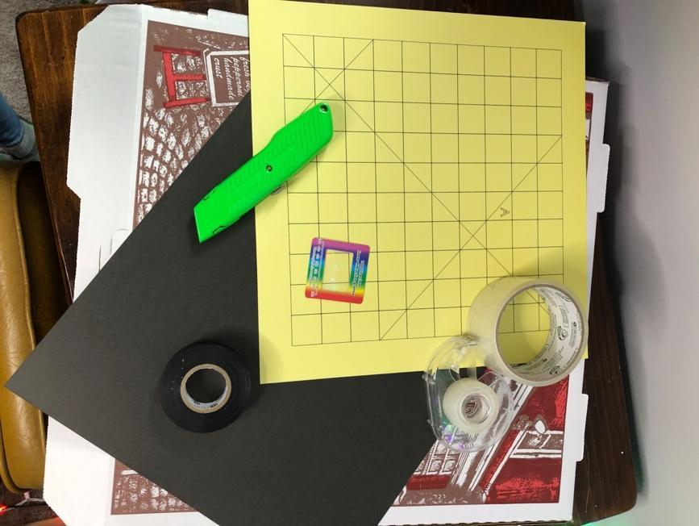
Materials:
- 12”x12” piece of corrugated cardboard (a medium or large pizza box works well)
- 2 x 2-inch diffraction grating (1000 line/mm)
- Black construction paper
- Scissors or box-cutter
- Ruler
- Packing tape
- Scotch tape
- Black electrical tape
Cutting Template for Spectroscope:
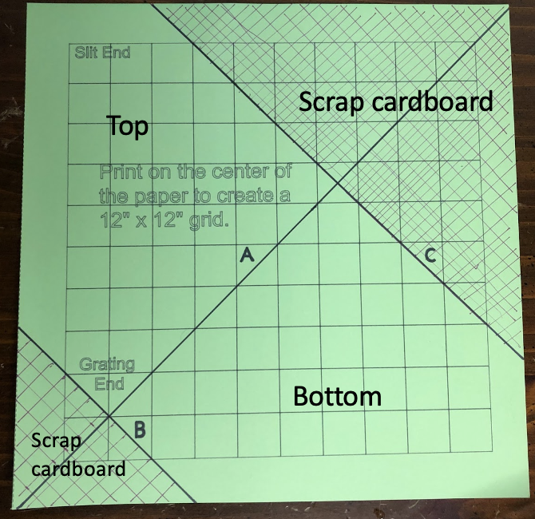
Watch the construction video by author Raphael Lucas: https://drive.google.com/file/d/1s0p2FzicmPxVIisyVsagl4qaqpQOOJf1/view?usp=sharing
Spectroscope Body Construction
- On a 12” x12” piece of corrugated cardboard (a medium or large pizza box works well) draw a 12”x12” grid, with 1”x1” grids. Draw diagonal lines A, B, and C, as indicated in the figure below. Or use the provided Cricut Printing File to quickly print a template; tape the template to the box.
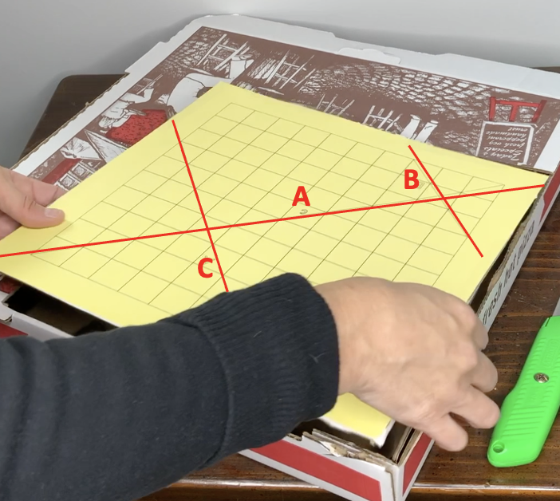
Note: If you use the Cricut Printing template, the machine will not draw the lines to the edge of the 12” x 12” paper. Imagine that the grid lines, and lines A, B, and C, go all the way to the edge of the paper. Draw the missing line fragments in, if it helps you.
2. Cut along line A to form 2 large triangles.
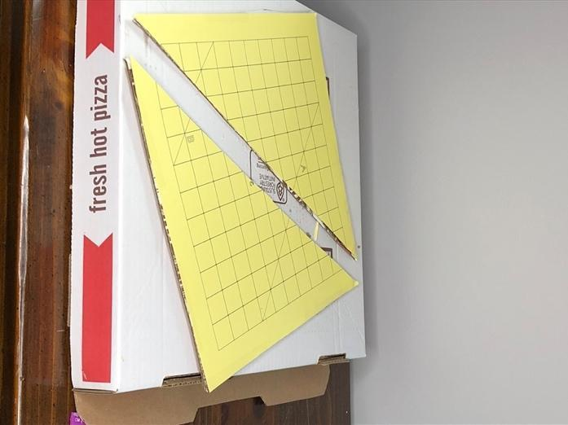
3. On each triangle, cut along lines B and C. These pieces form the top and bottom of the body of the spectroscope.
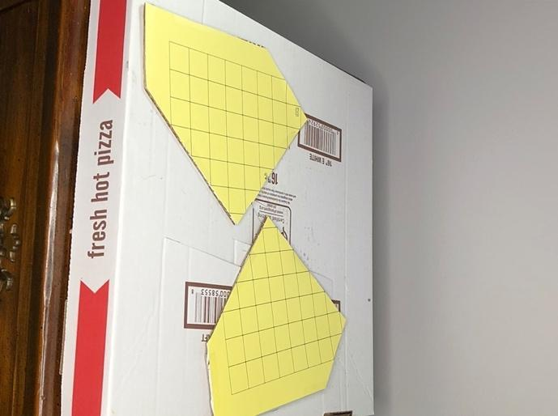
4. Cut three rectangles out of the remaining cardboard with the following dimensions. These are the sides of the spectroscope.
  - 2” x 7.75” (x2)
  - 2” x 9.5”

5. Trace the shape of the spectroscope body on black construction paper; cut out two pieces of black construction paper to line the inside of the spectroscope.

6. Tape the black construction paper to the top and bottom pieces of the spectroscope, on the sides that will be the inside of the spectroscope.

7. Cut rectangles out of the construction paper of the same dimensions as in step 4.

8. Tape the black construction paper to the side pieces of the spectroscope (the rectangles).

9. Attach the three rectangle pieces to the “bottom” of the spectroscope using packing tape.
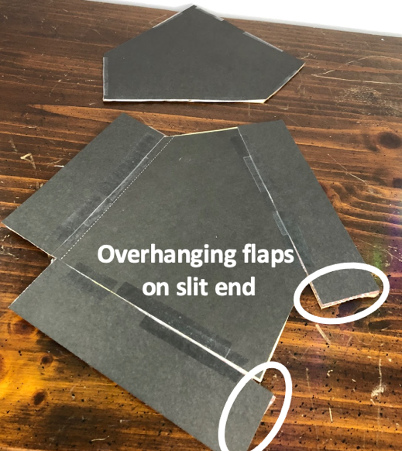

Note: One of the 2” x 7.75” sides and the 2” x 9.5” side will overhang on the slit end. These overhanging pieces will be used to create the slit
10. Add some black electrical tape along the inside seams.

11. Fold up the sides and attach the top piece with packing tape, forming a box.

12. Add some additional tape along the outside, to prevent any light from seeping through.
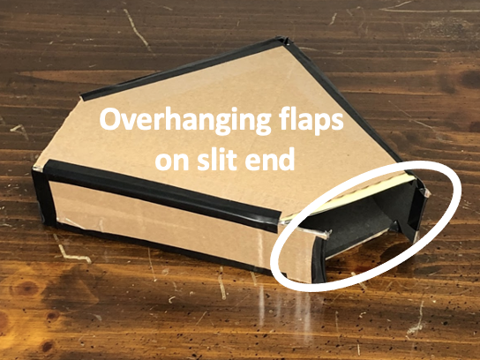
Slit End Construction:
- Bring the two extra flaps of cardboard together to make the slit.
- The slit should be no wider than the edge of a coin.
- Adjust the slit size by trimming the cardboard as necessary, and then tape it down, again covering the seams with black electrical tape.
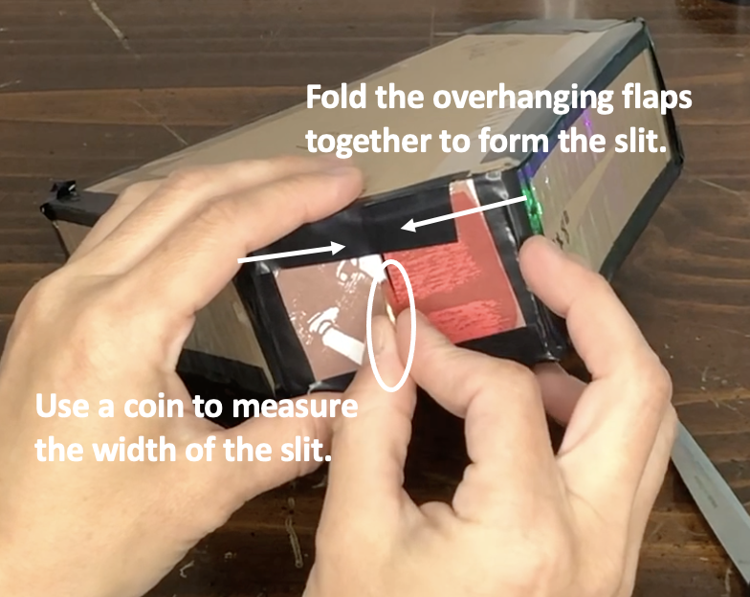
Grating End Construction:
- Draw a line from the slit to the grating end, parallel to the edge of the spectroscope.
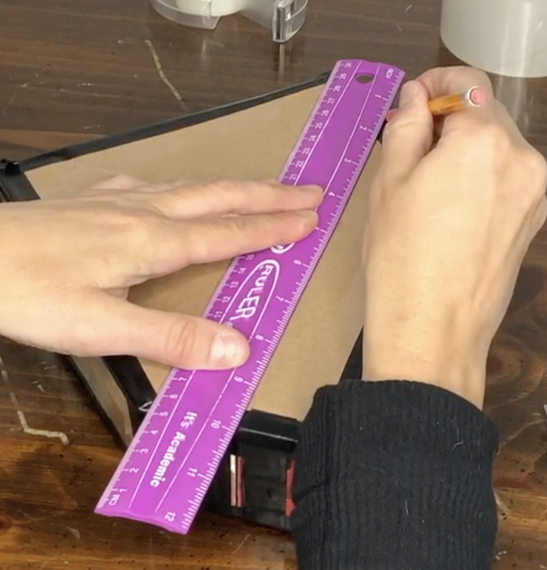
- Cut one 2” x 2” rectangle out of the
remaining cardboard.
- Cut a 1” x 1” hole out of the center.
- Tape the grating down to the hole (orient the diffraction grating with the rainbow going left to right).
- Line up the center of the grating with the line you drew from the slit.
- Attach the grating end to the spectroscope body, sealing the seams with black electrical tape.
Using the Spectroscope:
- Point the slit end of the box at any lightsource and look through the grating end. To the right of the slit you will see a rainbow spectrum. Never look directly at the Sun with the spectroscope.
- Try observing different types of light sources around the house and observe how the spectra change.
- If you carefully place your smartphone camera lens against the grating window you can adjust your camera to take a picture of the spectrum.
Examples of spectra from three common light sources:

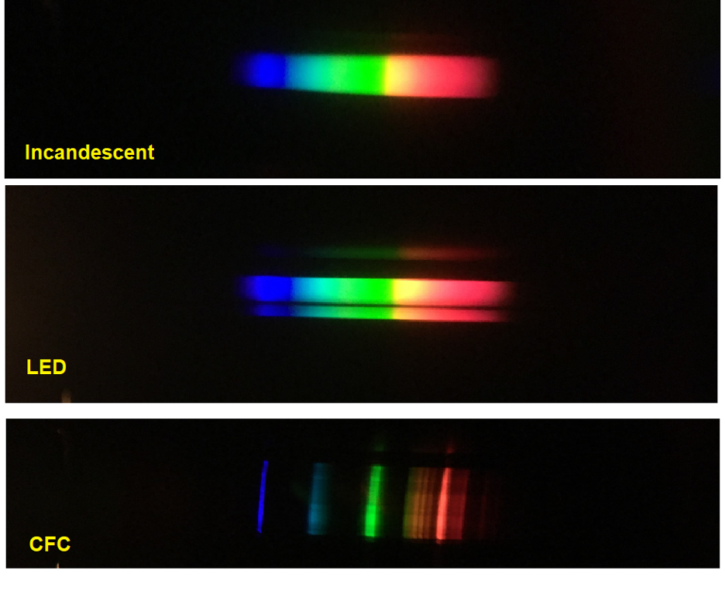

Rainbow Science Project: Make a Spectroscope
https://learning-center.homesciencetools.com/article/how-to-make-a-spectroscope-science-project

What You Need
- Cardboard tube from a toilet-paper roll
- Black construction paper
- Tape
- Scissors
- Diffraction grating

What You Do
1. Line the inside of the cardboard tube with black construction paper.

2. Cut two circles out of the construction paper. Make them slightly bigger than the cardboard tube. In the middle of one of the circles, cut a square with sides about 1.5cm long. Tape the diffraction grating over the square hole, and then tape the circle over one end of the cardboard tube with the diffraction grating on the inside.

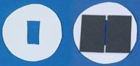

3. The center of the other circle needs to have a very narrow slit for light to enter through. Since cutting this can be difficult, just make a rectangular hole about 2.5cm long. Then tape two rectangles of black paper over the hole, leaving a narrow slit between them. It’s a good idea to cut your rectangles from the edge of the paper so you are sure to have straight edges to use for the sides of the slit. (The right-hand photo shows this step using a white circle so you can easily see how to line up the rectangles.)

4. Hold the slotted circle over the other end of the cardboard tube and look through the grating end at a light source. You should see a color spectrum on the inner side of the tube. (There might be one on either side of the slit.) It may be very narrow; turn the slotted circle until the spectrum widens out, and then tape the circle in place.
You now have a working spectroscope! Use it to look at several different types of light: a normal incandescent light bulb, fluorescent light, LED light, a glow stick, even sunlight. (But be very careful – do NOT look directly at the Sun through your spectroscope!) You can also look at the flame of a match or candle, if you have someone else hold it for you.

Do you see a difference in each light’s spectra? Incandescent light bulbs and sunlight will produce a continuous spectrum, where all the colors merge smoothly into each other. (Stars actually emit a dark-line spectrum, which has the colors broken up by dark lines. Only very precise spectroscopes can see the dark lines, however, so the Sun looks like a continuous spectrum.) A fluorescent light will produce a bright-line spectrum, which has bright lines separated by dark spaces. Try drawing each spectrum with colored pencils and comparing them. You can also try varying the width of the slit – does that change the appearance of the spectrum?

What Happened:
Each of the colors that light is made of has its own wavelength, which reflects and refracts at its own angle, different from all the other colors. When light hits the diffraction grating, it is reflected back onto the wall of the spectroscope. All the little grooves on the grating separate the colors so they reflect at their different angles. The beam of light hits the diffraction grating at one angle, but since each color bends back at a different angle, they are spread out along the spectroscope wall, allowing you to see them. Keep reading to find out more about the visible spectrum of light, and get answers to some classic science questions!

Introduction to the Science of Light:
https://learning-center.homesciencetools.com/article/light-science-lesson/

Visible Light Science Lesson
https://learning-center.homesciencetools.com/article/how-to-make-a-spectroscope-science-project

Why is the sky blue?
One of the most beautiful things about our world is a blue sky on a clear, sunny day. If you’ve seen pictures of the Apollo astronauts on the Moon, you might have noticed that the sky above them was black as night even in bright sunshine. What makes the difference? Why is Earth’s sky blue?

Unlike the Moon, the Earth is surrounded by an atmosphere. The atmosphere is a mixture of gasses, mostly nitrogen and oxygen. The way the Sun’s light travels through the atmosphere makes the sky colored.
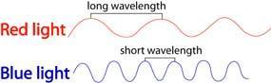
Why blue? It doesn’t look like it, but light is made up of several different colors, like you see in a rainbow. Each of these colors travels in a wave, but the wavelength (distance between the tops of each wave) varies. Red light has a long wavelength, while blue light has a much shorter wavelength. When light from the Sun enters our atmosphere, the waves collide with gas molecules. The longer wavelengths, like red and yellow, pass straight through and appear to us as “regular” sunlight. Shorter wavelengths, like blue, bump into the gas molecules and scatter in different directions. Some of it still makes it through directly, but the rest is reflected back to our eyes from all directions, so the whole sky looks blue.

You can see similar light scattering by mixing half a teaspoon of milk with a large (quart-size) jar of water. In a darkened room, shine a flashlight through the jar and look at the water. It should have a bluish tint, because the milk particles are scattering the blue light from the flashlight just like the gas molecules in our atmosphere do.
Maybe you’re asking a follow-up question: why are sunsets pink and orange? When the Sun is low in the sky, near the horizon, its light has to travel through a lot more atmosphere to reach us. The blue light is scattered so much in the extra atmosphere that none of it reaches our eyes from that direction, leaving us to see the beautiful reds and oranges there instead. Sometimes clouds or air pollution can make a sunset even more red because the particles in the cloud help scatter away the shorter wavelengths.
Add a little more milk to your jar – do the extra milk particles allow you to see an orange tint? Try looking in the side of the jar directly opposite where the flashlight is. This is like looking at the Sun on the horizon.

Why do stars twinkle?
If we lived on the Moon, we probably wouldn’t know the song, “Twinkle, Twinkle, Little Star.” Just like blue sky, a star’s twinkle is a result of Earth’s atmosphere. Stars don’t twinkle in space! As the light from a star enters the atmosphere, it hits gas molecules and scatters. Since the star is so far away, we only see a tiny beam of light from it. This beam gets scattered away from our eyes and then back into them almost like it is blinking on and off. It happens so fast that it just looks like it is twinkling. (Planets are closer to us and send more light; if some of the light beams are scattered away, others still get through to us, so planets don’t usually twinkle.)

Stars twinkle more when they are close to the horizon, because the light has to travel through more atmosphere before it reaches our eyes. Weather can affect how much stars twinkle, too. Cold air scatters more light than warm air, because molecules are closer together in cold air, making it harder for light to pass through without interference. (Think about how it’s harder to walk in a straight line through a crowd of people than through an empty room!)

The temperature variation in the atmosphere affects what astronomers call “seeing.” If there is a lot of variation, even a perfectly clear night will be bad for stargazing with a telescope. You might be able to see a twinkling star clearly with your naked eye, but an astronomer will say it’s “bad seeing” because it’s hard to study a star that just won’t stop flickering! Next time you’re outside on a clear winter night, look for twinkling stars near the horizon. If you have a telescope, you may even see the stars changing colors because their wavelengths are scattering in different directions.

