Experience a Solar Eclipse
By Marvin Nationales

Table of Contents
Lesson Overview and Objectives 2
Materials 4
5E Steps 5
Resources 13
Handouts 13

Lesson Overview
Level: High School Time: Two 55-minute class periods
In this lesson, students explore the experience of a total solar eclipse and learn about the mechanics of eclipses. Photographs and videos from the August 21, 2017, total solar eclipse can give students a sense of the event. Students also work through an interactive lesson to investigate the orbits and relative positions of the Moon, the Sun, and Earth to understand what causes eclipses and why they are rare.

Educator Background Knowledge
Note that there are sample answers available for teacher reference for two activities in the interactive lesson: Answer Key – The Tilt of the Moon’s Orbit and Infograph and Sample Answers – Modeling the Earth–Sun–Moon System.

Cue up the Emotional Reactions to a Total Solar Eclipse video (https://www.youtube.com/watch?v=66o0wyvZUUI).

Be sure that students already know that the Moon does not give off its own light and that it is visible because it reflects sunlight.

In addition, students should understand why there are Moon phases. If your students do not have this prerequisite knowledge, review how the relative positions of the Moon, the Sun, and Earth result in Moon phases before beginning the lesson.

It may be helpful to demonstrate the Earth–Sun–Moon system with a physical model, using a lamp and balls. Language supports (vocabulary visuals and sentence frames) are available for this lesson.

Learning Goals
Students will explore what it is like to observe a total solar eclipse and learn about what causes eclipses. The lesson features media resources from NASA, including videos, photographs, and multiple models of the Earth–Sun–Moon system.

Learning Objectives
- Students can explain the causes of solar eclipse.
- Students can use two-eyed seeing to understand the nature of solar and lunar eclipse.
- Students can model how the relative sizes, distances, and positions of the Moon, the Sun, and Earth relate to eclipses.
- Students can write an essay to compare and contrast solar eclipses and lunar eclipse using a Venn Diagram.
- Students can use media resources from NASA, including videos, photographs, and multiple models of the Earth–Sun–Moon system.
- Students can interview a community member to trace the causes of solar eclipse from a cultural perspective and create a multimedia presentation.
- Students can compare and contrast the scientific and culture-based explanations behind solar and lunar eclipse.

Framework for Heliophysics Education
NASA Question: What are the impacts of the Sun on humanity? Big Idea: The Sun is really big and its gravity influences all objects in the solar system.

NGSS Performance Expectations
At the High School level students conduct investigations into the strength of electrical forces between particles (HS-PS3-1) and into the relationship of electrical and magnetic fields (HS-PS2-5). HS-ESS1-1 directly addresses the layers of the Sun, fusion, 11-year solar cycle, sunspots, and solar flares.

HS-PS3-1: Energy: Create a computational model to calculate the change in the energy of one component in a system when the change in energy of the other component(s) and energy flows in and out of the system are known.
HS-PS2-5 Motion and Stability: Forces and Interactions: Plan and conduct an investigation to provide evidence that an electric current can produce a magnetic field and that a changing magnetic field can produce an electric current.
HS-ESS1-1: Earth’s Place in the Universe: Develop a model based on evidence to illustrate the life span of the Sun and the role of nuclear fusion in the Sun’s core to release energy that eventually reaches Earth in the form of radiation
MS-ETS1-4: Engineering Design: Develop a model to generate data for iterative testing and modification of a proposed object, tool, or process such that an optimal design can be achieved.
MS-ETS1-4: Develop a model to generate data for iterative testing and modification of a proposed object, tool, or process such that an optimal design can be achieved
MS-ESS1-1: Develop and use a model of the Earth-Sun-Moon system to describe the cyclic patterns of lunar phases, eclipses of the Sun and Moon, and seasons.

Targeted STEM Skills
- Develop and/or use a model to predict and/or describe phenomena.
- Develop and/or revise a model to show the relationships among variables, including those that are not observable but predict observable phenomena.

Materials
Lamp, balls, hula-hoop, colored pencils/markers, student worksheets and handouts

Handouts
- Pre and Post Test (and Answer Key)
- KWL Chart
- Venn Diagram
- Student Observation Form
- Student Worksheet
- Multimedia Rubric

Links to Digital Resources for Students
- Interactive Lesson: Why Isn't There an Eclipse Every Month? | Interactive Lesson
- Media Gallery: Phases of a Total Solar Eclipse
- Media Gallery: The Moon's Shadow During the 2017 Eclipse
- Interactive: NASA's Eyes on the 2017 Eclipse
- Media : Solar eclipses, explained
- Text: 10 Questions About The Solar Eclipse, Answered

Key Vocabulary
Solar eclipse, umbra, penumbra

Material Preparation
Cue up the Reactions to an Eclipse video to start approximately 20 seconds into the video, after the text on screen that tells students what the video is about.

5E Steps
Engage
1. Stimulate student curiosity by showing the Smarter Animals May ‘Freak Out’ More During Total Solar Eclipses video and Americans awestruck by rare total solar eclipse

Ask students to describe what they are seeing in the video (you can use mentimeter to gather students’ observations) by prompting them with questions like:
- Why did the sky suddenly get dark?
- Why do you think the animals or people reacted the way they did?
- Did the animals or people know that it was going to happen?
- What would you think if you experienced this sudden darkness but scientists had not predicted that it would occur?

You can also use a KWL chart (see Handouts) to gather students' observations, knowledge and understanding.

Note: Students may already understand that experiencing a total solar eclipse is a rare opportunity to directly witness the motion of celestial objects. If not, the range of reactions should illustrate that it is not a common occurrence. As seen in the video, people may experience a range of emotions and responses (including loss of speech, yelling, and crying) during the event. For some people, witnessing a total solar eclipse firsthand is awe-inspiring and instills a sense of connection to the universe.

Students may comment on the spectacular sight of the wispy corona surrounding an apparent hole in the sky during totality, that people are struck with a sense of wonder about the solar system, or on the feeling that Earth is just one small object in the cosmos. The emotional reaction to viewing a partial solar eclipse is typically more moderate in comparison.

Warning! Remind students that it is not safe to look directly at the Sun. When viewing an eclipse, it is important to use special solar filters such as certified "eclipse glasses" that block most of the Sun's light. It is only safe to look directly at the Sun during the moments of totality, when the Sun's disk is completely eclipsed by the Moon.

2. Activate students’ prior knowledge about solar eclipses and introduce the focus question: What determines when the Moon turns daylight into darkness?. Have students discuss their thoughts and experiences in small groups. They can use KWL Charts (see Handouts) to document their knowledge, questions and understanding.

Encourage students to share stories that they’ve heard or personal experiences of viewing a solar eclipse, including details such as how they felt or where and how they viewed it.

Come back as a class to discuss the cause and frequency of solar eclipses. Ask questions such as the following:
- What does a solar eclipse look like?
- What causes a solar eclipse?
- How often do solar eclipses occur?
- Are all solar eclipses the same?
- What questions do you have about eclipses?
- Introduce the focus question: What determines when the Moon turns daylight into darkness?

Explore
- Students examine the mechanics of solar and lunar eclipses with the interactive lesson on PBS LearningMedia’s Teacher/Student platform: Why Isn't There an Eclipse Every Month? They should use the Student Worksheet in the Handouts to answer the questions.
  - If students do not complete the interactive lesson by the end of class, remind them to save their work. Alternatively, the class could work through the interactive lesson together, providing more opportunities to discuss and model the eclipses. All handouts related to the interactive lesson are available within the lesson or on the lesson resource page. The interactive lesson should take about 45 minutes to complete. Note: You will need to make a Teacher or Student Account to access this interactive lesson on PBS Learning Media.

- Page 2: Solar Eclipses. This image is a composite of multiple images taken at various times during a total solar eclipse. During the partial phases, a solar filter was used over the camera lens. There was no filter used during totality. Sample answer: A partial solar eclipse is when the Moon blocks part of the Sun. The Moon covers the Sun completely during a total solar eclipse.
- Page 3: Apparent Sizes of the Sun and the Moon. In actuality, the orbit of the Moon around Earth is slightly elliptical, which means that the Moon’s apparent size is not always the same. The largest full Moon (at perigee, the closest approach to Earth) can look about 14 percent larger than the smallest full Moon (at apogee, the farthest point in its orbit). This fact will be important for the extension activity. Sample answer: If the Moon were farther away from Earth, it would look smaller in the sky. It could still pass in front of the Sun but would not cover the whole Sun. Sample answer: If the Moon were farther away from Earth, it would look smaller in the sky. It could still pass in front of the Sun but would not cover the whole Sun.

- Page 4: The Moon's Umbra and Penumbra. Note that the illustration is drawn from a point of view above Earth’s North Pole. The sizes and distances of the objects are not drawn to scale. If the Moon were slightly farther from Earth, as it is during an annular solar eclipse, the umbra would not reach Earth's surface. You may want to have students pause, and have a discussion about what causes solar and eclipses and why a total solar eclipse can occur. Sample answer: The total solar eclipse was only visible within the Moon's umbra, which only passed over certain areas of the United States.

- Page 5: Views of the 2017 Solar Eclipse. In addition to watching the video, if possible, have students explore the interactive NASA's Eyes on the 2017 Eclipse. Have them complete this handout to help them conceptualize why a total solar eclipse can be observed only from a small area on Earth. There is an alternative version of the handout if the interactive is no longer available. Sample answers for the handout:
  - Describe what the eclipse looked like as viewed from Kansas City.- As viewed from Kansas City, the Moon crossed over the Sun's disk, making the Sun look like a smaller and smaller crescent. The Moon completely covered the Sun for a few minutes and then continued crossing over until the Sun was no longer blocked. It was dark and scary.
  - Describe the positions of the Sun, the Moon, and Earth as viewed from Los Angeles.-The Moon passed between the Sun and Earth; however, as viewed from Los Angeles, the three objects were not perfectly in line with each other. The Moon partially blocked the Sun as it passed over the top half of it.
  - Name one location that saw less than 50 percent of the Sun blocked.-Southern Mexico
  - What did the Moon's shadow look like from space?-The Moon's shadow had two parts: the central umbra and the outer penumbra.
  - What did the Moon's shadow look like from Kansas City?-It looked like darkness.
  - Name one city that was within the Moon's umbra.-Kansas City
  - Name one city that was within the Moon's penumbra.-Los Angeles
  - Name one city that was in the path of totality.-Kansas City
  - In which direction does the Moon's shadow move along Earth's surface?-The shadow moves from west to east.
  - Describe how the movement of the Moon’s shadow results from the motion of the Moon.-The Moon blocks the Sun’s light from reaching Earth when it passes in front of the Sun; however, because the Moon is moving eastward in its orbit, the shadow also moves to the east.

- Page 6: The Tilt of the Moon’s Orbit. In this animation, the Moon and Earth are drawn to scale. The Sun would be located to the left, about 400 times farther than the Earth–Moon distance and approximately twice the diameter of the Moon's orbit. The ecliptic plane is designated by the olive-colored square. The light-blue circle shows the plane of the Moon's orbit; the white line shows the shape of its elliptical orbit. The darker half of the circle shows where the lunar orbital plane is below the ecliptic plane; the lighter half of the circle shows where it is above the ecliptic plane. Our point of view is fixed on Earth as it orbits the Sun, which makes the lunar orbit appear to rotate. Sample answer: An example of annotated images can be found here.

- Page 7: Lunar Eclipses. Sample answer: A lunar eclipse can happen during the full Moon phase when Earth is between the Sun and the Moon. Earth blocks the sunlight from reaching the Moon when the Moon passes through Earth’s shadow.

- Page 8: The Frequency of Eclipses. In this image, the paths near the poles are especially wide because of the angle of the shadow hitting Earth’s surface. Sample answer: It is more common to see a lunar eclipse; because Earth’s shadow is relatively large, a lunar eclipse lasts a long time and is visible to half of the planet. In contrast, a solar eclipse doesn’t last as long and is only viewable to people within the Moon’s small shadow, which only falls in skinny paths along Earth's surface. A lot of Earth’s surface is covered in water and there are no people viewing the eclipses in the ocean. The Moon’s shadow is much smaller than Earth’s shadow.

- Page 9: Modeling the Earth–Sun–Moon System. This part of the interactive lesson asks students to elaborate on their understanding of the Earth–Sun–Moon system. Students should be able to communicate that the Moon’s orbit is tilted relative to the ecliptic plane and that lunar eclipses can only occur when the full Moon is located at the intersection of the Moon’s orbit and the ecliptic plane. If you’d like students to include their paper drawings in My Work, have them upload a scan of their model on page 9 of the interactive lesson. Sample answer: An example of student drawings can be found here.

Students should then explore these NASA resources:
- Go to this website: Sun Overview: https://solarsystem.nasa.gov/solar-system/sun/overview/ or to this website: Eyes on Exoplanets: https://exoplanets.nasa.gov/eyes-on-exoplanets/#/
  - Navigate to information about the Sun and gather evidence on what elements are present in the Sun.
- Click Explore the Sun under the Helioviewer Project: https://helioviewer.org/
  - Compare the Earth’s size to the Sun and list the things that you discovered about the Sun.
- Lunar Eclipses and Solar Eclipses: https://spaceplace.nasa.gov/eclipses/en/
  - Complete the Venn Diagram by comparing and contrasting solar eclipses and lunar eclipses. Write a compare and contrast essay after completing the Venn diagram.

Explore more with videos:
Solar eclipse 101: https://www.youtube.com/watch?v=cxrLRbkOwKs
Lunar eclipse101: https://www.youtube.com/watch?v=VW2xRR75lKE

Read more about eclipses:
- Solar eclipse https://www.nationalgeographic.com/science/article/solar-eclipse-article
- Lunar eclipse https://moon.nasa.gov/news/172/what-you-need-to-know-about-the-lunar-eclipse/

Explore Science and Culture-Based Information:
- Solar eclipse science: https://www.livescience.com/32671-whats-a-solar-eclipse.html
- Solar eclipse culture:
https://www.britannica.com/list/the-sun-was-eaten-6-ways-cultures-have-explained-eclipses
- Lunar eclipse science: https://www.livescience.com/what-is-a-lunar-eclipse
- Lunar eclipse culture: https://theconversation.com/blood-moon-lunar-eclipse-myths-from-around-the-world-100548

Explain
Concepts explained and vocabulary defined:

1. Facilitate a discussion to build consensus on why eclipses do not occur every month.
Note: You may also want to illustrate the tilt of the Moon’s orbit with a physical model. A Hula-Hoop and a ball can be used to represent the orbit of the Moon: One student representing Earth stands inside the hoop (the Moon’s orbit) and holds the ball as the Moon, while another student represents the Sun. As Earth orbits the Sun, the orientation of the hoop should remain the same. The result is that on one side of the Sun, the Moon’s shadow falls above Earth, and on the other side of the Sun—six months later—the Moon’s shadow falls below Earth. In between, during two “eclipse seasons” about six months apart, an eclipse is possible. Because an eclipse season lasts about 34.5 days and a cycle of lunar phases takes about 29.5 days, there could be three eclipses during an eclipse season.

2. Students apply their mental models to describe why the Sun looks different during different phases of a solar eclipse, as seen in the Phases of a Total Solar Eclipse slideshow. After working through the interactive lesson, students should have a strong understanding of the scale of the Earth–Sun–Moon system and why eclipses occur. Have students work with a partner to talk about why the Sun appears as it does in the various images of the slideshow. If materials are available, they should be encouraged to use objects (such as balls or circles) to demonstrate the relative positions and sizes of the objects.
Note: The images of a partial eclipse were taken with a special filter that blocks most of the Sun's light and makes the sky look dark.

3. Students explore what a total solar eclipse looks like from additional perspectives with The Moon's Shadow During the 2017 Eclipse gallery. Have students discuss the following questions in small groups:
- Why is a solar eclipse only visible from a small part of Earth?
- Why does the shadow make a path across the United States?
- In what ways do the positions of the Moon and Sun affect things at Earth's surface?
- What other senses could you use to observe a total solar eclipse? How might sounds change during a total solar eclipse? How might air temperature be affected?

Note: When most of the Sun is blocked by the Moon, there are many interesting effects. The ambient light looks different (some describe it as "eerie") and shadows may look sharper. Sunlight shining through the leaves of trees makes crescent shapes on the ground. The air temperature decreases—it can drop by a significant amount, similar to the way it changes between midday and evening—and you may feel chilled. Animals may behave differently. For example, some birds and insects may become quiet while others become more vocal. Just before and after totality, shadow bands—thin, wavy bands of light—may be visible on the ground. During totality, stars and planets may be visible and the sky shows a gradient of colors, similar to a 360-degree sunset along the horizon.

4. Consider what people may think about the phenomenon of eclipses if they do not understand the motions of the Earth–Sun–Moon system. Watch the video Babylonians and the Saros Cycle. This video describes how ancient Babylonians thought eclipses were omens and kept meticulous records about their occurrences. By analyzing prior observations, they discovered a pattern to the timing of eclipses, which they could use to predict eclipses and protect the king from perceived potential danger. Ask students to consider:
- Why do you think ancient Babylonians feared eclipses?
- Do you think the Babylonians would have still thought of eclipses as omens if they had had a scientific understanding of why eclipses happen?

Note: Many ancient cultures worshiped the Sun and the Moon and associated the celestial objects with gods. Although the video focuses on solar eclipses, ancient Babylonians regarded both lunar and solar eclipses as omens.

5. Culminating activity Wrap-up (10–15 minutes)
Using this PBS exit ticket, students create a model and write an explanation to show their understanding of why eclipses happen.
- Question 1: The lunar cycle lasts about 29 days. Why is there always a lunar eclipse two weeks before or after a solar eclipse? Draw a model to support your explanation.
- Sample text answer: Lunar and solar eclipses can only occur during an eclipse season, when the Moon is near the ecliptic plane. At other times of year, the Moon is above or below the plane where the Sun and Earth are located. During an eclipse season, the Moon is close enough to the ecliptic plane to produce an eclipse at both the new Moon and full Moon, which are separated by two weeks. An eclipse season lasts about 34.5 days.

Extend
Indigenous Community-Based Activity: Students will interview an elder and trace the causes of solar eclipses in the Navajo culture and the practices they observe during this phenomenon. Then students will create a multimedia presentation summarizing the important ideas learned from the interview. Use the multimedia presentation rubric (see Handouts). Non-indigenous students can research eclipse stories from any cultures past or present using online resources (such as the link to solar eclipse culture:
https://www.britannica.com/list/the-sun-was-eaten-6-ways-cultures-have-explained-eclipses) and books.

Evaluate
- Students complete the Pre and Post Test (see Handouts).
- Students complete the Student Worksheet and Venn Diagram.
- Students complete the Exit Ticket closing activity.

Resources
- Pre-Post Test (and Answer Key)
- KWL Chart
- Student Observation Form
- Student Worksheet
- Venn Diagram
- Multimedia Rubric
- Exit ticket: Closing Activity Handout
- Interactive Lesson: Why Isn't There an Eclipse Every Month? | Interactive Lesson
- Media Gallery: Phases of a Total Solar Eclipse
- Media Gallery: The Moon's Shadow During the 2017 Eclipse
- Interactive: NASA's Eyes on the 2017 Eclipse
- Media: Solar eclipses, explained
- Text: 10 Questions About The Solar Eclipse, Answered
- Babylonians and the Saros Cycle

Handouts begin on the next page.
Pre-Post Test: Experience a Solar Eclipse

1. For a solar eclipse to occur, the alignment must be:

2. During what phase of the Moon can a lunar eclipse occur?

3. You are less likely to see a total solar eclipse than a total lunar eclipse because:

4. A total solar eclipse is visible from:

5. During a total lunar eclipse, an observer on Earth would see:

6. During a total lunar eclipse the Moon is in Earth's:

7. The duration of a lunar eclipse is:

8. What is the correct alignment during a total lunar eclipse?

9. The partial or total blocking of one object in space by another is called a(n):

10. A __________ eclipse occurs when a new Moon blocks your view of the Sun.

Pre-Post Test: Experience a Solar Eclipse Answer Key
1. For a solar eclipse to occur, the alignment must be: Solar eclipses only occur during the new moon, when the Moon and Sun are aligned on the same side of Earth (in other words, when the Moon is in the daytime sky)
2. During what phase of the moon can a lunar eclipse occur? A lunar eclipse can only occur during a Full Moon and when the Moon passes through all or a portion of Earth's shadow.
3. You are less likely to see a total solar eclipse than a total lunar eclipse because: Lunar eclipses are more widely visible because Earth casts a much larger shadow on the Moon during a lunar eclipse than the Moon casts on Earth during a solar eclipse. As a result, you are more likely to see a lunar eclipse than a solar eclipse.
4. A total solar eclipse is visible from: The total phase of the eclipse, where the Moon completely covers the Sun, is visible from along a narrow path of totality. Typically, this path across the globe is around 15,000 km (9000 miles) long, but only about 150 km (90 miles) wide.
5. During a total lunar eclipse, an observer on Earth would see: During a total lunar eclipse, viewers will see the shadow of the Earth slowly move across the surface of the Moon, covering it.
6. During a total lunar eclipse the Moon is in Earth's: A lunar eclipse occurs when the Sun, Earth, and Moon align so that the Moon passes into Earth's shadow.
7. The duration of a lunar eclipse is: Unlike solar eclipses, a total lunar eclipse lasts a few hours, with totality itself usually averaging anywhere from about 30 minutes to over an hour.
8. What is the correct alignment during a total lunar eclipse? For a lunar eclipse to occur, the Sun, Earth, and Moon must be roughly aligned in a line.
9. The partial or total blocking of one object in space by another is called a(n): eclipse
10. A solar eclipse occurs when a new Moon blocks your view of the Sun.

Name: Date: Class Period:
KWL Chart
Topic: Experience a solar Eclipse (Scientific and Culture-Based)
What I Know | What I Want to Know | What I Learned

Student Observation Notes
Date/Time | Observation/Notes
9/27/22 @ 2:07 p.m. | Type your observations here . . .
9/29/22 @ 10:47 am
Experience a Solar Eclipse: Student Worksheet

Opening Activity
Questions for video “Smarter Animals May ‘Freak Out’ More During Total Solar Eclipses.”
- Why did the sky suddenly get dark?

- Why do you think the animals reacted In that way?

- Did the animals know that It was going to happen?

- What would you think If you experienced this sudden darkness but scientists had not predicted that It would occur?

Group Discussion Questions:
- What does a solar eclipse look like?
- What causes a solar eclipse?
- How often do solar eclipses occur?
- Are all solar eclipses the same?
- What questions do you have about eclipses?

Hands-on Activity: Why Isn’t There an Eclipse Every Month?

Page1: What Is an Eclipse?
Question: What Is the difference between solar and lunar eclipse?
Answer:

Page 2: What Is Solar Eclipse?
Question: What Is the difference between a partial and total solar eclipse?
Answer:

Page 3: The Sizes of the Sun and Moon
Question: What would a solar eclipse look like If the Moon were farther away?
Answer:

Page 4: The Parts of the Moon’s Shadow
Question: Why did people who wanted to see the total solar eclipse of August 21, 2017, have to travel to particular areas of the United States? Use Information from the Illustration to support your answer.
Answer:

Page 5: Views of the 2017 Solar Eclipse
Question: What Is the umbra?
Answer:

Page 6: The Moon’s Orbit
Task: Label the models to explain why one results In a solar eclipse and the other does not.
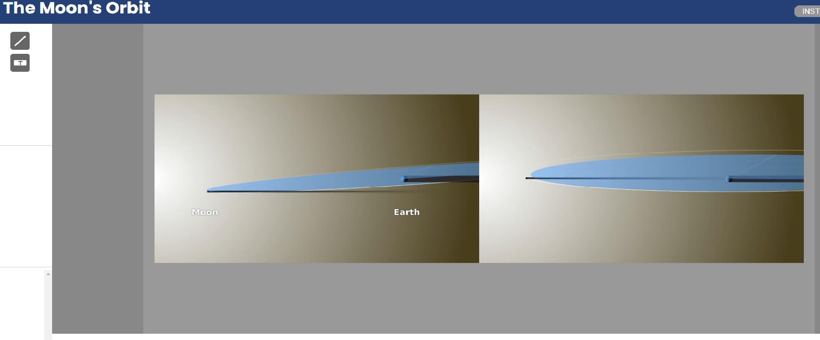

Page 7: Lunar Eclipse
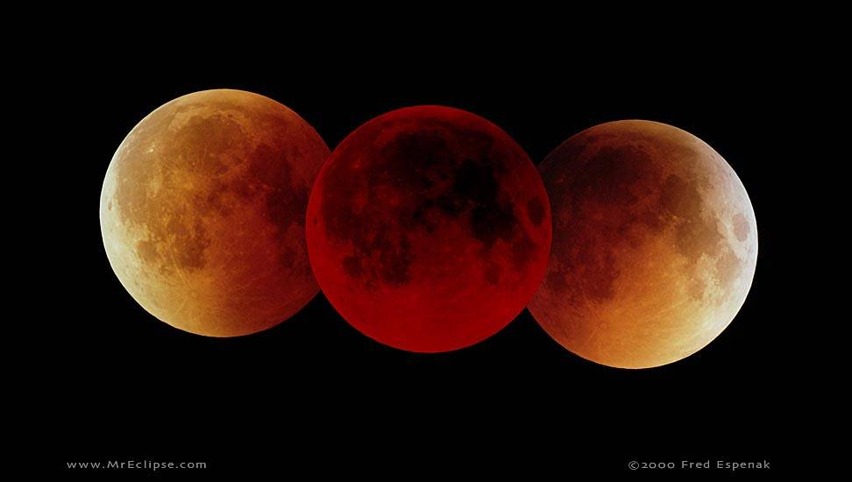
Task: Take Notes
- Describe the positions of the Sun, the Moon, and Earth that would produce a lunar eclipse. You may want to refer to the model of the Earth–Moon system on the previous page.
- During which phase of the Moon can a lunar eclipse happen?

Page 8: How Common are Eclipse?
Question: Why Is It more common to see a lunar eclipse than a solar eclipse? Refer to the map on the next page and/or the model of the Earth–Moon system on Page 6: The Moon’s Orbit .

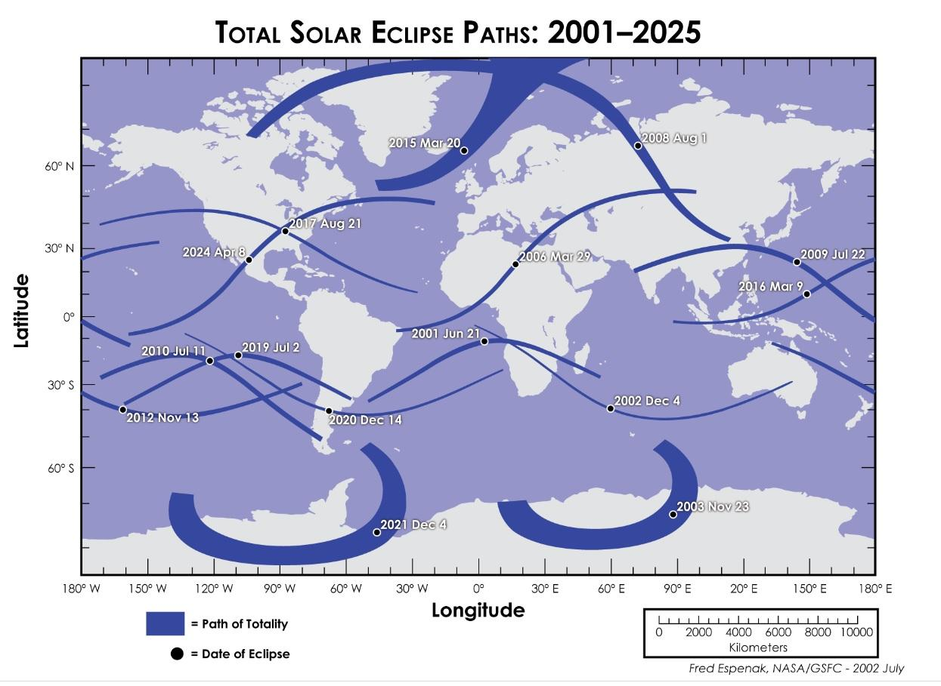
Answer:

Page 9: Modeling the Earth-Sun-Moon System

Task: In this lesson, you have seen how the Moon, the Sun, and Earth align to produce solar and lunar eclipses. Now create your own model to illustrate why lunar eclipses do not occur every month. You should submit this worksheet directly to your teacher.

Draw your model Inside the box:

Explore more NASA resources

Choose one of these two websites:
- Sun Overview: https://solarsystem.nasa.gov/solar-system/sun/overview/
- Eyes on Exoplanets: https://exoplanets.nasa.gov/eyes-on-exoplanets/#/

Navigate to information about the Sun and gather evidence on what elements are present in the Sun:

Click Explore the Sun under the Helioviewer Project: https://helioviewer.org/. Compare the Earth’s size to the Sun and list the things that you discovered about the sun:

Visit Lunar Eclipses and Solar Eclipses: https://spaceplace.nasa.gov/eclipses/en/. Complete the Venn Diagram by comparing and contrasting solar eclipses and lunar eclipses. Write a compare and contrast essay after completing the Venn diagram.
Explore: Compare and Contrast Solar and Lunar Eclipses
Directions: Complete the Venn Diagram by comparing and contrasting solar and lunar eclipses. Write a compare and contrast essay after completing the Venn Diagram.
Solar Eclipse Lunar Eclipse
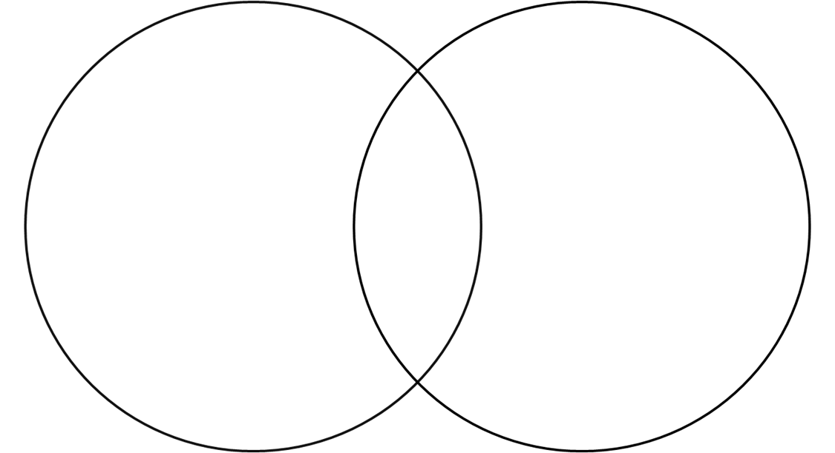
Compare and Contrast Essay:

Multimedia Rubric
Copyright © Texas Education Agency, 2006. All rights reserved.
Task Description: Teacher can use this space to describe the activity.
Criteria | % | Exemplary | Admirable | Acceptable | Attempted
Research of Topic | 20% | - Use of three or more sources, including at least two Internet and one print source; use of two search engines  - Variety of domain name suffix (.com, .edu, .net)  - Factual information is accurate  - Narrow focus of topic | - Use of two sources, including, including at least one Internet source; use of one search engine  - Most information can be confirmed  - Topic could be more narrowly focused | - Use of one Internet source  - Some errors in information  - Topic somewhat broad | - Use of only one source  - Numerous errors in information  - Topic too general
Organiza-tion (Outline or Story board for Planning) | 15% | - Logical sequencing  - Menus and paths are clear  - Original; inventive; creative | - Somewhat logical sequencing  - Menus and paths are mostly clear  - Original | - Sequencing is poorly planned  - Menus and paths are sometimes confusing  - Little originality | - Sequencing is confusing  - Menus and paths are confusing  - Inconsistent  - Rehash of other people’s ideas
Content | 20% | - Covers topic completely and in depth  - Content is readily understandable  - Media used contributes to understanding of topic | - Covers topic  - Content is mostly understandable  - Media used mostly contributes to understanding of topic | - Barely covers topic  - Content is somewhat understandable  - Media used somewhat contributes to understanding of topic | - Does not adequately cover topic  - Content is confusing  - Media used does not contribute to understanding of topic
Graphic Design | 25% | - Effective combination of multimedia and persuasive design elements  - Excellent use of navigational tools and buttons  - Graphics effectively entice audience; accurately convey message | - Good combination of multimedia and design elements  - Adequate navigational tools and buttons  - Visuals and images are attractive; adequately conveys message | - Some use of multimedia and design elements  - Some buttons and navigational tools work properly  - Use of visuals and images is limited; message is conveyed | - 0-1 media used  - Buttons and navigational tools are absent or confusing  - Use of visuals and images is confusing or absent; message is confusing
Mechanics | 10% | - Correct grammar, usage, mechanics, and spelling  - All sources are correctly cited | - Few grammar, usage, mechanics, or spelling errors  - Most sources are correctly cited | - Several grammar, usage, mechanics, or spelling errors  - Some sources are incorrectly cited | - Obvious grammar, usage, mechanics, or spelling errors  - Sources are not cited
Teamwork  (optional) | 10% | - Workload is divided and shared equally | - Some members contribute | - Few members contribute | - One or two people do all of the work

Assignment Score ______________ + Beyonder/Bonus ______________ =

Final Score ________________

