Exploring Eclipses
by Cris DeWolf
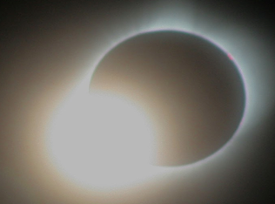
Level: 9-12 Time: 2-3 classes
Table of Contents
Lesson Overview and Objectives 2
Materials 4
5E Steps 5
Resources 6
Handouts 6

Lesson Overview
Students will use models to show how both total and annular solar eclipses occur. They will use another model to show both the difference between total and partial lunar eclipses as well as why lunar eclipses do not occur each month.

Educator Background Knowledge
The Moon’s orbit is elliptical. Its distance from Earth varies throughout its orbit from apogee - where it is farthest from Earth to perigee - where it is closest to the Earth. This affects what type of solar eclipses can occur. When the Moon is at apogee during a solar eclipse, a thin ring of the photosphere is observed. When the Moon is at perigee during the eclipse, the entire photosphere is blocked during totality and you can observe the solar corona.
The Moon’s orbital plane is also tipped with respect to the plane of Earth’s orbit around the Sun. This inclination of 5 degrees is the reason why we do not get a lunar eclipse during each full Moon.
Learning Goals
Students will use modeling to show their understanding of how eclipses occur, why solar eclipses occur very infrequently in their home region and why lunar eclipses do not occur each month.

Learning Objectives
- Use a model to show their understanding of how solar eclipses occur.
- Use a model to show their understanding of why lunar eclipses do not occur every month.
Framework for Heliophysics Education
NASA Question: What are the impacts of the Sun on humanity? Big Idea: The Sun is really big and its gravity influences all objects in the solar system.

NGSS Performance Expectations
MS-ESS1-1: Earth’s Place in the Universe. Develop and use a model of the Earth-Sun-Moon system to describe the cyclic pattern of lunar phases, eclipses of the Sun and Moon, and seasons.
HS-ESS1-4: Earth’s Place in the Universe. Use mathematical or computational representations to predict the motion of orbiting objects in the solar system.

Disciplinary Core Idea
- MS-ESS1-1A. The Universe and its Stars. Patterns of the apparent motion of the Sun, the Moon and stars in the sky can be observed, described, predicted, and explained with models.

Cross-cutting Practices
- Patterns
  - Empirical evidence is needed to identify patterns. Science assumes that objects and events in natural systems are understandable through measurement and observation.(MS-ESS-1)
  - Empirical evidence is needed to identify patterns. (HS-ESS1-5)
- Systems and System Models
  - Models (e.g., physical, mathematical, computer models) can be used to simulate systems and interactions.

Targeted STEM Skills
- Analyzing and interpreting data: Analyze data using tools, technologies, and/or models (e.g., computational, mathematical) in order to make valid and reliable scientific claims.
- Developing and Using Models: Develop a model based on evidence to illustrate the relationships between systems or between components of a system.
- Constructing Explanations: Apply scientific reasoning to link evidence to the claims to assess the extent to which the reasoning and data support the explanation or conclusion.
- Engaging in Argumentation from Evidence: Evaluate evidence behind currently accepted explanations or solutions to determine the merits of arguments.

Materials
- Styrofoam balls, one 4-inch, one ¾ -inch
- Stiff wire — 40 cm (Copper wire, uninsulated gauge works well)
- Toilet paper roll tube (or paper towel tube cut in half)
- Scissors
- Tape
- Flashlight (as “Sun”)
- Books, bricks, or other methods of supporting flashlight level at the proper height.
- Student handouts

Handouts (at the end of this document)
- Modeling Eclipses in the Classroom (Parts 1 & 2)
- See the lesson Impact Cratering for a Unit Test for this lesson and Magnetic Mysteries by Cris DeWolf

Links to Digital Resources for Students
- https://www.greatamericaneclipse.com
- Lessons will be adapted from https://www.unawe.org/activity/eu-unawe1302/
“Creating Eclipses in the Classroom” Total, Partial, and Annular eclipses will be modeled by students.
- https://www.jpl.nasa.gov/edu/teach/activity/when-do-lunar-eclipses-happen/ When do Lunar Eclipses Happen?
Key Vocabulary
Eclipse, umbra, penumbra, totality, annular eclipse, apogee, perigee, orbital plane, inclination, node, synodic month
Material Preparation
- Print copies of the activity handout for each student.
- Have activity supplies ready for each group. Numbers of each would be determined by the size of your groups.
- If needed, devise a way to darken your classroom.
5E Steps
Engage
Ask your students: “Have you ever seen a solar eclipse?”
- Wait for their responses. Ask probing questions like “Where did you see it?” “Did you travel with your family?”
- “The last total eclipse visible across almost the entire United States was in August of 2017. If you missed it, you have two opportunities coming up in the near future.” https://www.greatamericaneclipse.com/october-14-2023 and https://www.greatamericaneclipse.com/april-8-2024
- Show this video: https://www.youtube.com/watch?v=21zamcOLwDM&t=111s
Explore
Students build models to investigate where the Earth and Moon are in relation to each other during annular and total solar eclipses. They also construct a model that compares the inclination of the Moon’s orbit to the ecliptic to investigate why we do not get lunar eclipses each month during the new Moon.
Explain
Using their models, students will construct explanations as to where the Moon is in its orbit during annular and total solar eclipses, as well as where it is during total and partial lunar eclipses.

Extend
Students use their model for solar eclipses to show why we are at a special time, and that as the Moon migrates farther from Earth in its orbit we someday will no longer have total solar eclipses (in 1.5 billion years or so).

Evaluate
- What phase is the Moon in during solar eclipses?
- What phase is the Moon in during lunar eclipses?
- In terms of the Moon’s orbital path (shape of the orbit - apogee or perigee), what is the difference between total and annular solar eclipses?
- What part of the Moon’s shadow causes total solar eclipses? Partial solar eclipses?
- Why will we someday no longer have total solar eclipses?
Resources
- Modeling Eclipses in the Classroom (Parts 1 & 2) adapted by Cris DeWolf
- See the lesson Impact Cratering for a Unit Test for this lesson and Magnetic Mysteries by Cris DeWolf

Handouts
These begin on the next page.

Modeling Eclipses in the Classroom - Part I
Over the centuries, people around the world have used mythology to explain phenomena seen in our world. In China and other Asian countries, eclipses were explained as the Sun being eaten by a dragon. In these cultures people were told to make a lot of noise, and even to shoot arrows into the sky. This was an attempt, always successful, at scaring the dragon into regurgitating the Sun and restoring the day..
In modern times, science has provided answers to the mystery of what causes eclipses. We can use models to help us understand these scientific explanations of both lunar and solar eclipses.
Materials needed:
- Styrofoam balls, one 4-inch, one ¾ -inch
- Stiff wire - 40 cm (Copper wire, uninsulated gauge works well)
- Toilet paper roll tube (or paper towel tube cut in half)
- Scissors
- Tape
- Flashlight (as “Sun”)
- Books, bricks, or other methods of supporting flashlight level at the proper height.
Wanner, Noel. “The Sun-Eating Dragon Eclipse Stories, Myths, and Legends.” Solar Eclipse: Stories from the Path of Totality, The Exploratorium. https://www.exploratorium.edu/files/eclipse/dragon.html
Procedure
- You will be separating the two styrofoam balls with your piece of wire. Set it up to look like this:
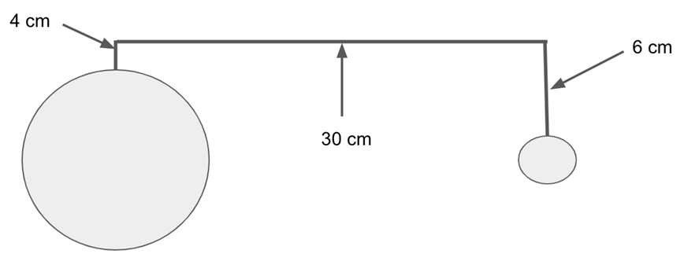
- Cut a fringe along the bottom of your cardboard tube and use that to tape it to the sheet of cardboard. You should support your flashlight with something that will allow the beam to be centered on your Earth and Moon - as shown in the image below.
● Turn on your flashlight.
Answers will vary.
- What do you see on the Earth?
___________________________________________________________________

- What type of eclipse is this? ____________________________________________

- What phase of the Moon is this? ________________________________________

- Rotate your Earth. What does the Moon’s shadow do?
______________________________________________________________________
______________________________________________________________________

- Can everyone on Earth see this eclipse? Explain your answer.
______________________________________________________________________
______________________________________________________________________

● Turn your model to this orientation:

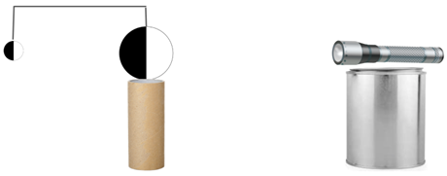
- What type of eclipse is this? ___________________________________________

- What phase of the Moon is this? _______________________________________

We do not see an eclipse of the Sun or the Moon every month. Why do you think this is so? The next part of this activity will help you understand why we do not.
This lesson was adapted from these sources:
Creating Eclipses in the Classroom:
https://www.scienceinschool.org/wp-content/uploads/2014/11/issue23_eclipses.pdf
When Do Eclipses Happen?
https://www.jpl.nasa.gov/edu/learn/project/when-do-lunar-eclipses-happen/
Modeling Eclipses in the Classroom - Part II
Why Don’t Lunar Eclipses Occur Each Month?
Introduction
How do we get a lunar eclipse? As the Moon orbits the Earth it completes a cycle of phases from full Moon back to full Moon again in roughly 29.5 days. This is called the Moon’s synodic period. It is also considered a synodic month. A lunar eclipse can occur when the Moon is behind the Earth with respect to the Sun and is in Earth’s shadow. But, this does not happen every synodic month. Why not? The answer is that the Moon’s orbit is inclined with respect to the plane of the ecliptic.
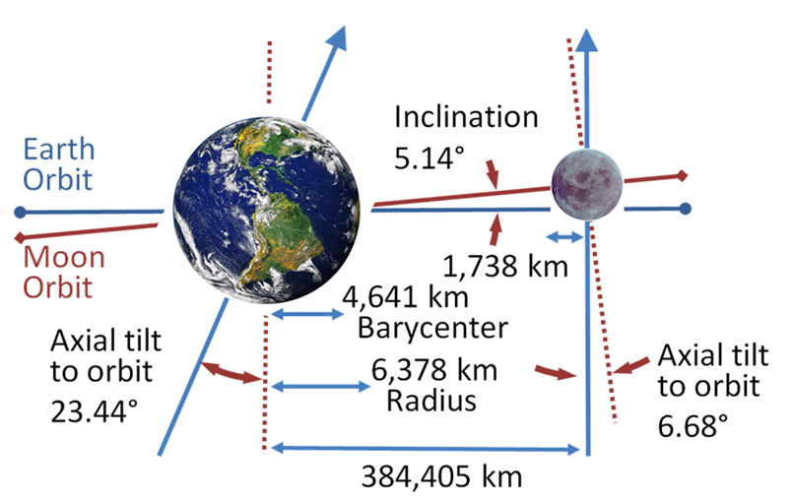
Image Credit: https://en.wikipedia.org/wiki/Orbit_of_the_Moon#/media/File:Earth-Moon.PNG
A lunar eclipse will only happen when the full Moon is at one node - a point where the orbital plane of the Moon and the plane of the ecliptic intersect - and the Sun is at the opposite node.
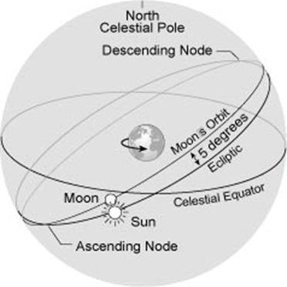
Image Credit: https://ase.tufts.edu/cosmos/view_picture.asp?id=385
Inclination of Moon’s Orbit
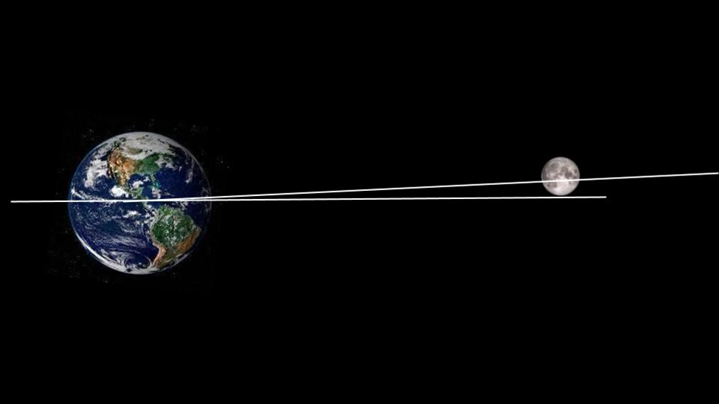
Image credit: https://eclipse.gsfc.nasa.gov/SEhelp/moonorbit.html

