How Does the Sun’s Magnetosphere Cause Aurora?
By Rachel Geiter

Table of Contents
Lesson Overview and Objectives 2
Materials 6
5E Steps 7
Resources 8
Handouts 9

Lesson Overview
Level: MS Time: One 48-minute class period
As a warm up activity, students will draw what they remember from the lesson How Does the Earth’s Magnetic Field Cause Aurora? about the Earth’s magnetosphere. The teacher will show different pictures of the Earth with its magnetic fields.

Teachers then go through a seven minute lecture about the ‘ingredients’ for solar wind.

Teachers can model with bubbles (solar flare: bubble doesn’t leave wand, coronal mass ejection (CME): bubble leaves, bigger bubble/bigger CME, or a bigger effect).
Students then go to an area of the room with information about an important ‘step’ to creating solar wind. They record information in their own words and draw one picture that explains the MOST important or interesting info for their group (using the Jigsaw method). After 5 minutes, they will return to their group and share what they learned.

Finally, students will be asked to create a kinesthetic memory aid for one of the five vocabulary words. Each group will do one, then students will share and pick one all students will use e.g., at the (next class the teacher will instruct all students on the different memory aids for each vocabulary word).

As an extension, students will make a solar wind wand, which they will use to make ‘solar wind’ (bubbles). They will practice different distances and sizes of bubbles.

Educator Background Knowledge
Magnetism drives the dynamic activity near the Sun's surface. Magnetism is found on the Sun because as the Sun rotates, the charged plasma circulates like a current in a wire and creates magnetic fields at many different scales.
Plasma is the fourth state of matter. Plasma can be produced by heating ordinary gas to thousands of degrees. The atoms begin to lose their electrons, creating a mixture of charged electrons and charged atoms.

Sunspots are a common example of magnetic fields on the Sun. They are so intense that they literally pop-through the surface of the Sun to create pairs of spots: one with a north-type and one with a south-type polarity. Because plasma can act like iron filings, you can see the magnetic ‘lines of force’ emanating from the sunspots to create the distinctive fields you see in bar magnets.
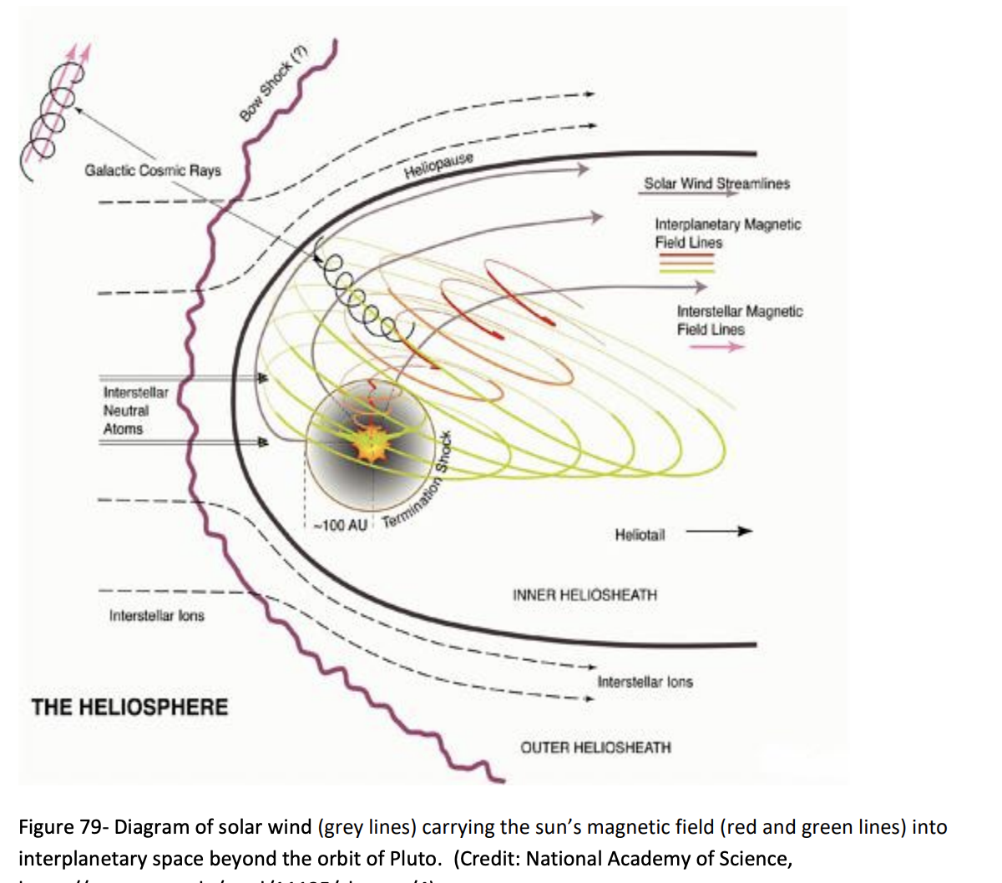

Magnetic fields mixed up in charged plasma can also change their shapes in a process that is called reconnection. When this happens, energy stored in the magnetic field is released to create a burst of x-ray light called a solar flare. Sometimes these reconnection events release so much energy that they eject billion-ton clouds of plasma into space. These coronal mass ejections (CMEs) can sometimes be directed at Earth and when they arrive a few days later can cause changes in Earth’s magnetic field. These disruptions are usually accompanied by spectacular Northern and Southern Lights called aurora.

The Sun’s magnetic field is thousands of times stronger than Earth’s magnetic field and should not be detectable from distances of millions of kilometers. However, the plasma leaving the surface of the Sun, the solar wind, drags some of the Sun’s magnetic field with it and the solar wind’s magnetic field can be detected across most of the solar system.

- Sun Churn - Magnet Academy: https://nationalmaglab.org/magnet-academy/history-of-electricity-magnetism/places/magnetic-field-of-sun/
- Solar Magnetism Infographic: https://cdn.mos.cms.futurecdn.net/VESuWqyrfzHh3UczNq4UFH-1024-80.jpg.webp

The Jigsaw Method: A teaching strategy that helps students collaborate and rely on one another. It is effective for accomplishing multiple tasks at once and giving students a greater sense of individual responsibility. Just as a jigsaw puzzle is a collection of various pieces that come together to make a complete picture, the jigsaw method of teaching is a collection of topics, which will be fully developed by students before coming together to make a complete idea. This type of cooperative learning strategy allows individuals or small groups to become responsible for a subcategory of a larger topic. After researching and developing their idea, each individual or small group then has the responsibility to teach it to the rest of the group or class.

Learning Goal
Students will explain how the Sun’s magnetic field affects the Earth.

Learning Objectives
- Students can explain what causes the magnetic fields in the Sun (movement of plasma).
- Students will model a solar flare, CME, and solar wind using bubbles.

Framework for Heliophysics Education
NASA Question: What are the impacts of the Sun on humanity? Big Idea: The Sun is active and can impact technology on Earth via space weather.
NASA Question: What causes the Sun to vary? Big Idea: Energy from the Sun is created in the core and travels outward through the Sun and into the heliosphere.

NGSS Performance Expectations
MS-PS2-5: Forces and Interactions: Conduct an investigation and evaluate the experimental design to provide evidence that fields exist between objects exerting forces on each other even though the objects are not in contact.
MS-PS2-3: Forces and Interactions: Ask questions about data to determine the factors that affect the strength of electric and magnetic forces.

Crosscutting Concepts
Systems and System Models: Models can be used to represent systems and their interactions—such as inputs, processes and outputs—and energy and matter flows within systems.

Targeted STEM Skills
- Asking Questions and Defining Problems: Asking questions and defining problems in grades 6–8 builds from grades K–5 experiences and progresses to specifying relationships between variables, and clarifying arguments and models. Ask questions that can be investigated within the scope of the classroom, outdoor environment, and museums and other public facilities with available resources and, when appropriate, frame a hypothesis based on observations and scientific principles. (MS-PS2-3)
- Planning and Carrying Out Investigations: Planning and carrying out investigations to answer questions or test solutions to problems in 6–8 builds on K–5 experiences and progresses to include investigations that use multiple variables and provide evidence to support explanations or design solutions. Conduct an investigation and evaluate the experimental design to produce data to serve as the basis for evidence that can meet the goals of the investigation. (MS-PS2-5)

Materials
- Whiteboard Markers (1 per student),
- Paper/pencil for notes,
- Bubbles with bubble wand (10 total),
- 5 large printed ‘jigsaw’ areas of info for key vocabulary (see Handouts) posted around the room,
- Sticky notes

Handouts
Jigsaw Stations with Vocabulary

Links to Digital Resources for Students

NASA Video - The Dynamic Solar Magnetic Field with Introduction: https://www.youtube.com/watch?v=hH9u5ql0MGw

Teacher Slides

Key Vocabulary
Plasma, Nuclear Fusion, Solar Flare, CME, Solar Wind

Material Preparation
Teacher will post jigsaw information around the room for student activity prior to the lesson.

5E Steps
Engage
How cool is the sun’s magnetosphere? Show the videos and go through teacher slides.
- As a warm up activity, students will draw what they remember from the lesson How Does the Earth’s Magnetic Field Cause Aurora? about the Earth’s magnetosphere. The teacher will show different pictures of the Earth with its magnetic fields.

- Teachers then go through a seven minute presentation about the ‘ingredients’ for solar wind. Teachers can model with bubbles (solar flare: bubble doesn’t leave wand, coronal mass ejection (CME): bubble leaves, bigger bubble/bigger CME, or a bigger effect).
Explore
Students learn more about one of the five key vocabulary at jigsaw stations:
- Students go to an area of the room with information about an important ‘step’ to creating solar wind and read the information.

Explain
Students write a summary of their word to their group:
- They record information in their own words and draw one picture that explains the MOST important or interesting information for their group. After 5 minutes, they will return to their group and share what they learned.

- Then, students will create a kinesthetic memory aid for one of the five vocabulary words.

Extend
Students will model a CME with bubbles and a bubble wand:
- As an extension, students will make a solar wind wand, which they will use to make ‘solar wind’ (bubbles). They will practice different distances and sizes of bubbles.

Evaluate
- Each group will come up with a kinesthetic memory tool for one of the five vocabulary words. Each group will do one, then students will share and pick one all students will use.
- The next day, students will learn each word and practice them, until they are able to do them independently.

Resources
- Jigsaw Stations with Vocabulary (see Handouts)
- Links to Digital Resources for Students

NASA Video - The Dynamic Solar Magnetic Field with Introduction: https://www.youtube.com/watch?v=hH9u5ql0MGw

Teacher Lecture Slides
- Sun Churn - Magnet Academy: https://nationalmaglab.org/magnet-academy/history-of-electricity-magnetism/places/magnetic-field-of-sun/

Solar Magnetism Infographic: https://cdn.mos.cms.futurecdn.net/VESuWqyrfzHh3UczNq4UFH-1024-80.jpg.webp
Handouts
These begin on the next page.
Plasma
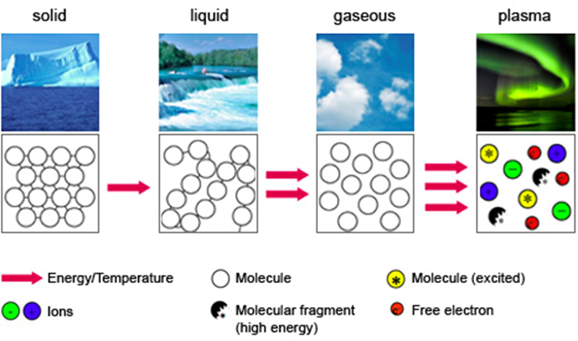
Plasma is superheated matter – so hot that the electrons are ripped away from the atoms forming an ionized gas.

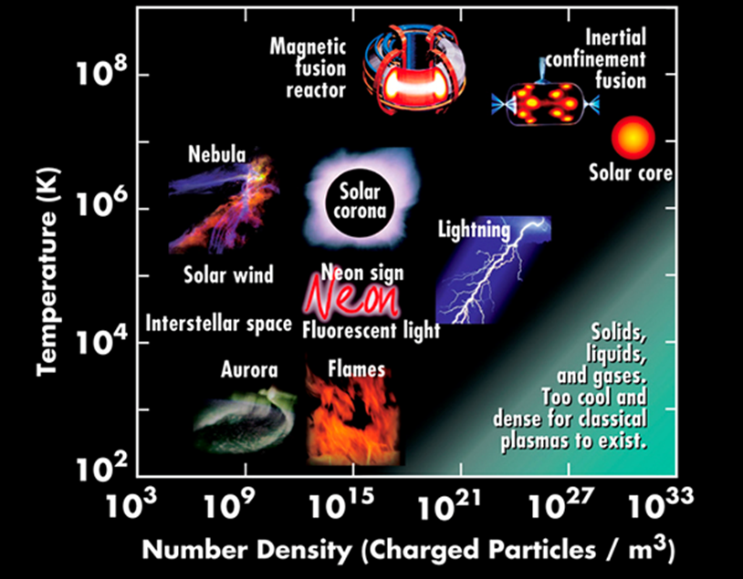
Plasma makes up over 99% of the universe. In the night sky, plasma glows in the form of stars, nebulas, and even the auroras that sometimes ripple above the north and south poles.

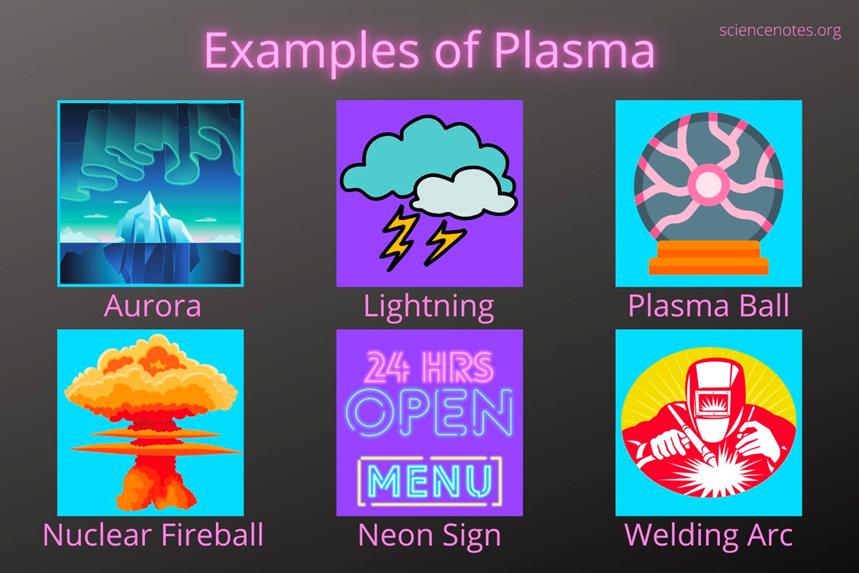
That branch of lightning that cracks the sky is plasma, so are the neon signs along our city streets. And so is our sun, the star that makes life on Earth possible.

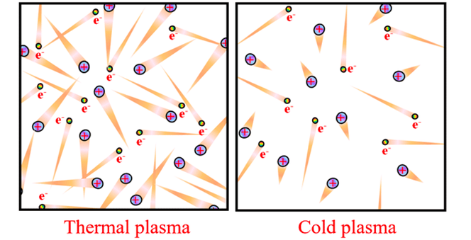
Plasma is often called “the fourth state of matter,” along with solid, liquid and gas. Just as a liquid will boil, changing into a gas when energy is added, heating a gas will form a plasma – a soup of positively charged particles (ions) and negatively charged particles (electrons).

Nuclear Fusion
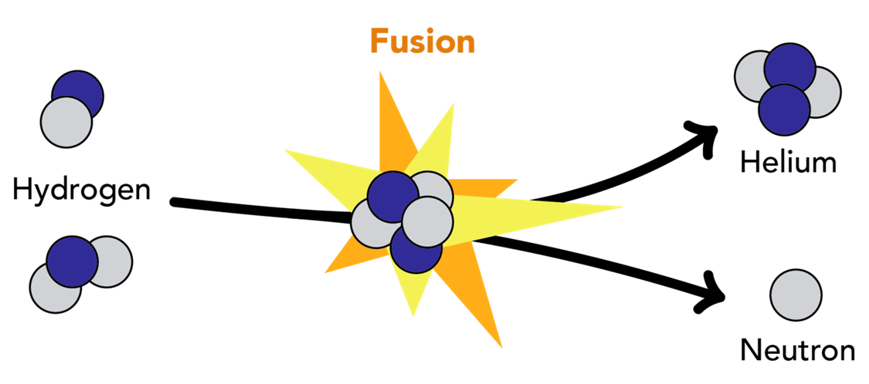
Fusion occurs when two or more atoms, the particles that make up all things, combine to make a single, new type of atom.
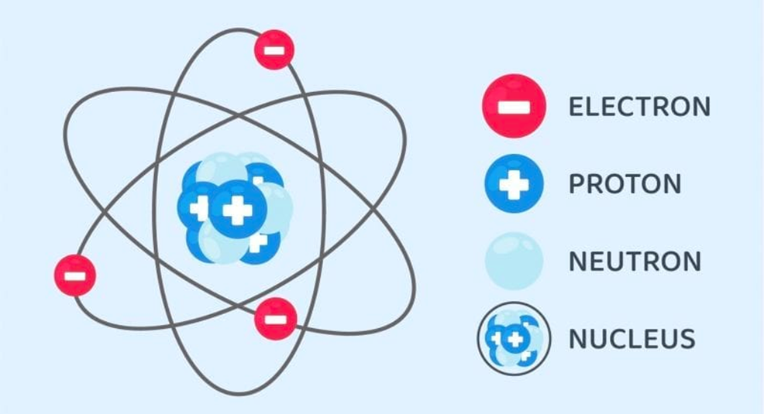
But this doesn’t happen spontaneously: because atoms are made of positively and negatively charged particles known as protons and electrons, they will often repel each other if they get too close.

This is similar to how the “negative” poles of two bar magnets will repel each other if you try to push them together.
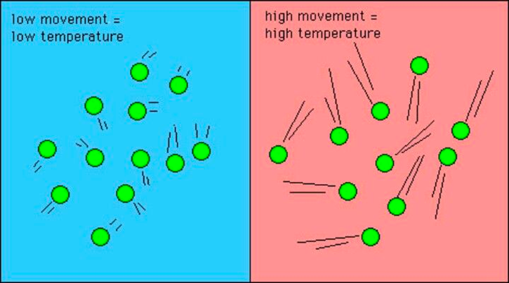
Fusion can only occur under special conditions where atoms are moving so fast that their kinetic energy–the energy the atom possesses due to its motion–overcomes the repulsive forces, increasing the probability that the centers of the atoms, known as nuclei, will collide and fuse into one.

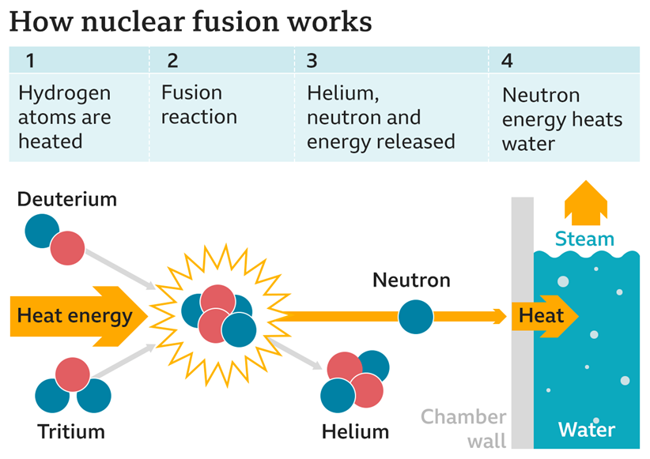
An atom’s speed can be increased by raising the temperature of the system that the atom is in. When the temperature is raised, heat energy is absorbed by the atoms and converted to kinetic energy, making them move faster. This energy can then be harnessed for other processes, such as powering an electrical generator.

Solar Wind
The solar wind is a continual stream of protons and electrons from the sun's outermost atmosphere — the corona.
These charged particles breeze through the solar system at speeds ranging from around 250 miles per second to 500 miles per second, in a plasma state. When the solar wind reaches Earth it sends a flurry of charged particles into the magnetosphere and along Earth's magnetic field lines, towards the poles.
The solar wind sweeps through the solar system far beyond the orbit of Pluto, forming a large "bubble" called the heliosphere. The heliosphere is shaped like a long wind sock as it moves with the Sun.
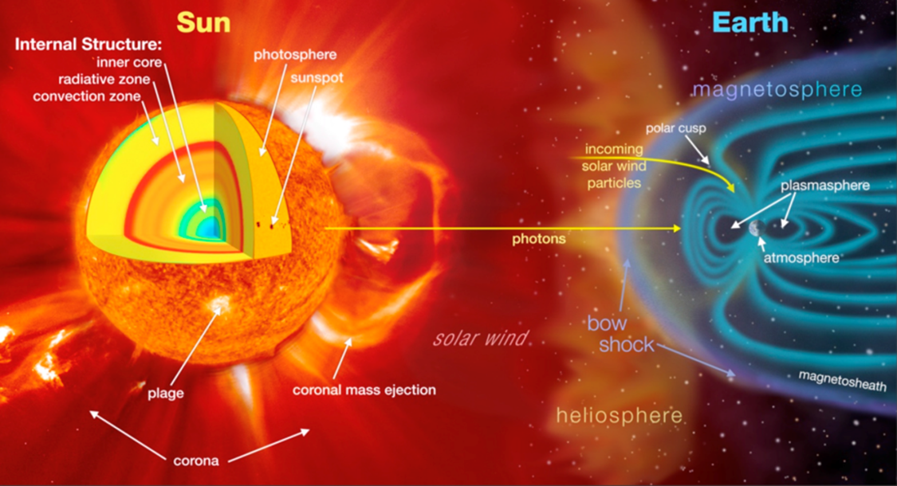
​​

The heliosphere acts as a protective shield, defending us against cosmic rays consisting of energetic particles that can damage living cells. Cosmic rays are generated outside our solar system and blaze along at almost the speed of light.
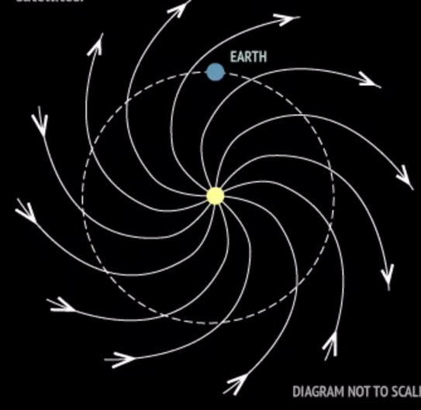
The heliosphere acts as a protective shield, defending us against cosmic rays consisting of energetic particles that can damage living cells. Cosmic rays are generated outside our solar system and blaze along at almost the speed of light.
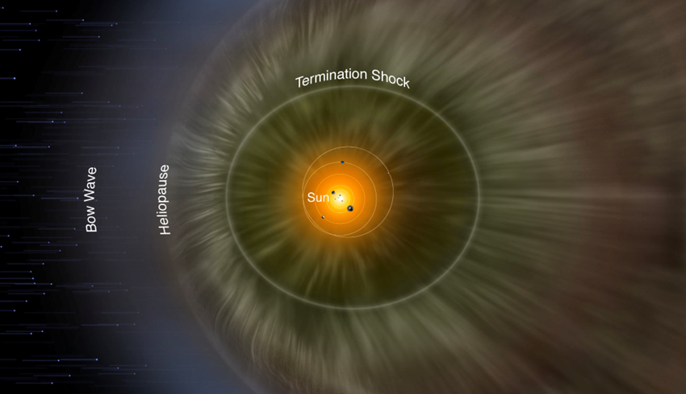
Without our protective bubble, these high-energy atom fragments would constantly bombard Earth. "Without the heliosphere, life would certainly have evolved differently — and maybe not at all.”
Solar Flare
A solar flare is a HUGE explosion on the Sun that happens when energy stored in 'twisted' magnetic fields (usually above sunspots) is suddenly released.
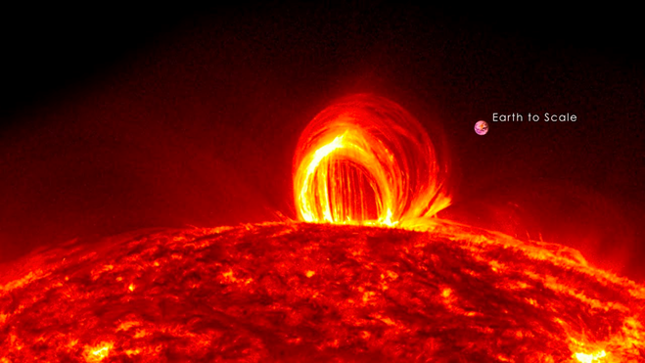
In a matter of just a few minutes they heat plasma to many millions of degrees and produce a burst of high energy particles.
Scientists classify solar flares according to their brightness in the x-ray wavelengths. There are three categories: X-class flares are big; they are major events that can trigger radio blackouts around the whole world and long-lasting radiation storms in the upper atmosphere.
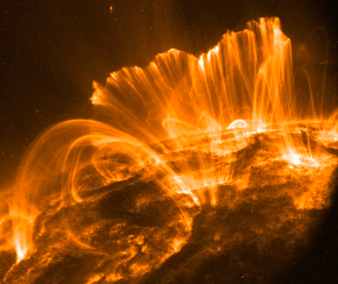
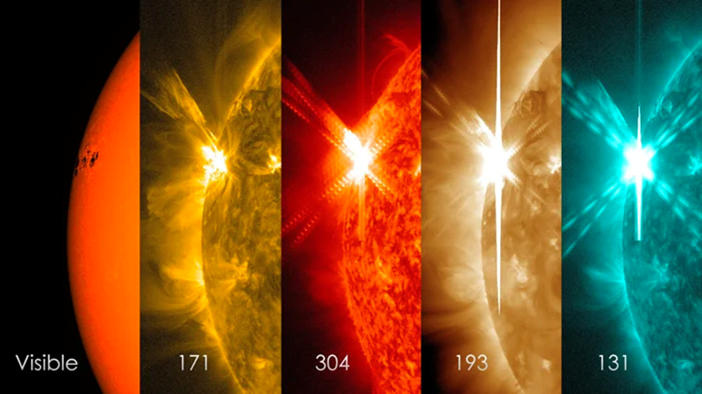M-class flares are medium-sized; they generally cause brief radio blackouts that affect Earth's polar regions. Minor radiation storms sometimes follow an M-class flare.
Compared to X- and M-class events, C-class flares are small with few noticeable consequences here on Earth.
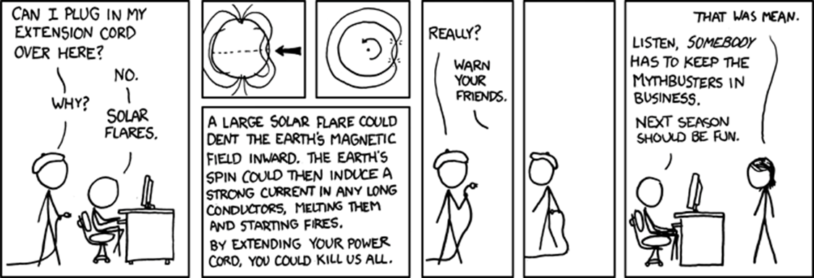
Solar flares are different to 'coronal mass ejections' (CMEs). CMEs are huge bubbles of gas threaded with magnetic field lines that are ejected from the Sun over the course of several hours, like a burp.
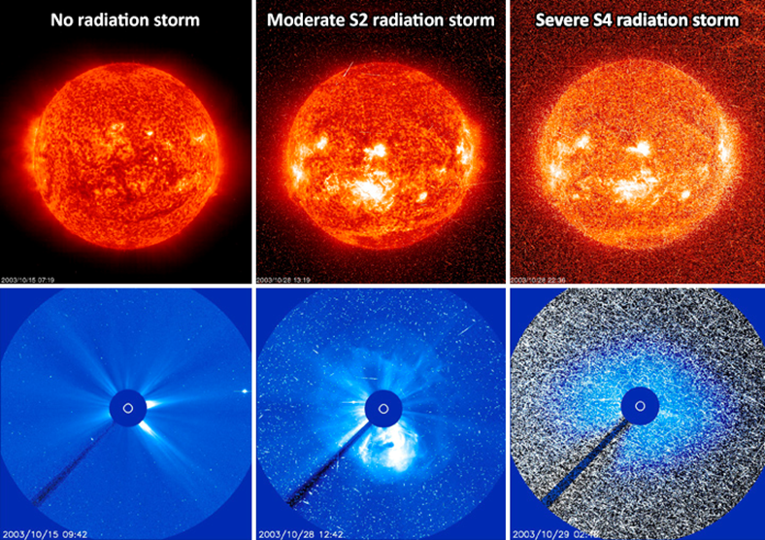

Coronal Mass Ejection (CME)
These colossal clouds of plasma can wreak havoc with power grids and satellites, but can also trigger stunning aurora displays. CMEs are large expulsions of plasma and magnetic fields from the sun's atmosphere — the corona.
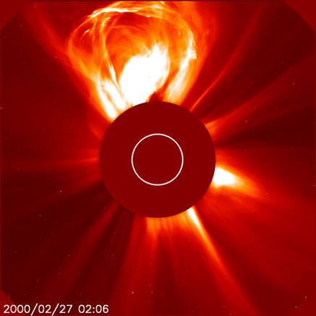
Compared to solar flares — bursts of electromagnetic radiation that travel at the speed of light, reaching Earth in just over 8 minutes — CMEs travel much slower. At their highest speeds of almost 1,900 miles per second CMEs can reach Earth in about 15 to
18 hours whilst slower CMEs traveling around 155 mi/s can take several days to arrive. These relatively slower travel times are useful as they give us more time to prepare for such an arrival. CMEs can wreak havoc with power grids, telecommunication networks and orbiting satellites and expose astronauts to dangerous doses of radiation.
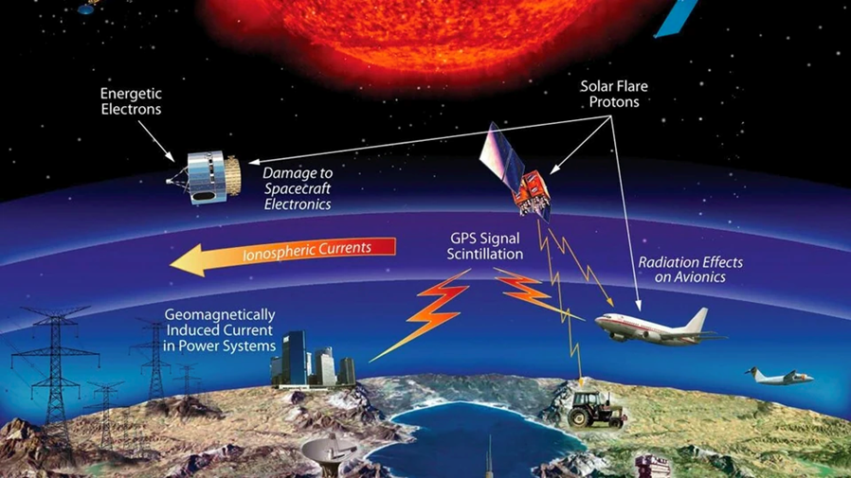
On the other hand, bigger CMEs can trigger impressive aurora displays that are visible at lower latitudes beyond their "normal" north/south pole area.
CMEs — like solar flares — are most common during solar maximum, a period in the sun's 11-year cycle of activity when the star is at its most active.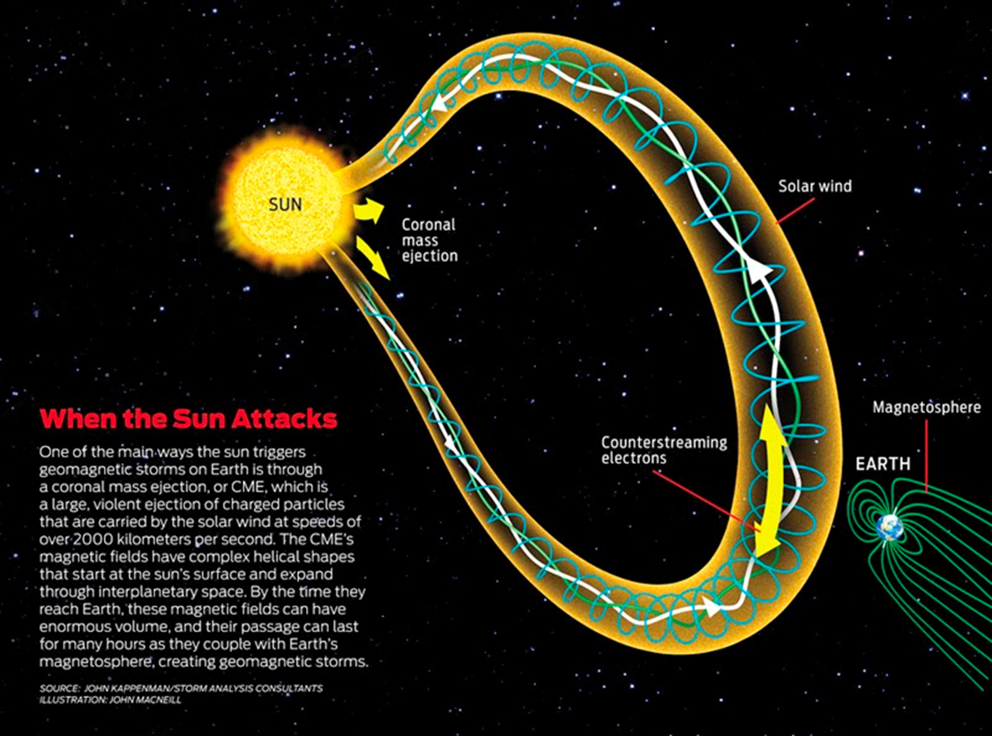
After CMEs are released, they swell in size as they travel away from the sun. "Larger CMEs can reach a size comprising nearly a quarter of the space between Earth and the Sun by the time it reaches our planet!”

