How do the Sun and Earth’s Magnetospheres Interact to Cause Aurora?
By Rachael Geiter
Table of Contents
Lesson Overview and Objectives 2
Materials 4
5E Steps 5
Resources 6
Handouts 8

Lesson Overview
Level: 8th Grade Time: 50 minutes
To engage students, the teacher demonstrates the aurora using a plasma ball and fluorescent light and provides students with a teacher-made seven-minute presentation about the magnetosphere and solar wind. During the presentation students write key vocabulary onto doodle notes (provided by the teacher partially filled out). Students watch a NASA video (Space Weather and Earth’s Aurora). Then students make the magnetosphere out of pipe cleaners and model a solar wind bubble interacting with the pipe cleaner magnetosphere.

For a formative assessment, students will answer ‘What causes aurora?’ by creating a short video under 30 seconds long to demonstrate solar wind and the magnetosphere. Students may compile videos to share with the school on the weekly news video.

Students will learn about the Kp index, and look at the last several months Kp values to investigate the question, When could we have seen an aurora in our town? Students will look at the forecast for this month to answer the question, How does the magnitude of a geomagnetic storm affect the visibility of an aurora in our town?
Teachers can also show this NASA solar cycle video so they can realize that in two years people will see more frequent aurora.

Educator Background Knowledge
The Earth has an invisible magnetic field, or “magnetosphere,” with a north and south pole, kind of like a bar magnet or “dipole.” The magnetosphere’s outer boundary is where a gusty stream of material carrying the Sun’s magnetic field into space, called the “solar wind”, meets the Earth’s magnetic field. Solar wind plasma squishes the sunward side of our magnetic field and stretches the side farther away from the Sun into a long “magnetotail.” The kind of aurora people see most often is triggered when the solar wind interacts with the sunward side of the magnetosphere, sending energized particles into the magnetotail, where they are accelerated toward the Earth’s poles. They then collide with atoms and molecules in the atmosphere, creating the beautiful aurora. Read more at the Aurorasaurus Blog Post: http://blog.aurorasaurus.org/?p=1389

‌Learning Goal
Students can describe and model why we see auroras on Earth.

Learning Objectives
Students will be able to
- Diagram how the Earth’s magnetosphere and solar wind interact.
- Model and describe the Earth’s magnetosphere.
- Explain the relationship between a coronal mass ejection (CME) or space weather and visibility of aurora.
Framework for Heliophysics Education
NASA Question: What are the impacts of the Sun on humanity? Big Idea: The Sun is active and can impact technology on Earth via space weather.
NASA Question: What causes the Sun to vary? Big Idea: Energy from the Sun is created in the core and travels outward through the Sun and into the heliosphere.

NGSS Performance Expectations
- MS-PS2-5: Forces and Interactions: Conduct an investigation and evaluate the experimental design to provide evidence that fields exist between objects exerting forces on each other even though the objects are not in contact.
- MS-PS2-3: Forces and Interactions: Ask questions about data to determine the factors that affect the strength of electric and magnetic forces.
Crosscutting Concepts
- Systems and System Models: Models can be used to represent systems and their interactions (such as inputs, processes and outputs) and energy and matter flows within systems.

Targeted STEM Skills
- Developing and Using Models: Modeling in 6–8 builds on K–5 and progresses to developing, using and revising models to describe, test, and predict more abstract phenomena and design systems. Develop a model to describe unobservable mechanisms.
- Analyzing and Interpreting: Data Analyzing data in 6–8 builds on K–5 and progresses to extending quantitative analysis to investigations, distinguishing between correlation and causation, and basic statistical techniques of data and error analysis. Analyze and interpret data to determine similarities and differences in findings.

Materials:
- Plasma Ball
- Fluorescent light
- Doodle note sheet (1 per student)
- Pipe cleaners in three different colors (two per student of each color, six total)
- Modeling the Magnetosphere with Pipecleaners Lab Sheet (1 per student)
- 1 smartphone or laptop per group to make videos

Links to Digital Resources for Teachers
- The Solar Cycle as Seen from Space (NASA): https://www.youtube.com/watch?time_continue=84&v=Z0uIcLZ5rh8&feature=emb_title&ab_channel=NASAGoddard
- Aurorasaurus Blog Post: http://blog.aurorasaurus.org/?p=1389
- Teacher Slides

Links to Digital Resources for Students
- NASA Video: Space Weather and Earth’s Aurora: video of magnetosphere interacting with solar wind: https://www.youtube.com/watch?v=HJfy8acFaOg
- NASA Video: Modelling Earth’s Magnetism: https://solarsystem.nasa.gov/resources/2286/modeling-earths-magnetism/
- Aurora and Solar Activity Archive:
https://www.spaceweatherlive.com/en/archive/2022/04.html
- Aurora KP Index Forecast: https://www.spaceweatherlive.com/en/auroral-activity/aurora-forecast.html

Key Vocabulary
Magnetosphere, solar wind, magnetotail, particles, electrons, magnetic reconnection, KP Index.

Material Preparation
- Prepare doodle notes before class.
- Have pipe cleaners ready (three different colors; two per student of each color, six total).
- Print out the lab handouts for students.
- Provide copies of the vocabulary sheets.
- Have rubric for videos printed (1 per small group)

5E Steps
Engage
The teacher demonstrates the aurora using a plasma ball and/or a fluorescent light. The class watches the NASA video: Space Weather and Earth’s Aurora.

Explore
Students look up aurora images and videos on an app (like Instagram) and share with each other in small groups.

Explain
The teacher provides students with a seven-minute presentation about the magnetosphere and solar wind. During the presentation students write key vocabulary onto doodle notes (provided by the teacher, can be partially filled out). Share the NASA video: Modeling Earth’s Magnetism. Students work together in small groups to make a visual model on a doodle note sheet.

Extend
Students will make the magnetosphere out of pipe cleaners. Then students model a solar wind bubble interacting with the pipe cleaner magnetosphere.

Students will learn about the Kp index, and look at the last several months Kp values at the website: Aurora and Solar Activity Archive to investigate the question, When could we have seen an aurora in our town?

Students will look at the forecast for this month at the website Aurora KP Index Forecast to answer the question, How does the magnitude of a geomagnetic storm affect the visibility of an aurora in our town?

Teachers can also show this NASA solar cycle video so they can realize that in two years people will see more frequent aurora.

Evaluate
Students will answer ‘What causes aurora?’ by creating a short video under 30 seconds long modeling the interaction of the Earth’s magnetosphere and the solar wind. See Rubric in Handouts. Students may compile videos to share with the school on the weekly news video.

Resources
Handouts
- Vocabulary Sheets: Plasma, Nuclear Fusion, Solar Flare, Solar Wind, Coronal Mass Ejection (CME)
- Word Puzzle: Auroras Fires in the Sky
- Modeling the Magnetosphere with Pipecleaners
- Rubric for Explaining Aurora Video

Links to Digital Resources for Teachers
- The Solar Cycle as Seen from Space (NASA): https://www.youtube.com/watch?time_continue=84&v=Z0uIcLZ5rh8&feature=emb_title&ab_channel=NASAGoddard
- Aurorasaurus Blog Post: http://blog.aurorasaurus.org/?p=1389
- Teacher Slides

Links to Digital Resources for Students
- NASA Video: Space Weather and Earth’s Aurora: video of magnetosphere interacting with solar wind: https://www.youtube.com/watch?v=HJfy8acFaOg
- NASA Video: Modelling Earth’s Magnetism: https://solarsystem.nasa.gov/resources/2286/modeling-earths-magnetism/
- Aurora and Solar Activity Archive:
https://www.spaceweatherlive.com/en/archive/2022/04.html
- Aurora KP Index Forecast: https://www.spaceweatherlive.com/en/auroral-activity/aurora-forecast.html

Handouts
These begin on the next page.
Plasma
Plasma is superheated matter – so hot that the electrons are ripped away from the atoms forming an ionized gas.
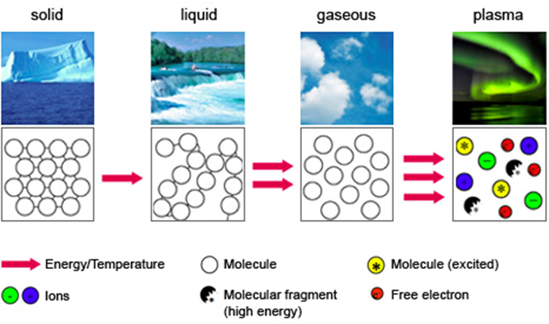
Plasma makes up over 99% of the universe. In the night sky, plasma glows in the form of stars, nebulas, and even the auroras that sometimes ripple above the north and south poles.
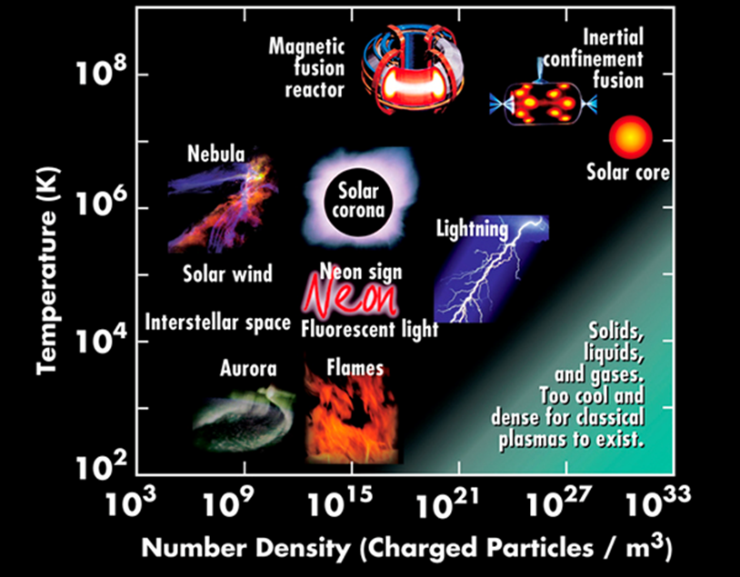
That branch of lightning that cracks the sky is plasma, so are the neon signs along our city streets. And so is our Sun, the star that makes life on Earth possible.
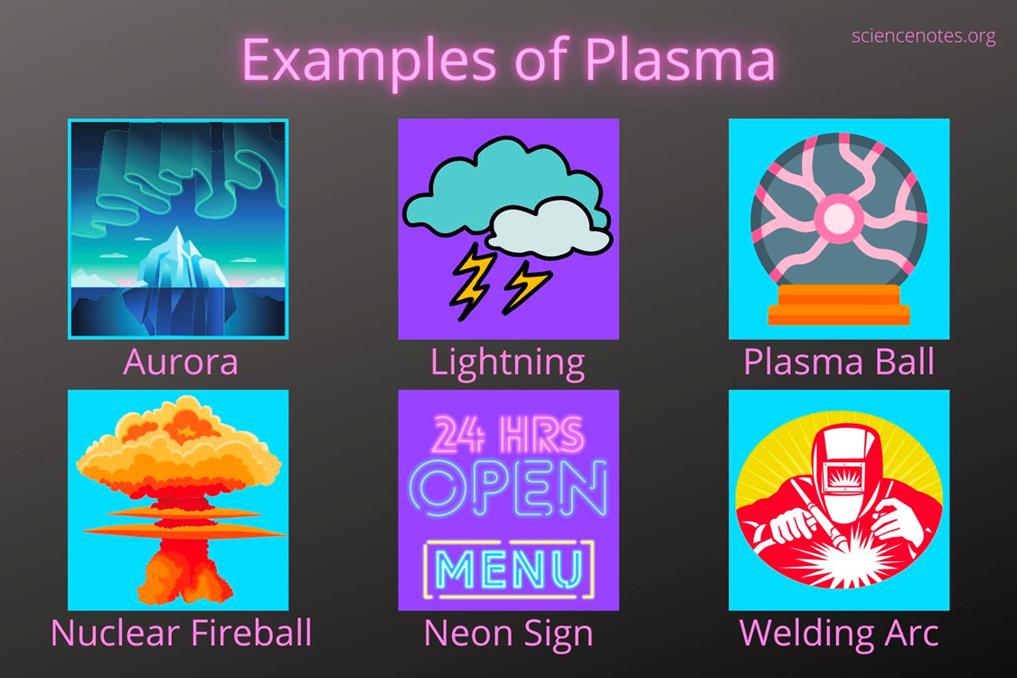
Plasma is often called “the fourth state of matter,” along with solid, liquid and gas. Just as a liquid will boil, changing into a gas when energy is added, heating a gas will form a plasma – a soup of positively charged particles (ions) and negatively charged particles (electrons).
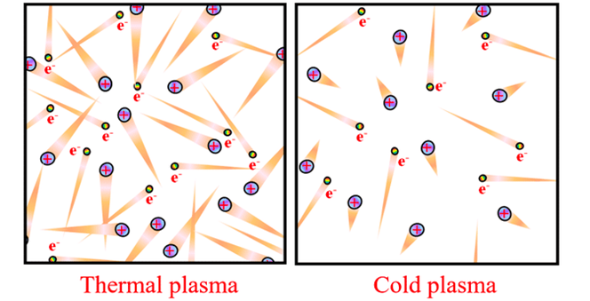
Nuclear Fusion
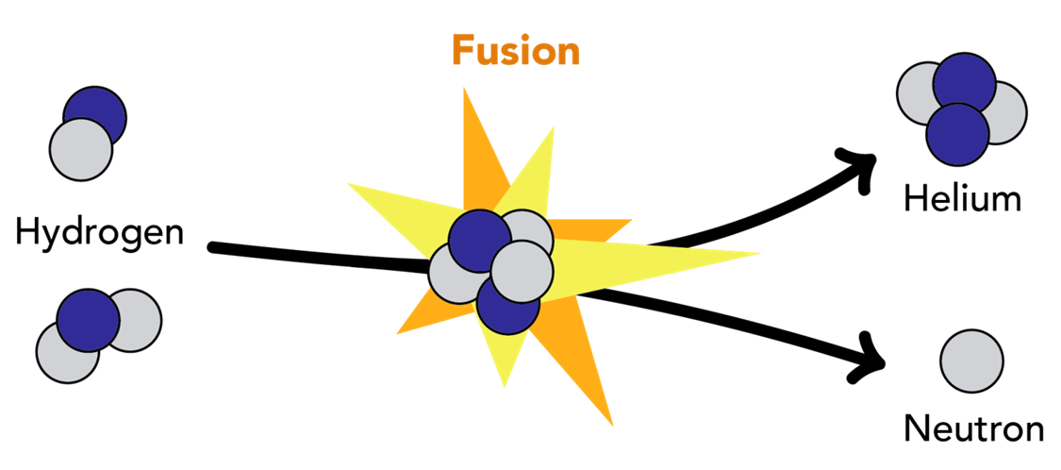
Fusion occurs when two or more atoms, the particles that make up all things, combine to make a single, new type of atom.
But this doesn’t happen spontaneously: because atoms are made of positively and negatively charged particles known as protons and electrons, they will often repel each other if they get too close.
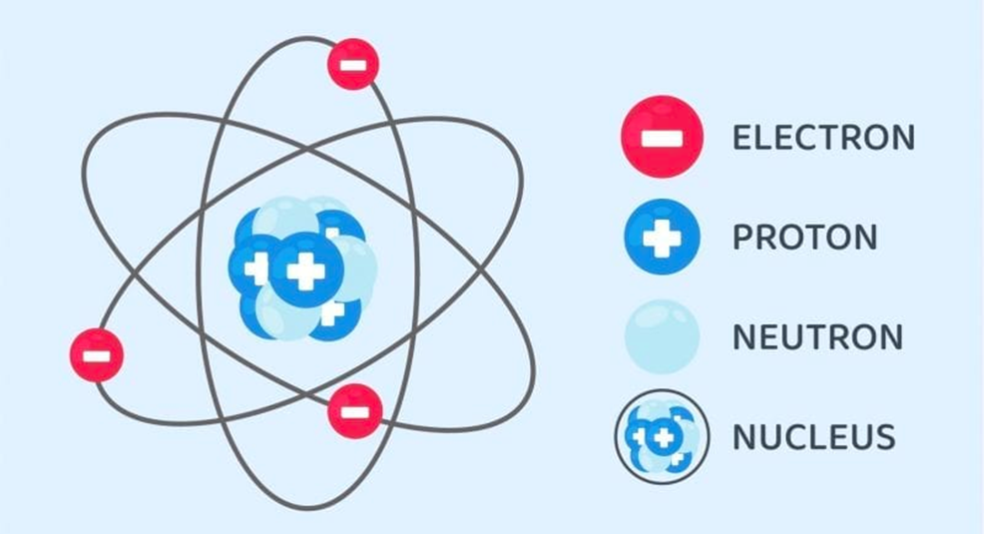
This is similar to how the “negative” poles of two bar magnets will repel each other if you try to push them together.
Fusion can only occur under special conditions where atoms are moving so fast that their kinetic energy–the energy the atom possesses due to its motion–overcomes the repulsive forces, increasing the probability that the centers of the atoms, known as nuclei, will collide and fuse into one.
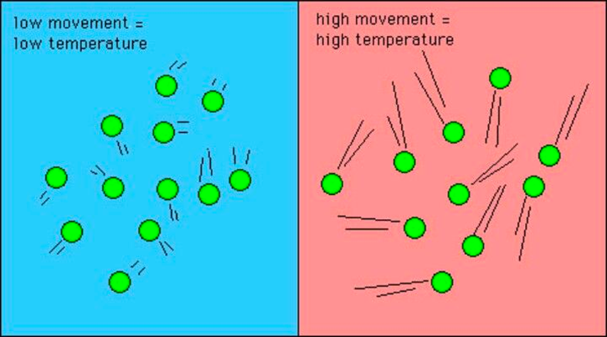
An atom’s speed can be increased by raising the temperature of the system that the atom is in. When the temperature is raised, heat energy is absorbed by the atoms and converted to kinetic energy, making them move faster. This energy can then be harnessed for other processes, such as powering an electrical generator.
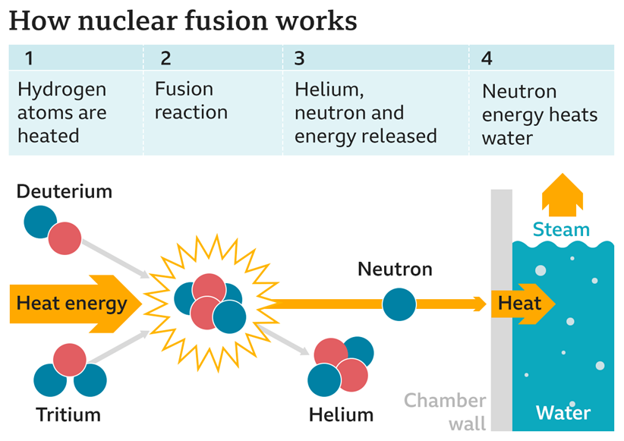
Solar Wind
The solar wind is a continual stream of protons and electrons from the Sun's outermost atmosphere — the corona.
These charged particles breeze through the solar system at speeds ranging from around 250 miles per second to 500 miles per second, in a plasma state. When the solar wind reaches Earth it sends a flurry of charged particles into the magnetosphere and along Earth's magnetic field lines, towards the poles.
The solar wind sweeps through the solar system far beyond the orbit of Pluto, forming a large "bubble" called the heliosphere. The heliosphere is shaped like a long wind sock as it moves with the Sun.
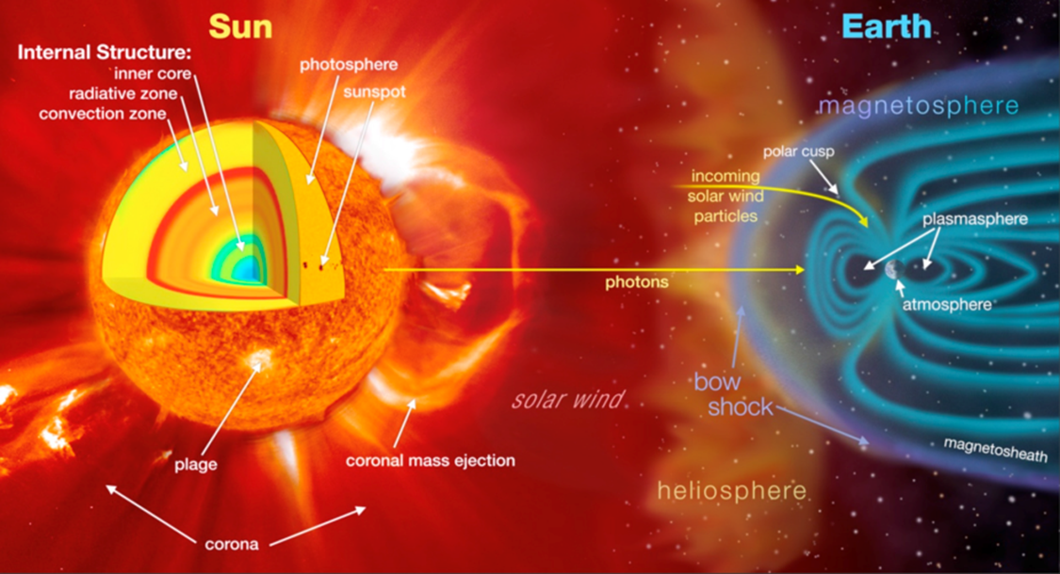
​​

The heliosphere acts as a protective shield, defending us against cosmic rays consisting of energetic particles that can damage living cells. Cosmic rays are generated outside our solar system and blaze along at almost the speed of light.
The heliosphere acts as a protective shield, defending us against cosmic rays consisting of energetic particles that can damage living cells. Cosmic rays are generated outside our solar system and blaze along at almost the speed of light.
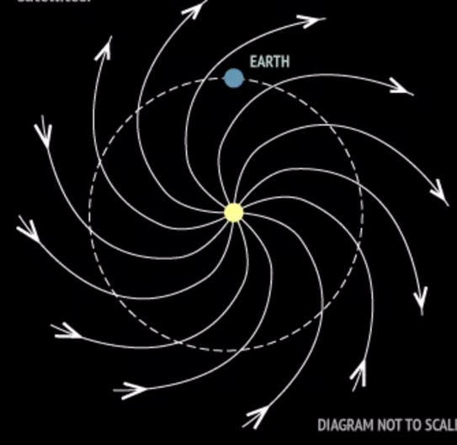
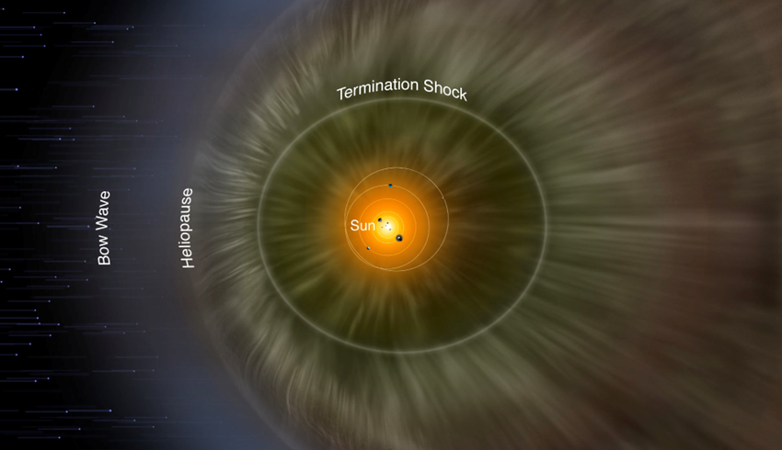
Without our protective bubble, these high-energy atom fragments would constantly bombard Earth. "Without the heliosphere, life would certainly have evolved differently — and maybe not at all.”
Solar Flare
A solar flare is a HUGE explosion on the Sun that happens when energy stored in 'twisted' magnetic fields (usually above sunspots) is suddenly released.
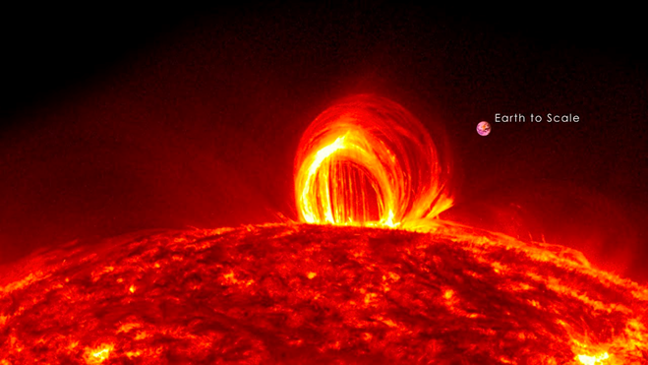
In a matter of just a few minutes they heat plasma to many millions of degrees and produce a burst of high energy particles.
Scientists classify solar flares according to their brightness in the x-ray wavelengths. There are three categories: X-class flares are big; they are major events that can trigger radio blackouts around the whole world and long-lasting radiation storms in the upper atmosphere.
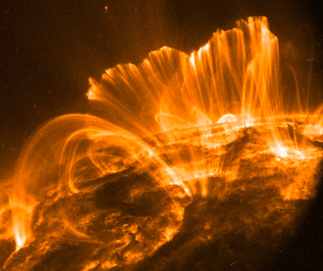
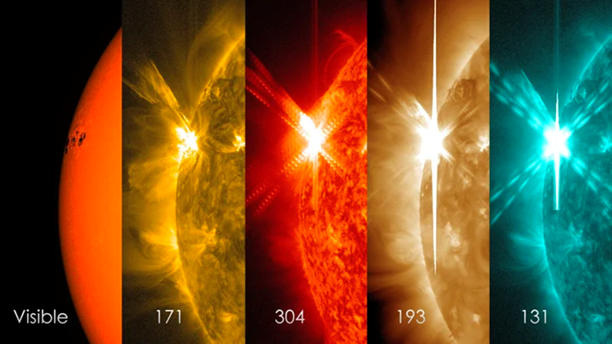
M-class flares are medium-sized; they generally cause brief radio blackouts that affect Earth's polar regions. Minor radiation storms sometimes follow an M-class flare.
Compared to X- and M-class events, C-class flares are small with few noticeable consequences here on Earth.
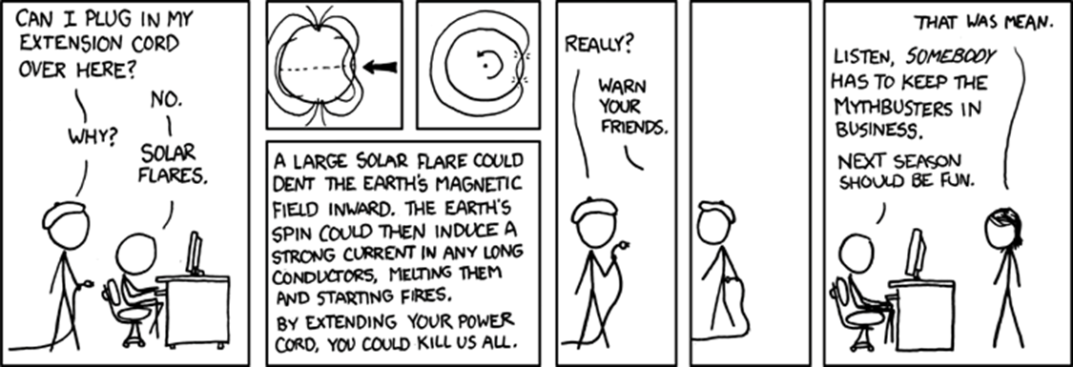
Solar flares are different to 'coronal mass ejections' (CMEs). CMEs are huge bubbles of gas threaded with magnetic field lines that are ejected from the Sun over the course of several hours, like a burp.
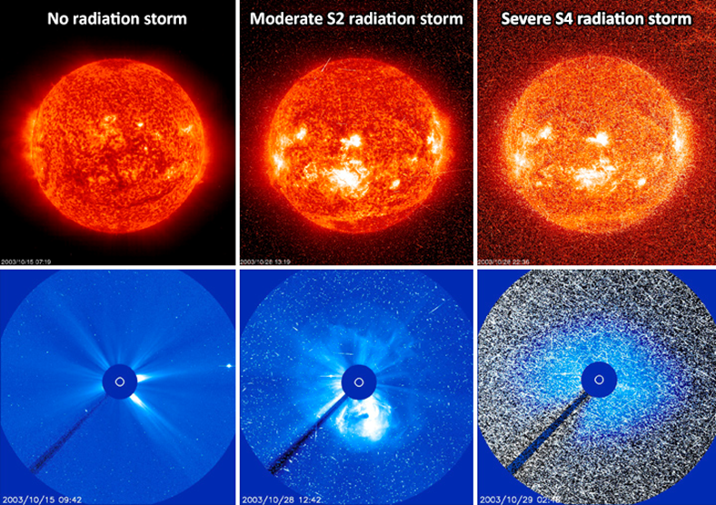
Coronal Mass Ejection (CME)
These colossal clouds of plasma can wreak havoc with power grids and satellites, but can also trigger stunning aurora displays. CMEs are large expulsions of plasma and magnetic fields from the Sun's atmosphere — the corona.
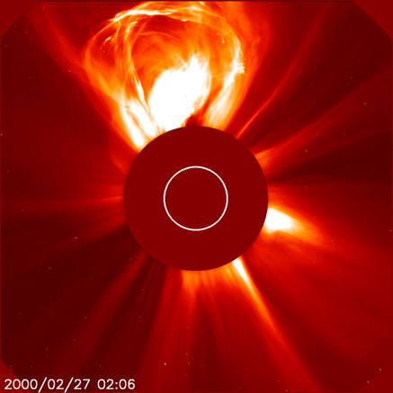
Compared to solar flares — bursts of electromagnetic radiation that travel at the speed of light, reaching Earth in just over 8 minutes — CMEs travel much slower. At their highest speeds of almost 1,900 miles per second CMEs can reach Earth in about 15 to
18 hours whilst slower CMEs traveling around 155 mi/s can take several days to arrive. These relatively slower travel times are useful as they give us more time to prepare for such an arrival. CMEs can wreak havoc with power grids, telecommunication networks and orbiting satellites and expose astronauts to dangerous doses of radiation.
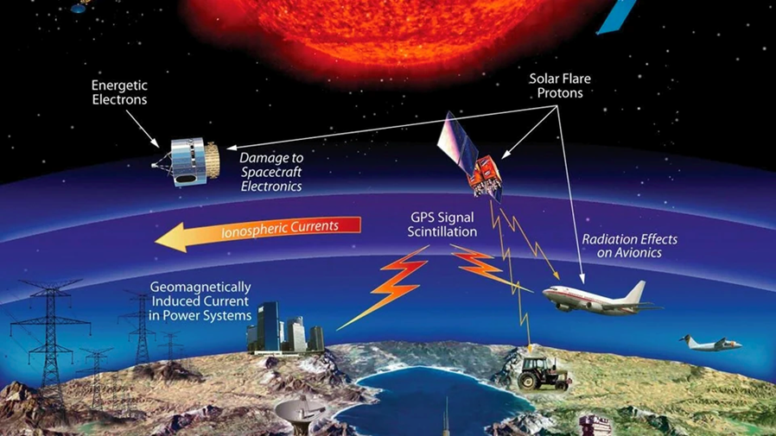
On the other hand, bigger CMEs can trigger impressive aurora displays that are visible at lower latitudes beyond their "normal" north/south pole area.
CMEs — like solar flares — are most common during solar maximum, a period in the Sun's 11-year cycle of activity when the star is at its most active.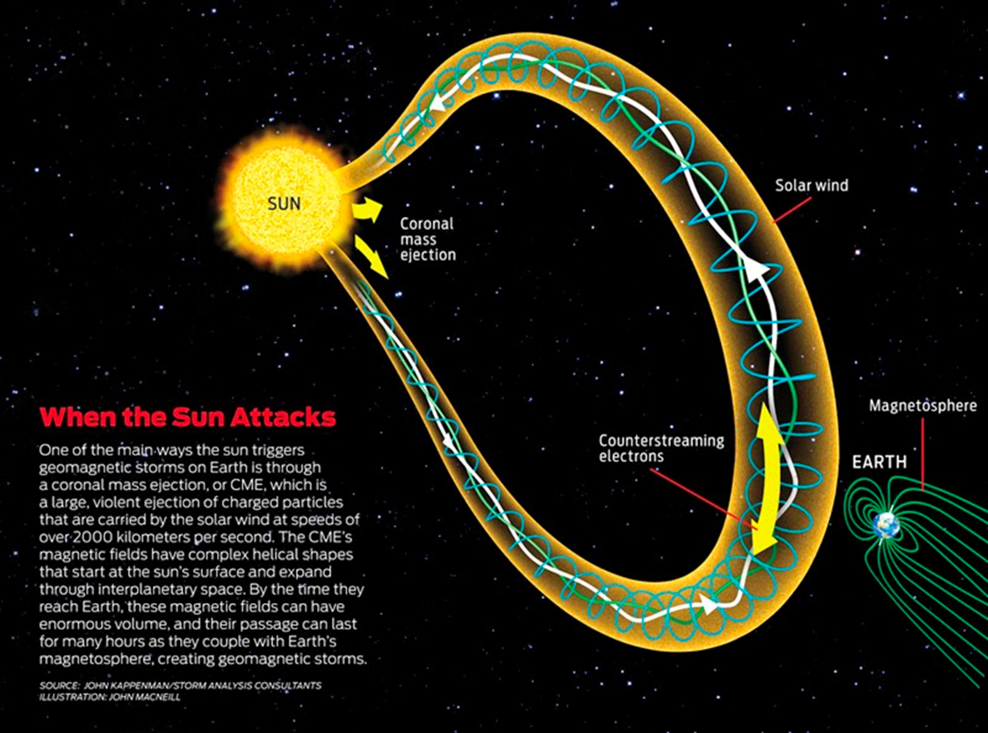
After CMEs are released, they swell in size as they travel away from the Sun. "Larger CMEs can reach a size comprising nearly a quarter of the space between Earth and the Sun by the time it reaches our planet!”
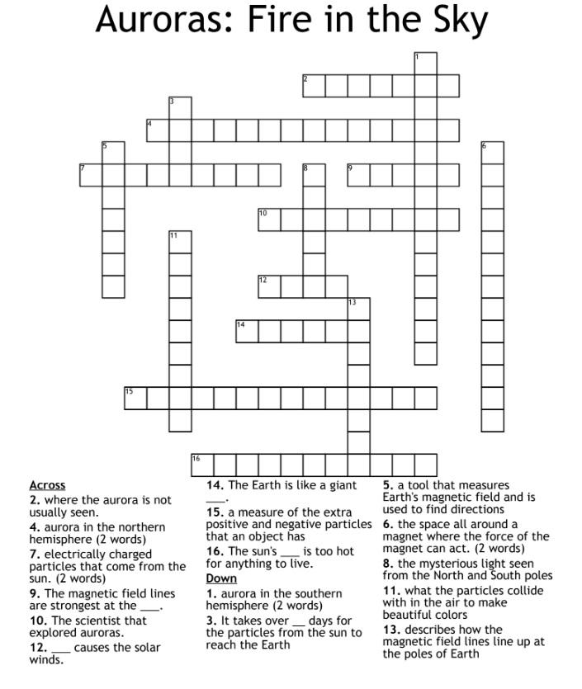
Chenille Stem Magnetosphere
The Earth has an invisible magnetic field, or “magnetosphere,” with a north and south pole, kind of like a bar magnet or “dipole.” The magnetosphere’s outer boundary is where a gusty stream of material carrying the Sun’s magnetic field into space, called the “solar wind”, meets the Earth’s magnetic field. Solar wind plasma squishes the sunward side of our magnetic field and stretches the side farther away from the Sun into a long “magnetotail.” The kind of aurora we see most often is triggered when the solar wind interacts with the sunward side of the magnetosphere, sending energized particles into the magnetotail, where they are accelerated toward the Earth’s poles. They then collide with atoms and molecules in the atmosphere, creating the beautiful aurora.
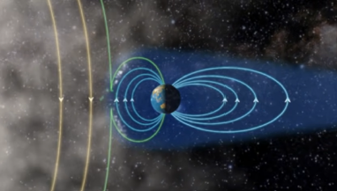
Check out this NASA video explaining the relationship between the Sun, the Earth’s magnetic field, and the aurora.
Dr. Alexa Halford, a space physics researcher at NASA, designed a simple chenille stem model of the magnetosphere to share with students. This activity can be a fun project or an educational tactile to help visualize some of the science behind magnetic field lines, auroras and other magnetosphere phenomena. A benefit of this model is that using chenille stems you can stretch the field lines to show which is more realistic to model the dynamic reconfigurations of the magnetic field that are constantly changing in response to the varying pressure of the solar wind. In addition, because this model shows magnetic field lines it is an excellent companion to our 3D Printed Magnetosphere Model, which focuses on the different regions of particles within the magnetosphere, but doesn’t show the lines.
Materials
Chenille stems in three colors to represent field lines at different distances from Earth. You can use any colors you like. Metallic chenille stems make this project extra fun!
- 2 in color A (I used blue)
- 3 in color B (I used green)
- 4 in a color C (I used grey)
Instructions
Note: Chenille stem sculpture is not an exact science, and when Dr. Alexa makes this model it turns out slightly different each time. It’s okay to experiment with ways to make the shapes of the magnetosphere. What will you come up with?
First, we’ll make lines to represent the Earth’s magnetic field. Twist the ends of the 2 color A chenille stems around one another to form a double-length chenille stem. Be sure the ends are wrapped tightly and a little bit tangled up so that they don’t easily pull apart. Similarly, combine the 3 color B chenille stems to form a triple-length chenille stem. | 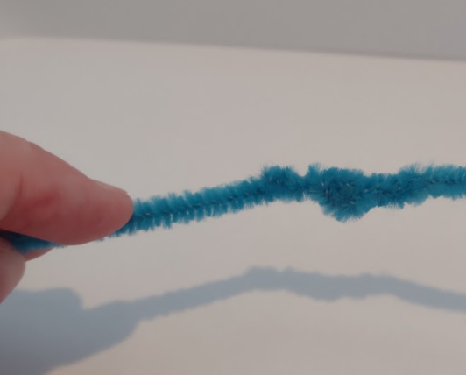
Place one side of the color A double-length chenille stem over the first three fingers of your non-dominant hand and hold the wrapped part in place with your thumb so it doesn’t unravel. | 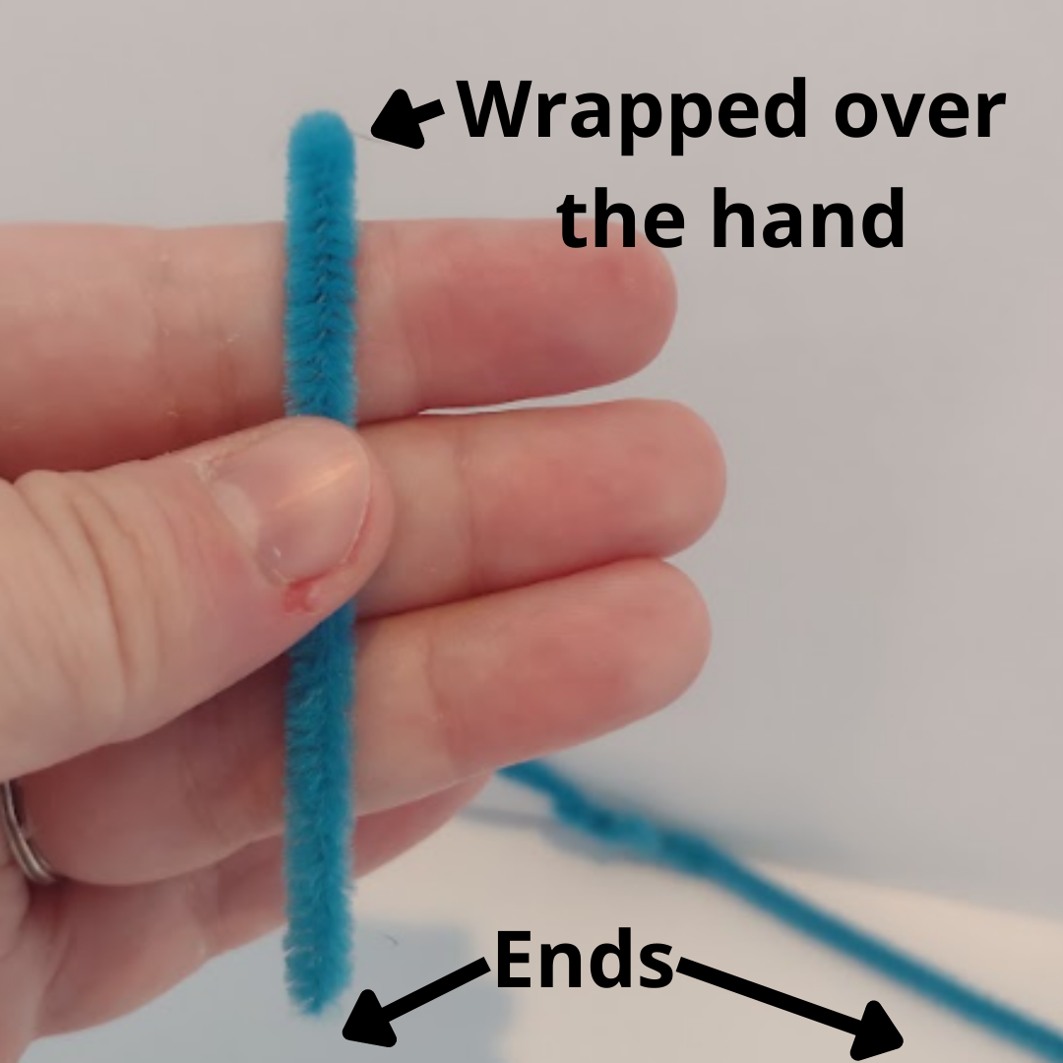
Wrap the rest of the color A double-length chenille stem back to front around your fingers 4 times. Tension should be firm, but not tight because you will be adding more chenille stems later. Note that the exact amount will vary based on the size of your hands and the length of the joined chenille stems. You can add another chenille stem or trim excess if needed. | 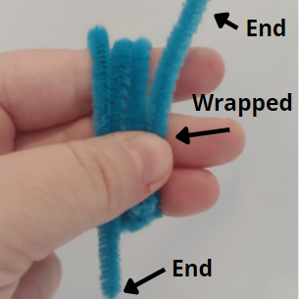
Thread the long remaining end of the double-length chenille stem through the channel between your first and middle finger. Pull to secure.
Now, add the end of the color B triple-length chenille stem and repeat the wrap process–except that this time, instead of wrapping around three fingers, you will wrap around four. Again, keep it firm but not tight, as you will need to fit more chenille stems in later. | 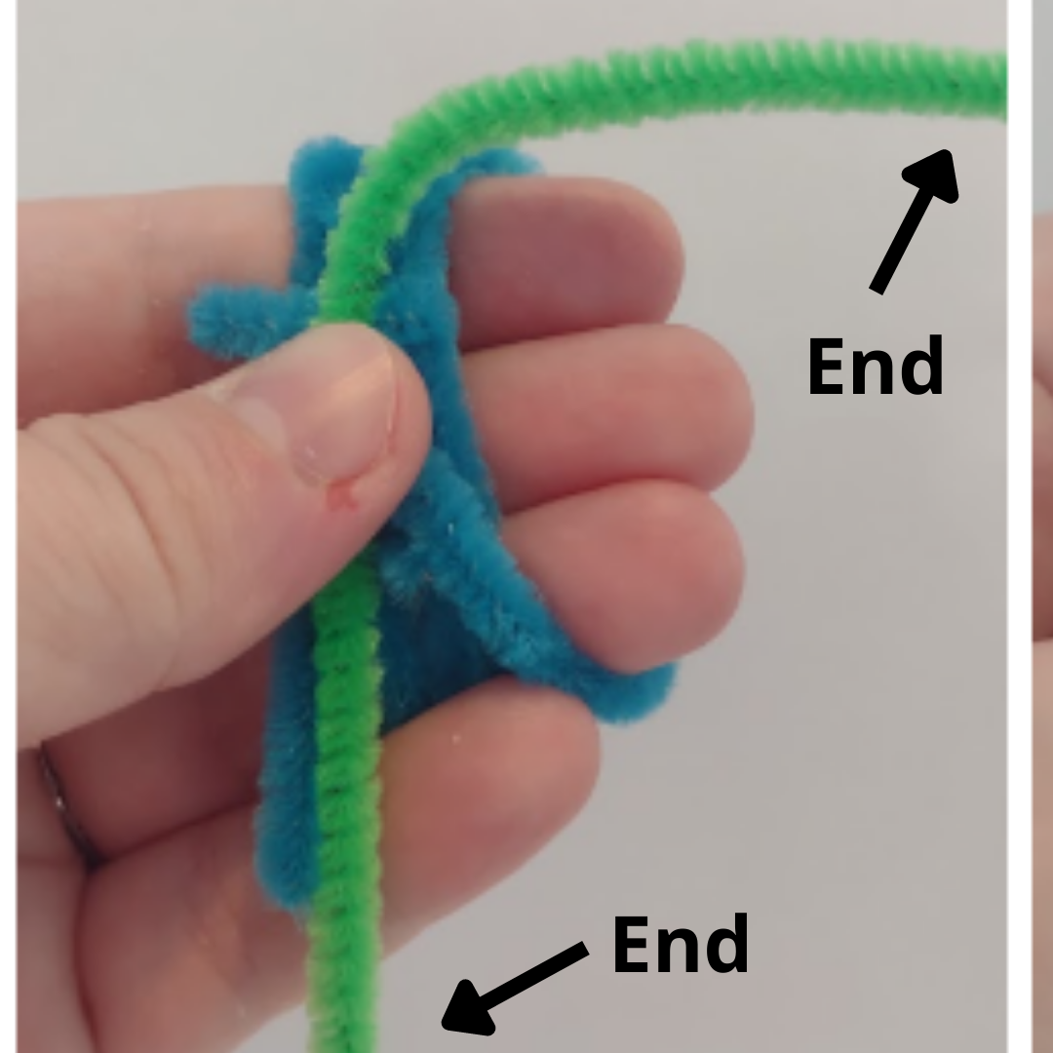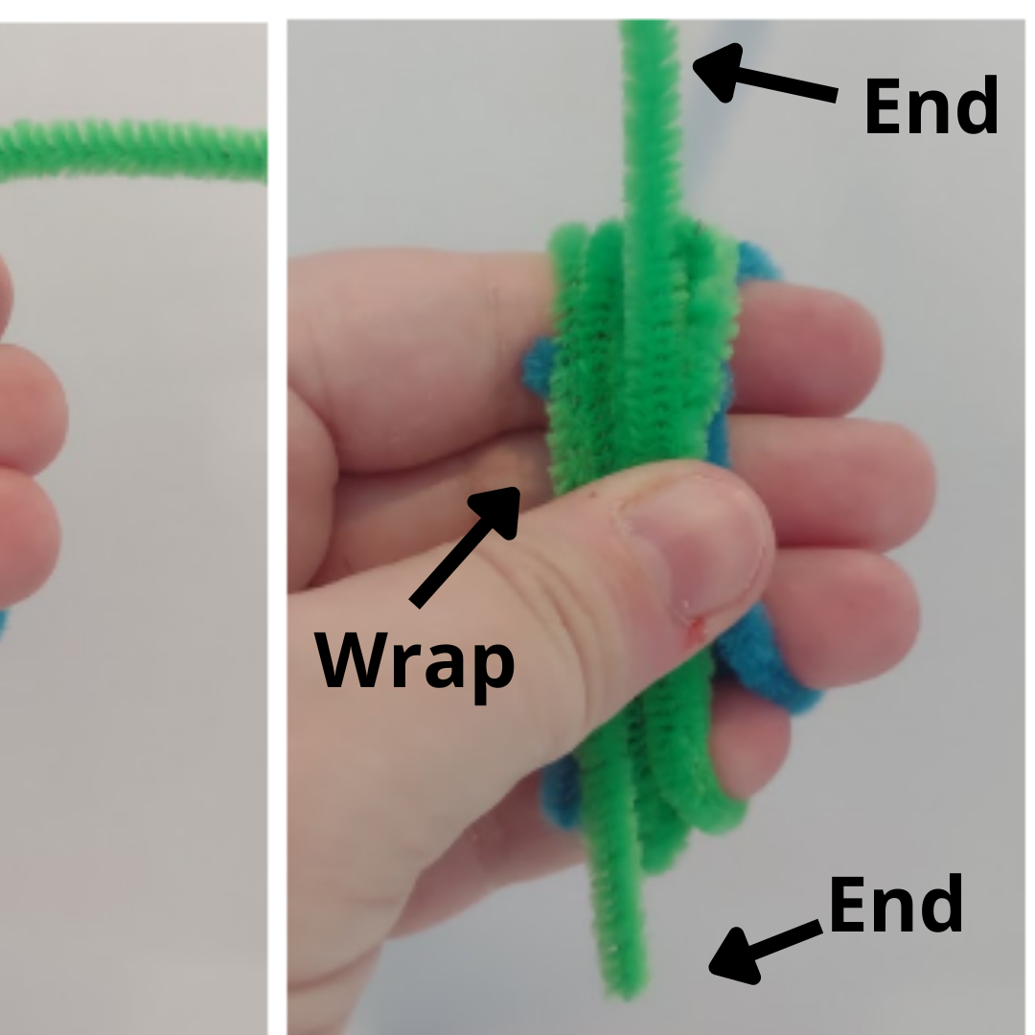
Thread the long remaining end of the color B triple-length chenille stem through the channel between your first and middle finger. Be sure to include the color A chenille stems; you are securing the entire piece together. | 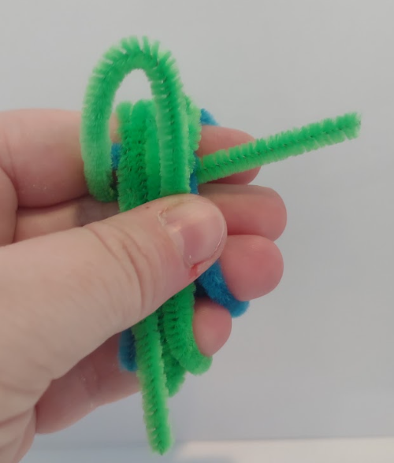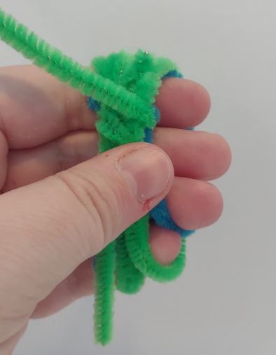
Remove the chenille stems from your fingers and wrap any remaining ends around the center of the join, forming an “Earth” as shown. If the Earth is too big, you can either trim the ends or wrap them around one of the chenille stems. The Earth should be firm but not tightly wrapped, as you will eventually insert 4-5 more chenille stems into its center.  Bend open the model and separate the loops so that you have four concentric pairs pointing different directions. These represent magnetic field lines connecting the Earth’s north and south poles. | 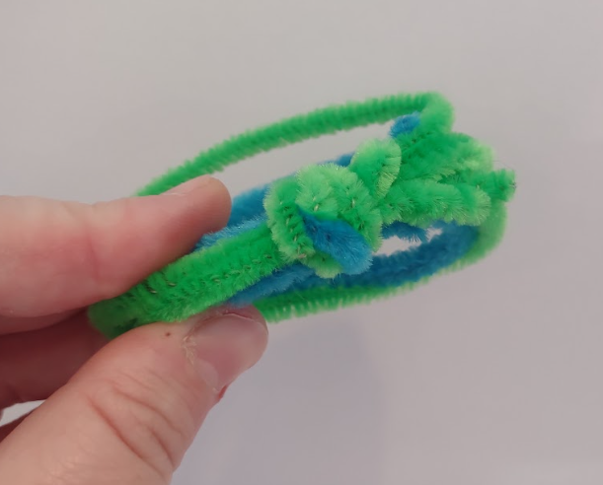
Bend open the model and separate the loops so that you have four concentric pairs pointing different directions. These represent magnetic field lines connecting the Earth’s north and south poles. | 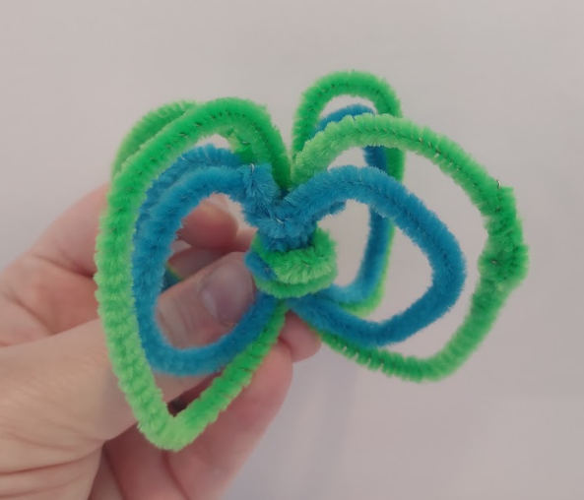
For the final set of field lines, insert one end of the four color C chenille stems into the Earth at one pole so it holds firmly. Then, insert the other end into the other pole. Repeat with the other color C chenille stems and line up with the other magnetic field lines.  For one of them, try to get both ends of the chenille stem all the way through the center of the model so that you can pull on them to shorten the color C loop. This forms the sunward side of the model. It should be slightly smaller than the others because the solar wind squishes the sunward side of the magnetosphere. Wrap or tuck any loose chenille stem ends out of sight. | 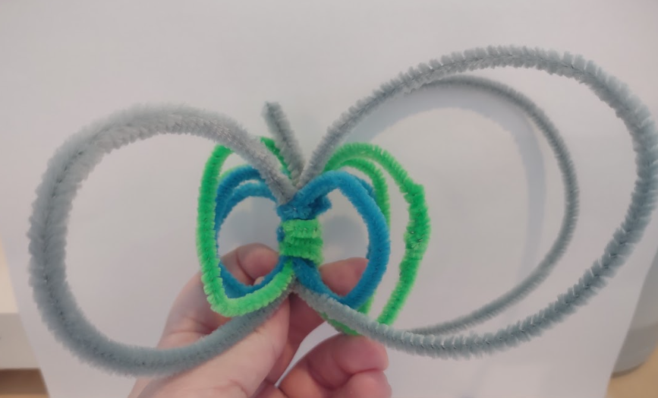
On the side opposite the sunward side, pull the color C loop into a teardrop shape to form the magnetotail, which is pulled out by the flowing solar wind. Your model is complete!  If you watch the video again, can you use your model to show how the solar wind creates aurora? | 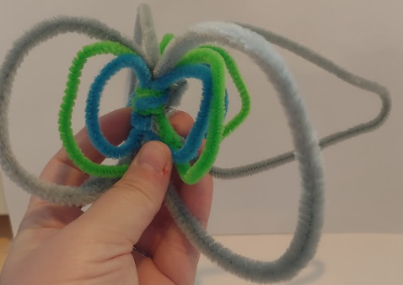
Note: Cats also love heliophysics–the study of the Sun and its relationship with the solar system–but chenille stems can be sharp and don’t make good toys for pets or very small children. | 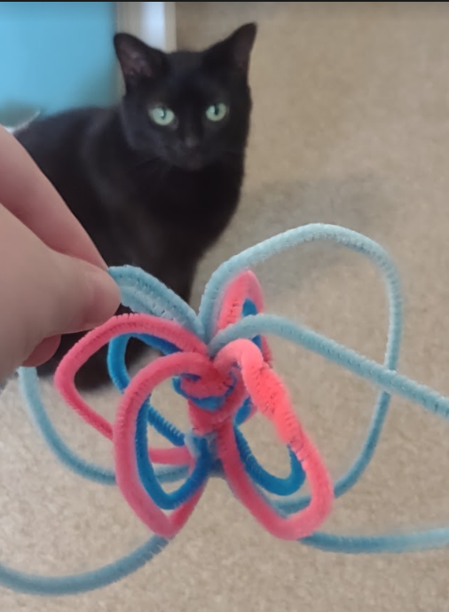

We hope that this activity can help illustrate some of the more abstract concepts of aurora. These activities from the University of Alaska Fairbanks also complement the above project. We’d love to hear about how you may find this useful.
If you’re looking to continue exploring, click here to find out how to make your own 3D printed model of the magnetosphere, and check out our blog for even more ideas!
Name:______________________________ Period:_____________ Date:________________

Explaining Aurora Video
RUBRIC
Meets | Project Item | Does Not Meet
 | Video includes props for CME, Earth, Sun, and Magnetosphere
 | Video is clear, audible, and interesting.
 | Video explains what a CME is from the sun accurately.
 | Video explains the Earth’s magnetosphere.
 | Video explains how the Sun’s plasma interacts with the Earth’s magnetosphere to create Aurora.

Name:______________________________ Period:_______________ Date:________________

Explaining Aurora Video
RUBRIC
Meets | Project Item | Does Not Meet
 | Video includes props for CME, Earth, Sun, and Magnetosphere
 | Video is clear, audible, and interesting.
 | Video explains what a CME is from the Sun accurately.
 | Video explains the Earth’s magnetosphere.
 | Video explains how the Sun’s plasma interacts with the Earth’s magnetosphere to create Aurora.

