How Do We Study the Sun from Earth?
by Thomas N. Tomas
Table of Contents
Lesson Overview and Objectives 2
Materials 6
5E Steps 9
Resources 10
Handouts 11

Level: Grades 5 and 6 Time: Ten 60-minutes class periods
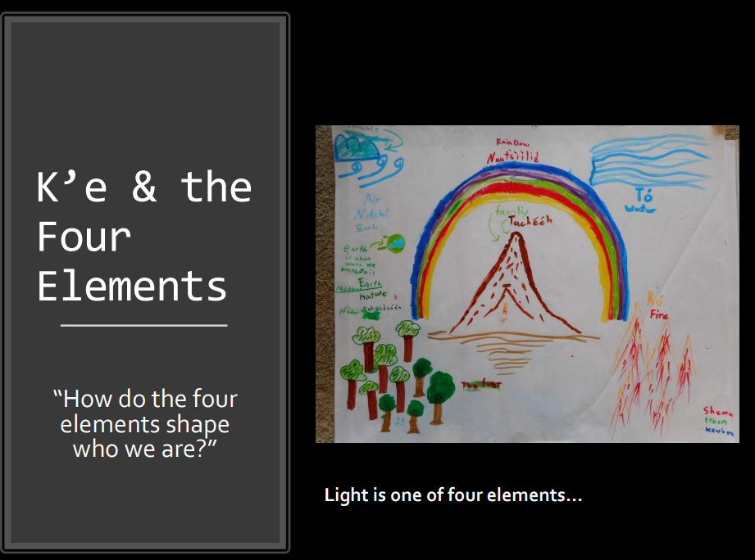
Note: This lesson was designed for Navajo students but is included in the HEAT collection to inspire and support all educators to incorporate indigenous knowledge.

Lesson Overview
Students will learn about the heliophysics associated with our closest star, the Sun. They begin with the relationships between the Sun, Earth, Self, and one’s shadow, then use a meter stick to measure length and angle of the shadow at the same time each day for two weeks. Students then construct and use a sundial to tell the time. Students will work in small groups to identify how the Sun is a natural system, beginning with a KWL chart. Then students will research, create a graphic organizer with the Sun as a natural system, and deliver a whole group presentation. Next, students will do a KWL chart pertaining to the two solar probes (Parker and Soho), followed by research and a draft of a graphic organizer concentrating on the probes as human-designed systems.

Educator Background Knowledge
The Sun takes about a month to rotate 360 degrees which can be seen using a Dobsonian telescope. As seen from the surface of Earth, the Sun has a diurnal path (daily, determined by rotation of Earth) and a seasonal path (quarterly, determined by the orbit of Earth around the Sun). A sundial can be used to track both. Shadows can be used to track how the Sun rises later and later each day as we approach the autumn solstice and in the days following. Seasonal changes caused by the orbit of Earth and tilt can be observed by noting where on the western horizon the Sun sets from their home perspective, for two weeks, providing dates and times.

Teachers may share the role of the Sun in Native Science: in the four elements that are part of the Dine’ or Navajo culture: The four elements shape who we are. The Heliosphere: One of four systems that comprise our biosphere. K’e as a relationship between Earth, Sun, Moon, Self and one’s shadow.

Guiding Questions:
- How do NASA missions contribute to Dine’ science?
- How does Dine’ science contribute to NASA missions?
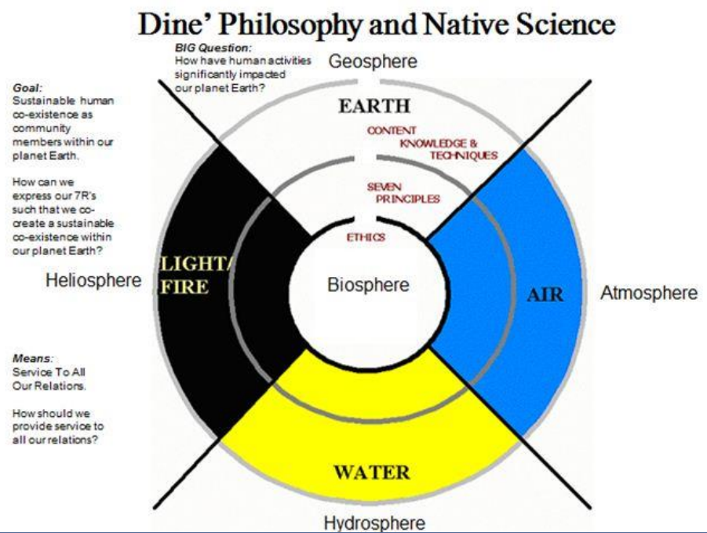

Learning Goals
Students will be able to answer these questions and the focal question:
- How does when and where we live shape who we are?
- How can we provide service to all our relations in ways that help us understand and address climate change?
- Focal Question: What is the Sun-Earth relationship and how do we know?

Learning Objectives
- Students will describe the Sun-Earth relationship as a natural system.
- Students will be able to support an argument that differences in the apparent brightness of the Sun compared to other stars is due to their relative distances from Earth.
Framework for Heliophysics Education
NASA Question: What are the impacts of the Sun on humanity? Big Idea: The Sun is really big and its gravity influences all objects in the solar system.
NASA Question: What causes the Sun to vary? Big Idea: The Sun is made of churning plasma, causing the surface to be made of complex, tangled magnetic fields.

NGSS Performance Expectations
- 5-ESS-1.1: Earth’s Place in the Universe: Support an argument that differences in the apparent brightness of the Sun compared to other stars is due to their relative distances from Earth.
- 5-ESS-1.2: Earth’s Place in the Universe: Represent data in graphical displays to reveal patterns of daily changes in length and direction of shadows, day and night, and the seasonal appearance of some stars in the night sky.
- 5-ESS-2: Earth’s Place in the Universe: Develop a model using an example to describe ways the geosphere, biosphere, hydrosphere, and/or atmosphere interact.
- MS-ESS1-1: Earth’s Place in the Universe: Develop and use a model of the Earth-Sun-Moon system to describe the cyclic patterns of lunar phases, eclipses of the Sun and Moon, and seasons.
- MS-ESS1-2: Earth’s Place in the Universe: Develop and use a model to describe
- the role of gravity in the motions within galaxies and the solar system.
- MS-ESS1-3: Earth’s Place in the Universe: Analyze and interpret data to determine scale properties of objects in the solar system.

Common Core Standards for Mathematical Practice
- MP.2: Reason abstractly and quantitatively. (MS-PS1-2), (MS-PS1-5)
- MP.4: Model with mathematics. (MS-PS1-5)
- 6.RP.A.3: Use ratio and rate reasoning to solve real-world and mathematical problems. (MS-PS1-2), (MS-PS1-5)
- 6.SP.B.4: Display numerical data in plots on a number line, including dot plots, histograms, and box plots. (MS-PS1-2)
- 6.SP.B.5: Summarize numerical data sets in relation to their context (MS-PS1-2)

Common Core Standards for ELA Literacy
- RI.5.1: Quote accurately from a text when explaining what the text says explicitly and when drawing inferences from the text.
- RI.5.7: Draw on information from multiple print or digital sources, demonstrating the ability to locate an answer to a question quickly or to solve a problem efficiently.(5-ESS3-1)
- RI.5.9: Integrate information from several texts on the same topic in order to write or speak about the subject knowledgeably. (5-ESS3-1)
- W.5.8: Recall relevant information from experiences or gather relevant information from print and digital sources; summarize or paraphrase information in notes and finished work, and provide a list of sources. (5-ESS3-1)
- W.5.9: Draw evidence from literary or informational texts to support analysis, reflection, and research. (5-ESS3-1)

Crosscutting Concepts
- Systems and System Models: A system can be described in terms of its components and their interactions. (5-ESS-2), (MS-ESS-2)

Targeted STEM Skills
- Analyzing and Interpreting Data Analyzing data in 3–5 builds on K–2 experiences and progresses to introducing quantitative approaches to collecting data and conducting multiple trials of qualitative observations. When possible and feasible, digital tools should be used. Represent data in graphical displays (bar graphs, pictographs and/or pie charts) to reveal patterns that indicate relationships. (5-ESS1-2)
- Engaging in Argument from Evidence Engaging in argument from evidence in 3–5 builds on K–2 experiences and progresses to critiquing the scientific explanations or solutions proposed by peers by citing relevant evidence about the natural and designed world(s). Support an argument with evidence, data, or a model. (5-ESS1-1)

Materials
- 10” Newtonian telescope on a Dobsonian mount.
- Hero Twins (book)
  - A video of the story is available at: https://www.youtube.com/watch?v=YyZn7dfi8DI
- Monster Slayer: A Navajo Folktale (book)
- Jo’hanna’ei, Bringer of Dawn (book)
- National Geographic, July 2004 article: “Hot News From Our Stormy Star”
- Space weather activity: Measuring how many days for the Sun to spin 360 degrees on its axis: https://spacemath.gsfc.nasa.gov/weekly/4Page1.pdf
- Estimating the Sun’s Rotation Period (Stanford): http://solar-center.stanford.edu/spin-sun/estimate.html
- Making a Sundial (globe.gov): https://www.globe.gov/documents/348614/41018820-9356-4929-a750-11391bf646ae

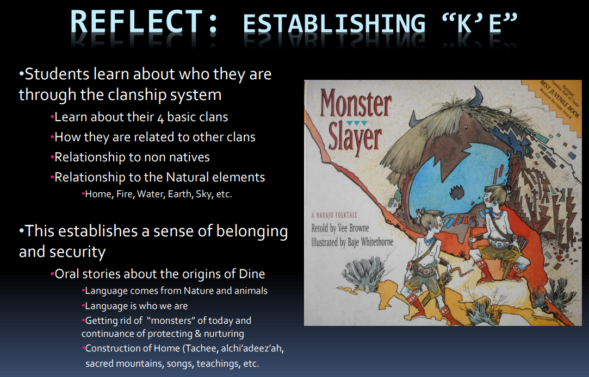

Handouts
- KWL Chart (see Handouts)
- Making a Sundial
- Systems: 5 Features
- Native Science Connections — Systems Thinking and Mother Earth, Father Sky

Links to Digital Resources for Students
- Sun 101 | National Geographic: https://www.youtube.com/watch?v=2HoTK_Gqi2Q
- The Sun: Crash Course Astronomy #10: https://www.youtube.com/watch?v=b22HKFMIfWo
- Sun and Earth size relationships: https://helioviewer.org
- Student Helioviewer: https://student.helioviewer.org/
- Heliophysics Missions https://science.nasa.gov/learn/heat/missions/
- Real World: Earth's Energy Balance — Energy In and Energy Out
https://nasaeclips.arc.nasa.gov/video/realworld/real-world-earths-energy-balance-energy-in-and-energy-out
- Gravity and Orbits Interactive: https://phet.colorado.edu/sims/html/gravity-and-orbits/latest/gravity-and-orbits_en.html
- We’re All Made of Stardust: Here’s How (Smithsonian Channel) video: https://www.youtube.com/watch?v=xIV-k39Kukw
- A Total Solar Eclipse Revealed Solar Storms 100 Years Before Satellites: https://www.youtube.com/watch?v=9oHhO2xA6e

Key Vocabulary
Characteristics of a system: inputs/outputs, interactions, boundaries, components, properties

Material Preparation
- Use a collimator to align mirrors within the Newtonian telescope.
- Make certain that the sundial is designed for your school’s latitude.
- Have models of the Earth, Moon, Sun, and measuring tape to help students experience scaled relationships between sizes and distances of each object.

5E Steps
Engage
Students will study sunspots using a 10” Newtonian telescope on a Dobsonian mount.

Watch the video: We are all made of stardust. Here's how! https://www.youtube.com/watch?v=xIV-k39Kukw
We are made of CHNOPS (carbon, hydrogen, nitrogen, oxygen, phosphorus, sulphur).

Students will learn about the significance of one’s shadow within the Navajo culture. Students will trace their shadows on the sidewalk and chart the changes in length and angle over two weeks.

Explore
Students will work in small groups to explore the relationships between our closest star (the Sun) and the Parker Solar Probe and Solar Orbiter using the Merge Cube (a free educational trial is available).

Students will use a KWL chart to explain what they know about the Sun. Next, students will research and chart the qualities of the Sun as a natural system.

Explain
Students will work in small groups to research the links provided, collaboratively create models of the Sun, and then present their graphic organizers to the whole group and explain how the Sun is a natural system. Students will explain relationships between the Sun, Moon, Earth and Self: Lunar eclipses, solar eclipses, Earth’s elliptical orbit, solstices and equinoxes, etc.
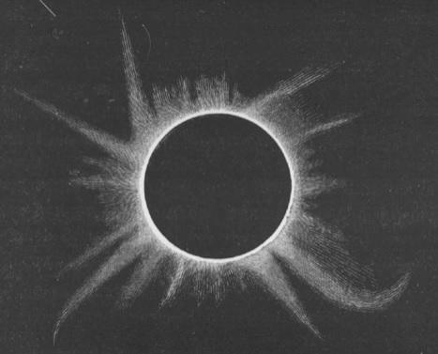
The NASA video A Total Solar Eclipse Revealed Solar Storms 100 Years Before Satellites shows images drawn by astronomers from around the world. Look back to an historic 1860 total solar eclipse, which many think gave humanity our first glimpse of solar storms, called coronal mass ejections, 100 years before scientists first understood what they were. Scientists observed these eruptions in the 1970s during the beginning of the modern satellite era, when satellites in space were able to capture thousands of images of solar activity that had never been seen before. But in hindsight, scientists realized their satellite images might not be the first record of these solar storms. Hand-drawn records of an 1860 total solar eclipse bore surprising resemblance to these groundbreaking satellite images.

Extend
Students will create multimedia presentations and present to the following audiences:
- Peers at school
- STEM Family Literacy Nights for family and community members
- Sister Schools via video conferencing
- An e-portfolio entry that provides each young scientist and engineer with an opportunity to tell her or his story as a learner.
- Students will consider how the human-designed (engineered) systems were constructed with the natural system in mind, i.e., compatibility.

Evaluate
Students will keep a Science and Engineering Notebook as well as an electronic notebook to be kept within their e-portfolio (e.g., Google Drive) located within their classroom website with access granted via each student’s email account.

Students’ work in their notebooks will serve as Common Formative Assessment opportunities. The teacher will seek out students’ on-track thinking as well as misconceptions, and then modify and differentiate instruction accordingly. Additional evaluation strategies will include quizzes, online discussion boards, and online forms.

Resources
- KWL Chart
- Making a Sundial (NASA)
- Systems: 5 Features
- Native Science Connections — Systems Thinking and Mother Earth, Father Sky

Links to Digital Resources for Students
- Sun 101 | National Geographic: https://www.youtube.com/watch?v=2HoTK_Gqi2Q
- The Sun: Crash Course Astronomy #10: https://www.youtube.com/watch?v=b22HKFMIfWo
- Sun and Earth size relationships: https://helioviewer.org
- Student Helioviewer: https://student.helioviewer.org/
- Sun-Earth: https://www.nasa.gov/mission_pages/sunearth/index.html
- Real World: Earth's Energy Balance — Energy In and Energy Out
https://nasaeclips.arc.nasa.gov/video/realworld/real-world-earths-energy-balance-energy-in-and-energy-out
- Gravity and Orbits Interactive: https://phet.colorado.edu/sims/html/gravity-and-orbits/latest/gravity-and-orbits_en.html
- We’re All Made of Stardust: Here’s How (Smithsonian Channel) video: https://www.youtube.com/watch?v=xIV-k39Kukw
- A Total Solar Eclipse Revealed Solar Storms 100 Years Before Satellites: https://www.youtube.com/watch?v=9oHhO2xA6e

Handouts
These begin on the next page.
K-W-L Chart

TOPIC:__________________________________

What I Know | What I Want to Know | What I Learned
