How Does the Earth’s Magnetic Field Cause Aurora?
By Rachel Geiter

Table of Contents
Lesson Overview and Objectives 2
Materials 4
5E Steps 4
Resources 5
Handouts 6

Lesson Overview
Level: Middle School Time: 1 50-minute class period
Teacher will introduce auroras with a favorite short video, then students will be asked to find videos they think are interesting on social media and share them with each other and the teacher. Students write down initial questions and share. Students create an initial model (individually, talking in groups, drawing an explanation, sharing with class). Students make connections between aurora and magnets (prior study). Teacher provides an overview of the magnetosphere with pictures/videos (7-10 min Slides). Students then follow instructions to make an edible model of the magnetosphere. They can eat it when their model is correct! Check for understanding: google slide with picture of edible model, students need to drag and drop labels of different parts of magnetosphere onto picture.

Educator Background Knowledge As electrically charged, molten iron churns far below Earth’s surface, within the planet’s outer core, it generates a magnetic field large enough to extend far out into space. On the Sun-facing side of Earth – where the magnetic field is compressed by the constant bombardment of the solar wind – the magnetosphere extends some 6 to 10 times the radius of Earth. The side of the magnetosphere facing away from the Sun – the nightside – stretches out into an immense magnetotail, which fluctuates in length and can measure hundreds of Earth radii, extending far past the Moon's orbit at 60 Earth radii.
‌

Learning Goal:
Students will be able to model Earth’s magnetic field.

Learning Objectives
- Students will understand why our planet creates a magnetic field (and why other planets don’t).
- Students will be able to model what the Earth’s magnetic field looks like and how it moves.
- Students will learn and identify the parts of the magnetic field.

Framework for Heliophysics Education
NASA Question: What are the impacts of the Sun on humanity? Big Idea: The Sun is active and can impact technology on Earth via space weather.
NASA Question: What causes the Sun to vary? Big Idea: Energy from the Sun is created in the core and travels outward through the Sun and into the heliosphere.

NGSS Performance Expectations
- MS-PS2-5. Motion and Stability: Forces and Interactions: Conduct an investigation and evaluate the experimental design to provide evidence that fields exist between objects exerting forces on each other even though the objects are not in contact.
- MS-PS2-3. Motion and Stability: Forces and Interactions: Ask questions about data to determine the factors that affect the strength of electric and magnetic forces.

Crosscutting Concepts:
- Systems and System Models: Models can be used to represent systems and their interactions –such as inputs, processes and outputs– and energy and matter flows within systems

Targeted STEM Skills:
- Asking Questions and Defining Problems: Asking questions and defining problems in grades 6–8 builds from grades K–5 experiences and progresses to specifying relationships between variables, and clarifying arguments and models.

Materials
- Magnetosphere Modeling Lab Sheets (1 per group)
- Per Student = Blueberry, Carrot, Cabbage (1 piece/layer), Onion (1 ring), Knife, Toothpicks
- Pencils, Colored Pencils
- Cell Phones

Handouts
- Modeling the Magnetosphere with Food: Student Lab
- Guided notes for Earth’s Magnetosphere

Links to Digital Resources for Students
- Check for Understanding (CFU) —See Handouts.
- Teacher Lecture on How Earth’s Magnetic Field Causes Aurora: Slides

Key Vocabulary
Molten Core, Magnetosphere

Material Preparation
- Gather supplies for the lab and place in tubs, ensure enough supplies for a group of four students per tub.
- Pre-cut onion layers and cabbage strips for group

5E Steps
Engage
- Show students a NASA video of aurora, such as NASA: The Mystery of the Aurora: https://www.youtube.com/watch?v=PaSFAbATPvk.

Explore
- Put students in groups of 2-3. Have students look up auroras on their favorite app (like Tiktok or Instagram) and share with another student.

Explain
- Teacher gives an overview of the magnetosphere using the slide deck that is located here.

Extend
- Students model the magnetosphere with food. The instructions are on the Student Worksheet.

Evaluate
Check for Understanding (CFU)
- Have students share background knowledge on sticky notes posted in the classroom with their name at the beginning of the lesson.
- The day after note taking, have students mark up their notes with colored pencils and write questions on the side, as well as a summary sentence at the end.
- On the Student Worksheet students should cut out the labels and paste the magnetic field parts onto the picture.

Resources
- Modeling the Magnetosphere with Food: Student Lab
- Guided notes for Earth’s Magnetosphere
- Student Worksheet
- Teacher Lecture: Slides

Handouts
These begin on the next page.
Modeling Earth's Magnetosphere With Food

Name:_____________________________ Period:________ Date:_____________________

How does Earth’s magnetic field cause aurora?
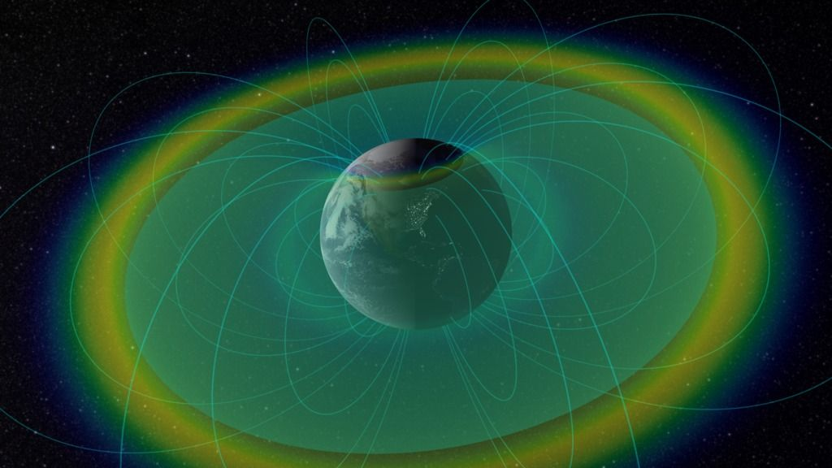
Goal: Create a visual model of the magnetic field around planet Earth.
Vocabulary: The Magnetopause (carrot), Cusps, Plasma Sheet (cabbage), Radiation Belts (onion ring), Earth (blueberry).
Materials: Blueberry, Carrot, Cabbage (1 piece/layer), Onion (1 ring), Knife, Toothpicks

- Your blueberry will represent the Earth.
- Around the Earth are radiation belts that look like a doughnut (the Earth being the doughnut hole). The rings are made of plasma (highly charged gas particles). Get a ring from an onion and cut it so it wraps neatly around your blueberry, and push a toothpick through the blueberry and onion layer so it holds them together.
- Next, cut out a piece/layer of cabbage so it’s the same size as the shape below.This represents the plasma sheet, which is flat and goes through the equator of the Earth; it has more plasma and a weaker magnetic field.

Plasma Sheet
- Cut a hole that is just small enough to fit your Earth/radiation belts.
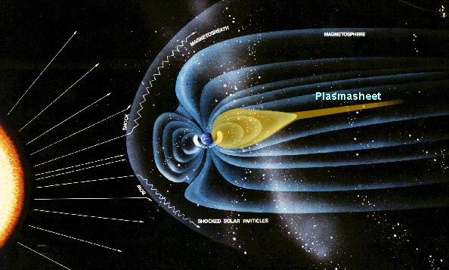
- Now get a carrot — this represents the magnetopause, which is the boundary of the Earth’s magnetic field. The sunward side is squished by particles from the Sun, while the side way from the Sun stretches into a long tail.
  - Measure 3 cm from the top of your carrot and cut in a small cone/hole on either side. This represents the cusps over Earth’s poles, which look like funnels, where the magnetic fields run in different directions.

- Carefully cut the carrot lengthwise.

- Push a toothpick through the Earth+radiation belts and push the carrots onto either side.
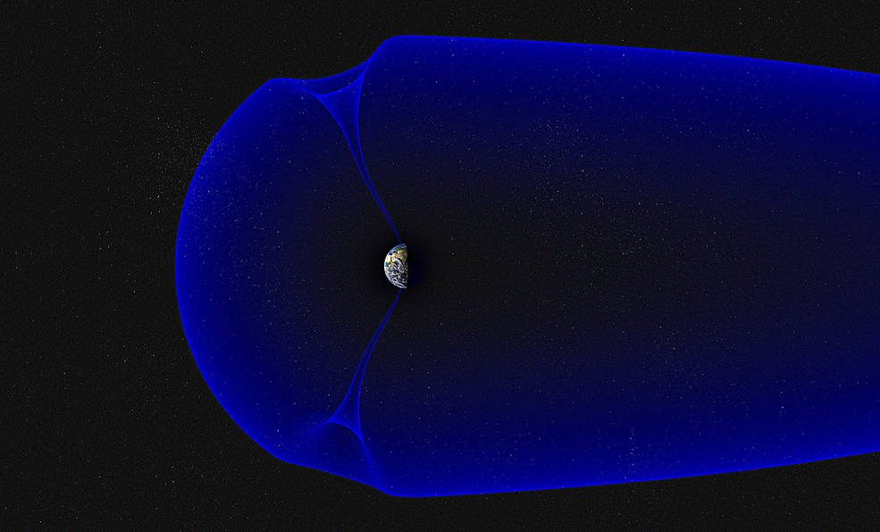
- Take the plasma sheet and attach it to the magnetopause (carrots) with toothpicks.

- Check with your teacher that you have correctly modeled the magnetosphere of the Earth. If you are correct, you can eat your model!

Student Worksheet Notes for Earth’s Magnetosphere

      - Draw what space is filled with:

      - Charged particles are __________________.

      - Draw picture of charged particles:

      - What protects us? The _______________________________!

      - Sketch below and label the magnetotail.

      - Why is the Earth magnetic? (give two reasons):

      - Draw a picture of the inner core here:

      - The Sun facing side of the magnetosphere is ________________ Earth radii.

      - The far side (away from Sun) = ________________ Earth radii.
The Earth’s Magnetosphere
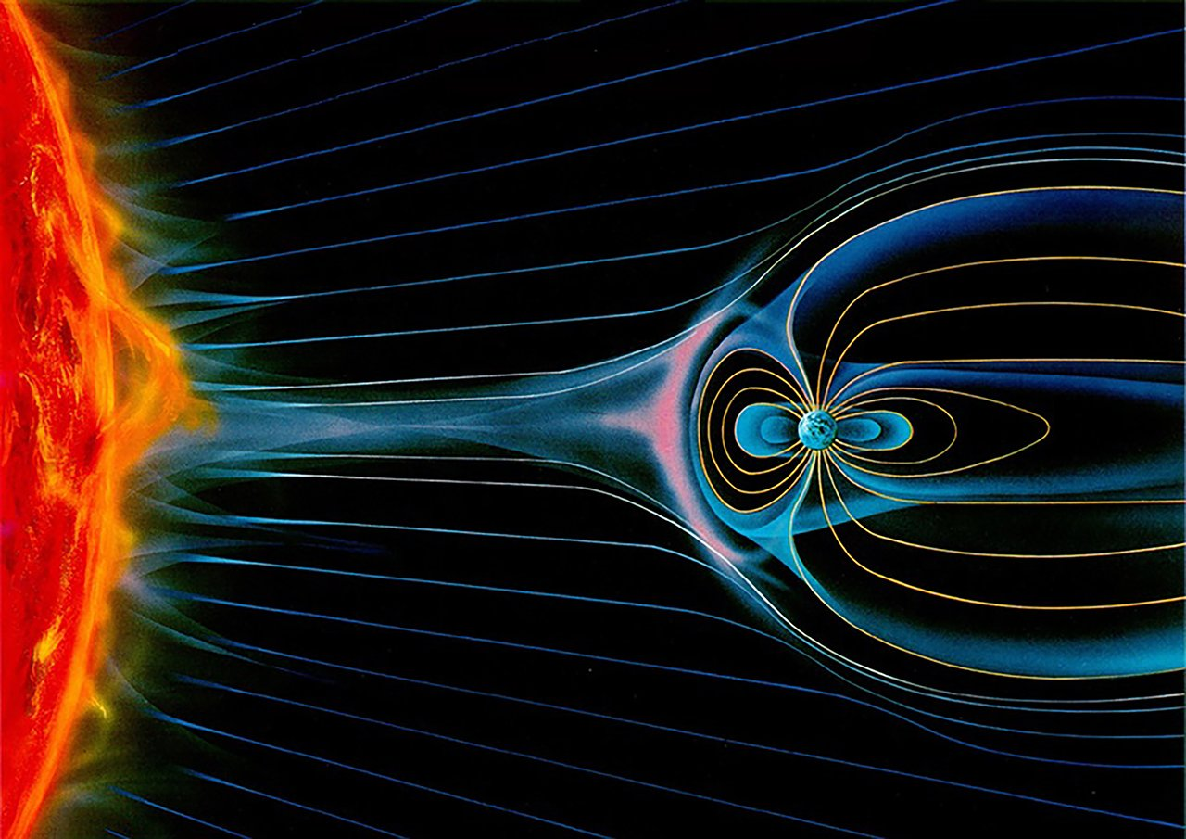
Cut out the labels below and tape them to the diagram above.

