Impact Cratering and the Age of the Solar System
by Cris DeWolf
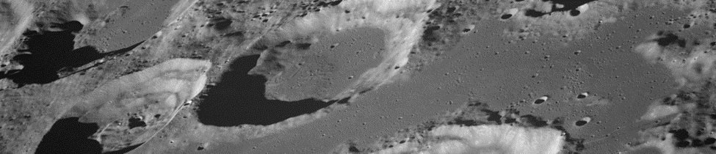
Table of Contents
Lesson Overview and Objectives 2
Materials 4
5E Steps 5
Resources 7
Handouts 9

Lesson Overview
Level: 9-12 Time: 3-4 class periods
For this lesson, students will gather evidence through a variety of media to support the claim that Earth is 4.6 billion years old, and formed along with the rest of our solar system from material in a nebula. Assessment of learning goals will be based on the student’s CER (Claim-Evidence-Reasoning) essay.

Educator Background Knowledge
Current thinking on the origin of the moon is that it formed after a Mars-sized object (Theia) collided with the early Earth. Material ejected into Earth orbit coalesced into the moon. Based on ages found for meteorites of lunar origin, as well as from moon rock collected by astronauts in the Apollo missions, places the age of our Moon at 4.51 billion years. Ages of this material were determined using a method known as radiometric dating. After it formed, large impacts continued to occur (See Late Heavy Bombardment). And impacts have continued ever since, just (usually) smaller. Patterns of overlapping craters can be used to establish a sequence of events, which impact occurred first, next, last? This method of dating is called relative dating. The Law of Superposition tells us that in a sequence of rock strata (or craters) the oldest is usually on the bottom of the sequence of layers.
Learning Goals
Students will be able to use evidence to support the claim that Earth is over 4.5 billion years old. They will gather evidence using relative dating and radiometric dating techniques, and via select readings.

Learning Objectives
- Use principles of relative dating to establish a chronology of impact events on the moon’s surface.
- Show an understanding of half-life by using the PhET simulation Radioactive Dating Game (PhET)
- Students will be able to support the claim that Earth is 4.6 billion years old with evidence, explaining their reasoning (C-E-R)
Framework for Heliophysics Education
NASA Question: What causes the Sun to vary? Big Idea: Our Sun, like all stars, has a life cycle.

NGSS Performance Expectations
HS-ESS1-6: Earth’s Place in the Universe: Apply scientific reasoning and evidence from ancient Earth materials, meteorites, and other planetary surfaces to construct an account of Earth’s formation and early history.

Disciplinary Core Ideas
- ESS1.C: The History of Planet Earth: Although active geologic processes, such as plate tectonics and erosion, have destroyed or altered most of the very early rock record on Earth, other objects in the solar system, such as lunar rocks, asteroids, and meteorites, have changed little over billions of years. Studying these objects can provide information about Earth’s formation and early history.
- PS1.C: Nuclear Processes: Spontaneous radioactive decays follow a characteristic exponential decay law. Nuclear lifetimes allow radiometric dating to be used to determine the ages of rocks and other materials. (secondary)
Targeted STEM Skills
- Constructing Explanations and Designing Solutions: In 9–12 builds on K–8 experiences and progresses to explanations and designs that are supported by multiple and independent student-generated sources of evidence consistent with scientific ideas, principles, and theories.
- Apply scientific reasoning to link evidence to the claims to assess the extent to which the reasoning and data support the explanation or conclusion.
Cross-Cutting Practices
- Stability and Change: Much of science deals with constructing explanations of how things change and how they remain stable.

Materials
Per student group: meteorite sample or images, magnifiers, magnets.
Handouts (See Handouts at the end of the lesson)
- Claim-Evidence-Reasoning (C-E-R) worksheet
- Radioactive Dating Game (pHet) Instructions
- MoonTrek
- LRO Background
- Unit Test for this lesson, Magnetism Mysteries and Exploring Eclipses as a unit
Links to Digital Resources for Students
- Radioactive Dating Game (PhET)
- “Alabama Woman Hit by Meteorite”
https://www.youtube.com/watch?v=hOKbs-xKD5Q
- “The Chelyabinsk Meteor: What We Know”
https://www.youtube.com/watch?v=JB2eoQfOGBA
- Formation of Planets in Protoplanetary Disks
- “Eyes on Exoplanets” website: https://exoplanets.nasa.gov/eyes-on-exoplanets/#/

Key Vocabulary
Planetesimal, asteroid, meteor, meteorite, crater, radiometric dating, relative dating, half-life, isotope

Material Preparation
- Obtain a sample of an iron-nickel meteorite, if possible. Use of images will work if meteorite samples are unavailable.
*Suggested image: https://www.jpl.nasa.gov/images/pia12191-magnified-look-at-a-meteorite-on-mars
- If using actual samples, have magnets and magnifiers available for student use.

5E Steps
Engage
Was Chicken Little right? Is the sky falling?

Question: Has anyone ever been hit by a meteorite? Some people must have been.

See map at http://goskysentinel.com
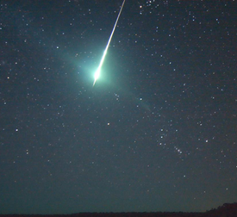
Explore
Show the video: “Alabama Woman Hit by Meteorite”
https://www.youtube.com/watch?v=hOKbs-xKD5Q

Initiate a discussion: “This happened a long time ago. Have meteorites hurt anyone more recently?”.

Show the video: “The Chelyabinsk Meteor: What We Know”
https://www.youtube.com/watch?v=JB2eoQfOGBA

What are “shooting stars”? Where do they come from? If you have access to a meteorite (iron-nickel preferably) allow students to examine it, using magnets and magnifiers. If it is a slice they should be able to see the Widmanstätten pattern of crystallization.

Have your students read the Meteors and Meteorites article on the NASA Solar System Exploration website.

Questions for guiding discussion:
- What is the difference between meteoroids, meteors, and meteorites?
- Would you say that a lot of “extraterrestrial” material falls on Earth each day? Explain.
- Even though there are a number of meteor showers each year, why does little of this infalling material make it to the surface?
- What can we learn about the origins of the solar system from meteorites?

When meteorites impact the Earth, the moon, or even other solar system objects they will leave a crater in that object’s surface. The pattern of overlap in some craters with each other can be used to establish their age relative to each other. This technique of relative dating is commonly used by geologists.

Lunar Image Analysis
Students will determine the formation sequence of a series of overlapping craters from Lunar Reconnaissance Orbiter images, see Tasks 1-4.

Optional activity: Moon Trek: NASA Portal to Lunar Exploration
Students can use relative dating here to establish relative age of features such as rilles.

Dating Techniques: When geologists tell us that a rock is 3.5 billion years old, how do they know? Clues to the age of a rock can be found using relative dating techniques, but to determine what is known as the absolute age of a rock geologists use radiometric dating.

Students watch this video: How do we know how old the Earth is?

After discussing the video students visit PhET to determine the age of a rock using the simulation found here: Radioactive Dating Game (PhET)

Explain
How can we tell how old meteorites and other rocks found on Earth are?
Students share what they have learned so far about both radiometric and relative dating as it applies to determining the age of both rocks here on Earth as well as samples we have from meteorites and the moon.
Extend
Students watch this video: .Formation of Planets in Protoplanetary Disks
Guiding Questions for Discussion
- What is happening in the disk?
- Does all the material gather into planets?
- Is this happening today anywhere else in the universe? (Exoplanets!)
Have students explore the NASA “Eyes on Exoplanets” site: https://exoplanets.nasa.gov/eyes-on-exoplanets/#/
Have students share any systems with a planet (or planets) in the habitable zone around their star. Explain what a habitable zone is.
Evaluate
Students will submit a completed C-E-R essay, using what they have learned to explain how the evidence they collected supports the idea that Earth is ~ 4.6 billion years old.

Resources
- Claim-Evidence-Reasoning Chart
- Radioactive Dating Game (pHet) instructions by Kevin Fairchild
- LRO Background by Cris DeWolf
- Moon Trek interactive handout by Cris DeWolf
- Unit Test by Cris DeWolf (for this lesson and the lessons Magnetic Mysteries and Exploring Eclipses)
Lesson Image credits:
- Banner Image: View of Goclenius and Other Craters https://moon.nasa.gov/resources/257/view-of-goclenius-and-other-craters/?category=images
- Meteor image: It’s Fireball Season: https://svs.gsfc.nasa.gov/11231

Handouts
These begin on the next page.

Claim, Evidence, and Reasoning Student Worksheet

Name: _________________________________Date: ____________
Claim:  Sentence starters:  My claim is…  I think….  I noticed…. | Claim:
Evidence:  Sentence starters:  The data shows…  My evidence is…  My proof is… | Evidence:
Reasoning:  Sentence starters:  I know this is true because…  The reason this is…  This happened because… | Reasoning:

Radioactive Dating Game
by Kevin Fairchild, La Costa Canyon High School, 2011
- HALF LIFE
- Click the “Pause” button at the bottom of the window.
- Click the “Add 10” button below the “Bucket o’ Atoms” repeatedly, until there are no more atoms left in the bucket.
- There are now 100 carbon-14 atoms on the screen. The half-life of carbon-14 is about 5700 years. If you left those 100 carbon-14 atoms to sit around for 5700 years, how many would you expect to decay during that time?

- Click the “Play” button at the bottom of the window. Watch the graph at the top of the window carefully. Was your prediction from #3 correct?

- Was it close?

- Click “Reset All Nuclei” and then repeat step #4. Was your prediction from #3 correct this time?

- Was it close?

- Is radioactive decay an easily predictable process or a statistical process?
B. DECAY RATES
- Click the “Decay Rates” tab at the top of the screen.
- On the right side of the screen, click the button next to Uraniam-238. This time we will watch the decay of this atom. Uranium-238 has a half-life of about 4.5 billion years.
- On the bucket of atoms, there is a slider. Drag the slider all the way to the right and watch the graph at the bottom of the screen.
- Fill in the answers in this table:
After one half-life (4.5 billion years), what percent of the original uranium remains?
After two half-lives (9 billion years), what percent of the original uranium remains?
After three half-lives (13.5 billion years), what percent of the original uranium remains?
After four half-lives (18 billion years), what percent of the original uranium would remain?
- Suppose you found a rock, and through testing found out that it had just as much lead-206 as uranium-238 in it. How old would you conclude the rock to be?
C. MEASUREMENT
- Click the “Measurement” tab at the top of the screen.
- Click “Plant Tree” at the bottom of the screen. The tree will grow and live for about 1200 years, then die and begin to decay. Let the time run and watch the graph at the top of the screen.
- According to the graph, what is the percent of C-14 in the tree while it is alive?

- Why?

- According to the graph, approximately how many years has the tree been dead when its C-14 percent is down to 50%?

- According to the graph, approximately how many years has the tree been dead when its C-14 percent is down to about 12.5%?
Click “Rock” on the right side of the screen. Click “Uranium-238” underneath “Probe Type” in the upper left of the screen. To measure longer times, we need to use an element that decays more slowly than C-14.
- Before you click anything, make some predictions. How much uranium will be remaining when the rock is 4.5 billion years old?

- How much will be remaining when the rock is 9 billion years old?

- How much will be remaining when the rock is 13.5 billion years old?

- Click “Erupt Volcano” to begin the process of creating an igneous rock. Watch the graph at the top of the screen. Check your predictions from #7. Were they correct?

D. DATING GAME
Now that we understand radioactive decay and half-lives, we can use them to determine how old rocks or fossils are.
- Click the “Dating Game” tab at the top of the screen.
- You can drag the probe to different items on or below the surface of Earth. The probe tells you how much of the original element is still in the rock or fossil. You can measure C-14 or U-238, whichever works better for the item you are measuring.
- You can use the graph to match the percent of element remaining, and then use the time shown to estimate the age of the rock or fossil.
- Let’s do an example:
  - Drag the probe to the dead tree to the right of the house.
  - Look at the probe reading: it tells you that there is 97.4% of the original C-14 remaining in the dead tree.
  - Now find the green arrows on the graph at the top of the screen. Drag those arrows right or left until the top line tells you that the C-14 percentage is 97.4%, the reading from the probe.
  - When you get the graph to read 97.4%, it tells you that the time has been 229 years.
  - Type this number into the box for “Estimate age of dead tree” and click “Check Estimate”.
  - You should get a green smiley face, indicating that you have correctly figured out the age of the dead tree.
- Repeat the above process for all the other items. Fill in the table on the next page.
Hint: For the last four items on the list, neither C-14 or U-238 will work well. Select “Custom”, and pick a half-life that gives you something other than 0.0% on the probe.
Item | Age | Element Used
Animal Skull
House
Living Tree
Distant Living Tree
Bone
Wooden Cup
Human Skull
Fish Bones
Rock 1
Rock 2
Rock 3
Rock 4
Rock 5
Fish Fossil
Dinosaur Skull
Trilobite
Small Human Skull

LRO BACKGROUND INFORMATION
Preparing the way for a return to the Moon…
LRO — The Lunar Reconnaissance Orbiter
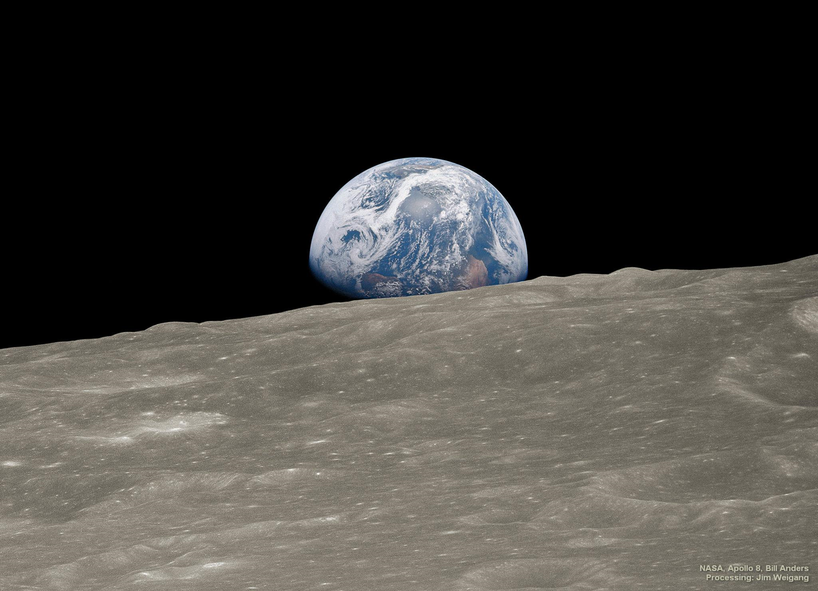
At the core of NASA’s future in space exploration is the return to the Moon. Once there, we will build a sustainable long-term human presence with new spacecraft, robotics and life-sustaining technologies.
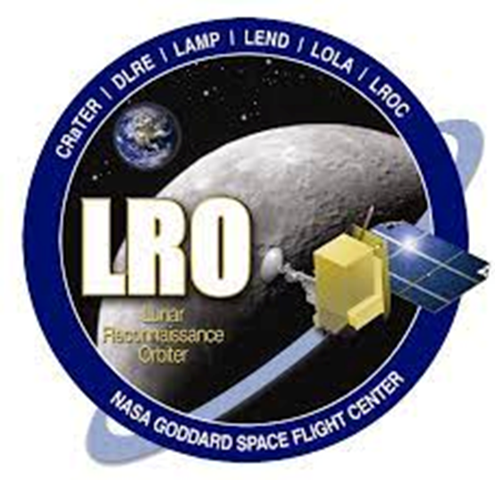
The Lunar Reconnaissance Orbiter (LRO) is an unmanned mission to create a comprehensive atlas of the Moon’s features, search for safe and interesting landing sites, identify important lunar resources, and characterize how the lunar radiation environment will affect humans.
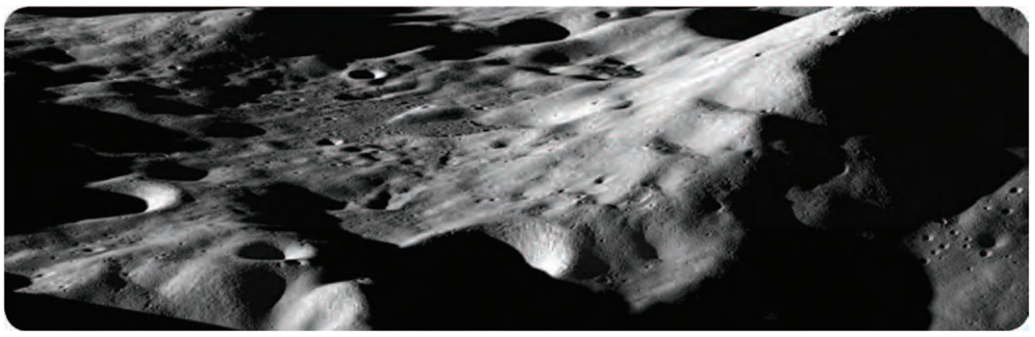

What do you see in this picture? Write down 5 things and share out when we discuss this image in a few minutes.

What more would you need to tell exactly where you are?

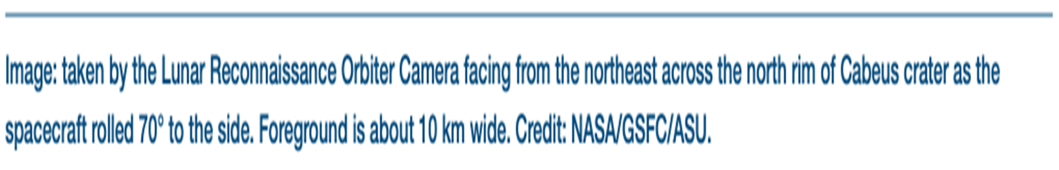
Moon Trek: NASA Portal to Lunar Exploration
Moon Trek is a tool for exploring our Moon that uses images from many manned and unmanned lunar missions to provide detailed maps that can be used for both planning future lunar missions as well as education and research. The following lesson with Moon Trek will help you develop the skills needed to be a successful Moon explorer!
- Open the Moon Trek portal by clicking this link: https://trek.nasa.gov/moon/
- For now, we are going to skip the site tutorial and dive right in to explore the Moon. So, click the “Skip Tutorial” button you see on your screen.
- You will see a flat projection of the lunar surface. We need to change to a globe view. To do so, click the globe icon you will find in the lower left corner of your screen. Then select 3D Globe from the pop-up menu options.
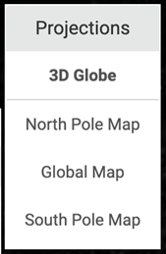
- By left clicking on the map and dragging your mouse you can rotate the Moon globe. Artemis III will be returning men, and women, to the Moon. It is planned to land near the lunar south pole. Like Earth the globe of the Moon has longitude and latitude coordinates that can be used to identify specific locations on the Moon. The south pole of the Moon should have a latitude of -90 degrees. Coordinates are displayed in the lower left corner of the window and change as you move the cursor. Click and drag the Moon globe until you can find the south pole.

Question 1: What is the south polar region of the Moon like? Is it smooth and flat? Are there lots of craters? Will it be more challenging to safely land here than it was for Apollo missions that landed in lunar maria?
- By right clicking and dragging your mouse you can zoom in on the Moon globe. Zoom in on the south pole.
Question 2: Why do you think so much of the south polar region is black? Is it dark? Do the black regions represent areas where there are deep holes (craters)?
Now, switch from the 3D Globe view to the South Pole Map.
One of the proposed landing sites for Artemis III is near the Shackleton Crater. Use the “fly to” button to move to this crater on your globe. This button is found in the lower right corner of the window. It is the left button that looks like an airplane. Enter the crater’s coordinates: -89.90,0.00 and press return. You should see a yellow blinking dot appear on the rim of a large dark crater. To verify that this is Shackelton we will use another tool. Click on the right button of the button bar next to the airplane icon you used before. This opens a new window ( shown below). Click on the Nomenclature button. Labels for all the features found on the Moon’s surface will now be displayed on the map.
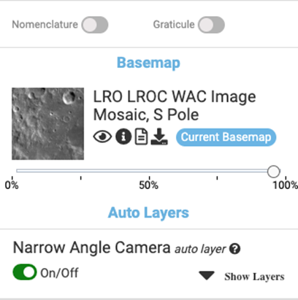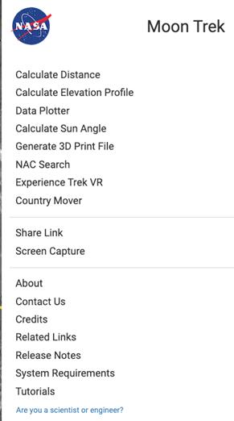
Question 3: Did you find Shackleton Crater? You may need to zoom in on the map to see the name of the crater displayed.
Question 4: While the rim of this crater does get some sunshine, the crater floor never does. It is forever in the dark. What substance that astronauts living in a base on the Moon may need can be found down there?
Switch to a Global Map of the Moon using the Projections tool in the lower left corner of the window. You will likely need to zoom back out to see a clear view on the entire nearside of our Moon. Also be sure that the Nomenclature button is still selected so that you see labels for the various features found on the Moon’s surface. In the upper left quadrant of the screen you should be able to find Oceanus Procellarum (Ocean of Storms) In the Ocean of Storms are many craters, and also features called rilles. Marius rille is a long meandering lava tube that formed during a period of basaltic lava eruptions on the Moon long ago. To start, we are going to find a crater called Marius P. Using the Fly to tool and entering these coordinates: 17.8910,-51.3381, find this crater. The Marius rille passes this crater to the south. The rille is cut by a smaller crater, just to the south of Marius P.
Question 5: Which is older, the crater or the rille? What principle of relative dating would you use to support your choice?

Question 6: Which is oldest — the Oceanus Procellarum, the Marius Rille, or the crater mentioned in Question 5? Again, what principle of relative dating did you use to determine this?
A cool feature of this online mapping tool is that you can make measurements and profiles. You can measure the diameter of craters and you can also draw a profile and use this to determine how deep a crater is. A crater has to be in full sunshine for this to work. Let’s try one using the Copernicus Crater.
Fly to 9.6209,-20.0786. You should arrive at one of the central peaks which is basically a mountain in the center of this crater. Using the cursor and scroll wheel of your mouse to zoom, scaling the image so you can clearly see the entire crater centered on your screen.
Click on the menu in the upper right corner of the window. The window you see shown here will open. We will be using the Calculate Distance and Calculate Elevation Profile options.
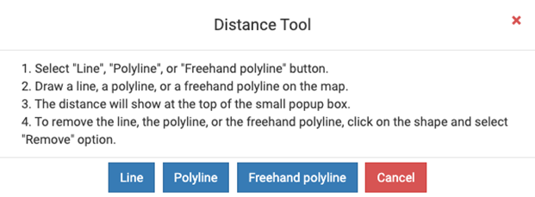

Select “Line” from the Distance Tool options. Draw a line from one side of the crater to the other, starting and stopping at the edge of the rim. Hold down the mouse button as you draw the line, releasing the button when you reach the opposite rim. A window will open telling you the distance result.
Question 7: How far is it across the crater? In other words, what is the crater’s diameter?
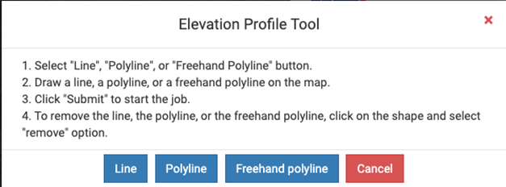
Next we will be creating an elevation profile across this crater extending from just to the left of one rim and just to the right of the opposite rim.
Select “Line” from the Elevation Profile Tool. Draw a line extending from just to the left of the left rim to just past the right rim, passing through the central peak. When you have drawn the line the window shown here will open. Click the Submit button to have the computer create your crater elevation profile.
Take a screenshot of the elevation profile and paste it below.

Moving the cursor along the profile will show you the elevation at each point.
Question 8: How deep is the deepest part of the crater?
Question 9: Knowing the craters maximum depth, and the depth of the highest part of the central peak, how high is this “mountain” in the middle of Copernicus Crater?
Some “man made” features can be seen in images of the Moon’s surface taken from orbit. Fly to these coordinates for the Apollo 16 landing site: -8.9734,15.5011. Zoom in until you can see the base of the lunar lander from this mission.
Question 10: Look for faint lines extending away from the landing site. What do you think made them?
Thanks for exploring our Moon!
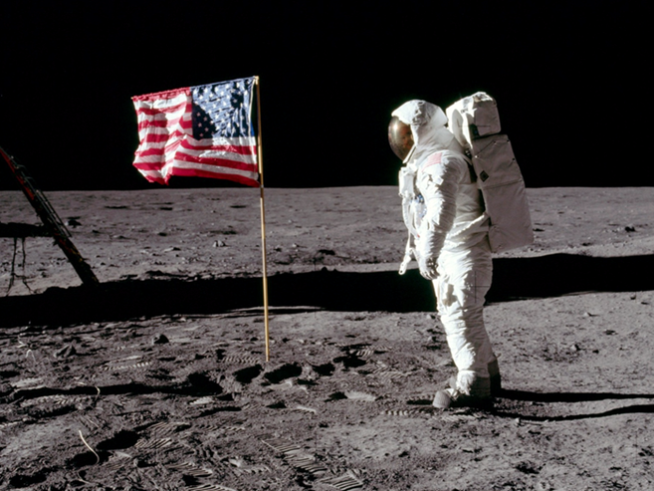
Our Star, The Sun/Sun-Earth Connection:Unit Test
1. It takes photons produced in the core of the Sun around one million years to reach the surface – but only around 8 minutes to get from there to the Earth. Why?
a. The speed of light slows down in the high-density core of the Sun.
b. Gamma photons are slower than visible light photons.
c. Sunspots block some of the photons, slowing their passage.
d. Photons are continually absorbed and reemitted by the densely packed atoms in the core, acting like a ball in a pinball machine.
2. How do stars like the Sun produce energy?
a. Stars like the Sun burn hydrogen in their core.
b. Stars like the Sun produce energy due to gravitational compression of the matter in their core.
c. stars like the Sun fuse H into He in their core.
d. Stars like the Sun fuse He into C in their core.
3. What is the eventual fate of our Sun?
a. The Sun will use all of its nuclear fuel, collapse and explode as a supernova.
b. The Sun will continue to shine as it currently does forever.
c. The Sun will be swallowed by the supermassive black hole at the center of our galaxy.
d. The Sun will inflate into a red giant once it has used up the H in its core. Once it has fused all the He into C, fusion ceases and the Sun becomes a white dwarf.

4. The Sun has a cycle between periods of low activity and high activity. How long does it take to go from one “Solar max” to the next?
a. On average, it takes 22 years.
b. On average, it takes 11 years.
c. On average, it takes 33 years
d. On average, it takes a century
5. Why does the surface of the Sun (the photosphere) appear granulated?
a. Granules are areas of higher elevation making the photosphere appear “bumpy”.
b. Carbon produced in the core is being carried up to the surface by convection, producing a granular appearance.
c. Convection currents within the convective zone carry energy up toward the photosphere. The tops of the convection current “bubbles” are the granules observed.
d. Matter in the corona cools and condenses, sinking to the surface making the granules.
6. What makes sunspots cooler than the surrounding photosphere?
a. Twisted magnetic fields reduce convection from below the photosphere, lowering the temperature in that “spot”.
b. Coronal holes cause an escape of solar plasma.
c. Solar flares dissipate heat
d. Condensation of solar plasma in the corona

7. What is Heliophysics?
a. Heliophysics is the study of how the Sun produces energy.
b. Heliophysics is the study of how to send spacecraft to the Sun.
c. Heliophysics is the study of how the Sun interacts with the rest of the solar system, including Earth.
d. Heliophysics is the study of the Greek god Helios
8. What solar phenomena enhance the solar wind – leading to space weather, including geomagnetic storms?
a. Sunspots and spicules
b. Solar flares, coronal mass ejections and coronal holes
c. Coronal holes and sunspots
d. Convection currents, magnetic reversals, and coronal holes
9. What are coronal mass ejections?
a. Huge outbursts of solar plasma
b. Causes of geomagnetic storms on Earth
c. Potentially damaging to satellites and power distribution infrastructure
d. All of the above
10. What are solar flares?
a. Outbursts of solar plasma
b. Strong sources of X-ray radiation
c. Explosive outbursts caused by magnetic reconnection
d. All of the above
11. What was one of the main goals of the THEMIS mission?
a. It was launched to study ozone holes in our atmosphere.
b. It was launched to investigate cloud cover and climate change.
c. It was launched to study the causes of auroral substorms.
d. It was launched to measure changing CO2 levels in the atmosphere.
12. What are coronal holes?
a. Gaps in the sun’s magnetic field that funnel cosmic rays to the poles.
b. Extensions of sunspots from the photosphere out into the corona.
c. Openings in the Sun’s magnetic field that allow more charged particles to escape into space.
d. Craters left from the impact of sun-diving comets.
13. What is the difference between a solar flare and a coronal mass ejection?
a. solar flares originate in the photosphere and coronal mass ejections originate in the sun's corona.
b. Flares are an outburst of high energy radiation and CMEs are outbursts of high energy particles.
c. Both are caused by interactions between magnetic fields.
d. All of these are correct
14. The _____ was a series of several large CMEs that hit Earth in the 1800s. If an event like this were to occur today, much of our technologic infrastructure would be damaged. Transformers around the planet would explode, collapsing the electrical power grids. Electronics onboard key satellites would be damaged, causing communication and navigation failures. Recovery could take years.
a. Aurora borealis
b. Carrington Event
c. Chicxulub Event
d. Hawking Event
15. A _____ is an instrument that measures changes in Earth’s _____.
a. seismometer/magnetic field
b. magnetometer/gravitational field
c. magnetometer/geomagnetic field
d. None of the above
16. The visible surface of the Sun is called the ___.
a. corona
b. chromosphere
c. photosphere
d. convective zone
17. Magnetic fields are 3-dimensional and have an x, y, and z component (Bx, By, & Bz).Which of these three field components of the Interplanetary Magnetic Field (IMF) of a CME needs to be southward directed to increase the chances of a geomagnetic storm and an auroral display we could see here in mid-Michigan?
a. Bx
b. By
c. Bz
18. The planetary K index (Kp) must be at least _____ to see aurora at our latitude, if Bz is also the correct direction.
a. 4
b. 6
c. 8
d. 10
19. Ionized gasses, atoms that have been stripped of their electrons and carry a positive charge, are called:
a. Plasma
b. Toroids
c. Nuclei
d. Nucleoids
20. The solar wind, a constant outflow of high energy particles from the sun, can flow faster, with more particles, when what events happen?
a. coronal holes, solar flares, CMEs
b. sunspots, prominences, solar eclipses
c. coronal holes, sunspots, magnetic storms
d. auroras, sunspots, flares
21. What causes a solar eclipse?
a. The Earth comes between the Sun and the Moon
b. The Moon comes between the Sun and Earth
c. The Sun comes between the Moon and Earth
22. What are more commonly seen here in Michigan — solar eclipses or lunar eclipses?
a. Solar eclipses
b. Lunar eclipses
c. Neither are seen here in Michigan
23. What carries heat from deeper in the Sun to the photosphere?
a. radiation
b. convection
c. conduction
24. When will be the next opportunity for you to view a total solar eclipse here in the United States?
a. October 14th, 2023
b. April 8th, 2024
c. May 13th, 2025
d. June 17th, 2026
25. Will you be able to see the next total solar eclipse in your backyard?
a. Yes
b. No
26. Why can total solar eclipses only be viewed along a very narrow path, while total lunar eclipses can be viewed over a much larger area?
a. The Moon’s shadow is very small compared to the Earth’s.
b. The Earth’s shadow is very small compared to the Earth’s.
c. The Moon is closer than the Sun.
27. Why do sunspots appear darker than the rest of the photosphere?
a. Sunspots are warmer than the rest of the photosphere
b. Sunspots are cooler than the rest of the photosphere
28. How far is the Sun from the Earth?
a. 93 million miles
b. 150 million kilometers
c. 1 astronomical unit (AU)
d. All of the above
e. None of the above
29. What NASA mission was our school a part of that used a ground-based magnetometer installed behind the wrestling building, adjacent to the cross-country course?
a. MAVEN
b. SDO
c. THEMIS
d. SOFIA
30. How does the Sun produce energy in its core?
a. Burning hydrogen
b. Nuclear fission
c. Nuclear fusion
d. atomic energy
Our Star, The Sun/Sun-Earth Connection Unit Test: Answer Key
- It takes photons produced in the core of the Sun around one million years to reach the surface – but only around 8 minutes to get from there to the Earth. Why?
d. Photons are continually absorbed and reemitted by the densely packed atoms in the core, acting like a ball in a pinball machine.
- How do stars like the Sun produce energy?
c. stars like the Sun fuse H into He in their core.
- What is the eventual fate of our Sun?
d. The Sun will inflate into a red giant once it has used up the H in its core. Once it has fused all the He into C, fusion ceases and the Sun becomes a white dwarf.
- The Sun has a cycle between periods of low activity and high activity. How long does it take to go from one “Solar max” to the next?
b. On average, it takes 11 years.
- Why does the surface of the Sun (the photosphere) appear granulated?
c. Convection currents within the convective zone carry energy up toward the photosphere. The tops of the convection current “bubbles” are the granules observed.
- What makes sunspots cooler than the surrounding photosphere?
a. Twisted magnetic fields reduce convection from below the photosphere, lowering the temperature in that “spot”.
- What is Heliophysics?
c. Heliophysics is the study of how the Sun interacts with the rest of the solar system -including the Earth.
- What solar phenomena enhance the solar wind – leading to space weather, including geomagnetic storms?
b. Solar flares, coronal mass ejections and coronal hole
- What are coronal mass ejections?
- Huge outbursts of solar plasma
- Causes of geomagnetic storms on Earth
- Potentially damaging to satellites and power distribution infrastructure
- All of the above

- What are solar flares?
- Outbursts of solar plasma
- Strong sources of X-ray radiation
- Explosive outbursts caused by magnetic reconnection
- All of the above
- What was one of the main goals of the THEMIS mission?
c. It was launched to study the causes of auroral substorms.
- What are coronal holes?
c. Openings in the Sun’s magnetic field that allow more charged particles to escape into space.
- What is the difference between a solar flare and a coronal mass ejection?
a. Solar flares originate in the photosphere and coronal mass ejections originate in the sun's corona.
b. Flares are an outburst of high energy radiation and CMEs are outbursts of high energy particles.
c. Both are caused by interactions between magnetic fields.
d. All of these are correct
- The _____ was a series of several large CMEs that hit Earth in the 1800s. If an event like this were to occur today, much of our technologic infrastructure would be damaged. Transformers around the planet would explode, collapsing the electrical power grids. Electronics onboard key satellites would be damaged, causing communication and navigation failures. Recovery could take years.
b. Carrington Event
- A _____ is an instrument that measures changes in Earth’s _____.
c. magnetometer/geomagnetic field
- The visible surface of the Sun is called the ___.
c. photosphere
- Magnetic fields are 3-dimensional and have an x, y, and z component (Bx, By, & Bz).Which of these three field components of the Interplanetary Magnetic Field (IMF) of a CME needs to be southward directed to increase the chances of a geomagnetic storm and an auroral display we could see here in mid-Michigan?
c. Bz
- The planetary K index (Kp) must be at least _____ to see aurora at our latitude but Bz must also be in the correct direction.
b. 6
- Ionized gasses, atoms that have been stripped of their electrons and carry a positive charge, are called:
- Plasma
- The solar wind, a constant outflow of high energy particles from the sun, can flow faster, with more particles, when what events happen?
- coronal holes, solar flares, CMEs
- What causes a solar eclipse?
b. The Moon comes between the Sun and Earth
- What are more commonly seen here in Michigan — solar eclipses or lunar eclipses?
b. Lunar eclipses
- What carries heat from deeper in the Sun to the photosphere?
b. convection
- When will be the next opportunity for you to view a total solar eclipse here in the United States?
b. April 8th, 2024
- Will you be able to see the next total solar eclipse in your backyard?
b. No
- Why can total solar eclipses only be viewed along a very narrow path, while total lunar eclipses can be viewed over a much larger area?
a. The Moon’s shadow is very small compared to the Earth’s.
- Why do sunspots appear darker than the rest of the photosphere?
b. sunspots are cooler than the rest of the photosphere
- How far is the Sun from the Earth?
- 93 million miles
- 150 million kilometers
- 1 astronomical unit (AU)
- All of the above
- What NASA mission was our school a part of that had a ground-based magnetometer installed behind the wrestling building, adjacent to the cross-country course?
c. THEMIS
- How does the Sun produce energy in its core?
c. Nuclear fusion

