Magnetic Mysteries: Sun-Earth Interactions

by Cris DeWolf
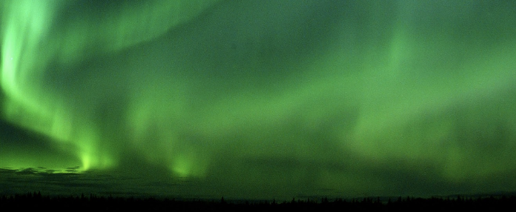

Table of Contents
Lesson Overview and Objectives 2
Materials 4
5E Steps 5
Resources 7
Handouts 8

Lesson Overview
Level: 9-12 Time: 4-5 class periods, may need more for Extend
“Why was the sky on fire last night?” Students investigate the question of what causes aurora by using Helioviewer to examine solar activity, as well as archival data on planetary K indices (Kp) to investigate the effect of solar activity on our magnetosphere.

Educator Background Knowledge
- For a tutorial on Kp, educators can read the material found here: https://sunearthday.nasa.gov/swac/tutorials/mag_kp.php NASA Space Weather Action Center. (n.d.). Sunearthday.nasa.gov. Retrieved July 30, 2022, from https://sunearthday.nasa.gov/swac/tutorials/mag_kp.php
- An article on solar flares and coronal mass ejections (CMEs) can be found here: https://tinyurl.com/2n4zwcym Wall:MSFC, J. (2013, June 5). Solar Flares and Coronal Mass Ejections. NASA. https://www.nasa.gov/audience/foreducators/9-12/features/F_Dangers_of_Solar_Flares_and_CME.html
- Aurora were observed from mid-USA northward on October 11, 2021 and is supported with the data available. https://www.washingtonpost.com/weather/2021/10/12/aurora-us-canada-northern-lights/
‌
Learning Goals
Students will use NASA resources to answer the question: What caused the sky to “burn” last night?

Learning Objectives
- Make connections between Kp indices and solar activity.
- Be able to support a claim with evidence and reasoning.

Framework for Heliophysics Education
NASA Question: How do the Earth, the solar system, and heliosphere respond to changes on the Sun? Big Idea: The Sun defines the space around it, which is different from interstellar space.

NGSS Performance Expectations
HS ESS1-1: Earth’s Place in the Solar System: Develop a model based on evidence to illustrate the life span of the Sun and the role of nuclear fusion in the Sun’s core to release energy that eventually reaches Earth in the form of radiation.

Targeted STEM Skills
Scale, Proportion, and Quantity
- The significance of a phenomenon is dependent on the scale, proportion, and quantity at which it occurs.
Developing and Using Models
- Modeling in 9–12 builds on K–8 experiences and progresses to using, synthesizing, and developing models to predict and show relationships among variables between systems and their components in the natural and designed world(s).
- Develop a model based on evidence to illustrate the relationships between systems or between components of a system.

Materials
Computer with Internet access, Data projector, Plasma globes, short fluorescent tubes

Handouts
(at the end of this document)
Prior to doing this lesson with your students, they should have had a lesson on the properties of the Sun. Depending on the background of your students, you may also need to introduce or review Claim-Evidence-Reasoning writing skills.
- Our Dynamic Sun: (Guide for using Helioviewer)
- The Sun-Earth Connection CER
- See the lesson Impact Cratering for a Unit Test for this lesson and Exploring Eclipses by Cris DeWolf

Links to Digital Resources for Students
- Helioviewer: https://helioviewer.org
- Space Weather Live: https://www.spaceweatherlive.com
- CER Resources: modelteaching.com CER Resources

Key Vocabulary
Solar flares, coronal mass ejections (CMEs), solar wind, sunspots, magnetic fields, plasma, Kp index, aurora borealis, Daylight Savings Time (DST)

Material Preparation
- Teachers should complete the lesson “Our Dynamic Sun” to learn how to use Helioviewer prior to having their students do this lesson.
- Materials may be assigned through Google Classroom or other LMS, or printed.
- Lab prep — have enough plasma globes and fluorescent tubes so groups are no larger than 3-4 students. Must be done in a classroom with lab stations, or outlets that drop down from the ceiling. Works best in a darkened room.

5E Steps
Engage
View aurora, read Native American stories
- Project the video clip of the aurora: NASA: Mystery of the Aurora
- Share Native American stories of the Aurora borealis from Legends and Folklore of the Northern Lights (focus can be for tribes from your region)
- Share pictures of aurora from Detroit News archives from Hartland, MI on March 17, 2017. Teachers can look for images of aurora seen in their region.
- If there was a recent display of Northern lights in your region, substitute this event for the one in March of 2017. Look for images and/or videos available for it online.

Explore
Modeling Aurora — Auroras in the Classroom
Students will use plasma globes and fluorescent tubes to model the process that cause aurora. Teachers will use this resource to guide the student exploration. They should explicitly share that the source of the energy that drives aurora is the Sun. This Sun-Earth connection will be explored more later using Helioviewer and the space weather site. Questions to consider:
- What is the glowing substance dancing inside the lamp? (Plasma)
- Why is it glowing? (The gases are ionized into a plasma, Light is produced by the excited electrons from the gas.)
- How did the fluorescent tube light up? (An electric field surrounds the plasma globe. Electrons in this field excite the electrons in the gas inside the tube, making the gas glow.)

Our Stormy Sun
Students will use the Space Weather Live and Helioviewer sites to explore conditions on the Sun and in space for both the night of & several days prior to the auroral display on the evening of March 17, 2017. Look for solar wind speeds and densities, Interplanetary magnetic field, and Kp index. Questions to consider:
- Were there any “gusts” of increased solar wind speed on this date?
- Were there any periods of increased solar wind density on this date?
- What is Bz doing on this date? Are there any periods of extended southward (-) directed Bz?
- Do these periods (if any exist!) correspond to periods of increased solar wind speed or particle density?
- Look at a magnetogram of the sun for both the 17th and the 2 days prior. What would you say about the intensity of the magnetic field in any active regions present?

Explain
Write a claim for what caused the display of Northern lights on March 17th 2017.
Use the information you gathered to share your reasoning that supports your claim.

The Sun-Earth Connection CER 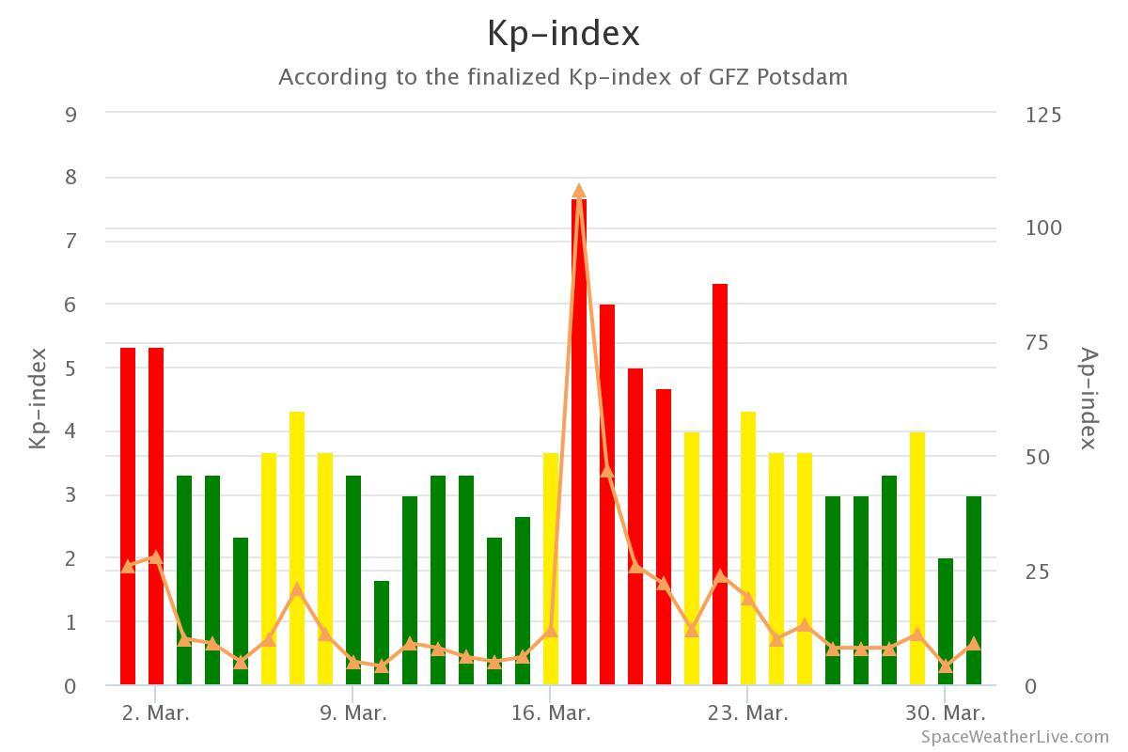
Extend
Check the archives on Spaceweatherlive.com for other dates when there was a high Kp. Use what you have learned to predict whether or not there may have been aurora visible in our area on those dates. Use reasoning to support these claims.
Bonus points if you find evidence online that aurora did indeed occur on these dates.

Evaluate
Claim, evidence, reasoning papers by students.

Resources
- Our Dynamic Sun: (Guide for using Helioviewer) by Cris DeWolf
- The Sun-Earth Connection CER by Cris DeWolf
- See the lesson Impact Cratering for a Unit Test for this lesson and Exploring Eclipses by Cris DeWolf

Handouts
These begin on the next page.

Our Sun, A Magnetic Powerhouse
Introduction
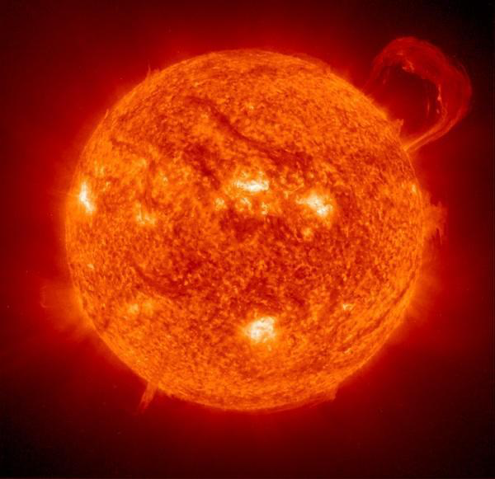
Sol, the Sun – our star – is a complex ever-changing source of energy. This energy makes our planet the blue oasis of life it is today. The Sun, like all stars, manufactures the energy it radiates into space through hydrogen fusion in its core. The energy first moves through the radiative zone, just outside the Sun’s core. As this energy heats the solar plasma of the convective zone, huge cells of circulating plasma form. The energy is carried upward to the photosphere. These convection cells are responsible for creating magnetic fields within the Sun. These fields can interact with each other, producing physical effects that we can see. Sunspots and solar flares are examples.

The extent of this magnetism-related activity on the Sun is cyclic. It rises and ebbs with a regular repeating pattern. Astronomers refer to this repeating solar activity as a solar cycle. Currently, we are at the beginning of Cycle 25.

To examine the extent of magnetic activity on the Sun, to see where there are areas of strong magnetic fields and low magnetic fields, astronomers use magnetograms. They are made using instruments that can detect both the strength and location of magnetic fields. On these grayscale plots of magnetic intensity, black regions are areas of strong inward (south) directed polarity and white regions are areas of strong outward (north) directed polarity. Gray indicates areas with weak, diffuse magnetic fields.

In this investigation, you will be examining magnetograms looking for patterns and relationships within solar cycles. You will be getting the magnetograms you need from the Helioviewer website. Helioviewer is a web-based platform for exploring datasets from a number of different heliophysics missions. You will be working with images made from data gathered by instruments onboard the Solar Dynamics Observatory (SDO) spacecraft. Images and movies of the data can be created at the site and downloaded to your computer.

Investigation
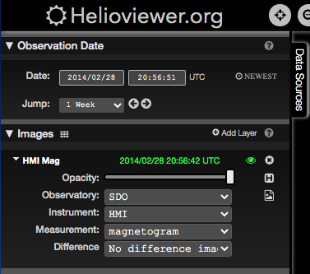
To start your exploration of our dynamic star, go to https://www.helioviewer.org/. Make sure that SDO is the observatory, that the HMI instrument is selected, and the measurement is a magnetogram. Change the date to February 28th, 2014. Once your image opens, click the image icon on the toolbar located in the upper right corner of the site window and download a screenshot of the current Helioviewer Viewport.
Insert the image to the right in the table cell below:

Examine this magnetogram of the Sun from February of 2014.
- Are there many areas of black and white, or is it uniformly “gray”?

- How would you describe the distribution of magnetic fields on the Sun on this day?

- Predict what you might see on an image using continuum as the measurement. Using a continuum gives you a white light view of the Sun.
For the same date, change the measurement to “continuum.” Again, use the tools in the toolbar to download an image of the current Helioviewer Viewport.
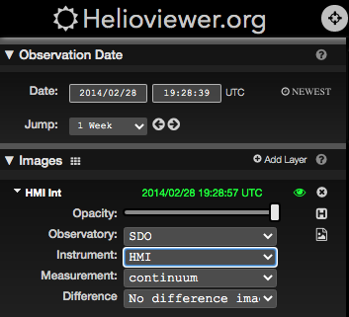
Insert this image in the table cell below:
2014_02_28_19_45_48_HMI_Int.png
Examine this continuum image of the Sun from February of 2014.

- Does this image match your prediction?

- Compare the two images from February 2014. Are the sunspots (dark regions in the continuum image) in the same places as the most intense magnetic fields on the magnetogram?

- Would you be able to make a generalization that the largest sunspots are associated with the strongest magnetic fields?

Solar plasma, being charged, will flow along magnetic field lines and form huge structures. These structures are best viewed using images from a different instrument – AIA, or the Atmospheric Imaging Assembly. So, on the Helioviewer page, change the instrument from HMI to AIA and select this wavelength for your image: 335 angstroms. This wavelength of light is given off by Iron ions heated to temperatures of 2,500,000 Kelvin by intense magnetic activity in the solar corona.

Return to the Helioviewer site. Switch the instrument used from HMI to AIA and set the measurement to 335. Make sure that the date is 2-28-2014. Download the image and insert it in the table cell below.

Examine this image.
- Does it show the magnetic fields associated with the regions containing sunspots?

Now we will switch to a more recent date. Change the date to June 20th, 2020. Make sure you have HMI selected as the instrument, and magnetogram as the measurement. Download the image and insert it in the table cell below.
Examine this image.
- Are there any areas of intense magnetism?

- How does the level of magnetic activity on this date compare to that on February 28th, 2014?

- Do you think you will see any sunspots on the continuum image of the Sun on this June 2020 date?

- Why or why not?
For the same date, change the measurement to “continuum”. Again, use the tools in the toolbar to download an image of the current Helioviewer Viewport. Download the image and insert it in the table cell below.

Examine this image.
- Describe what you see.

- Are there any sunspots?

- Predict what you should expect to see on an AIA 335 angstrom image on this date.

Return to the Helioviewer site. Switch the instrument used from HMI to AIA and set the measurement to 335. Make sure that the date is 6-20-2020. Download the image and insert it in the table cell below.

Examine this image.
- Describe what you see.

- Compare this image at 335 angstroms to the one for 2/28/14. Which shows more intense magnetic activity?

Write a claim supported by all the evidence you have gathered for how magnetic activity on the Sun produces sunspots.

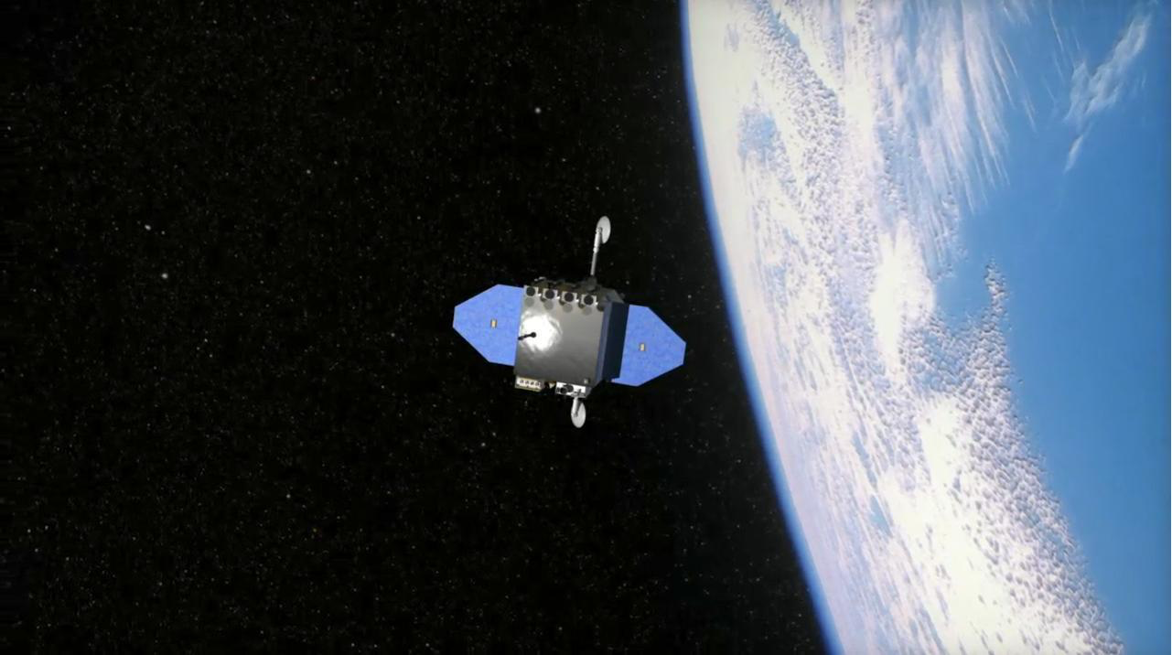
The Solar Dynamics Observatory, launched in February of 2010, is the first mission launched as part of NASA’a “Living With a Star” program. SDO studies our Sun from Earth orbit.
Heliophysics Data Log (paste into .xls)
Access data here: https://spaceweather.com
Date | Time (UTC) | Solar Wind |  | Solar Flare Class | Kp Index | IMF (Bz)
 |  | Speed (km/sec) | Density (protons/cm3)

The Sun-Earth Connection Claims, Evidence, Reasoning

Our star has impacts on the Earth beyond simply providing the energy that makes our planet a living world. You have been exploring the processes that create “space weather”, paint aurora across our northern skies, and that also occasionally threaten our technological infrastructure.
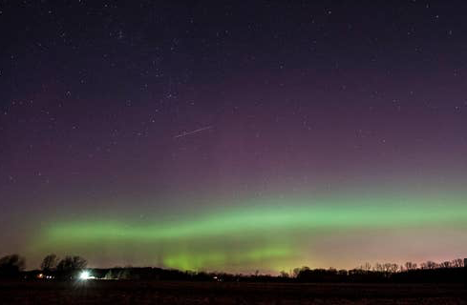
On March 17th, 2015, the night skies here in Michigan as far south as the northern suburbs of Detroit glowed with the fiery lights of the Aurora borealis. Did disturbances day’s earlier in the Sun’s magnetic field lead to this spectacular display?

To look for connections between what had happened on the Sun with what happened on Earth on 3/17/2015 you will be using archival data from the Solar Dynamics Observatory (SDO) on the Helioviewer.org website and from the Spaceweather.com website.

A C.E.R. starts with a question. Our question, introduced earlier, is “Why was the sky on fire last night (3/17!)”. To attempt to answer this question, we make a claim. The claim should be based on what you may already know about aurora. Our claim will be:

“The sky was on fire due to disturbances in the Sun’s magnetic field a few days ago.”

This claim must be backed up by evidence. Next, you will gather evidence about magnetic disturbances both on the Sun as well as here on Earth for the time period of 3/14/15 through 3/17/15.

Evidence Gathering Procedure
- Open a web-browser on your computer and go to spaceweather.com. Once there, go to the archive pages, changing the date from today’s date to March 17th, 2015.
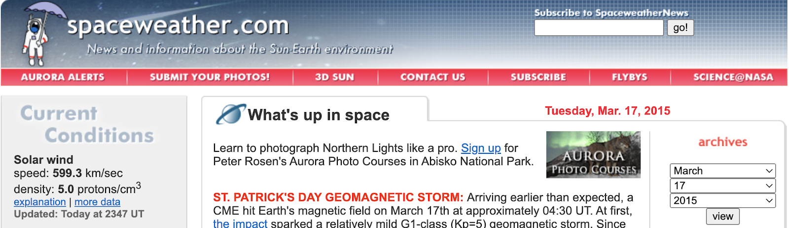
- Click on view.

- What is the 24-hr max Kp for this date?

- Is this at or above the minimum Kp value that could result in the northern lights being visible in our area?

- What is the value of Bz, and is it north or south directed?

- Read about the St. Patrick’s Day Geomagnetic Storm near the top of the web page. Was it caused by the impact of a CME?

- What else did it say about this storm?

- Were there any sunspots present?

Change the date to March 15th, 2015 in the archive.
- Read about the solar flare and CME that happened on this day. Watch the video of the CME. What do NOAA forecast models suggest may happen on St. Patrick’s Day?

Over the course of this unit we have been able to make the generalization that disturbances in the Sun’s magnetic field can lead to aurora displays in the night skies of our area. Go to Helioviewer.org and take a look at a magnetogram with the HMI instrument on the Solar Dynamic Observatory (SDO).

- The relative size and brightness of white areas (north polarity) in this image, as well as the darkness of black areas (south polarity), are indicators of the overall strength of the magnetic field in an active region on the Sun’s surface. On March 15th, 2015 were there any active regions with strong magnetic fields?

Change to a continuum (white-light) image on the HMI instrument of SDO.

- Were there any areas with large sunspots? Were they in the same areas as the strong magnetic fields?

- Why did it take so long after the CME for the northern lights to light up our skies on St. Patrick’s Day?

Summary
Tying our evidence together by explaining how it supports our initial claim: “The sky was on fire due to disturbances in the Sun’s magnetic field a few days ago.” Please use complete sentences in a paragraph.

____________________________________________________________________________

____________________________________________________________________________

____________________________________________________________________________

____________________________________________________________________________

____________________________________________________________________________

____________________________________________________________________________

