Magnetism and the Earth’s Magnetic Field

By Wendy Esch

Table of Contents
Lesson Overview and Objectives 2
Materials 4
5E Steps 6
Resources 9
Handouts 11

Lesson Overview
Level: MS and HS Time: Three 88-minute class periods
Students will investigate magnetism and electromagnetism using a smartphone magnetometer. Students will be given materials to make a simple motor, then they will generate electricity by playing jump rope outside, and use a compass to locate objects when they are given a compass heading. They will also examine the problem with using a compass during a geomagnetic storm. All of the material examined up to this point will be applied to the study of Earth’s magnetic field. Lastly, students will use their smartphones to calculate the strength of the magnetic field at their location and potentially determine the existence of a geomagnetic storm.

Educator Background Knowledge
General knowledge of magnetism and electricity.
‌
Learning Goals
Students will investigate magnets and electromagnets and then relate them to motors and generators. This is then related to the Earth’s magnetic field and what happens to it when a geomagnetic storm occurs. They will also use their smartphone as a magnetometer to do several magnetism lab activities.

Learning Objectives
Students will:
- Experiment with magnets and use their smartphones to measure magnetism. They will then download the data to MS Excel and graph the data.
- Draw magnetic field lines around a bar magnet.
- Use a smartphone magnetometer to measure the magnetic field of a simple electromagnet and observe how the strength of the field changes with distance.
- Use materials to make a simple motor and explain how it works.
- Demonstrate the generator effect due to electromagnetic induction when a conductor (extension cord) moves through Earth’s magnetic field.
- Describe the difficulty in using a compass for navigation during a geomagnetic storm.
- Explain the changes that occur to the Earth’s magnetic field over time.
- Calculate the strength of the Earth’s magnetic field using their smartphone magnetometer.
- Detect a geomagnetic storm using a smartphone.

Framework for Heliophysics Education
NASA Question: What are the impacts of the Sun on humanity? Big Idea: The Sun is really big and its gravity influences all objects in the solar system.

NGSS Performance Expectations
HS-PS2-5: Motion and Stability: Forces and Interactions: Plan and conduct an investigation to provide evidence that an electric current can produce a magnetic field and that a changing magnetic field can produce an electric current.

MS-PS2-3: Motion and Stability: Forces and Interactions: Ask questions about data to determine the factors that affect the strength of electric and magnetic forces.

MS-PS2-5: Conduct an investigation and evaluate the experimental design to provide evidence that fields exist between objects exerting forces on each other even though the objects are not in contact.

Common Core Standards for Mathematical Practice
- CCSS.MATH.PRACTICE.MP1: Make sense of problems and persevere in solving them.
- CCSS.MATH.PRACTICE.MP3: Construct viable arguments and critique the reasoning of others.
- CCSS.MATH.PRACTICE.MP8: Look for and express regularity in repeated reasoning.

Targeted STEM Skills
- Analyzing and interpreting data
- Constructing explanations and designing solutions
- Asking questions and defining problems
- Planning and carrying out investigations
- Engaging in argument from evidence
- Developing and using models
- Using mathematical and computational thinking

Materials
- Magnets
- Various metals
- Compass (those that are transparent work best)
- Copper wire, Nickel, Iron, Cobalt, Tin, Magnesium, etc.
- Common nail
- Pencil
- Kit, World’s Simplest Motor (these run between $7.50 and $11.00)
- Poster board
- Extension cord
- 2 alligator clips
- D-cell battery
- Galvanometer (these run about $15)
- Brunton Compass (this runs about $25)
- Smartphone app: Physics Toolbox
  - Free IOS: https://apps.apple.com/us/app/physics-toolbox-sensor-suite/id1128914250
  - Free android and IOS: https://www.vieyrasoftware.net/physics-toolbox-sensor-suite
- Laptop with MS Excel (students need an email account)
- Science notebook (composition notebook)

Handouts
- Student Lab Worksheet: Bar Magnet Activity (see Handouts).
- Student Lab Worksheet: What is an Electromagnet? Make the World’s Simplest Motor (see Handouts).
- Student Lab Worksheet: The Declining Magnetic Field (see Handouts).
- Student Lab Worksheet: Geomagnetism I: Polar Wander (see Handouts).
- Student Lab Worksheet: Geomagnetism II: Magnetic Reversals (see Handouts).
- Heliophysics Quiz (see Handouts).
- Teacher Guide: Magnetism and the Magnetic Field Around a Bar Magnet
http://cse.ssl.berkeley.edu/SEGwayed/lessons/exploring_magnetism/magnetism_and_electromagnetism/Guide_activity1.pdf
- Teacher’s Guide: Make a Simple Electromagnet (World’s Simplest Motor) http://cse.ssl.berkeley.edu/SEGwayed/lessons/exploring_magnetism/magnetism_and_electromagnetism/Guide_activity2.pdf
- Teachers Guide: Jump Rope Generator http://cse.ssl.berkeley.edu/SEGwayed/lessons/exploring_magnetism/magnetism_and_electromagnetism/Guide_activity3.pdf
- Teachers Guide: Navigating the Earth with a Compass: http://cse.ssl.berkeley.edu/SEGwayed/lessons/exploring_magnetism/magnetism_on_earth/guide_activity5.pdf
- Teachers Guide: The Declining Magnetic Field:
http://cse.ssl.berkeley.edu/SEGwayed/lessons/exploring_magnetism/magnetism_on_earth/guide_activity7.pdf
- Teachers Guide: Geomagnetism I: Polar Wander: http://cse.ssl.berkeley.edu/SEGwayed/lessons/exploring_magnetism/magnetism_on_earth/guide_activity6.pdf
- Teachers Guide: Geomagnetism II: Magnetic Reversals: http://cse.ssl.berkeley.edu/SEGwayed/lessons/exploring_magnetism/magnetism_on_earth/guide_activity8.pdf
- Exploring Magnetism with Smart Devices: https://spacemath.gsfc.nasa.gov/SMBooks/MagnetismGuide.pdf:
  - H1: Using your Smartphone to Measure Magnetism (page 102)
  - M8: Using your Smartphone to Measure the Strength of an Electromagnet
  - M3: Calculating the Total Magnetic Field
  - M4: Comparing Earth’s Magnetic Field
  - H8: Detecting Geomagnetic Storms with a Smart Device.
- Heliophysics Unit Test: This covers content from three lessons: Sun Earth Interactions, Magnetism and the Earth’s Magnetic Field (this lesson) and Aurora Research and Heliophysics. See the Aurora Research and Heliophysics lesson for the Unit Test.

Key Vocabulary
Magnetism, electromagnet, current, dynamo, electromagnetic, magnetic force, field, Gauss, tesla, vector, magnetometer, plasma, flare, CME, Kp index

Material Preparation
- Make copies of any handouts listed above or have the students use a computer or tablet to view the links to handouts.
- Assemble the materials listed above for easy access.

Note: This lesson is set up by “Day by Day” in steps that cover the 5E Model as follows.

5E Steps
Engage
Student engagement occurs in the initial set of small labs which are done in class and outside.

Explore
Students explore given materials and have to construct and make the simple motor actually work.

Explain
After each of the mini-lab activities are completed, discussion takes place between students and the students and the teacher to make sure the learning goal is met and to dispel misconceptions.

Extend
Extension activities include the labs where the students use their smartphone magnetometer to calculate the strength of Earth’s magnetic field and the detection of a geomagnetic storm.

Evaluate
This is accomplished by the daily discussions between the students and the teacher as well as a Heliophysics Quiz. See Handouts.

There is also a Unit Test that covers content from three lessons: Sun Earth Interactions, Magnetism and the Earth’s Magnetic Field (this lesson) and Aurora Research and Heliophysics. See the Aurora Research and Heliophysics lesson for the Unit Test.
Day 1: Exploring Magnetism
- Break the students into pairs. Have them complete the Magnetism and the Magnetic Field Around a Bar Magnet Activity. Make sure to diagram the magnetic field close to the magnet as well as far away at the edge of the piece of posterboard. Give them plenty of time to complete the magnetic field activity around the bar magnet. See the Student Lab Worksheet: Bar Magnet Activity (see Handouts).
- While they are in the lab, have students complete the Exploring Magnetism with Smart Devices activity (on page 102), H1, Using the smartphone to measure magnetism. Part of the lab has the students download the data to excel and has them print their graph.
- Come back together as a class and discuss what was learned and have them share their magnetic map which was drawn and their graph from Excel. Talk about the heliophysics connection with the students. Students should take notes in their science notebook.

Day 2: The Earth’s Magnetic Field
- Review with the students what the learning objectives were yesterday.
- Students in their pairs complete the lab activity: Construct a Simple Electromagnet and complete the lab activity, see the Student Worksheet: What is an Electromagnet? Make the World’s Simplest Motor (see Handouts).
- They should also complete the lab using their smartphone: M8, measuring the strength of an electromagnet (page 85).
- Discuss with the students how the motor works.
- Come back together as a class and discuss with students the use of Claim, Evidence, and Reasoning (CER) thinking to communicate their findings. Have them write these notes in their science notebook.
- Students then move outside to complete the Jump Rope Generator Lab and the Student Worksheet: Jump Rope Generator (see Handouts). Discussion of the lab will be done back in the classroom.
- While outside, the students should complete the lab Navigating the Earth with a Compass. When students have completed the gathering of their data, move back into class.
- Give students time to meet with their partner to complete the scale drawings from the compass lab.
- Conduct a discussion with students about the jump rope generator lab, have them jot down some notes in their notebooks about the lab. Also, discuss the scale drawings made in the compass lab. Make sure they understand that a small deviation from magnetic north can result in being 100’s of miles off course.
- After the discussion above, have students return to their lab partner and complete the three investigations on the Earth’s Declining Magnetic Field, Geomagnetism I: Polar Wander and Geomagnetism II: Magnetic Reversals. Note: These links have the Student Worksheets in them which should be printed for students or separated out of the larger pdf and placed in the cloud for student access
- When the students have completed the three activities, discuss what they learned about the Earth’s magnetic field from having completed the activities. Have them jot their notes down in their science notebook.

Day 3 Exploring Magnetism with Smart Devices
- Review with the students what the learning objectives were yesterday.
- Have the students pair up once again and complete the labs M3 and M4 from the Exploring Magnetism with Smart Devices Guide: https://spacemath.gsfc.nasa.gov/SMBooks/MagnetismGuide.pdf:
  - M3: Calculating the Total Magnetic Field, page 63.
  - M4: Comparing Earth’s Magnetic Field, page 66.
- Have students complete lab H8: Detecting Geomagnetic Storms with a Smart Device, page 127.
- Come back together as a class and discuss with students the use of Claim, Evidence, and Reasoning (CER) thinking to communicate their findings. Have them write these notes in their science notebook.
- Have students complete the Heliophysics Quiz. See Handouts.

Resources
- Student Lab Worksheet: Bar Magnet Activity (see Handouts).
- Student Lab Worksheet: What is an electromagnet? Make the world’s simplest motor (see Handouts).
- Student Lab Worksheet: The Declining Magnetic Field (see Handouts).
- Student Lab Worksheet: Geomagnetism I: Polar Wander (see Handouts).
- Student Lab Worksheet: Geomagnetism II: Magnetic Reversals (see Handouts).
- Heliophysics Quiz
- Heliophysics Unit Test: This covers content from three lessons: Sun Earth Interactions, Magnetism and the Earth’s Magnetic Field (this lesson) and Aurora Research and Heliophysics. See the Aurora Research and Heliophysics lesson for the Unit Test.
- Teacher Guide: Magnetism and the Magnetic Field Around a Bar Magnet
http://cse.ssl.berkeley.edu/SEGwayed/lessons/exploring_magnetism/magnetism_and_electromagnetism/Guide_activity1.pdf
- Teacher’s Guide: Make a Simple Electromagnet (World’s Simplest Motor) http://cse.ssl.berkeley.edu/SEGwayed/lessons/exploring_magnetism/magnetism_and_electromagnetism/Guide_activity2.pdf
- Teachers Guide: Jump Rope Generator http://cse.ssl.berkeley.edu/SEGwayed/lessons/exploring_magnetism/magnetism_and_electromagnetism/Guide_activity3.pdf
- Teachers Guide: Navigating the Earth with a Compass: http://cse.ssl.berkeley.edu/SEGwayed/lessons/exploring_magnetism/magnetism_on_earth/guide_activity5.pdf
- Teachers Guide: The Declining Magnetic Field:
http://cse.ssl.berkeley.edu/SEGwayed/lessons/exploring_magnetism/magnetism_on_earth/guide_activity7.pdf
- Teachers Guide: Geomagnetism I: Polar Wander: http://cse.ssl.berkeley.edu/SEGwayed/lessons/exploring_magnetism/magnetism_on_earth/guide_activity6.pdf
- Teachers Guide: Geomagnetism II: Magnetic Reversals: http://cse.ssl.berkeley.edu/SEGwayed/lessons/exploring_magnetism/magnetism_on_earth/guide_activity8.pdf
- Exploring Magnetism with Smart Devices: https://spacemath.gsfc.nasa.gov/SMBooks/MagnetismGuide.pdf:
  - H1: Using your Smartphone to Measure Magnetism (page 102)
  - M8: Using your Smartphone to Measure the Strength of an Electromagnet
  - M3: Calculating the Total Magnetic Field
  - M4: Comparing Earth’s Magnetic Field
  - H8: Detecting Geomagnetic Storms with a Smart Device.

Handouts
These begin on the next page.

Name ____________________________________________________Date _____________

Magnetism and the Magnetic Field around a Bar Magnet
Student Lab Worksheet

Materials: White poster board, Bar magnet, Transparent compass

- What types of materials interact with magnets?

- What happens when you bring a compass near a magnet?

- Draw what you hypothesize the magnetic field will look like around the single bar magnet. Include arrows that point in the direction the compass points north.

- Draw how it looks from your measurements with the compass:

- How does the magnetic field vary far from the magnet? Why do you think this occurs?

Name ____________________________________________________Date _____________

Electromagnets and the Earth's Magnetic Field
Student Lab Worksheet

1. What is an electromagnet?

Set up the electromagnet using the materials you are given.

2. How much weight can the electromagnet hold before it breaks?

3. Describe how a compass needle reacts when it is brought near the electromagnet.

4. Explain how the magnetic field of Earth is generated now that you know how an
electromagnet works.

Make a simple motor using the materials you have been given.

How does the world's simplest motor work?

Name ____________________________________________________Date _____________

Jump Rope Generator: Observations

Fill out the table with your measurements of greatest deflection on the galvanometer in each of the four cases. Then answer the questions below the table.

 | Cord aligned east-west | Cord aligned north-south
Slow
Fast

Questions:

1. What effect does the rotational speed of the cord have on the deflection of the galvanometer?

2. Describe the conditions in which you had the maximum voltage (or current) through the galvanometer.

3. Describe the conditions in which you had the minimum voltage (or current) through the galvanometer.

4. Explain why the galvanometer needle moves when you play jump-rope with the extension cord.

5. Explain why the orientation of the jump rope to Earth’s magnetic field affects the galvanometer reading.

Name ___________________________________________________Date __________

Navigating the Earth with a Compass

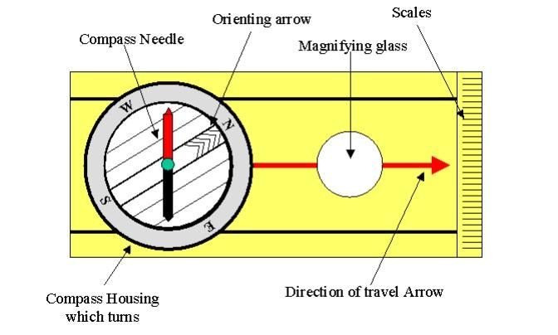
A compass, like the one sketched above, is one of the oldest pieces of human technology that is based on measuring something ‘invisible’ – Earth’s magnetic field. Navigators have used compasses for centuries, and learned quite a lot about how they work and what Earth’s magnetic field looks like. This activity will get you acquainted with Earth’s magnetism in a very direct way. Your teacher will review with you the basic use of a compass. Use the above figure of a typical compass to “get your bearings.”

Part A: In your school yard, and without letting anyone see you, take a bearing on a particular object (tree, building, car, etc.) located a few hundred yards away. Note the bearing in “degrees,” and write the answer in the box below:

Hand this paper to your classmate and have them stand in the same spot you did, and use the bearing to figure out the object at which you were looking. Don’t make it easy for them by selecting an isolated object!

Part B: During a “magnetic storm,” bearings can suddenly change by up to 5 degrees. Work with a partner to develop a way to determine if a magnetic storm is occuring by using a compass. Write up your idea. Test it over several days by comparing your results with the magnetic storm dial on the following website: http://sprg.ssl.berkeley.edu/dst_index

Write up a description of whether or not your idea worked.

Name ___________________________________________________Date ____________

The Declining Magnetic Field

Earth’s magnetic field is declining in strength. Some scientists think that it may actually vanish in the near future and be replaced by a growing magnetic field with an opposite magnetic polarity – a phenomenon called a Magnetic Reversal. The graph shows the measured strength of Earth’s magnetic field since 1900, measures in multiples of 10²² Ampere x meters².

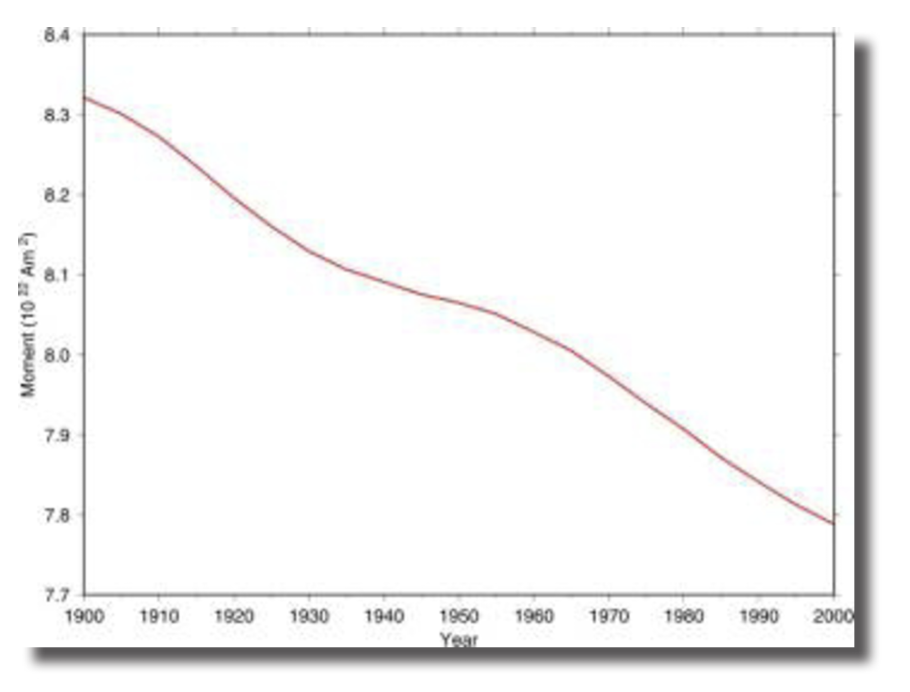

Question 1 – By how much has the field changed in intensity between 1900 and 2000?
Question 2 – What has been the rate of this change per year, in terms of its percentage change per year?
Question 3 – Based on your answer to Question 2, how many years from now will it take for the field to decrease to zero strength?
Question 4 – What will be the year when the field reaches zero strength?

Inquiry Problem: What effects do you think will happen when Earth’s magnetic field vanishes temporarily for a few decades or centuries? Support your conjecture with evidence from relevant information sources.

Name ___________________________________________________Date ____________

Geomagnetism I: Polar Wander

The Earth rotates around an axis through its center. This axis passes through the surface at the North and South Geographic Poles. The magnetic poles change in strength and move over time. The curve in the figure above gives the location of Earth’s magnetic pole in the Northern Hemisphere as it has moved during the last 400 years! The scale of the above plot is approximately 1 centimeter represents 163 km.

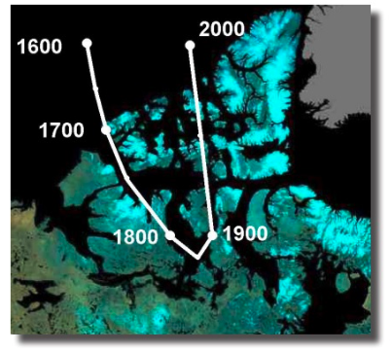
- What is the total distance that the magnetic pole wandered from 1600 AD to 2000 AD?
- What is the average speed of the wander from 1600 AD to 2000 AD?

Inquiry Problem: The probability of seeing an aurora is highest in the circular belt centered on the Magnetic Pole, with a radius of 800 km. Explore how the viewing of aurora will change over the next 100 years, at the present rate of polar wander
Name ___________________________________________________Date ____________

Geomagnetism II: Magnetic Reversals

Geologists have measured the strength of Earth’s magnetic field going back thousands of years. They do this by measuring its fossil traces left in the rock deposits around the world whose ages can be accurately dated. These measurements are shown in the table below. The units used to represent the magnetic dipole strength in the table below are 10²² Ampere x meters². Today’s strength (Time = 0.0) has a value if 8.0 x 10²² Ampere x meters² on the vertical scale. The “Time” columns indicate how many thousands of years before the present time that the field was at the indicated strength. For example, the first table entry ‘20’ means 20,000 years ago, at which time the strength was 12.0 x 10²² Ampere x meters².
Create a graph of Time (in years) versus Magnetic Field Strength using the table below. Remember to mark your x – and y – axis with labels and units.

Time | Strength | Time | Strength | Time | Strength | Time | Strength
0 | 8.0 | 220 | 5.7 | 440 | 6.3 | 660 | 7.0
20 | 12.0 | 240 | 6.5 | 460 | 7.0 | 680 | 3.5
40 | 3.2 | 260 | 4.5 | 480 | 6.0 | 700 | 5.0
60 | 5.0 | 280 | 5.0 | 500 | 5.7 | 720 | 5.5
80 | 6.6 | 300 | 6.0 | 520 | 4.6 | 740 | 8.2
100 | 3.8 | 320 | 5.8 | 540 | 3.8 | 760 | 6.5
120 | 4.3 | 340 | 6.4 | 560 | 4.2 | 780 | 0.5
140 | 6.5 | 360 | 8.5 | 580 | 4.7 | 800 | 3.4
160 | 6.3 | 380 | 5.0 | 600 | 6.0
180 | 2.2 | 400 | 7.5 | 620 | 5.5
200 | 6.0 | 420 | 8.4 | 640 | 8.5

From the tabulated entries above, answer the following questions:

- What is the range of the magnetic field strength?
- What is the average value of the magnetic field strength?
- How many times has the magnetic strength dipped below ½ of its current value of 12.0 x 10²² Ampere x meters²?
- When was the last time that the magnetic strength reached 1/3 of its current level?
- When was the last time the magnetic strength was close to zero?
- When did the fastest change in the magnetic field strength occur in the last 800,000 years?
Inquiry Problem: Do you think the magnetic field strength will actually reach zero? Using the plotted datam explain your reasoning.
Name ___________________________________________________Date ____________

Heliophysics Quiz
True or False
1. Electrons in the plasma from the Sun give off light to produce aurora.
2. Solar flares are always accompanied by a CME.
3. The Earth's magnetotail is located on the nighttime side of the Earth.
4. Sunspots occur in areas where there is a magnetic disturbance on the Sun.
5. The Sun's magnetic field and Earth's magnetic field come in contact with each other at the magnetosphere.

Fill in the Blank
6. A rapid release of heat and light located close to the Sun's surface is ____________
7. An Earth-directed CME is called _____________________________________________
8. The strongest class of solar flare is given the letter _____________________________
9. The closest star to Earth is called ____________________________________________
10. The letters CME stand for __________________________________________________
11. What is the evidence that magnetic disturbances on the Sun lead to disturbances in Earth's magnetic field?

