Motion of a Coronal Mass Ejection

by Christian J. Mercado
Credit: Kurzgesagt – In a Nutshell

Table of Contents
Lesson Overview and Objectives 2
Materials 4
5E Steps 5
Resources 11
Handouts 11

Lesson Overview
Level: 9-12 Time: 5 class periods
In this lesson, students will learn about coronal mass ejection (CME) processes that take place in the Sun. An important part of space weather research is to measure the velocity of CME and their acceleration as they leave the Sun. This is done by tracing features in the CME and measuring their positions at different times. Students will see this process using simulators and calculate the velocity and acceleration of a coronal mass ejection (or CME) based on its position in a series of images from the LASCO instrument on SOHO.

Educator Background Knowledge
- Sun
- Plasma and magnetic field
- Coronal Mass Ejection (CME)
- Coronagraph
- Motion Physics

Learning Goals
Understand the concept of Coronal Mass Ejection (CME) using using the timestamp on “coronagraph” images captured by NASA’s SOHO mission.

Learning Objectives
- Students will study through simulators the motion of coronal mass ejections.
- Students will calculate the average velocity of a coronal mass ejection.
- Students use graphical analysis and fundamental astronomical data to calculate how much time is needed for the CME to reach Earth.
Framework for Heliophysics Education
NASA Question: What are the impacts of the Sun on humanity? Big Idea: The Sun is active and can impact technology on Earth via space weather.
NASA Question: What causes the Sun to vary? Big Idea: The Sun is made of churning plasma, causing the surface to be made of complex, tangled magnetic fields.

NGSS Performance Expectations
HS-PS2-1: Motion and Stability: Forces and Interactions: Analyze data to support the claim that Newton’s second law of motion describes the mathematical relationship among the net force on a macroscopic object, its mass, and its acceleration.

Disciplinary Core Ideas
- HS-ESS1.A: Earth’s Place in the Universe: The Universe and Its Stars: The star called the Sun is changing and will burn out over a lifespan of approximately 10 billion years.

Common Core Standards for Mathematical Practice
- High School: Statistics and Probability: Interpreting Categorical and Quantitative Data HSS-ID.A.1: Represent data with plots on the real number line (dot plots, histograms, and box plots).

Targeted STEM Skills
- Patterns: Patterns in rates of change and other numerical relationships can provide information about natural systems.
- Scale, Proportion, and Quantity: The significance of a phenomenon is dependent on the scale, proportion, and quantity at which it occurs.
- Stability and Change: Change and rates of change can be quantified and modeled over very short or very long periods of time. Some system changes are irreversible.

Materials
- Computer with Internet connection and printer
- Ruler
- Calculator
- Measure App (optional)
Handouts
- There are three data tables located online in the interactive: Coronal Mass Ejections. They do the calculations for the students who do the measurements.
https://cesar.esa.int/tools/15.coronal_mass_ejections/index.php?Step=2&Set=1
Links to Digital Resources for Students
- Measuring the Motion of a Coronal Mass Ejection: https://soho.nascom.nasa.gov/classroom/cme_activity.html
- Using the Solar & Heliospheric Observatory Satellite (SOHO) to Measure the Motion of a Coronal Mass Ejection: https://www.sciencebuddies.org/science-fair-projects/project-ideas/Astro_p020/astronomy/measure-the-motion-of-a-coronal-mass-ejection
- Coronal Mass Ejections: https://cesar.esa.int/tools/15.coronal_mass_ejections/index.php?Step=2&Set=1
- SteroCat: https://ccmc.gsfc.nasa.gov/analysis/stereo/
- Could Solar Storms Destroy Civilization? Solar Flares & Coronal Mass Ejections: https://www.youtube.com/watch?v=oHHSSJDJ4oo
Key Vocabulary
Coronal Mass Ejection (CME): A release of large amounts of plasma and magnetic field from a star that occurs during a realignment of the star’s complex magnetic fields. The plasma in a CME is a cloud of protons and electrons that can travel at varying high speeds, but slower than the speed of light.
Coronagraph: An astronomical instrument that blocks the direct light of the Sun so that other features (such as the corona itself, sunspots, and coronal mass ejections) can be seen and measured.
Material Preparation
- Review the lesson and resources and make copies of the Lab Report for students.
- If virtual, upload all documents to the cloud for student access.
- Create groups of two students (pairs) to analyze NASA/ESA SOHO space observatory images and videos.
- Students will analyze authentic data from the NASA/ESA SOHO space observatory to determine the speed of a coronal mass ejection (CME).
- Computer lab for students to carry out the Extend activities.

5E Steps
Engage
The Sun sometimes releases huge bursts of electrified gasses into space. These bursts are called coronal mass ejections (or CMEs). Watch the video “Could Solar Storms Destroy Civilization? Solar Flares & Coronal Mass Ejections.”
Questions for students:
- What are solar flares and coronal mass ejections, and how do they occur?
- What potential impacts can solar storms have on Earth's technology and infrastructure?
- How do scientists monitor and predict solar storms, and what measures can be taken to mitigate their potential effects on civilization?
Explore
Analyze the CME using the StereoCAT Simulation and have students answer the following questions.
- On July 23, 2012, the Sun unleashed two massive clouds of plasma that barely missed a catastrophic encounter with Earth’s atmosphere.
- Determine how fast the CME is moving on July 23, 2012 using the simulator.
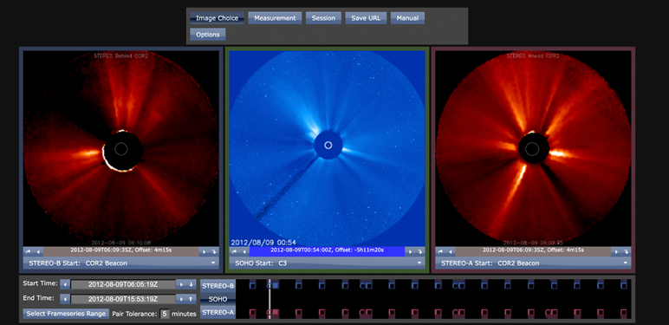

Explain
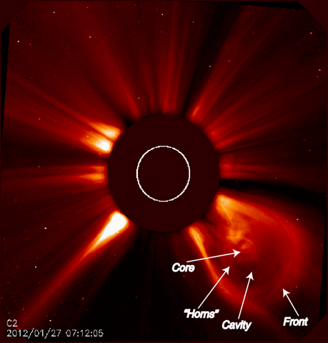
Answer the following questions based on the video and simulator observed in the last section (the StereoCAT Simulation).
- Based on the video and simulator, where do you think the center of the Coronal Mass Ejection is?
- What do you think is causing the cavity in the Coronal Mass Ejection?
- List the damages that a CME would cause to Earth.
Extend
Students will use data from the Solar & Heliospheric Observatory Satellite (SOHO) mission to measure the motion of a coronal mass ejection.
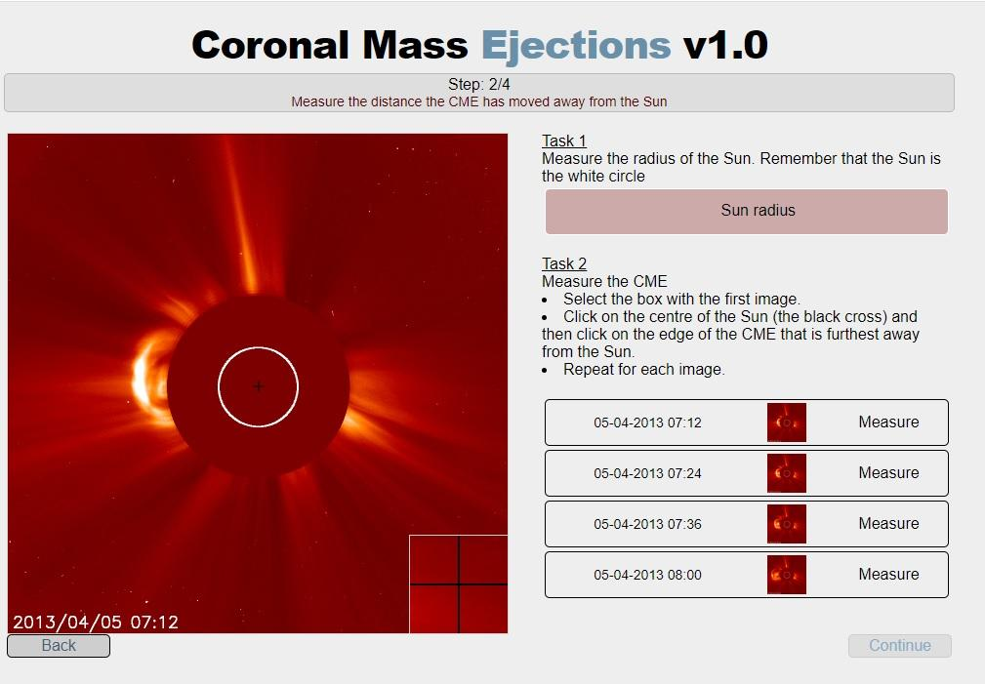
English View

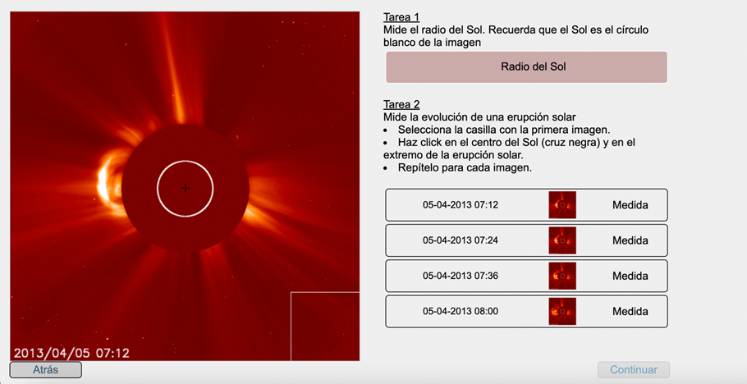
Spanish view

Students will use the Coronal Mass Ejections simulator (Task 2) from CESAR, an educational ESA initiative whose main objective is to engage secondary school students with astronomy:

To get to the Spanish version, go back to Task 1 and click the small flag at the bottom of the right side of the screen.
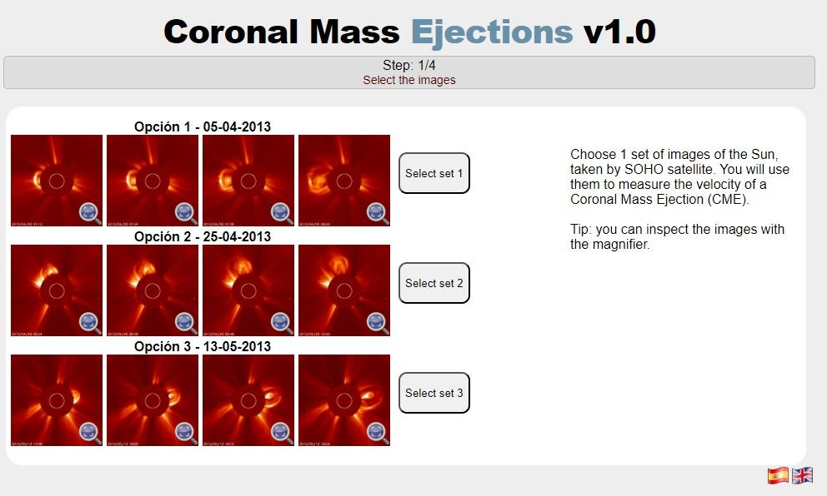
Evaluate
Based on the data obtained, the students will measure the velocity of a coronal mass ejection and the time it takes to get from the Sun to Earth.

English view: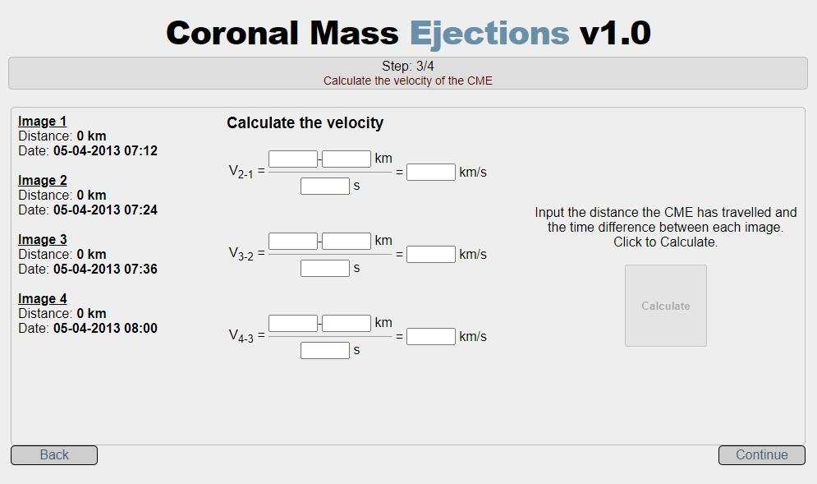
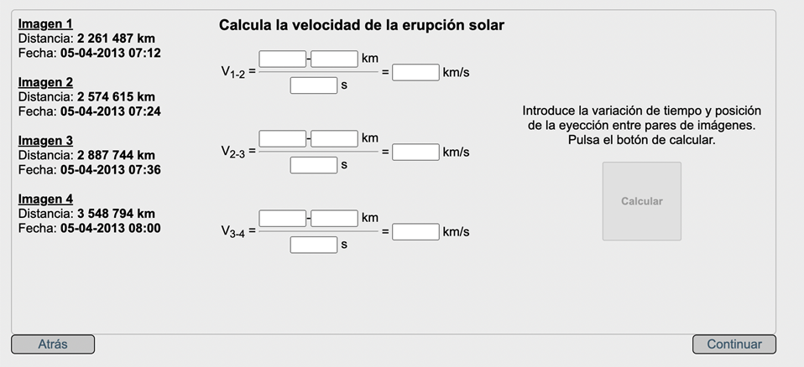
Spanish view:

Resources
- CME Analysis with StereoCAT for Space Weather. https://ccmc.gsfc.nasa.gov/RoR_WWW/SWREDI/2016/StereoCAT_limitations_MLeilaMays_BThompson.pdf
- StereoCat: https://ccmc.gsfc.nasa.gov/analysis/stereo/
- CESAR Interactive. Coronal mass ejections v1.0. Step 2. https://cesar.esa.int/tools/15.coronal_mass_ejections/index.php?Step=2&amp;Set=1

Handouts
The data tables may be printed out from the interactive: CESAR Interactive. Coronal mass ejections v1.0. Step 2. https://cesar.esa.int/tools/15.coronal_mass_ejections/index.php?Step=2&amp;Set=1

