https://arce.org/resource/ra-creator-god-ancient-egypt/

The Origin and Nature of the Sun

by Marvin Nationales
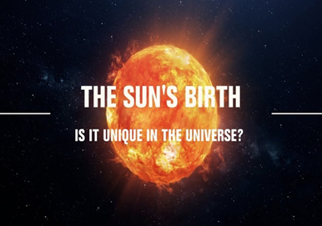
Uploaded from European Research Council, 2/16/21

Table of Contents
Lesson Overview and Objectives 2
Materials 5
5E Steps 6
Resources 8
Handouts 10

Lesson Overview
Level: 9-12 Time: Two class periods
Explore the origin of the Sun using scientific and traditional ways of tracing how the Sun came into existence. The lesson is an introduction to Heliophysics and features media resources from NASA, including videos, photographs, and multiple models of the Sun.

Educator Background Knowledge
The Sun is an important factor for life on Earth. Almost all of the energy used by all living creatures on Earth originates in the Sun. Plants use energy from the Sun directly, converting it into food via photosynthesis. The energy then moves up the food chain as animals eat the plants and other animals eat those animals. Humans have found many ways to use the Sun’s energy. The energy in the food we eat originated in the Sun; the energy stored in fossil fuels comes from very old dead plants and therefore from the Sun. The Sun causes wind, so windmills use energy from the Sun, and of course solar power uses energy directly from the Sun.

Learning Goals
In this lesson, students will develop two-eyed-seeing in understanding the origin of the Sun. Students will be reading and watching mythology stories and scientific-based discussions on the origin and nature of the Sun. Students also work through an interactive lesson to investigate how the Sun came into existence. After learning the origin of the Sun, students will interview a community member to learn about the origin of the Sun from a cultural perspective.

Learning Objectives
- Students can trace the scientific and culture-based origin of the Sun.
- Students can compare and contrast the scientific from culture-based explanations on the origin of the Sun.
- Students can use two-eyed seeing in understanding the origin and nature of the Sun.
- Students can identify the central idea and provide text evidence upon reading a scientific (Informational) and culture-based (Literary ) text.
- Students can use the NASA STEM Engagement resources to explore the Sun’s atmosphere.
- Students can interview a community member to trace the Sun’s origin from a cultural perspective.

Framework for Heliophysics Education
NASA Question: What causes the Sun to vary? Big Idea: Our Sun, like all stars, has a life cycle.

NGSS Performance Expectations
At the high school level students conduct investigations into the strength of electrical forces between particles (HS-PS3-1) and into the relationship of electrical and magnetic fields (HS-PS2-5). HS-ESS1-1 directly addresses the layers of the Sun, fusion, 11-year solar cycle, sunspots, and solar flares.
HS-PS3-1: Energy: Create a computational model to calculate the change in the energy of one component in a system when the change in energy of the other component(s) and energy flows in and out of the system are known.
HS-PS2-5: Motion and Stability: Forces and Interactions: Plan and conduct an investigation to provide evidence that an electric current can produce a magnetic field and that a changing magnetic field can produce an electric current.
HS-ESS1-1 Earth’s Place in the Universe: Develop a model based on evidence to illustrate the life span of the Sun and the role of nuclear fusion in the Sun’s core to release energy that eventually reaches Earth in the form of radiation.

Cross-Cutting Practices
- Cause and Effect: Events have causes, sometimes simple, sometimes multifaceted. Deciphering causal relationships, and the mechanisms by which they are mediated, is a major activity of science and engineering.
- Energy and Matter: Tracking energy and matter flows, into, out of, and within systems helps one understand their system’s behavior.
- Structure and Function: The way an object is shaped or structured determines many of its properties and functions.
- Stability and change: For both designed and natural systems, conditions that affect stability and factors that control rates of change are critical elements to consider and understand

Disciplinary Core Ideas
- ESS2.D: Earth Systems: Weather and Climate (9-12)
- LS1.C: From Molecules to Organisms: Structures and Processes: Organization for Matter and Energy Flow in Organisms (6-8)
- LS2.A: Ecosystems: Interactions, Energy, and Dynamics: Interdependent Relationships in Ecosystems (3-5)
- PS3.D: Energy: Energy in Chemical Processes and Everyday Life (6-8)

Targeted STEM Skills
- Planning and Carrying Out Investigations
- Analyzing and Interpreting Data
- Constructing Explanations and Designing Solutions
- Engaging in Argument from Evidence
- Obtaining, Evaluating, and Communicating Information

Materials
Internet connection, pen, notepad, reading texts, videos

Handouts
- KWL Chart
- Observation Notes
- Venn Diagram
- Multimedia Rubric

Links to Digital Resources for Students
Scientific Explanations
- How was the Sun formed?
- Discovering the origin of our Sun Video
- Earth's Sun: Facts about the Sun's age, size and history
- Discovering the origin of our Sun
- Where Did the Sun Come from? The Search Continues
Culture-Based Explanations
- How Different Cultures Once Considered the Sun
- Myths about Sun
- Helios: The Solar God (Titan) of Greek Mythology
- Ra and the Sun Boat (God of Sun) Egyptian Mythology
Key Vocabulary
Electromagnetic radiation: energy that travels in the form of a wave; examples include visible light, radio waves, infrared and ultraviolet light, X-rays, and gamma rays.
Protostar: a contracting mass of gas which represents an early stage in the formation of a star, before nucleosynthesis has begun.
Indigenous Knowledge: a traditional story, especially one concerning the early history of a people or explaining some natural or social phenomenon, and typically involving supernatural beings or events.
Material Preparation
Prepare these links before starting the lesson. Some of these will be shared with the students and some will be shown to the whole class.
- Maui Snaring the Sun: http://www.sacred-texts.com/pac/maui/maui07.htm
- How was the Sun formed?
- Discovering the Origin of our Sun Video
- Earth's Sun: Facts about the Sun's age, size and history
- Discovering the Origin of our Sun
- Where Did the Sun Come from? The Search Continues
- How Different Cultures Once Considered the Sun
- Myths about Sun
- Helios: The Solar God (Titan) of Greek Mythology
- Ra and the Sun Boat (God of Sun) Egyptian Mythology

5E Steps
Engage
- Explain to the class that we will be learning about the origin of the Sun.
- Using Mentimeter, ask students, “Where did the Sun come from?” Have students share their ideas in pairs, groups, or with the whole class.
- Using Pear Deck*, use the KWL Chart to assess what students know about the origin of the Sun (scientific and from mythology, or culture-based) and have the students write down things they know about the origin of the Sun. *You need to make a Pear Deck account.
- The KWL Chart in the Handout section can be used if the teacher has no Pear Deck account.
Explore
- Watch Videos: Students will watch a video about Discovering the Origin of our Sun Video (Scientific) and Ra and the Sun Boat (Culture-based)
- Read Articles : Students will read two articles (How Was The Sun formed? and The Story of Ra and write down important details from the texts.
- Explore NASA Resources: https://www.youtube.com/watch?v=L_3rsArLhks&t=144s
- Worksheet: Compare and contrast the scientific and mythological explanations on the origin of the Sun using a graphic organizer.
- Ten big questions about the Sun answered: https://www.skyatnightmagazine.com/space-science/questions-about-sun-answered/
- Navigate NASA resources:
  - Go to this website: https://solarsystem.nasa.gov/solar-system/Sun/overview/ or https://exoplanets.nasa.gov/eyes-on-exoplanets/#/
    - Navigate the Sun and gather evidence on what elements present in the Sun.
  - Click Explore the Sun under the Helioviewer Project.
    - Compare our Earth’s size to the Sun and list the things that you discovered about the Sun.
  - Play Helios: https://spaceplace.nasa.gov/helios-game/en/
- Record your Observation Notes on the handout.
- Complete the Venn Diagram on the handout by comparing and contrasting scientific and culture-based origin of the Sun. Write a compare and contrast essay after completing the Venn Diagram.
Explain
Concepts discussed and vocabulary defined with students.
- What are the materials and elements that combined together that formed the Sun?
- What caused the cloud to flatten into a disc-like pancake?
- What process drives the Sun to expand?
- What are the six layers of the Sun? Describe each layer.
- What is the mass of the Sun?
- How big is the Sun?
- What is the function of the heliosphere and the Sun’s magnetic field?
- What will happen to Earth if our Sun disappears?
Extend
Indigenous Community-Based Activity: Students will interview an elder and trace the Sun’s origin in the Navajo (or other Indigenous) culture and the role it plays in their lives. Then students will create a multimedia presentation summarizing the important ideas learned from the interview. Use the multimedia presentation rubric (see Handouts). Non-indigenous students can research Sun stories from any cultures past or present using online resources and books.

Evaluate
Use the Pre-Post test in Handouts.

Resources
Handouts
- Pre-Post Test
- Answer Key
- KWL Chart
- Observation Notes
- Venn Diagram
- Multimedia Rubric
Scientific Explanations
- How was the Sun formed?
- Discovering the origin of our Sun Video
- Earth's Sun: Facts about the Sun's age, size and history
- Discovering the origin of our Sun
- Where Did the Sun Come from? The Search Continues
Culture-Based Explanations
- How Different Cultures Once Considered the Sun
- Myths about Sun
- Helios: The Solar God (Titan) of Greek Mythology
- Ra and the Sun Boat (God of Sun) Egyptian Mythology

Handouts
These begin on the next page.

Pre/Post Test: The Origin and Nature of the Sun
1. The energy from the Sun is created by a process called:
- Nuclear reaction
- Nuclear core
- Nuclear fusion
- Nuclear fission
2. Energy is created in the core when two _____________ atoms join together to form a ______________ atom.
- Nitrogen, helium
- Hydrogen, helium
- Carbon, hydrogen
- Helium, hydrogen
3. The temperature inside the Sun's core can reach about:
- 15,000 degree Fahrenheit
- 15,000,000 degrees Celsius
- 15,000,000 degrees Fahrenheit
- 15,000,000,000 degrees Celsius
4. The middle layer of the Sun's interior that contains very tightly packed gas is called the _____________.
- Photosphere
- Chromosphere
- Convection Zone
- Radiation Zone
5. How does heat transfer through the Sun?
- From the outer layers go to the core
- It radiates out to all layers
- It is transferred through light energy
- Radiates from the core then to the outer layers by convection
6. In which area of the Sun does gas rise as it heats up, then fall back down as it cools?
- The radiation zone
- The core
- The convection zone
- The corona
7. When we look at the Sun, what layer are we viewing?
- Chromosphere
- Convection zone
- Corona
- Photosphere
8. The particles of the corona extends into space for millions of kilometers and spreads into streams of electrically charged particles called:
- Solar flares
- Solar winds
- Coronal ejection
- Coronal discharge
9. Huge loops of reddish gas that connect sunspots are called:
- Solar wind
- Prominences
- Solar flares
- Coronal loops
10. The Sun is billions of years old and it is expected to last for billions of years. Which of the following would be the BEST method to study how the Sun will change over the next few billion years.
- Make observations of similar stars
- Build the model of the Sun in a lab.
- Create a computer model to simulate what will happen to the Sun as it ages.
- Observe the Sun and make detailed notes for the next billion years.
Pre/Post Test: The Origin and Nature of the Sun Answer Key
1. The energy from the Sun is created by a process called:
c. Nuclear fusion
2. Energy is created in the core when two _____________ atoms join together to form a ______________ atom.
b. Hydrogen, helium
3. The temperature inside the Sun's core can reach about:
b. 15,000,000 degrees Celsius
4. The middle layer of the Sun's interior that contains very tightly packed gas is called the _____________.
d. Radiation Zone
5. How does heat transfer through the Sun?
d. Radiates from the core then to the outer layers by convection
6. In which area of the Sun does gas rise as it heats up, then fall back down as it cools?
c. The convection zone
7. When we look at the Sun, what layer are we viewing?
d. Photosphere
8. The particles of the corona extends into space for millions of kilometers and spreads into streams of electrically charged particles called:
b. Solar winds

9. Huge loops of reddish gas that connect sunspots are called:
b. Prominences
10. The Sun is billions of years old and it is expected to last for billions of years. Which of the following would be the BEST method to study how the Sun will change over the next few billion years.
c. Create a computer model to simulate what will happen to the Sun as it ages.

Name: Date: Class Period:
KWL Chart
Topic: Origin and Nature of the Sun (Scientific and Culture-Based)
What I Know | What I Want to Know | What I Learned

Student Observation Notes
Date/Time | Observation/Notes
9/27/22 @ 2:07 p.m. | Type your observations here . . .
9/29/22 @ 10:47 am
Explore: Compare and Contrast the Origin of the Sun
Directions: Complete the Venn Diagram by comparing and contrasting scientific and culture-based origin of the Sun. Write a compare and contrast essay after completing the Venn Diagram.
Scientific Origin of the Sun Culture-Based Origin of the Sun
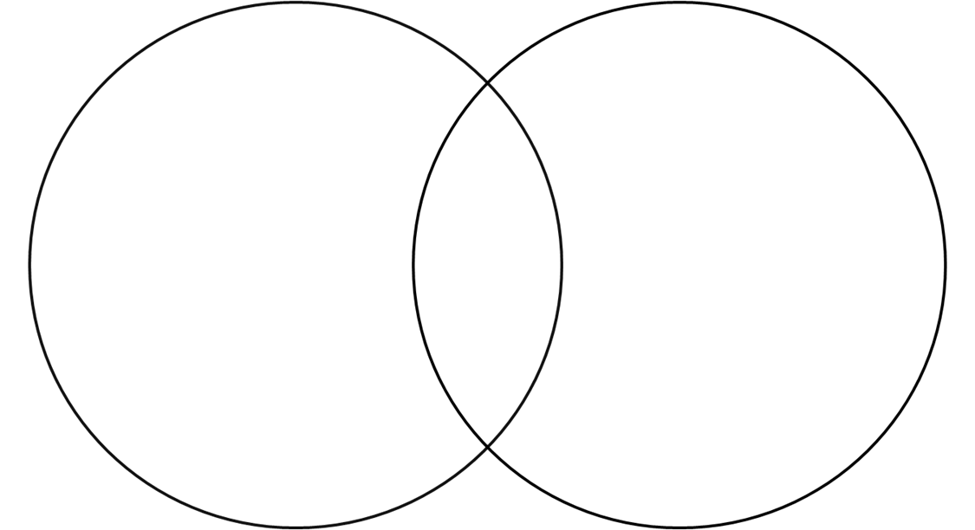

Compare and Contrast Essay:

Multimedia Rubric
Copyright © Texas Education Agency, 2006. All rights reserved.
Task Description: Teacher can use this space to describe the activity.
Criteria | % | Exemplary | Admirable | Acceptable | Attempted
Research of Topic | 20% | - Use of three or more sources, including at least two Internet and one print source; use of two search engines  - Variety of domain name suffix (.com, .edu, .net)  - Factual information is accurate  - Narrow focus of topic | - Use of two sources, including, including at least one Internet source; use of one search engine  - Most information can be confirmed  - Topic could be more narrowly focused | - Use of one Internet source  - Some errors in information  - Topic somewhat broad | - Use of only one source  - Numerous errors in information  - Topic too general
Organiza-tion (Outline or Story board for Planning) | 15% | - Logical sequencing  - Menus and paths are clear  - Original; inventive; creative | - Somewhat logical sequencing  - Menus and paths are mostly clear  - Original | - Sequencing is poorly planned  - Menus and paths are sometimes confusing  - Little originality | - Sequencing is confusing  - Menus and paths are confusing  - Inconsistent  - Rehash of other people’s ideas
Content | 20% | - Covers topic completely and in depth  - Content is readily understandable  - Media used contributes to understanding of topic | - Covers topic  - Content is mostly understandable  - Media used mostly contributes to understanding of topic | - Barely covers topic  - Content is somewhat understandable  - Media used somewhat contributes to understanding of topic | - Does not adequately cover topic  - Content is confusing  - Media used does not contribute to understanding of topic
Graphic Design | 25% | - Effective combination of multimedia and persuasive design elements  - Excellent use of navigational tools and buttons  - Graphics effectively entice audience; accurately convey message | - Good combination of multimedia and design elements  - Adequate navigational tools and buttons  - Visuals and images are attractive; adequately conveys message | - Some use of multimedia and design elements  - Some buttons and navigational tools work properly  - Use of visuals and images is limited; message is conveyed | - 0-1 media used  - Buttons and navigational tools are absent or confusing  - Use of visuals and images is confusing or absent; message is confusing
Mechanics | 10% | - Correct grammar, usage, mechanics, and spelling  - All sources are correctly cited | - Few grammar, usage, mechanics, or spelling errors  - Most sources are correctly cited | - Several grammar, usage, mechanics, or spelling errors  - Some sources are incorrectly cited | - Obvious grammar, usage, mechanics, or spelling errors  - Sources are not cited
Teamwork  (optional) | 10% | - Workload is divided and shared equally | - Some members contribute | - Few members contribute | - One or two people do all of the work

Assignment Score ______________ + Beyonder/Bonus ______________ =

Final Score ________________

