Our Sun as a Natural System
Tom N. Tomas

Table of Contents
Lesson Overview and Objectives 2
Materials 4
5E Steps 6
Resources 10
Handouts 11

Note: This lesson was designed for Navajo students but is included in the HEAT collection to inspire and support all educators to incorporate indigenous knowledge.

Lesson Overview
Level: 5-6th grade Time: Twelve 1-hour class periods
Students will learn about the Sun’s spectral lines that include hydrogen, helium, argon, neon, and sodium using DIY spectroscopes to understand how scientists use high-tech spectroscopes to study distant stars and exoplanets. Geissler tubes will provide access to the five elements listed above. Then we will hold the Sun in our hands with the Merge Cube (a free educational trial is available). Students will also develop systems thinking by studying the Sun as a natural system and spacecraft such as satellites as human-designed systems.

Students will learn how to create a spectroscope to identify elements in a gas cloud while using gas discharge lights: hydrogen, helium, argon, neon, and sodium. Plus, we will use the DIY spectroscope to study the streetlights around our homes and surrounding community. We will learn how each gas cloud provides a unique set of spectral lines, like a fingerprint, and that scientists use high-tech spectroscopes to ‘read’ the Sun, and distant stars.

Satellites such as the Parker Solar Probe, Solar Orbiter, and the Solar Dynamics Observatory are human-designed spacecraft that gather data about our closest star. Students will study data from those satellites, etc. to understand and learn how to live with our closest star.

Educator Background Knowledge
Our Sun ‘varies’ over many timescales from tens of millions of years as it evolves as a star, and over minutes to hours due to solar activity and solar flares. Teachers may emphasize that these vast timescales are beyond human understanding but we have created technology to extend human senses to observe the Sun (and other stars) over vast timescales of change.
Additional topics:
- Systems thinking: human-designed systems
- Mixed reality as a technology, i.e., using MergeCube
- Solar Flares and Coronal Mass Ejections https://www.jpl.nasa.gov/nmp/st5/SCIENCE/cme.html#:~:text=CMEs%20often%20occur%20along%20with,to%20three%20CMEs%20per%20day.
- KP Index (Estimated Planetary K-index) Tutorial: https://sunearthday.nasa.gov/swac/tutorials/mag_kp.php
- Spectroscopy helps us identify the elements that exist within a celestial body.

Teachers may share the role of the Sun in Native Science: The Heliosphere: One of four systems that comprise our biosphere.

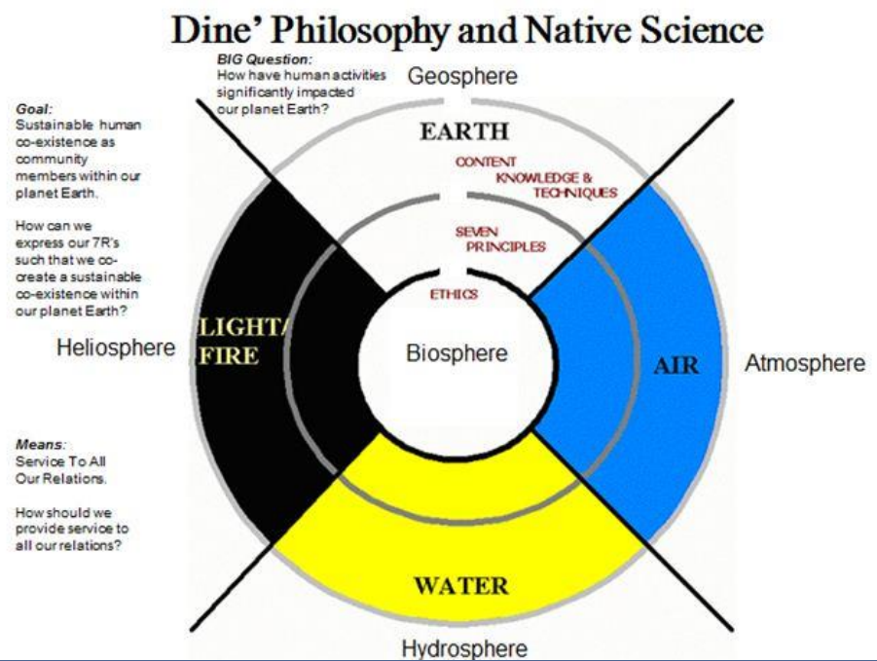
‌
Learning Goals
Students understand the features of our Sun as a natural system compared with human-made systems such as satellites.

Learning Objectives
- Students will be able to describe the characteristics of the Sun as a natural system.
- Students will be able to compare the Sun as a natural system with satellites like the Parker Solar Probe, Solar Orbiter, and Solar Dynamic Observatory which are human-made systems.

Framework for Heliophysics Education
NASA Question: What causes the Sun to vary? Big Idea: Our Sun, like all stars, has a life cycle.

NGSS Performance Expectations
- 5-ESS3-1: Earth and Human Activity: Obtain and combine information about ways individual communities use science ideas to protect the Earth’s resources and environment.
- MS-ESS3-2: Earth and Human Activity: Analyze and interpret data on natural hazards to forecast future catastrophic events and inform the development of technologies to mitigate their effects.
Common Core Standards for Mathematical Practice
- MP.2: Reason abstractly and quantitatively.
- MP.4: Model with mathematics.
- 6.RP.A.3: Use ratio and rate reasoning to solve real-world and mathematical problems.
- 6.SP.B.4: Display numerical data in plots on a number line, including dot plots, histograms, and box plots.
- 6.SP.B.5: Summarize numerical data sets in relation to their context.

Common Core Standards for ELA Literacy
- ELA/Literacy – RI.5.1 Quote accurately from a text when explaining what the text says explicitly and when drawing inferences from the text. (5-ESS3-1)
- RI.5.7 Draw on information from multiple print or digital sources, demonstrating the ability to locate an answer to a question quickly or to solve a problem efficiently. (5-ESS3-1)
- RI.5.9 Integrate information from several texts on the same topic in order to write or speak about the subject knowledgeably. (5-ESS3-1)
- W.5.8 Recall relevant information from experiences or gather relevant information from print and digital sources; summarize or paraphrase information in notes and finished work, and provide a list of sources. (5-ESS3-1)
- W.5.9 Draw evidence from literary or informational texts to support analysis, reflection, and research. (5-ESS3-1)

Crosscutting Concepts
- Systems and System Models: A system can be described in terms of its components and their interactions. (5-ESS3-1)

Targeted STEM Skills
- Obtaining, Evaluating, and Communicating Information Obtaining, evaluating, and communicating information in 3– 5 builds on K–2 experiences and progresses to evaluating the merit and accuracy of ideas and methods. Obtain and combine information from books and/or other reliable media to explain phenomena or solutions to a design problem. (5-ESS3-1)
- Analyzing and Interpreting Data Analyzing data in 6–8 builds on K–5 and progresses to extending quantitative analysis to investigations, distinguishing between correlation and causation, and basic statistical techniques of data and error analysis. Analyze and interpret data to determine similarities and differences in findings. (MS-ESS3-2)

Materials:
- Books about the Sun and other stars
- Geissler Tubes: Hydrogen, Helium, Neon, etc.
- Plasma Light by Stemclas
- Pizza Box Spectroscope Materials:
  - 12”x12” piece of corrugated cardboard (a medium or large pizza box works well)
  - 2 x 2-inch diffraction grating (1000 line/mm)
  - Black construction paper
  - Scissors or box-cutter
  - Ruler
  - Packing tape
  - Scotch tape
  - Black electrical tape
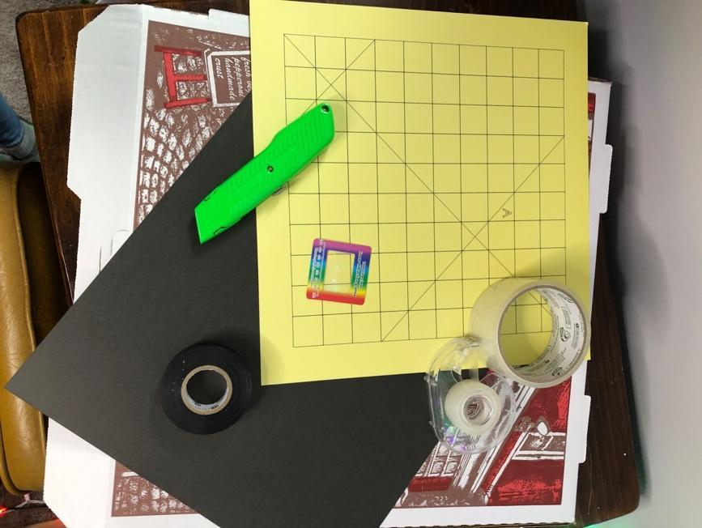
Handouts
- KWL Chart
- Pizza Box Spectroscope
- Systems Thinking
- Native science connections: Systems Thinking and Mother Earth, Father Sky

Links to Digital Resources for Students
- Pizza Box Spectroscope: Construction Movie: https://drive.google.com/drive/folders/17IVqXomqgNogHsDGp1tabTVrGyWF96nE
- Spectroscopy: A Key Part of the Astronomer's Toolbox:
http://ircamera.as.arizona.edu/NatSci102/NatSci/lectures/spectroscopy.htm
- Where Does the Sun's Energy Come From?:
https://spaceplace.nasa.gov/sun-heat/en/
- Play Helios: A Game About How the Sun Makes Energy!... Nuclear Fusion:
https://spaceplace.nasa.gov/helios-game/en/
- Sunspots and Solar Flares:
https://spaceplace.nasa.gov/solar-activity/en/
- Helioviewer (Sunspots in real time): https://helioviewer.org/
- SOHO: Solar and Heliospheric Observatory: https://soho.nascom.nasa.gov/
https://soho.nascom.nasa.gov/data/realtime-images.html
- Astronomy: The Sun (8 of 16) Sunspots:
https://www.youtube.com/watch?v=BGR9Q3pVtwo&t=132s
- SC.8.E.5.6 Chasing Sunspots:;
https://www.youtube.com/watch?v=Y8eCcebGiN4
- Realistic Simulations Reveal Something New Under the Sun: https://www.nas.nasa.gov/pubs/stories/2017/feature_solar_simulations_Stejko.html
- Toroidal Magnetic Fields: https://www.nas.nasa.gov/publications/articles/feature_solar_simulations_Stejko.html
- The Difference between Solar Flares and Coronal Mass Ejections: https://www.youtube.com/watch?v=TWjtYSRlOUI&t=11s
- Real World: Limits of the Solar System: https://nasaeclips.arc.nasa.gov/video/realworld/real-world-limits-of-the-solar-system
- What Is Plasma | Properties of Matter | Chemistry | FuseSchool: https://www.youtube.com/watch?v=94tReSbyPYc
- Exoplanet Travel Bureau:
https://exoplanets.nasa.gov/alien-worlds/exoplanet-travel-bureau/
- Graphic Novels Astrobiology (NASA):
https://astrobiology.nasa.gov/resources/graphic-histories/
- Coronal Mass Ejections Interactive Activity:
https://cesar.esa.int/tools/15.coronal_mass_ejections/index.php?Step=2&Set=3
- The Carrington event of 1859 — the largest solar flare ever recorded.
https://www.youtube.com/watch?v=9cNf8xK67JA
- Real World: Limits of the Solar System
https://nasaeclips.arc.nasa.gov/

Key Vocabulary
Spectroscope, spectral lines, spectroscopy, gas discharge lights, hydrogen, helium, argon, neon, sodium, periodic table of elements, CHNOPS (carbon, hydrogen, nitrogen, oxygen, phosphorus, sulphur), habitable zone, hr diagram

Material Preparation
- Make sure students have access to the digital resources.
- Have models of Earth, Moon, Sun, and measuring tape to help students experience scaled relationships between sizes and distances of each object.

5E Steps
Engage
Share these NASA videos and images:
- Parker Solar Probe Instruments https://science.nasa.gov/mission/parker-solar-probe/
- Parker Solar Probe: Getting to the Sun http://parkersolarprobe.jhuapl.edu/The-Mission/index.php#
- Parker Solar Probe: Orbital Path http://parkersolarprobe.jhuapl.edu/The-Mission/index.php#
- Parker Solar Probe: Why won’t it melt http://parkersolarprobe.jhuapl.edu/Spacecraft/index.php#Extreme-Environments
- SOHO: Solar and Heliospheric Observatory https://soho.nascom.nasa.gov/
- The Very Latest SOHO Images https://soho.nascom.nasa.gov/data/realtime-images.html

Explore
- Students will work in small groups to explore the relationships between our closest star and the Parker Solar Probe (PSP) and Solar Orbiter using Merge Cube (a free educational trial is available).
- Students will learn that if the Sun were 8.5” in diameter, our planet Earth would be less than 1/16” and located 75 feet away. Plus, the PSP would be 3 feet away from the Sun.
- Next, students will research and chart the qualities of the Sun as a natural system using the digital resources provided.
- Then the students will research how the Parker Solar Probe, Solar Orbiter, and Solar Dynamics Observatory are human-designed systems.
Explain
- Students will work in small groups to present their graphic organizers (such as a KWL) to the whole group and explain how the Sun is a natural system and the NASA satellites are human-designed systems.
- Students will make and demonstrate use of Pizza Box Spectroscope and use Geissler tubes and explain the spectral lines during parent meetings, community gatherings, and STEM Family Literacy Events.

Extend
Students will create multimedia presentations and present to the following audiences:
- Peers at school
- STEM Family Literacy Nights for family and community members
- Sister Schools via video conferencing
- E-portfolio entries provide each young scientist and engineer with an opportunity to tell her or his story as a learner.

Evaluate
- Students will keep a Science and Engineering Notebook as well as an electronic notebook to be kept within their e-portfolio located within their classroom website with access granted via each student’s email account.
- Student work within their notebooks will serve as Common Formative Assessment opportunities. The teacher will seek out students’ on-track thinking as well as misconceptions, and then modify and differentiate instruction accordingly using quizzes, group discussion boards, and online forms.

Resources
- KWL Chart Pizza Box Spectroscope by Raphael Lucas
- Systems Thinking
- Native science connections: Systems Thinking and Mother Earth, Father Sky

Links to Digital Resources for Students
- Pizza Box Spectroscope: Construction Movie: https://drive.google.com/drive/folders/17IVqXomqgNogHsDGp1tabTVrGyWF96nE
- Spectroscopy: A Key Part of the Astronomer's Toolbox:
http://ircamera.as.arizona.edu/NatSci102/NatSci/lectures/spectroscopy.htm
- Where Does the Sun's Energy Come From?:
https://spaceplace.nasa.gov/sun-heat/en/
- Play Helios: A Game About How the Sun Makes Energy!... Nuclear Fusion:
https://spaceplace.nasa.gov/helios-game/en/
- Sunspots and Solar Flares:
https://spaceplace.nasa.gov/solar-activity/en/
- Helioviewer (Sunspots in real time): https://helioviewer.org/
- SOHO: Solar and Heliospheric Observatory: https://soho.nascom.nasa.gov/
https://soho.nascom.nasa.gov/data/realtime-images.html
- Astronomy: The Sun (8 of 16) Sunspots:
https://www.youtube.com/watch?v=BGR9Q3pVtwo&t=132s
- SC.8.E.5.6 Chasing Sunspots:;
https://www.youtube.com/watch?v=Y8eCcebGiN4
- Realistic Simulations Reveal Something New Under the Sun: https://www.nas.nasa.gov/pubs/stories/2017/feature_solar_simulations_Stejko.html
- Toroidal Magnetic Fields: https://www.energy.gov/science/doe-explainstokamaks#:~:text=One%20set%20of%20magnetic%20coils,short%20way%20around%20the%20torus
- The Difference between Solar Flares and Coronal Mass Ejections: https://www.youtube.com/watch?v=TWjtYSRlOUI&t=11s
- Real World: Limits of the Solar System: https://nasaeclips.arc.nasa.gov/video/realworld/real-world-limits-of-the-solar-system
- What Is Plasma | Properties of Matter | Chemistry | FuseSchool: https://www.youtube.com/watch?v=94tReSbyPYc
- Exoplanet Travel Bureau:
https://exoplanets.nasa.gov/alien-worlds/exoplanet-travel-bureau/
- Graphic Novels Astrobiology (NASA):
https://astrobiology.nasa.gov/resources/graphic-histories/
- Coronal Mass Ejections Interactive Activity:
https://cesar.esa.int/tools/15.coronal_mass_ejections/index.php?Step=2&Set=3
- The Carrington event of 1859 — the largest solar flare ever recorded.
https://www.youtube.com/watch?v=9cNf8xK67JA
- Real World: Limits of the Solar System
https://nasaeclips.arc.nasa.gov/

Handouts
These begin on the next page.
Pizza Box Spectroscope
Materials:
- 12”x12” piece of corrugated cardboard (a medium or large pizza box works well)
- 2 x 2-inch diffraction grating (1000 line/mm)
- Black construction paper
- Scissors or box-cutter
- Ruler
- Packing tape
- Scotch tape
- Black electrical tape

Cutting Template for Spectroscope:
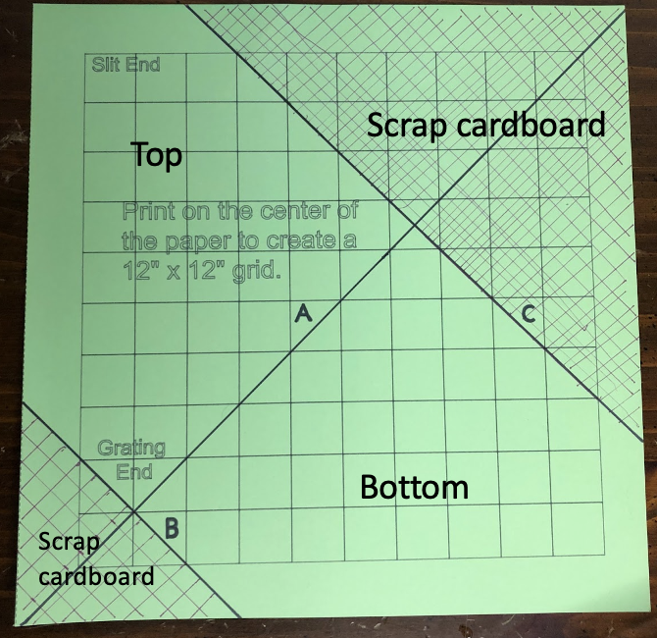
Watch the construction video by author Raphael Lucas: https://drive.google.com/file/d/1s0p2FzicmPxVIisyVsagl4qaqpQOOJf1/view?usp=sharing
Spectroscope Body Construction
- On a 12” x12” piece of corrugated cardboard (a medium or large pizza box works well) draw a 12”x12” grid, with 1”x1” grids. Draw diagonal lines A, B, and C, as indicated in the figure below. Or use the provided Cricut Printing File to quickly print a template; tape the template to the box.
Note: If you use the Cricut Printing template, the machine will not draw the lines to the edge of the 12” x 12” paper. Imagine that the grid lines, and lines A, B, and C, go all the way to the edge of the paper. Draw the missing line fragments in, if it helps you.
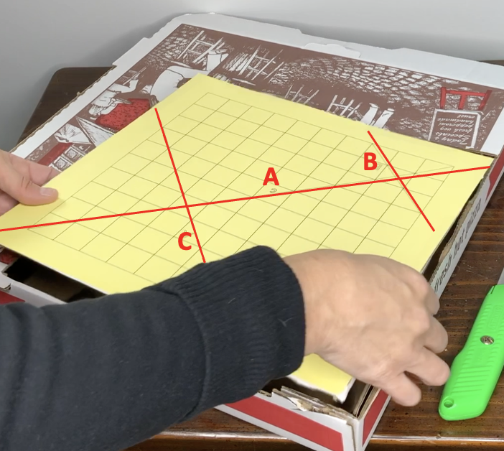
2. Cut along line A to form 2 large triangles.
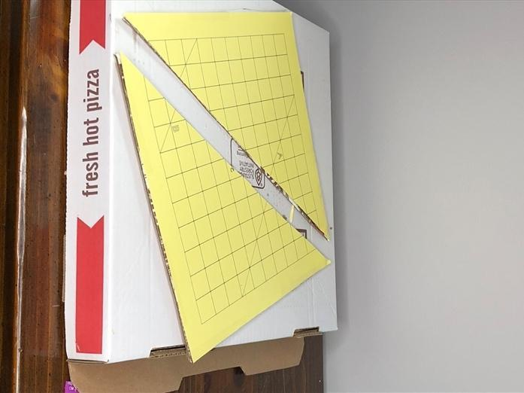
3. On each triangle, cut along lines B and C. These pieces form the top and bottom of the body of the spectroscope.
4. Cut three rectangles out of the remaining cardboard with the following dimensions. These are the sides of the spectroscope.
  - 2” x 7.75” (x2)
  - 2” x 9.5”
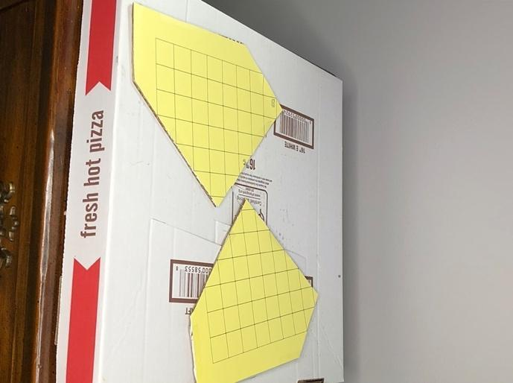
5. Trace the shape of the spectroscope body on black construction paper; cut out two pieces of black construction paper to line the inside of the spectroscope.

6. Tape the black construction paper to the top and bottom pieces of the spectroscope, on the sides that will be the inside of the spectroscope.

7. Cut rectangles out of the construction paper of the same dimensions as in step 4.

8. Tape the black construction paper to the side pieces of the spectroscope (the rectangles).

9. Attach the three rectangle pieces to the “bottom” of the spectroscope using packing tape.

Note: One of the 2” x 7.75” sides and the 2” x 9.5” side will overhang on the slit end. These overhanging pieces will be used to create the slit
10. Add some black electrical tape along the inside seams.

11. Fold up the sides and attach the top piece with packing tape, forming a box.

12. Add some additional tape along the outside, to prevent any light from seeping through.
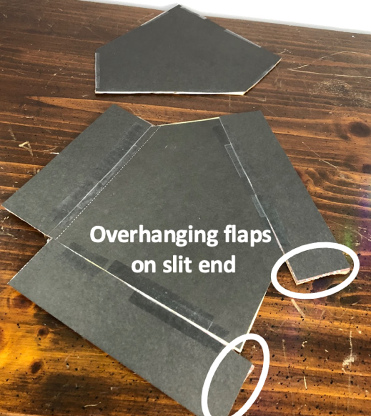

Slit End Construction:
- Bring the two extra flaps of cardboard together to make the slit.
- The slit should be no wider than the edge of a coin.
- Adjust the slit size by trimming the cardboard as necessary, and then tape it down, again covering the seams with black electrical tape.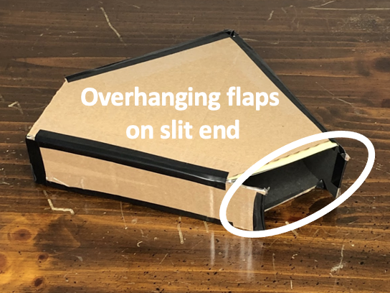

Grating End Construction:
- Draw a line from the slit to the grating end, parallel to the edge of the spectroscope.
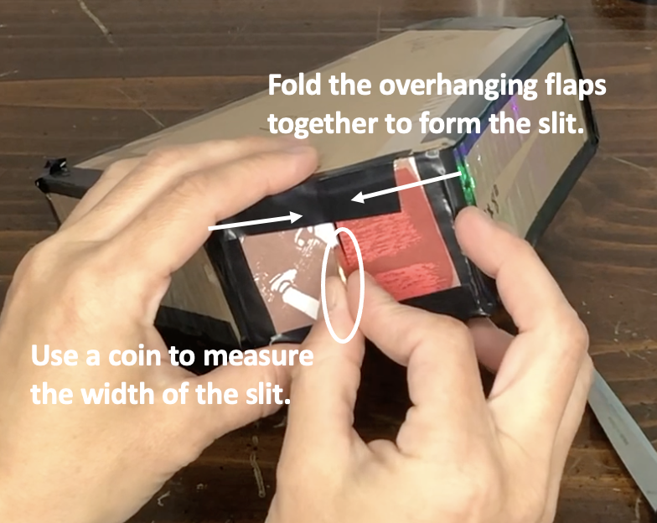
- Cut one 2” x 2” rectangle out of the
remaining cardboard.
- Cut a 1” x 1” hole out of the center.
- Tape the grating down to the hole (orient the diffraction grating with the rainbow going left to right).
- Line up the center of the grating with the line you drew from the slit.
- Attach the grating end to the spectroscope body, sealing the seams with black electrical tape.
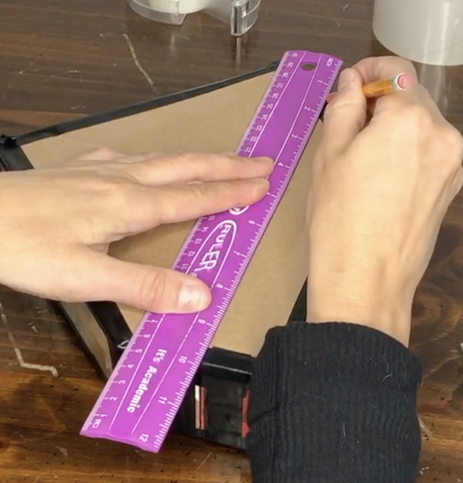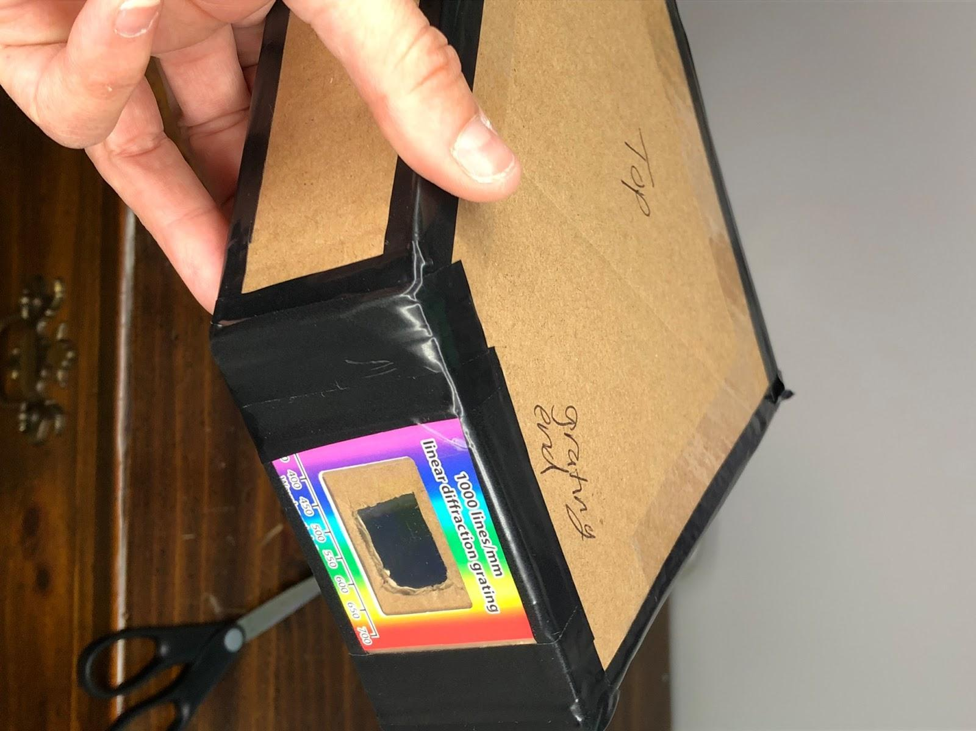
Using the Spectroscope:
- Point the slit end of the box at any lightsource and look through the grating end. To the right of the slit you will see a rainbow spectrum. Never look directly at the Sun with the spectroscope.
- Try observing different types of light sources around the house and observe how the spectra change.
- If you carefully place your smartphone camera lens against the grating window you can adjust your camera to take a picture of the spectrum.
- Examples of spectra from three common light sources:

