Sun-Earth Interactions
By Wendy Esch

Table of Contents
Lesson Overview and Objectives 2
Materials 4
5E Steps 5
Resources 8
Handouts 9

Lesson Overview
Level: MS and HS Time: Two 88-minute class periods
Students will gather data and research possible answers to the cause of a series of events. The unusual events are written on a calendar. Discussion and research will lead them to the fact that the Sun was the culprit. Then, students will research how the Sun looks the day the lab is done on various websites (SDO, Spaceweather.com) and then they will use eclipse glasses to go outside and view the Sun. A “Sunspotter solar telescope” can also be used to look at the Sun.

Back in the classroom, students will brainstorm a list of phenomena and events which occur before, during, and after a geomagnetic storm. Students will be reintroduced to what a star is and how its behavior can lead to consequences here on Earth other than light and heat. Students will read, develop questions, and answer them on a current news article about Solar Cycle 25.

Educator Background Knowledge
Heliophysics is the science of understanding the Sun and its interactions with Earth and the solar system, including space weather. Space weather is defined as the transfer of energy and particles from the Sun into the rest of the solar system in the form of solar wind, CMEs, and solar flares, among other phenomena.

Three heliophysics questions teachers should be able to answer. Use the NASA resource to find out the answers.
- What causes the Sun to vary?
- How do Earth, the planets, and the heliosphere respond?
- What are the impacts for humanity?

Teacher resource: NASA: The Sun-Earth Connection: https://science.nasa.gov/heliophysics/

Learning Goal
To understand the cause of aurora and other geomagnetic phenomena.

Learning Objectives
Students will gather data, research possible solutions, and design a solution to the problem. Students will also read for information.

​​Framework for Heliophysics Education
NASA Question: What are the impacts of the Sun on humanity? Big Idea: The Sun is active and can impact technology on Earth via space weather.
NASA Question: How do the Earth, the solar system, and heliosphere respond to changes on the Sun? Big Idea: The Sun defines the space around it, which is different from interstellar space.
NASA Question: What causes the Sun to vary? Big Idea: Energy from the Sun is created in the core and travels outward through the Sun and into the heliosphere.

NGSS Performance Expectations
HS-ESS1-1: Earth’s Place in the Universe: Develop a model based on evidence to illustrate the life span of the Sun and the role of nuclear fusion in the Sun’s core to release energy that eventually reaches Earth in the form of radiation.

Common Core Standards for Mathematical Practice
- CCSS.MATH.PRACTICE.MP1: Make sense of problems and persevere in solving them.
- CCSS.MATH.PRACTICE.MP3: Construct viable arguments and critique the reasoning of others.
- CCSS.MATH.PRACTICE.MP8: Look for and express regularity in repeated reasoning.

Targeted STEM Skills
- Analyzing and interpreting data (MS)
- Constructing explanations (MS)
- Asking questions and defining problems (MS, HS)
- Conducting investigations (MS, HS)
- Engaging in argument from evidence (HS)

Materials
Computer with internet access, NASA eclipse glasses, Sun spotter solar viewer

Handouts
- Mysterious Events
- Calendar Mysterious Events
- Research Information: Satellite Information Sheet, Weather Information Sheet, Unusual Lights in the Sky Information Sheet, Nuclear Weapons Information Sheet, Solar Wind Information Sheet, Earth’s Magnetosphere Information Sheet, Solar Surface Activity Information Sheet.
- Research Notes Handout
- NASA Article: Solar Cycle 25 is Here: https://www.nasa.gov/press-release/solar-cycle-25-is-here-nasa-noaa-scientists-explain-what-that-means
- Heliophysics Unit Test: This covers content from three lessons: Sun Earth Interactions, Magnetism and the Earth’s Magnetic Field (this lesson) and Aurora Research and Heliophysics. See the Aurora Research and Heliophysics lesson for the Unit Test.

Links to Digital Resources for Students
- Helioviewer: https://helioviewer.org
- SpaceWeather.Com: https://www.spaceweather.com/
- Space Weather Live: https://www.spaceweatherlive.com/

Key Vocabulary
Solar flare, aurora, magnetosphere, solar wind, x-ray radiation, gamma ray radiation, geomagnetic storm, sunspots.

Material Preparation
- Make copies or have the students use a computer to view the linked handouts.
- Print and cut the news articles of mysterious events into separate slips of paper to give each group. These can be laminated and used again.

5E Steps
Engage
Students are engaged by reading news articles of the mysterious events and are hopefully intrigued by the thought of solving a mystery.

Steps:
- Break up students into pairs. Give each group two of the news clippings.
- Have the students read their events and place anything they think is pertinent to the mystery on their calendar for their two news events. Allow time for this.

Explore
Students take notes on the dates and times the mysterious events occurred on a calendar and then research potential suspects as to the cause of the mysterious events. They also spend some time on Helioviewer or Space Weather Live to see what the Sun looks like today and then go outside to look at the Sun with the eclipse glasses and the Sun spotter solar viewer, if available.

Steps:
- Have each student group share what they thought was pertinent to the mystery and have other groups fill in their calendars with the data. Allow for discussion.
- Once the calendar is complete, make sure that all information was added.
- Students should now complete research on what could have been the cause of the mysterious events which were in the news articles. Students should have a copy of the research notes handout. Make available the research information for students to conduct their research. Assign each group of two an information sheet to research. The topics to research are:
- Satellite information
- Weather information
- Unusual lights in the sky
- Earth’s magnetosphere
- Nuclear weapons
- Solar wind
- Solar-surface activity

Students should write down any information from their research that they feel is pertinent to the mystery in the appropriate section in the research notes. When all are done, each group should share their research and all students should fill out the research notes. Have a discussion about student ideas as to the origin of the mysterious events. Once it is decided that the Sun was the culprit, have students look up and view the Sun today using these resources:
- Helioviewer: https://helioviewer.org
- SpaceWeather.Com: https://www.spaceweather.com/
- Space Weather Live: https://www.spaceweatherlive.com/

Then have students go outside and view the Sun with the eclipse glasses. A telescope with a solar filter or a Sun spotter telescope could also be used.

Explain
The students and the teacher have a discussion about what sort of events occur before, during, and after a geomagnetic storm. The students make a list and take notes on these events. The teacher takes some time to explain these if the students have questions, many of these topics can be addressed in future lessons.

Steps:
- Back in the classroom, have a discussion about the phenomena or events which occur before, during, and after a geomagnetic storm. Some possible answers include: solar wind speed increase, solar wind density increase, solar flares, coronal mass ejections, sunspots, compression of the magnetosphere on the dayside of Earth, increases in gamma and X ray radiation as measured by satellites, aurora, disruption of cell phone and TV stations, elevated Kp levels as measured by magnetometers, changes in the shape and location of the auroral oval, spectrogram plot of magnetometer signature showing lots of red and yellow instead of green, Bz vector of the IMF is south, to name a few.

Discussion Questions
- List of those phenomena or events which occur before, during, and after a geomagnetic storm.
- Think about what we learned in the mysterious events activity and use resources such as Helioviewer.org and spaceweather.com.
- Now, the students should be ready to receive information on what a star is, specifically what is the Sun, how it generates energy, how it remains constant and in what ways it changes.

Extend
Have students read the article NASA Solar Cycle 25 article or other resource, formulate questions the article answers, and answer them. https://www.nasa.gov/press-release/solar-cycle-25-is-here-nasa-noaa-scientists-explain-what-that-means

Evaluate
Students are presented with events such as Kp readings, solar wind density and speed, solar event status, the shape and orientation of the auroral oval, IMF vector direction (Bz) and they discuss the likelihood of aurora at the school's location.

There is also a Unit Test that covers content from three lessons: Sun Earth Interactions, Magnetism and the Earth’s Magnetic Field (this lesson) and Aurora Research and Heliophysics. See the Aurora Research and Heliophysics lesson for the Unit Test.

Resources
- Mysterious Events
- Calendar Mysterious Events
- Research Notes
- Research information: Satellite Information Sheet, Weather Information Sheet, Unusual Lights in the Sky Information Sheet, Nuclear Weapons Information Sheet, Solar Wind Information Sheet, Earth’s Magnetosphere Information Sheet, Solar Surface Activity Information Sheet. See Handouts below.
- NASA Article: Solar Cycle 25 is Here: https://www.nasa.gov/press-release/solar-cycle-25-is-here-nasa-noaa-scientists-explain-what-that-means
- Helioviewer: https://helioviewer.org
- SpaceWeather.Com: https://www.spaceweather.com/
- Space Weather Live: https://www.spaceweatherlive.com/
- Heliophysics Unit Test: This covers content from three lessons: Sun Earth Interactions, Magnetism and the Earth’s Magnetic Field (this lesson) and Aurora Research and Heliophysics. See the Aurora Research and Heliophysics lesson for the Unit Test.

Handouts
These begin on the next page.
News Flashes for Mysterious Events

- News Flash: April 21
It was a tense and fearful hour for a California snowboarding club earlier today. Some of their club members were on an extreme-snowboarding expedition on Mount Everest, halfway around the world. The California club members were communicating with the expedition by shortwave radio when suddenly, at 3:18p.m. Pacific Daylight Time, all radio signals were interrupted. At first, club members feared that the expedition may have encountered an avalanche or some other mishap, bit they were relieved to learn that everyone in the expedition was safe when radios began to function normally about an hour later.
- News Flash: April 21
Air-traffic controllers in Chicago reported that 15 airplanes in various parts of the country lost radio contact for about an hour. The problem occurred at 3:18 p.m. Pacific Daylight Time and continued until 4:20 p.m. Pacific Daylight Time.
- News Flash: April 21
International Space Station radiation sensors showed very high levels of X-rays and gamma rays earlier today. The unusual radiation was detected at 3:18 p.m. Pacific Daylight Time. Sources report that analysts in Washington, D.C.’s, Defense Department spent the rest of the evening investigating the incident.
- News Flash: April 23
ABZ television broadcasts were disrupted today for two hours.
- News Flash: April 23
A group of college science students and professors working in California’s Mojave Desert witnessed very unusual clouds of light and color in the sky in the direction of Los Angeles. They Immediately suspected a nuclear explosion in Los Angeles.
- News Flash: April 23
A huge power surge caused electrical blackouts in New York, Boston, and Seattle. Power was restored to Boston after four hours and to Seattle after six hours.
News Flashes for Mysterious Events (continued)

- News Flash: April 23
A laboratory in Phoenix, another in San Francisco, and an amateur scientist in Main all reported that their very accurate compasses showed slight shifts in the direction of Magnetic North.
- News Flash: April 23
Cell phones across the Western United States stopped working today.
- News Flash: April 24
Cell phones across the Western United States are still not working. Hospitals report that the inability to contact doctors during emergencies may have resulted in several deaths.
- News Flash: April 24
The blackout continues in New York. Traffic lights are out, causing traffic problems, and some looting is taking place.
- News Flash: April 24
Compass readings show that Magnetic North has returned to its normal position today after its unusual shift yesterday.
- News Flash: April 25
New York’s blackout continues. Seven elderly people who depend on electric heaters have died due to freezing temperatures during unseasonably cold weather.
- News Flash: April 25
Cell phone use was restored across the United States.
- News Flash: April 26
New York’s blackout finally ended today when power was restored.

Calendar Mysterious Events

April 21

April 22

April 23

April 24

April 25

April 26

Research Notes
Your team will do some research to try to solve the mystery of what caused the events in April. Below are seven possible “suspects” in the mystery. There are information sheets about each one. Your team should investigate the ones that you suspect caused the problems in April. You may investigate them in any order.
Satellites: Artificial satellites that orbit Earth do many jobs.
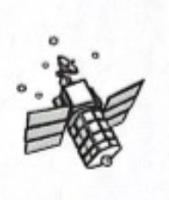
Check the condition of 14 satellites to see if they have been working properly.
Notes:

Research Notes Continued
Weather: Could bad weather be causing some of the problems?
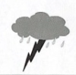
Check weather reports.
Notes:

Unusual Lights in the Sky: Check reports of strange colored lights in the sky.
Notes:

Research Notes Continued
Nuclear Weapons: Nuclear bombs give off X-rays and gamma rays. Check military reports to see if any nuclear testing occurred.
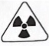
Notes:

Solar Wind: Solar wind is a steady flow of particles from the Sun.
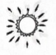
Was the solar wind normal?
Notes:

Solar-Surface Activity: Sunspots and solar flares are activities that we can observe on the surface of the Sun. Look at the photographs of the sun and data for late April.

Research Notes Continued

Notes:

Earth’s Magnetosphere: Earth has a magnetic field around it.
Check to see if the magnetosphere was normal.
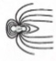
Notes:

Satellite Information Sheet
There are thousands of artificial satellites in orbit around Earth. These satellites do various jobs, such as help predict the weather or aid in communication. They send information back to Earth by radio waves.

Damage Report on Some Key Satellites
Satellite | Purpose | Damage
A | ZBS Television | None
B | Monitor weather | None
C | Monitor ozone layer | None
D | Internet | None
E | Military | Report not available
F | Cell Phones | Disabled April 23
G | NBZ Television | None
H | Monitor rainforest foliage | None
I | Cell Phones | None
J | Monitor ocean temperature and sea level | None
K | ABZ Television | Disabled April 23
L | Monitor solar wind | None
M | ATM communications | None
N | Navigation | Disabled April 23

Weather Information Sheet
U.S. Weather Report: April 20 – 22
The nation’s weather was generally calm with cool temperatures and some rain in the Northeast, cool and sunny weather in the central U.S., and sunny and mild in the Southwestern U.S.
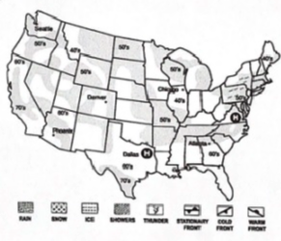
U.S. Weather Report: April 23 – 25
Cold winds from the North have dropped temperatures. An unseasonable mid-spring chill has settled across the North, bringing with it some snow. Rains with thunderstorms in the Southeast with sunny but cool temperatures in the central and Southwestern U.S.
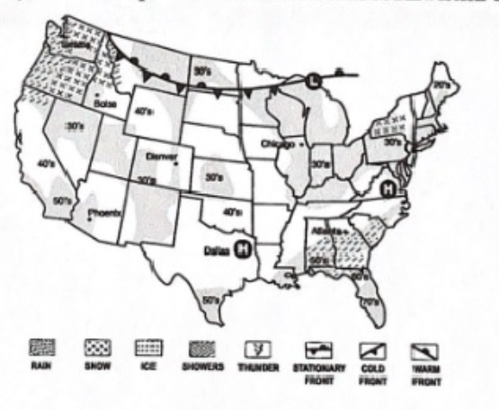
Unusual Lights in the Sky Information Sheet

Reports for April 20 – 26
DATE | LOCATION | DETAILS
April 20 | Fallon, Nevada | Fast-moving bright lights seen in the sky above the “Top Gun” Airforce Base. Unidentified.
April 21 |  | No reports.
April 22 | Marshalltown, Iowa | Flying disk reported seen at 3:00 a.m. Unidentified. The sheriff says it may have been a glow-in-the-dark Frisbee left in a tree.
April 23 | Locations all across North America | Colored lights filled the sky for several hours after midnight. Unidentified. Berkeley Space Science lab says this may have been the aurora, but it is usually seen much closer to the North or South Poles.
April 24 | Locations in Canada and the Northern U.S. | Colored lights filled the sky to the north. Possible aurora.
April 25 |  | No reports.
April 26 | Chicago, Illinois | Several people reported seeing a line of white lights glowing in the sky near the airport. Unconfirmed. Scientists say lights may be airliner landing lights.

Nuclear Weapons Information Sheet
Military scientists use satellites to watch for the use of nuclear weapons by other countries. The satellites can detect X-rays and gamma rays given off during nuclear explosions. These military satellites were functioning normally in April.

Classified Military Satellite Report
Date | Status | Time | Notes
April 20 | Normal
April 21 | Alert | 7:18 p.m. | Increase in X-ray and gamma-ray levels detected. Defense systems on alert: Def Con 3.
 |  | 7:20 p.m. | The increase in X-ray and gamma-ray levels identified as not coming from Earth. Military defense systems taken off alert.
 |  | 7:25 p.m. | Communications with all other nuclear powers confirm that no detonation of nuclear weapons occurred.
April 22 | Normal
April 23 | Normal
April 24 | Normal
April 25 | Normal
April 26 | Normal

Solar Wind Information Sheet
The solar wind is a constant flow of electrically charged particles (protons and electrons) that speed away from the Sun in all directions at hundreds of kilometers per hour.
Speed of particles from the Sun in April
April 20 | Normal
April 21 | Normal
April 22 | Normal
April 23 | Greatly increased
April 24 | Greatly increased
April 25 | Normal
April 26 | Normal
April 27 | Normal

Solar Wind Speed in April
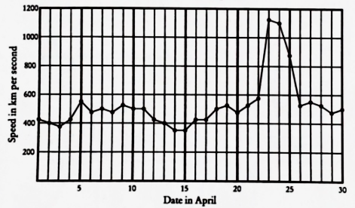
Earth’s Magnetosphere Information Sheet
Earth is surrounded by an invisible magnetic field called the magnetosphere (mag-NEET-o-sfeer). It protects Earth from energetic particles coming from the Sun in the solar wind. The magnetosphere fans out from Earth’s magnetic poles, something like the field of a bar magnet.
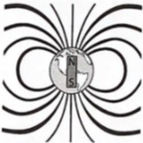

On the side of the Earth facing the Sun, the magnetosphere is flattened by the solar wind. On the side facing away from the Sun, the magnetosphere is blown away from Earth into a tail that stretches out into space.
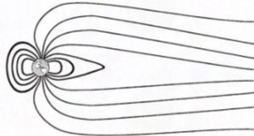

Earth’s Magnetosphere Information Sheet Continued

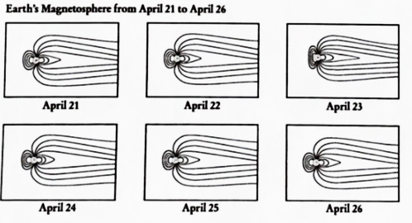
Solar Surface Information Sheet
Sunsports are dark spots that appear on the surface of the Sun. They last for several days or weeks. Solar flares are extremely bright areas on the surface of the Sun that last only a few hours. Scientists have noticed that flares are more likely to happen at times of high sunspot activity.

Solar flares are ranked by their intensity:
C = small, M = medium (10 times more powerful than a C-flare), X = large (100 times more powerful than a C-flare)
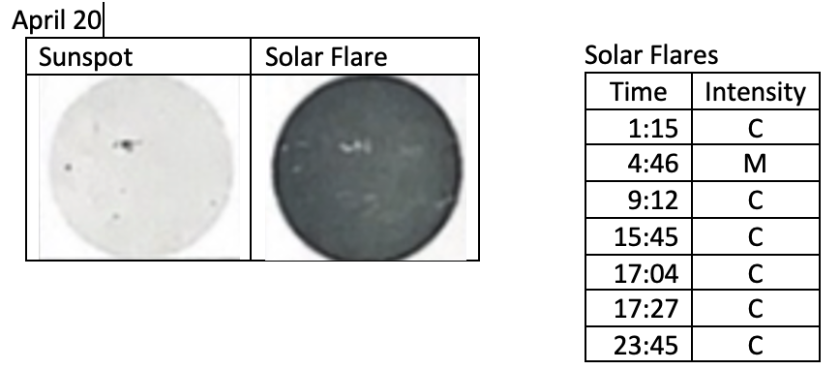

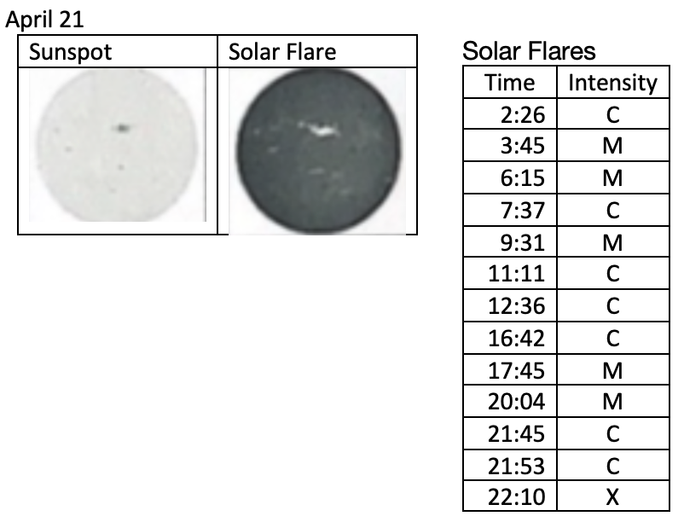

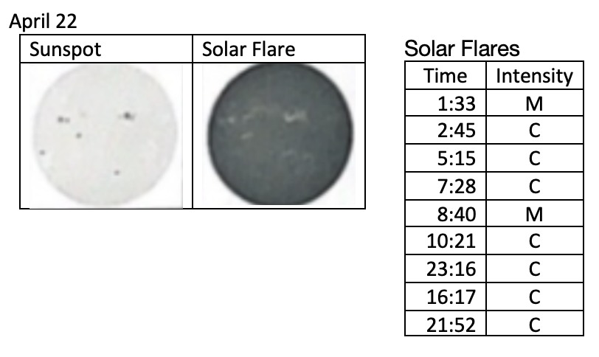

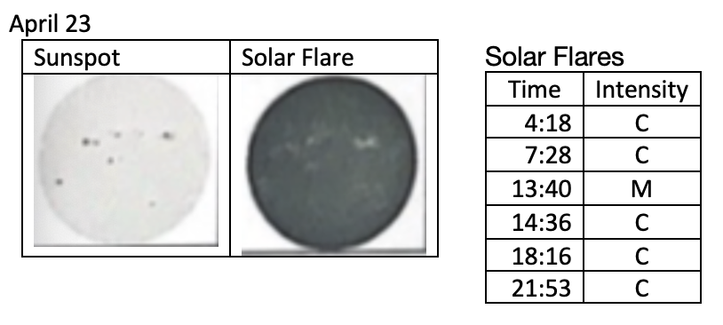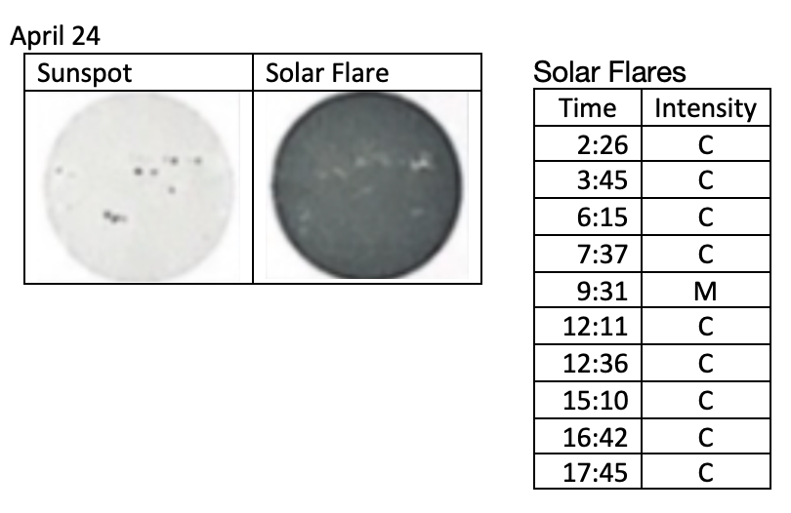
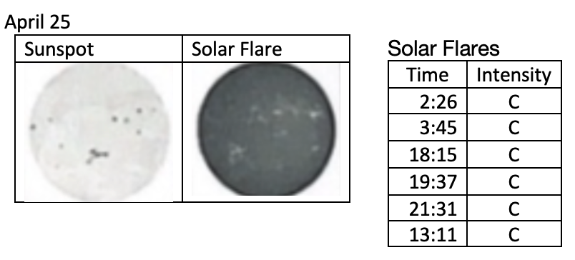
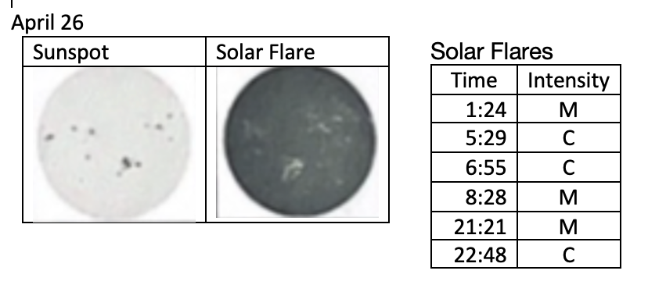
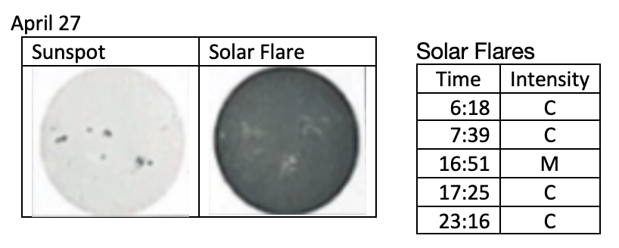
Solar Surface Information Sheet Continued

