The Sun and Convection Currents
By Christian J. Mercado
Table of Contents
Lesson Overview and Objectives 2
Materials 3
5E Steps 5
Resources 10
Handouts 11

Lesson Overview
Level: 9-12 Time: 5 class periods
In this lesson, students will learn about convective heat transfer processes that take place in the Sun. Hot plasma rises from the core towards the surface, where it cools and sinks back towards the core. This process forms convection cells that we see as solar granules. Students will see this convection process using simulators, the Swedish Solar Telescope: Solar Closeups website and by conducting a convection experiment.

Educator Background Knowledge
- Heat Transfer
- Convection
- First Law of Thermodynamics

Learning Goals
- Students will use a convection simulator to understand how convection phenomena on Earth are similar to those on the Sun.
- Students will analyze current videos of convection processes in the Sun to study and draw conclusions about these processes.
- Students will perform a convection experiment to model how convective processes are carried out in the Sun.

Learning Objectives
At the end of the lesson, students will
- Understand what convection currents are.
- See how convection currents work.
- Understand how convection processes take place in the Sun.
Framework for Heliophysics Education
NASA Question: How do the Earth, the solar system, and heliosphere respond to changes on the Sun? Big Idea: The Sun is the primary source of light in our solar system.
NASA Question: What causes the Sun to vary? Big Idea: Energy from the Sun is created in the core and travels outward through the Sun and into the heliosphere.

NGSS Performance Expectations
PS1.C: Matter and Its Interactions: Nuclear Processes: The sub-atomic structural model and interactions between electric charges at the atomic scale can be used to explain the structure and interactions of matter, including chemical reactions and nuclear processes.

Common Core Standards for Mathematical Practice
- High School: Statistics and Probability: Interpreting Categorical and Quantitative Data HSS-ID.A.1: Represent data with plots on the real number line (dot plots, histograms, and box plots).

Targeted STEM Skills
- Changes of energy and matter in a system can be described in terms of energy and matter flows into, out of, and within that system

Materials:
- Computers/Tablets
- Digital thermometer
- Pencil
- Portable heat source
- Glitter
- Fireproof surface
- Water
- Food coloring
- Two clear baking dishes

Handouts
- Heat Transfer Worksheet

Links to Digital Resources for Students
- Heat Transfer Worksheet: https://www.teachengineering.org/content/cub_/activities/cub_solar/cub_solar_lesson02_activity1_worksheet.pdf
- Convection current JavaScript HTML5 Applet Simulation*: https://iwant2study.org/lookangejss/03thermalphysics_09transferofthermalenergy/ejss_model_convectioncurrent02/
*Note this Open Source Applet has ads which can be removed from the screen.
- Our Sun and Heat Transfer Basics: https://www.teachengineering.org/activities/view/cub_solar_lesson02_activity1
- Swedish Solar Telescope: Solar Closeups: https://svs.gsfc.nasa.gov/4715
Key Vocabulary
Heat transfer, surface temperature, convection, the convection zone of the Sun

Material Preparation
- Review the lesson and resources and make copies of the Handout for students.
- If virtual, upload all documents to the cloud for student access.
- Divide into two groups: 1) Experimental group that will work with everything related to instrumentation: placement of measuring instruments, clear baking dish (ideal: 8x8 inch [20x20 cm], portable heat source, digital thermometer, food coloring (orange works well for the Sun), glitter, fireproof surface, and the water. 2) Analytical group: they will use their computer/tablets to take the data of the experiment. Students work in groups (Experimental + Analytical).
- Alternatively students can work in pairs, if there are enough tablets.
- Verify and have prepared the areas to be used
- A computer lab for students to carry out the Extend activities.

5E Steps
Engage
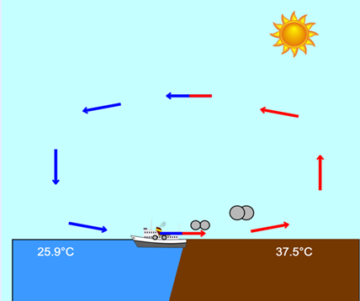
Have students analyze the Convection current JavaScript HTML5 Applet Simulation* and answer the following questions:
- What do the blue and red lines represent?
- Why is the temperature in the sea different on land?
- What happens to the temperature at night?
- What role does the Sun play in the convection process?
*Note this Open Source Applet has ads which can be removed from the screen. To run the applet to look like this check the Wind box and click play.

Explore
Swedish Solar Telescope: Solar Closeup: In this close-up image of the solar photosphere, we see the dark regions of sunspots, and solar granules changing with time. These granules are the tops of convection cells where hot gas rises from the interior to cool and then descend back down. (Credit: NASA Scientific Visualization Studio). Explain how the convection cells are observed in that part of the Sun.

Image credit: SkyMarvels.com

Explain
Students will answer the following questions based on the images previously observed referring to the image below.

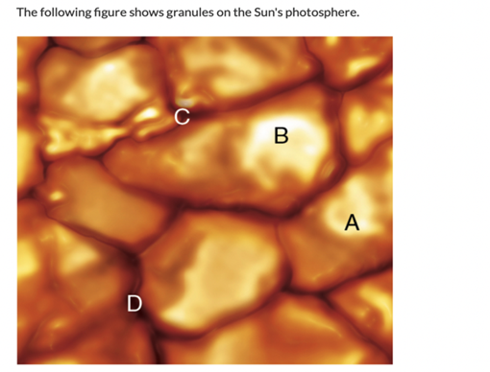
Questions:
- The bright regions are zones where ______ gas rises.
- The dark borders are the places where the _____ gas sinks.
- The gas moves outwards or inwards at speeds up to 7000 m/s. How much would it be in km/s?
Extend
Conduct an experiment. Students will learn how convection moves the energy of the Sun from its core outwards. Heat affects the density of water as well. Students can create their own convection current with water that will allow them to see currents by the density difference of water at different temperatures.
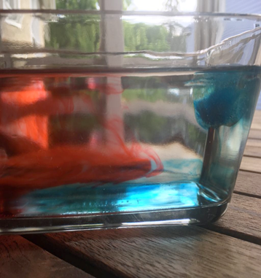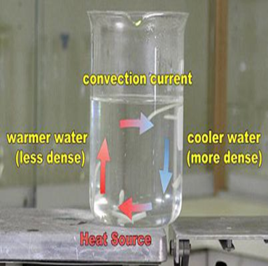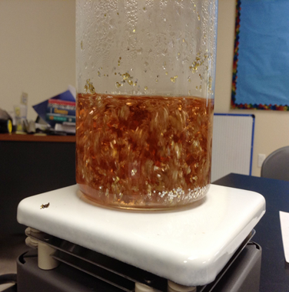
Have students follow the steps in the lesson (Credit: TeachEngineering.org) https://www.teachengineering.org/activities/view/cub_solar_lesson02_activity1
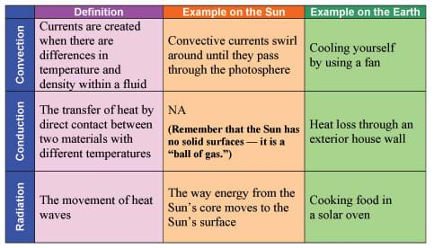
Table 1 provides examples of convection, conduction and radiation on the Sun and on Earth.
- Explain to students the three different modes of heat transfer (radiation, conduction and convection). Refer to examples in Table 1.
- Have students write their heat transfer definitions on the worksheet, with an example of each that they have experienced or seen in their own lives.
- Tell students that they will be recording observations and data on their worksheets to use in making a bar graph at the end of the demonstration.
- Make sure all students can see the demonstration and that, for safety, no student is too close to the flame. If students are doing the steps on their own, make sure no student is too close to the flame.
- Place the baking dish on two piles of dictionaries that are high enough and far enough apart to place a fireproof plate and sternoTM can (or warming candle) under the baking dish.
- Pour cool water into the baking dish.
- Make sure the table is very still so that the water does not move. Take the temperature of the water in Celsius or Fahrenheit. Have students record the temperature. Repeat the temperature several times so all students have time to record the temperature on their worksheets (a volunteer may want to keep track on the board).
- Carefully light the heat source. Drop a few drops of food coloring and some glitter into the water. It works best to drop the glitter and food coloring into the water directly above the heat source.
- Take the temperature of the water in Celsius or Fahrenheit at two-minute intervals. Be sure to take the temperature in roughly the same location in the dish every time. What is happening to the glitter as the water gets hotter? Have students record the temperatures.
- The heat source should slowly heat the water in the middle of the baking dish. The food coloring helps students observe the movement of the water.
- The glitter flows from the high heat in the center to the outsides where it is cooler. Convection transfers heat (energy) by currents of gas or liquid. (It may help to have students get up and walk past the demonstration so that they can get a closer look i f you are performing this as a demonstration.)
- Have students record their observations on the worksheet.
  - Explain to students that their evaluation will be graded on how thoroughly and accurately they record the demonstration.
  - Have students make a bar graph of the temperature. What do they notice about the temperature? (The water temperature should show an increase.)
- Review the ways that heat moves.
  - Conduction = by direct contact of two materials
  - Convection = by the interaction of fluid molecules (such as air or water)
  - Radiation = by the movement of heat waves.
Evaluate
Based on the data obtained, the students will build a graph of the different temperature points of water. See the Handout. (Credit: Teachengineering.org)
- What is happening to the glitter as the water gets hotter?
- What observations can you make about the temperature?
- What kind of energy is occurring?

Resources
- Heat Transfer Worksheet: https://www.teachengineering.org/content/cub_/activities/cub_solar/cub_solar_lesson02_activity1_worksheet.pdf
- Convection current JavaScript HTML5 Applet Simulation*: https://iwant2study.org/lookangejss/03thermalphysics_09transferofthermalenergy/ejss_model_convectioncurrent02/
- Our Sun and Heat Transfer Basics: https://www.teachengineering.org/activities/view/cub_solar_lesson02_activity1
- Swedish Solar Telescope: Solar Closeups: https://svs.gsfc.nasa.gov/4715
- Wee, W. by L. K. Physics. Open Educational Resources / Open Source Physics. https://iwant2study.org/ospsg/index.php/interactive-resources/physics
- NASA Scientific Visualization Studio https://svs.gsfc.nasa.gov/
- Heat transfer: TeachEngineering.org: https://www.teachengineering.org/populartopics/heattransfer
Handouts
This begins on the next page.

Heat Transfer Worksheet
From Teachengineering.org

Name: ___________________________ Date: __________________

- In the table below, fill in your definition and a real-life example.
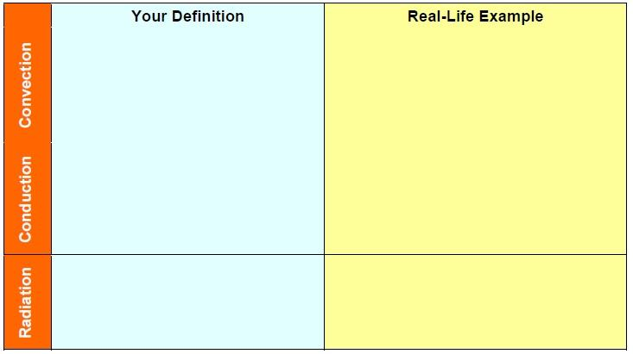
- What is happening to the glitter as the water gets hotter? Record your observations below.

- Record the temperatures at different time lengths below.

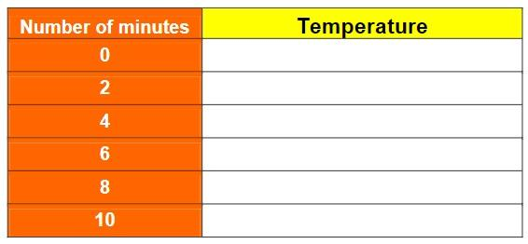
4. Make a bar graph of the data you collected.

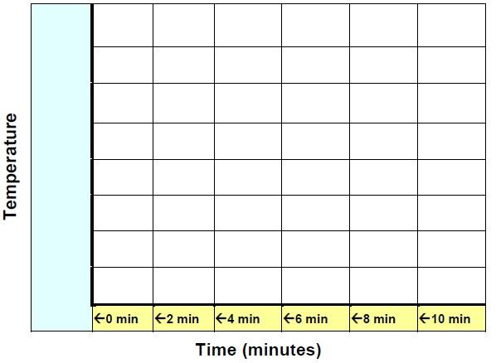
5. What observations can you make about the temperature?

6. What kind of energy is occurring?

