Urban Heat Islands: Using Simulated Regolith Mars Soil
by Christian J. Mercado
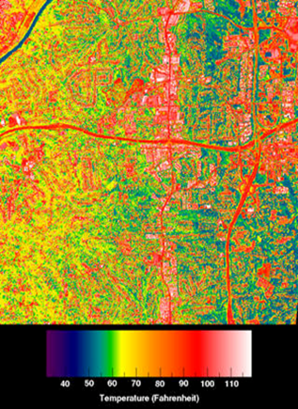
Table of Contents
Lesson Overview and Objectives 2
Materials 4
5E Steps 7
Resources 11
Handouts 12

Lesson Overview
Level: 9-12 Time: 5 class periods
In this lesson students will study the effects of human impact on the environment and its relationship to changes in temperature. Unlike other lessons, in this one we will use simulated Mars soil. This will allow them to measure the different changes that Martian soil may have had when the planet Mars was habitable at some point.

Educator Background Knowledge
- The processes of heat energy transfer from the Sun to the Earth.
- How does the atmosphere work as a protective shield from the Sun's energy?
- Why do different materials experience differences in surface temperature?
- How has human activity led to the creation of Urban Heat Islands?

Learning Goals
- Students will be able to collect and analyze data on the relationship between surface variance and temperature using the simulated Mars soil.
- Students will be able to design a Urban Heat Islands Story Map Picture to minimize the effect of human development on surface temperature.
- Students will be able to present their claims and findings from their Urban Heat Islands story map activity design, and explain how it mitigates humans’ effect on surface temperature.

Learning Objectives
- Students will analyze regolith Mars soil surface temperature data to use as evidence to explain the urban heat island effect.
- Students will explore the role of Earth’s energy balance creating a surface temperature difference picture in the creation of urban heat islands.
- Students will evaluate examples of human activity that have led to the creation of urban heat islands.
Framework for Heliophysics Education
NASA Question: What are the impacts of the Sun on humanity? Big Idea: The Sun is active and can impact technology on Earth via space weather.

NGSS Performance Expectations\
MS-ESS3-3: Earth and Human Activity: Apply scientific principles to design a method for monitoring and minimizing a human impact on the environment.
MS-ETS1-1: Engineering Design: Define the criteria and constraints of a design problem with sufficient precision to ensure a successful solution, taking into account relevant scientific principles and potential impacts on people and the natural environment that may limit possible solutions.
HS-ESS3-3: Earth and Human Activity: Create a computational simulation to illustrate the relationships among management of natural resources, the sustainability of human populations, and biodiversity
Common Core Standards for Mathematical Practice
High School: Statistics and Probability: Interpreting Categorical and Quantitative Data HSS-ID
- Represent data with plots on the real number line (dot plots, histograms, and box plots).
- Interpret the slope (rate of change) and the intercept (constant term) of a linear model in the context of the data.
- Compute (using technology) and interpret the correlation coefficient of a linear fit.

Targeted STEM Skills
- Cause and Effect: Cause and effect relationships may be used to predict phenomena in natural or designed systems. (MS-ESS3-4)

Materials
- Computers/Tablets
- Infrared thermometer
- Pencil
- Data table
- Five different types of materials found outside: grass, pavement (driveway, road), sidewalk, plant (tree or bush), and bare soil
- Regolith Mars Soil
- Earth soil
- Two plant pots

Handouts
- Lab Report (temperature chart, data table and bar chart model)

Links to Digital Resources for Students
- The Greenhouse Effect (English): https://phet.colorado.edu/sims/html/greenhouse-effect/latest/greenhouse-effect_en.html
- The Greenhouse Effect (Spanish): https://phet.colorado.edu/sims/html/greenhouse-effect/latest/greenhouse-effect_es.html
- Creation of Urban Heat Islands Story Map: https://nasa.maps.arcgis.com/apps/MapSeries/index.html?appid=44b9c8738f0e47e68d9e8ae2c530ed08
- United Nuclear Simulated Regolith Mars Soil: https://www.amazon.com/-/es/simulado-Regolith-estudiantes-Educativos-marciana/dp/B085Q22JS3/ref=sr_1_1?keywords=mars%2Bsoil&qid=1656384106&sr=8-1&th=1
Key Vocabulary
Temperature, surface temperature, human activity/development, design constraints, Urban Heat Islands

Material Preparation
- Review the lesson and resources and make copies of the Lab Report for students.
- If virtual, upload all documents to the cloud for student access.
- Divide into two groups: 1) Experimental group that will work with everything related to instrumentation: placement of measuring instruments, the Martian soil and photographs. 2) Analytical group: they will use their computer/tablets to take the data of the experiment.
- Two groups are formed for the experiment working in pairs (one of each type).
  - Experimental group: Focuses on instrumentation-related tasks.
    - Placement of measuring instruments.
    - Study of the Martian soil.
    - Taking photographs.
  - Analytical group: Works with computers/tablets for data collection and analysis.
    - Collecting data from the experiment.
    - Recording measurements and observations.
    - Organizing and analyzing the data.
- The two groups collaborate to ensure a comprehensive understanding of the experiment's results. The experimental group performs hands-on activities, while the analytical group processes and interprets the data.
- Another option is to have students work in pairs if you have enough computers for a 2:1 ratio.
- Verify and have prepared the areas to be used.
  - Experimental Area: This is the space where the experimental group will work with the instrumentation, such as placing measuring instruments, studying the Martian soil, and taking photographs.
  - Analytical Area: This refers to the space where the analytical group will be stationed with their computers or tablets to collect and analyze the data obtained from the experiment.
- It's important to ensure that these areas are appropriately set up, equipped, and ready for the experiment to take place smoothly.
- A computer lab for students to carry out the Extend activities.

5E Steps
Engage
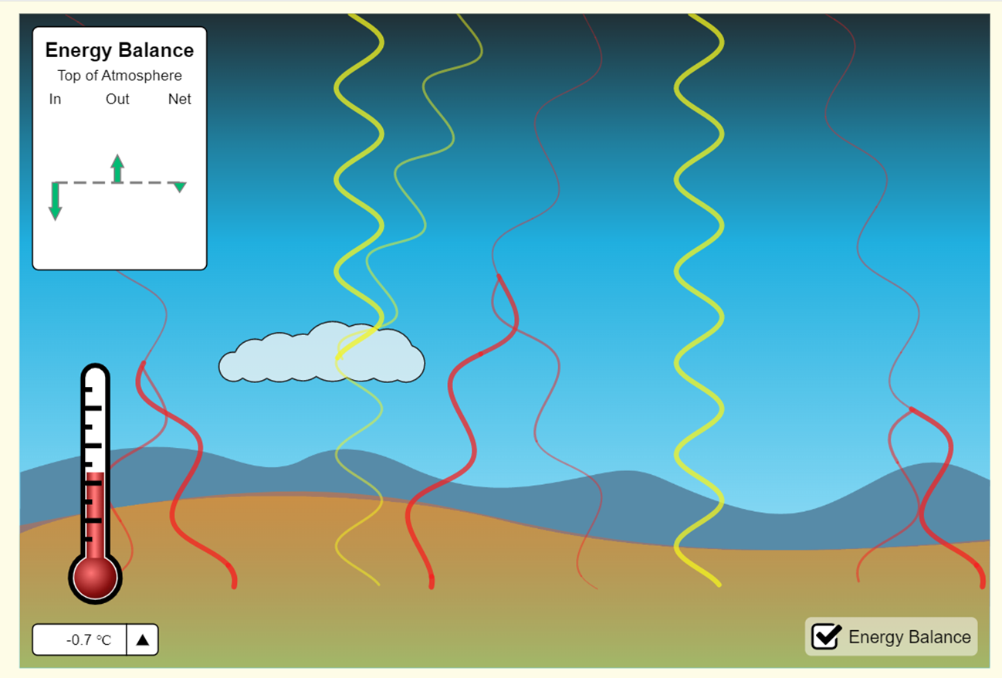
Surface Temperature Differences Simulator (English)
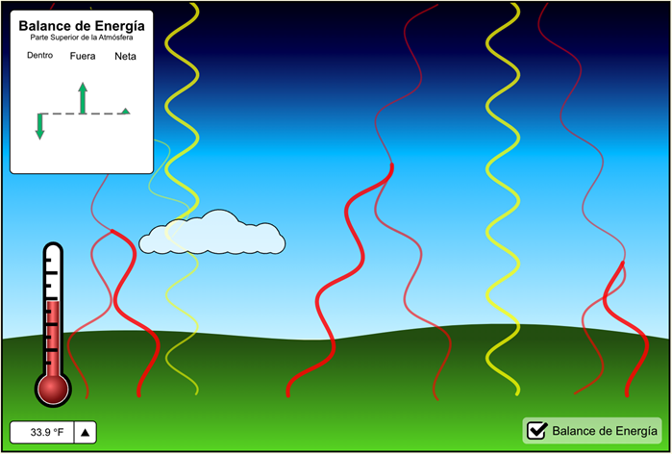
Surface Temperature Differences Simulator (Spanish)
Analyze the PhET greenhouse effect simulation and have students answer the following questions:
- What do the yellow and red zig zag lines represent?
- What happens to the surface temperature when greenhouse gases increase?
- What role do clouds play in temperature changes?
The Greenhouse Effect (English) | The Greenhouse Effect (Spanish)
Explore
Surface Temperature Differences Urban Heat Islands Story Map: In the image below, different surface temperatures were measured on an Autumn afternoon. Notice that the temperatures of the various surfaces are different from the air temperature.

Guiding Questions:
- What is the temperature difference between sunlit concrete and shaded concrete?
- What does this difference in temperature tell you about how surfaces are heated?
- Which type of area do you think is warmer, urban areas or rural areas? Why?
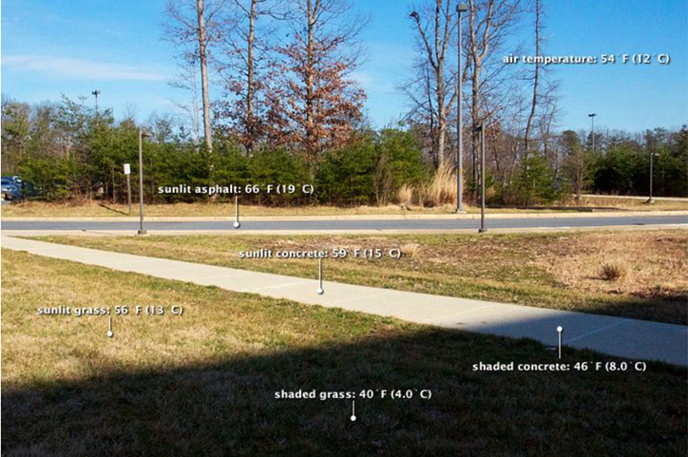
Explain
In this section students will watch the NASA video: Real World: Earth's Energy Balance: Energy In and Energy Out and answer the following questions:
- What type of energy do we receive from the Sun?
- What percentage of the energy from the Sun gets absorbed by the land and ocean rather than reflected back to space?
- Which surfaces are more reflective, deserts or rainforests? Why?
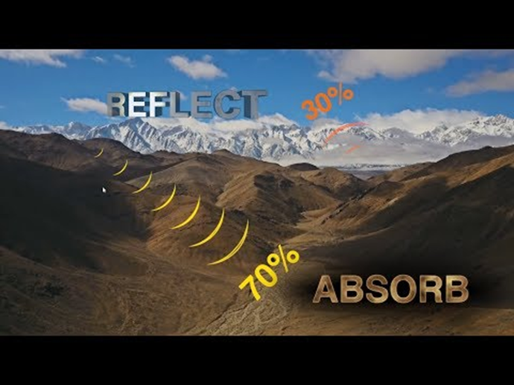

Extend
Tell students they will be conducting an investigation to answer the question: Do different surface materials have different temperatures during the same time of the day?

Provide students with the Lab Report (in Handouts at the end of the lesson) that they can fill out for this experiment.
- Each group will do a Surface Temperature Differences Urban Heat Islands Story Map picture of their area.
- Students will fill in the Temperature Chart with five different surface types that they identify on the area. Next, they will fill in the surface temperature of the material.
- Based on the data obtained, students will build a graph of the different temperature points of the Martian soil.

Evaluate
Based on the data obtained, students will build a graph of the different temperature points of the Martian soil and answer the following questions.

On the bar chart template on the Lab Report students fill in numbers 1-5 with the different surfaces they found and answer these questions about the data.
- What patterns do you notice when comparing the temperatures of natural and artificial materials?
- How was the Martian soil affected in the different places it was placed?
- What could this data tell us about the past of the red planet (Mars)?
Resources
- Lab Report
- Phet Interactive Simulations. PhET: https://phet.colorado.edu/
- NASA Scientific Visualization Studio: https://svs.gsfc.nasa.gov/
- Story map series. my NASA data: https://nasa.maps.arcgis.com/apps/MapSeries/index.html?appid=44b9c8738f0e47e68d9e8ae2c530ed08
- NASA video: Real World: Earth's Energy Balance: Energy In and Energy Out

Handouts
These begin on the next page.

LAB REPORT
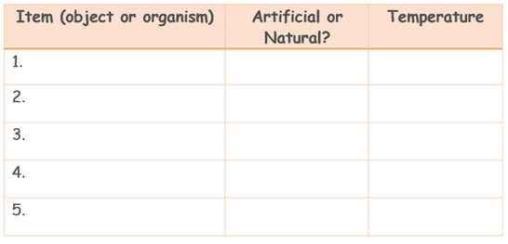
Temperature Chart: Fill in the following chart with five different surface types that you identify. Next fill in the surface temperature of the material.

. Bar Chart Template: Fill in numbers 1-5 with the different surfaces you found and answer the questions about the data on the next page.

Questions:
- What patterns do you notice when comparing the temperatures of natural and artificial materials?

- How was the Martian soil affected in the different places it was placed?

- What could this data tell us about the past of the red planet (Mars)?

Bar Chart Model (for reference)
