What Happens When Solar Weather Reaches Earth? Aurora Borealis and Aurora Australis
By Thomas N. Tomas

Table of Contents
Lesson Overview and Objectives 2
Materials 7
5E Steps 9
Resources 10
Handouts 12

Lesson Overview
Level: 5th and 6th Grade Time: Ten 60-minute class periods

Note: This lesson was designed for Navajo students but is included in the HEAT collection to inspire and support all educators to incorporate indigenous knowledge.

This lesson will fit within a broader interdisciplinary thematic unit. Students will learn about relationships between the Sun and Earth by researching how the Sun creates patterns on Earth. Students will begin by asking, “Why are there satellite outages and radio drop-outs?” This question will lead students to auroras and solar storms. Note: When faint radio stations drop-outs, it is an indication of the Sun’s X-ray flux increasing. The insights gleaned will vary greatly and then our focus will concentrate on Coronal Mass Ejections (solar ‘burps’) and solar flares and how these forms of space weather interact with Earth’s ionosphere, in part, by creating the auroras in the southern and northern hemispheres. Students will study the NASA EZIE mission: Electrojet Zeeman Imaging Explorer (EZIE). Students will also study the Magnetospheric Multiscale (MMS) Mission, a Solar-Terrestrial Probe that is used to study magnetic reconnection. Students will use magnets and iron filing containers to explore, engage in, examine, and visualize magnetic fields.

Educator Background Knowledge
Teachers may share the role of the Sun in Native Science: The Heliosphere: One of four systems that comprise our biosphere. How do the four elements shape who we are?
Systems thinking – Natural and human-designed systems

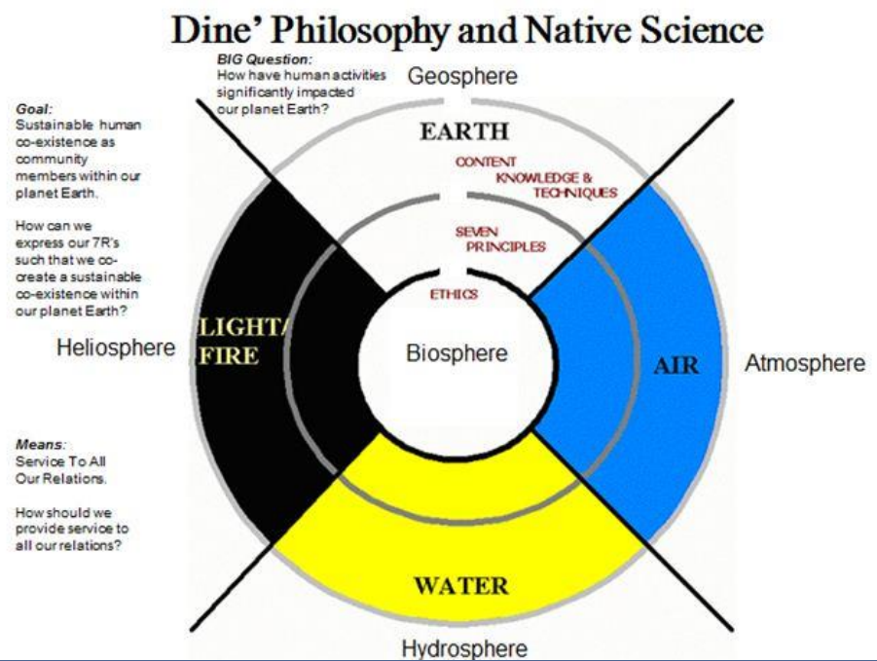
‌
Auroras in the Classroom Activity
This is a good NASA image to demonstrate to your students how the Northern Lights form. Where do the auroras (Aurora Borealis, Aurora Australis) come from? The solar wind continually bathes our planet’s magnetosphere with charged particles emitted from the Sun. During periods of intense solar activity – mainly during events known as coronal mass ejections or CMEs – the quantity of charged particles colliding with the magnetosphere increases dramatically.
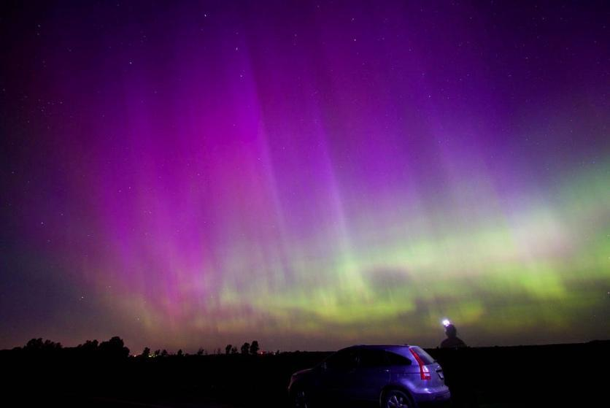
The energy from these particles acts much like the electricity flowing through the low-pressure gas found in a fluorescent light bulb. When electricity flows through the gas in the light bulb, electrons of the atoms of the gas are moved to a higher energy state. This is known as excitation. When the electrons return to their ground state, the excess energy is released as photons of light at wavelengths specific to the type of gas atoms that were excited.

Electrical currents are created by the high-energy particles from the Sun. Electrical fields are associated with these currents. Similar to the fluorescent light, gasses in the upper atmosphere are excited by energy from these electrical fields. They also give off light as their electrons return to the ground state of colors depending on the gasses present. This light is our Northern Lights!

Our model functions in a similar way. A plasma sphere – easily found in stores such as Wal-Mart – creates an electrical field around itself. This field will “light up” a fluorescent bulb held within the field. The closer you bring the bulb to the plasma sphere, the brighter it becomes. Try it! Have an aurora in your classroom, and hopefully get the chance to see one sometime in our night sky.

Learning Goals
How does the Sun create patterns on Earth?

Learning Objectives
- Students will learn how the Earth and the heliosphere respond to the Sun by studying patterns on Earth that are the result of the Sun’s weather such as CMEs and solar flares.
- The interaction of Earth’s ionosphere and solar flares can lead to satellite outages and radio drop-outs.
- Students will learn how such solar and planetary system interactions result in auroras.
- The Earth’s magnetosphere is composed of magnetic fields that serve as a shield from solar weather

In addition, students will study and learn about
- the solar weather as a natural system.
- EZIE small satellites as a human-designed system
- the four Magnetospheric Multiscale (MMS) spacecraft as human-designed systems
- the ionosphere, mesosphere, stratosphere, and troposphere.
- the interactions between the Sun’s weather and Earth’s ionosphere.

Framework for Heliophysics Education
NASA Question: What are the impacts of the Sun on humanity? Big Idea: The Sun is active and can impact technology on Earth via space weather.

NGSS Performance Expectations
- 5-PS2-1: Motion and Stability: Forces and Interactions: Support an argument that the gravitational force exerted by Earth on objects is directed down.
- 5-PS3-1: Energy: Use models to describe that energy in animals’ food (used for body repair, growth, motion, and to maintain body warmth) was once energy from the Sun.
- 5-ESS2-1: Earth’s Systems: Develop a model using an example to describe ways the geosphere, biosphere, hydrosphere, and/or atmosphere interact.
- 5-ESS3-1: Earth and Human Activity: Obtain and combine information about ways individual communities use science ideas to protect the Earth’s resources and environment.
- MS-ESS3-2: Earth and Human Activity: Analyze and interpret data on natural hazards to forecast future catastrophic events and inform the development of technologies to mitigate their effects.

Common Core Standards for Mathematical Practice
- MP.2: Reason abstractly and quantitatively. (MS-PS1-2), (MS-PS1-5)
- MP.4: Model with mathematics. (MS-PS1-5)
- 6.RP.A.3: Use ratio and rate reasoning to solve real-world and mathematical problems. (MS-PS1-2), (MS-PS1-5)
- 6.SP.B.4: Display numerical data in plots on a number line, including dot plots, histograms, and box plots. (MS-PS1-2)
- 6.SP.B.5: Summarize numerical data sets in relation to their context (MS-PS1-2)

Common Core Standards for English Language Arts
- ELA/Literacy – RI.5.1: Quote accurately from a text when explaining what the text says explicitly and when drawing inferences from the text. (5-ESS3-1)
- RI.5.7: Draw on information from multiple print or digital sources, demonstrating the ability to locate an answer to a question quickly or to solve a problem efficiently.(5-ESS3-1)
- RI.5.9: Integrate information from several texts on the same topic in order to write or speak about the subject knowledgeably. (5-ESS3-1)
- W.5.8: Recall relevant information from experiences or gather relevant information from print and digital sources; summarize or paraphrase information in notes and finished work, and provide a list of sources. (5-ESS3-1)
- W.5.9: Draw evidence from literary or informational texts to support analysis, reflection, and research. (5-ESS3-1)

Crosscutting Concepts:
- Cause and Effect: Cause and effect relationships are routinely identified and used to explain change. (5-PS2-1)
- Systems and System Models: A system can be described in terms of its components and their interactions. (5-ESS2-1), (5-ESS3-1)

Targeted STEM Skills
- Engaging in Argument from Evidence: Engaging in argument from evidence in 3–5 builds on K–2 experiences and progresses to critiquing the scientific explanations or solutions proposed by peers by citing relevant evidence about the natural and designed world(s). Support an argument with evidence, data, or a model. (5-ESS1-1)
- Developing and Using Models: Modeling in 3–5 builds on K–2 experiences and progresses to building and revising simple models and using models to represent events and design solutions. Develop a model using an example to describe a scientific principle. (5-ESS2-1)
- Obtaining, Evaluating, and Communicating Information Obtaining, evaluating, and communicating information in 3– 5 builds on K–2 experiences and progresses to evaluating the merit and accuracy of ideas and methods. Obtain and combine information from books and/or other reliable media to explain phenomena or solutions to a design problem. (5-ESS3-1)

Materials
- Books about the Sun and the aurora

Handouts
KWL Chart
Systems Thinking with K’e:
- Components
- Inputs/Outputs
- Boundaries
- Interactions
- Properties

Links to Digital Resources for Students
- Electrojet Zeeman Imaging Explorer (EZIE mission): https://science.nasa.gov/missions/ezie
https://www.jhuapl.edu/PressRelease/201229-NASA-selects-EZIE-heliophysics
- Magnetospheric Multiscale (MMS) Mission: https://mms.gsfc.nasa.gov/
- Exploring Earth’s Magnetic Field: https://spacemath.gsfc.nasa.gov/NASADocs/magbook2002.pdf
- Earth’s Magnetosphere:
https://www.nasa.gov/mission_pages/sunearth/multimedia/magnetosphere.html
- Ionosphere, Thermosphere & Mesosphere:
https://science.nasa.gov/heliophysics/focus-areas/ionosphere_thermosphere_mesosphere
- What is an Aurora?: https://www.youtube.com/watch?v=czMh3BnHFHQ
- NASA Aurorasaurus: https://www.aurorasaurus.org/
- NASA Approves Heliophysics Missions to Explore Sun, Earth’s Aurora
https://www.nasa.gov/press-release/nasa-approves-heliophysics-missions-to-explore-sun-earth-s-aurora
- Magnetospheric Multiscale (MMS) Mission: https://mms.gsfc.nasa.gov/
- Exploring Magnetism with Smart Devices A NASA Educator’s Guide for Grades 3-12: https://spacemath.gsfc.nasa.gov/SMBooks/MagnetismGuide.pdf
- Earth's Magnetosphere: https://www.nasa.gov/mission_pages/sunearth/multimedia/magnetosphere.html
- Could Solar Storms Destroy Civilization? Solar Flares & Coronal Mass Ejections: https://www.youtube.com/watch?v=oHHSSJDJ4oo
- Heliosphere: https://science.nasa.gov/heliophysics/focus-areas/heliosphere
- Comparative Magnetospheres: A Noteworthy Coronal Mass Ejection: Information: https://svs.gsfc.nasa.gov/4188
Video: https://www.youtube.com/watch?v=DyuTyEw3etk

Key Vocabulary
Coronal Mass Ejections (CME), Solar flares, Aurora Borealis, Electrojet Zeeman Imaging Explorer (EZIE), Solar Storms, Sun Spots, Auroral Electrojet (AE) index, Earth’s magnetic field, Magnetosphere, Magnetic Reconnection, EZIE, Magnetospheric Multiscale (MMS) Mission, Satellite outage, Radio drop-outs.

Material Preparation
- Make sure students have access to the provided digital resources.

5E Steps
Engage
- Students will use magnets and Ironman iron filings within clear plastic cases.
- Students will illustrate and take digital images of the magnetized iron filings and draw scientific conclusions.
- Students will watch videos of CMEs, solar flares, and other forms of solar weather colliding with Earth’s magnetic field, forming aurora.

Explore
- Students will work in small groups to explore the relationships between our closest star and our Earth’s magnetic field.
- Students will use a KWL chart to explain what they know about the Sun.
- Students will research the various layers of Earth’s atmosphere: ionosphere, mesosphere, stratosphere, and troposphere as components of the atmosphere as a natural system.
- Next, students will research and chart the qualities of Earth’s geodynamo and magnetosphere as natural systems
- Then the students will research how the EZIE small satellites and MMS probes are human-designed systems.

Explain
Students will present on
- Solar weather within our heliosphere and its interactions with Earth’s magnetosphere.
- Polarity of the electrical charge within the plasma involved in the CME, solar flares, characteristics of Earth’s ionosphere, and the polarity of Earth’s magnetosphere are conditions with certain outcomes.
- Earth’s Geodynamo as a natural system, and how it provides Earth with a magnetic field, shielding us from harmful solar weather.
- Solar storms deliver electrically polarized particles that sometimes match and sometimes oppose the polarity of Earth’s magnetosphere. Circumstances within the solar weather such as these determine the severity of consequences to our magneto shield and human-designed systems such as electrical grids, transformers, GPS satellites, communications satellites, etc..

Extend
Students will create multimedia presentations and present to the following audiences:
- Students will research and seek solutions to severe solar weather patterns.
- Peers at school
- STEM Family Literacy Nights for family and community members
- Sister Schools via video conferencing
- E-portfolio entry provides each young scientist and engineer with an opportunity to tell her or his story as a learner.

Evaluate
- Students will keep a Science and Engineering Notebook as well as an electronic notebook to be kept within their e-portfolio located within their classroom website with access granted via each student’s email account.
- Students’ work within their notebooks will serve as Common Formative Assessment opportunities. The teacher will seek out students’ on-track thinking as well as misconceptions, and then modify and differentiate instruction accordingly. Additional evaluation strategies will include quizzes, online forms, and collaborative discussion boards.

Resources
KWL Chart
Systems Thinking with K’e:
- Components
- Inputs/Outputs
- Boundaries
- Interactions
- Properties
- Electrojet Zeeman Imaging Explorer (EZIE mission): https://science.nasa.gov/missions/ezie
https://www.jhuapl.edu/PressRelease/201229-NASA-selects-EZIE-heliophysics
- Magnetospheric Multiscale (MMS) Mission: https://mms.gsfc.nasa.gov/
- Exploring the Earth’s Magnetic Field: https://spacemath.gsfc.nasa.gov/NASADocs/magbook2002.pdf
- Earth’s Magnetosphere:
https://www.nasa.gov/mission_pages/sunearth/multimedia/magnetosphere.html
- Ionosphere, Thermosphere & Mesosphere:
https://science.nasa.gov/heliophysics/focus-areas/ionosphere_thermosphere_mesosphere
- What is an Aurora?: https://www.youtube.com/watch?v=czMh3BnHFHQ
- NASA Aurorasaurus: https://www.aurorasaurus.org/
- NASA Approves Heliophysics Missions to Explore Sun, Earth’s Aurora
https://www.nasa.gov/press-release/nasa-approves-heliophysics-missions-to-explore-sun-earth-s-aurora
- Magnetospheric Multiscale (MMS) Mission: https://mms.gsfc.nasa.gov/
- Exploring Magnetism with Smart Devices A NASA Educator’s Guide for Grades 3-12: https://spacemath.gsfc.nasa.gov/SMBooks/MagnetismGuide.pdf
- Earth's Magnetosphere: https://www.nasa.gov/mission_pages/sunearth/multimedia/magnetosphere.html
- Could Solar Storms Destroy Civilization? Solar Flares & Coronal Mass Ejections: https://www.youtube.com/watch?v=oHHSSJDJ4oo
- Heliosphere: https://science.nasa.gov/heliophysics/focus-areas/heliosphere
- Comparative Magnetospheres: A Noteworthy Coronal Mass Ejection: Information: https://svs.gsfc.nasa.gov/4188
Video: https://www.youtube.com/watch?v=DyuTyEw3etk

Handouts
These begin on the next page.

K-W-L Chart

TOPIC:__________________________________

What I Know | What I Want to Know | What I Learned

